CSIT314 (Software Development Methodologies) - Tutorial 5

**Paper Research Conference Management   
System**

by NextLevel

Final Report

# Contribution Table

|  |  |  |  |
| --- | --- | --- | --- |
| **Name** | **Rating** | **Contribution** | **Signature** |
| Aaron Vincent | Contributed | Diagrams, Taiga |  |
| Brandon Chew | Contributed | Back-end Codes,  Unit Testing, Report |  |
| Mikael Denys Widjaja | Contributed | Wireframes, Diagrams, Front-End Codes, Report |  |
| Patricia Natasha | Contributed | Back-End Codes,  Use Cases, Diagrams, Report |  |
| Roswin Dingenus | Contributed | BCE, Sequence diagrams, Class diagrams |  |
| Wynne Hewitt | Contributed | Front-End Codes, Video, Wireframes, Report |  |
| Yechan Kim | Contributed | Test Cases, Databases, Report |  |

# Members Details

|  |  |  |  |
| --- | --- | --- | --- |
| **Name** | **UOW ID** | **Role** | **UOW Mail** |
| Aaron Vincent | 7431363 | Diagram Designer | av907@uowmail.edu.au |
| Brandon Chew | 7365779 | Back End Developer | bc084@uowmail.edu.au |
| Mikael Denys Widjaja | 7435241 | Front End Developer | mdw527@uowmail.edu.au |
| Patricia Natasha | 7433566 | Back End Developer | pn249@uowmail.edu.au |
| Roswin Dingenus | 7433578 | Diagram Designer | rd982@uowmail.edu.au |
| Wynne Hewitt | 7432082 | Front-End Developer | wh834@uowmail.edu.au |
| Yechan Kim | 7432318 | Tester, Database Designer | yk517@uowmail.edu.au |

**Contribution Table**2

**Members Details**3

**A. User Stories**9

**B. Completed Tasks for each user story**13

SPRINT 1 13

SPRINT 2 16

SPRINT 3 17

SPRINT 4 20

SPRINT 5 22

SPRINT 6 24

**C. Use Case Diagrams**25

System Admin 25

Author 26

Reviewer 27

Conference Chair 28

**D. Analysis and Designs for Each Use Case**29

SPRINT 1 29

Taiga 29

Class Diagram 30

Data Persistent 30

#1 - As a system admin, I want to login as a system admin so that I can access the system admin’s dashboard. 30

#4 - As a system admin, Logout from the system so that I can logout from the system. 33

#2 - As an author, I want to login as an author so that I can access the author’s dashboard. 35

#242 - As an author, I want to logout from the system so that I can logout from the system. 37

#3 - As a reviewer, I want to login as a reviewer so that I can access the reviewer’s dashboard. 39

#246 - As a reviewer, I want to logout from the system so that I can logout from the system. 41

#252 As a conference chair, I want to login as a conference chair so that I can access the conference chair’s dashboard. 42

#253 As a conference chair, I want to logout from the system so that I can logout from the system. 44

#5 As a system admin, I want to create user so that I can create a user. 47

#6 As a system admin, I want to view user so that I can get all existing users and see their respective information. 51

#8 As a system admin, I want to update author so that I can update author information. 54

#9 As a system admin, I want to update reviewer so that I can update reviewer information. 56

#18 As a system admin, I want to update conference chair so that I can update conference chair information. 58

#7 As a system admin, I want to update system admin so that I can update system admin information. 59

#232 As a system admin, I want to update role of author so that I can update author role. 62

#240 As a system admin, I want to update role of reviewer so that I can update reviewer role. 64

#241 As a system admin, I want to update role of conference chair so that I can update conference chair role. 67

#220 As a system admin, I want to update role of system admin so that I can update system admin role. 69

**SPRINT 2**71

Taiga 71

Class Diagram 72

Data Persistent 73

#10 As an author, I want to submit papers so that my papers can be reviewed. 74

#11 As an author, I want to view submitted papers so that I can view a list of papers that I have submitted. 76

#12 As an author, I want to update submitted papers so that the paper is updated. 78

#13 As an author, I want to delete submitted papers so that the paper is removed from the list. 80

#243 As an author, I want to read submitted paper so that I can see the content of my paper 82

SPRINT 3 84

Taiga 84

Class Diagram 85

Data Persistent 86

#247 As a reviewer, I want to view unbidded papers so that I can view the paper that hasn’t been bidded 87

#16 As a reviewer, I want to bid for a paper so that I am able to get the paper I wish to review. 89

#17 As a reviewer, I want to view bidded paper so that I can view my bidded paper. 91

#19 As a reviewer, I want to delete bidded paper so that I can undo my bids. 93

#20 As a reviewer, I want to view assigned papers so that I can view my assigned papers. 95

#21 As a reviewer, I want to submit review to each paper so that I can review the paper. 97

#25 As a reviewer, I want to set the max number of assigned papers so that I will not overwork myself. 100

#249 As a reviewer, I want to read my review’s content so that I can read my own review on the paper 102

#248 As a reviewer, I want to read paper’s content so that I can read the paper’s content. 104

#27 As a conference chair, I want to view bidded paper of all reviewer so that I can view all the papers that have been bidded by reviewers. 106

#28 As a conference chair, I want to allocate papers to reviewers manually so that I can manually allocate the papers to the reviewers. 108

#233 As a conference chair, I want to unallocate papers allocated to reviewers so that I can remove any allocations made. 110

SPRINT 4 112

Taiga 112

Class Diagram 113

Data Persistent 114

#22 As a reviewer, I want to view other reviews of the same paper so that I can compare with other reviews. 115

#251 As a reviewer, I want to read other reviewers’ review on the paper so that I can compare with other reviews 117

#23 As a reviewer, I want to edit my own review so that I can edit my review accordingly. 119

#24 As a reviewer, I want to delete my own review so that I can delete my review if I wish to. 121

#26 As a reviewer, I want to comment on the review made by other reviewers so that I can share my thoughts with other reviewers. 123

#250 As a reviewer, I want to view comments on the review so that I can view other reviewers’ comments. 126

#256 As a conference chair, I want to read paper’s content so that I can read the paper’s content 128

#30 As a conference chair, I want to view all undecided papers so that I can view all undecided papers and decide on them. 130

#254 As a conference chair, I want to read the reviews’ content so that I can make a decision. 132

#31 As a conference chair, I want to accept paper so that the author can be marked pass. 134

#32 As a conference chair, I want to reject paper so that the author can be marked fail. 136

#33 As a conference chair, I want to view list of accepted and rejected papers so that I can check the list. 138

SPRINT 5 140

Class Diagram 141

Data Persistent 141

#203 As a reviewer, I want to edit submitted comment so that I can edit/update my submitted comment for other reviewer’s review. 143

#204 As a reviewer, I want to delete submitted comment so that I can delete my submitted comment for other reviewer’s review. 145

#14 As an author, I want to view reviews of my own & co-author papers so that I can view a list of reviews on reviewers’ opinions. 147

#15 As an author, I want to rate the reviews of my own papers so that I can rate the reviews on my submitted paper. 150

#245 As an author, I want to view rated reviews so that I can see my ratings on paper reviews. 152

#202 As an author, I want to delete my rating of the reviews on my own papers so that I can delete my own rating for the reviews on my submitted paper. 154

#255 As a conference chair, I want to cancel paper decision so that I can redecide whether to accept or reject the papers. 156

#244 As an author, I want to read review’s content so that I can read the review on my submitted paper 158

SPRINT 6 160

Class Diagram 160

Data Persistent 161

#221 As a conference chair, I want to allocate papers to reviewers automatically so that I can quickly allocate the papers to the reviewers. 163

Wireframe for Index / Login 165

Wireframe for Author 166

Wireframe for Conference Chair 169

Wireframe for Reviewer 172

Wireframe for System Admin 176

**C. Test-Driven Development**179

Sprint 1 Unit Testing 179

Codes 179

CMD result when running test units 192

SPRINT 1 193

Test Plan 193

SPRINT 2 196

Test Plan 196

SPRINT 3 199

Test Plan 199

SPRINT 4 203

Test Plan 203

SPRINT 5 206

Test Plan 206

SPRINT 6 209

Test Plan 209

**D. CI/CD**212

**E. Ethical Consideration and Discussions**214

**F. Data-Driven Development**221

1. Model Requirements 221

2. Data Collection 221

3. Data Cleaning 221

4. Feature Engineering 221

5. Model Training 222

6. Model Evaluation 222

7. Model Deployment 222

8. Model Monitoring 222

**G. Meeting Records**223

1. Minutes-of-Meeting 223

Kick Off meeting 223

Sprint 1 meeting 225

Sprint 2 meeting 228

Sprint 3 meeting 230

Sprint 4 meeting 232

Sprint 5 meeting 234

Sprint 6 meeting 237

Final meeting 240

2. Gantt Chart 242

SPRINT 1 242

SPRINT 2 245

SPRINT 3 246

SPRINT 4 **Error! Bookmark not defined.**

SPRINT 5 250

SPRINT 6 251

# A. User Stories

|  |  |  |  |
| --- | --- | --- | --- |
| **As a …** | **I want to …** | **So that …** | **ID** |
| System Admin | Login as system admin | I can access the system admin’s dashboard | #1 |
|  | Create user | I can create a user | #5 |
|  | View users | I can get all existing users and see their respective information. | #6 |
|  | Update author | I can update author information | #8 |
|  | Update reviewer | I can update reviewer information | #9 |
|  | Update conference chair | I can update conference chair information | #18 |
|  | Update system admin | I can update system admin information | #7 |
|  | Update role of author | I can update author role | #232 |
|  | Update role of reviewer | I can update reviewer role | #240 |
|  | Update role of conference chair | I can update conference chair role | #241 |
|  | Update role of system admin | I can update system admin role | #220 |
|  | Logout from the system | I can logout from the system | #4 |
| Author | Login as an Author | I can access the author’s dashboard | #2 |
|  | Submit papers | My paper can be reviewed | #10 |
|  | View submitted papers | I can view a list of papers that I have submitted | #11 |
|  | Read submitted paper | I can see the content of my paper | #243 |
|  | Update submitted papers | I can update my submitted paper data | #12 |
|  | Delete submitted papers | I can delete my submitted paper from the database | #13 |
|  | View reviews of my own & co-author papers | I can view a list of reviews on reviewers’ opinions | #14 |
|  | Read Review’s Content | I can read the review on my submitted paper | #244 |
|  | Rate the reviews of my own papers | I can rate the reviews on my submitted paper | #15 |
|  | Delete the review rating of my own papers | I can delete my own rating for the reviews on my submitted paper | #202 |
|  | View rated reviews | I can see my ratings on paper reviews. | #245 |
|  | Logout from the system | I can logout from the system | #242 |
| Reviewer | Login as a reviewer | I can access the reviewer’s dashboard | #3 |
|  | View unbidded papers | I can view the paper that hasn’t been bidded | #247 |
|  | Bid for a paper | I am able to get the paper I wish to review | #16 |
|  | View bidded papers | I can view my bidded paper | #17 |
|  | Delete bidded paper | I can undo my bids. | #19 |
|  | View assigned papers | I can view my assigned papers. | #20 |
|  | Submit review | I can review the paper | #21 |
|  | View reviewed papers | I can view a list of paper that has been reviewed | #22 |
|  | Read my review’s content | I can read my own review on the paper | #249 |
|  | Read other reviewers review on the paper | I can compare with other reviews | #251 |
|  | Edit my own review | I can edit my review accordingly. | #23 |
|  | Delete my own review | I can delete my review if I wish to. | #24 |
|  | Set the max number of assigned papers | I will not overwork myself. | #25 |
|  | View comments on the review | I can view other reviewers’ comments. | #250 |
|  | Comment on the review made by other reviewers | I can share my thoughts with other reviewers. | #26 |
|  | Edit submitted comment | I can edit/update my submitted comment for other reviewer’s review | #203 |
|  | Delete submitted comment | I can delete my submitted comment for other reviewer’s review | #204 |
|  | Read paper’s content | I can read the paper’s content | #248 |
|  | Logout from the system | I can logout from the system | #246 |
| Conference chair | Login as a conference chair | I can access the conference chair’s dashboard | #252 |
|  | View bidded paper of all reviewers | I can view all the papers that have been bidded by reviewers | #27 |
|  | Allocate papers to reviewers manually | I can manually allocate the papers to the reviewers | #28 |
|  | Allocate papers to reviewers automatically | I can quickly allocate the papers to the reviewers | #221 |
|  | Unallocate paper assigned to reviewer | I can remove any allocations made. | #233 |
|  | View all undecided papers | I can view all undecided papers and decide on them. | #30 |
|  | Read review’s content | I can make a decision. | #254 |
|  | Accept paper | The author can be marked pass. | #31 |
|  | Reject paper | The author can be marked fail. | #32 |
|  | Cancel paper decision | I can redecide whether to accept or reject the papers. | #255 |
|  | View list of accepted and rejected papers | I can check the list | #33 |
|  | Read paper’s content | I can read the paper’s content | #256 |
|  | Logout from the system | I can logout from the system | #253 |

# 

# **B. Completed Tasks for each user story**

## SPRINT 1

|  |  |
| --- | --- |
| **User story** | **Tasks** |
| As a system admin, I want to login as a system admin so that I can access the system admin’s dashboard. | * Analyze requirement (2 days) * Develop diagram design (3 days) * Develop wireframe (8 hours) * Develop database (2 days) * Develop test case (2 days) * Code back-end (2 days) * Code front-end (2 days) * Test code(4 days) |
| As a system admin, Logout from the system so that I can logout from the system. | * Analyze requirement (2 days) * Develop diagram design (3 days) * Develop wireframe (8 hours) * Develop database (2 days) * Develop test case (2 days) * Code back-end (2 days) * Code front-end (2 days) * Test code(4 days) |
| As an author, I want to login as an author so that I can access the author’s dashboard. | * Analyze requirement (2 days) * Develop diagram design (3 days) * Develop wireframe (8 hours) * Develop database (2 days) * Develop test case (2 days) * Code back-end (2 days) * Code front-end (2 days) * Test code(4 days) |
| As an author, I want to logout from the system so that I can logout from the system. | * Analyze requirement (2 days) * Develop diagram design (3 days) * Develop wireframe (8 hours) * Develop database (2 days) * Develop test case (2 days) * Code back-end (2 days) * Code front-end (2 days) * Test code(4 days) |
| As a reviewer, I want to login as a reviewer so that I can access the reviewer’s dashboard. | * Analyze requirement (2 days) * Develop diagram design (3 days) * Develop wireframe (8 hours) * Develop database (2 days) * Develop test case (2 days) * Code back-end (2 days) * Code front-end (2 days) * Test code(4 days) |
| As a reviewer, I want to logout from the system so that I can logout from the system. | * Analyze requirement (2 days) * Develop diagram design (3 days) * Develop wireframe (8 hours) * Develop database (2 days) * Develop test case (2 days) * Code back-end (2 days) * Code front-end (2 days) * Test code(4 days) |
| As a conference chair, I want to login as a conference chair so that I can access the conference chair’s dashboard. | * Analyze requirement (2 days) * Develop diagram design (3 days) * Develop wireframe (8 hours) * Develop database (2 days) * Develop test case (2 days) * Code back-end (2 days) * Code front-end (2 days) * Test code(4 days) |
| As a conference chair, I want to logout from the system so that I can logout from the system. | * Analyze requirement (2 days) * Develop diagram design (3 days) * Develop wireframe (8 hours) * Develop database (2 days) * Develop test case (2 days) * Code back-end (2 days) * Code front-end (2 days) * Test code(4 days) |
| As a system admin, I want to create user so that I can create a user. | * Analyze requirement (2 days) * Develop diagram design (3 days) * Develop wireframe (8 hours) * Develop database (2 days) * Develop test case (2 days) * Code back-end (2 days) * Code front-end (2 days) * Test code(2 days) |
| As a system admin, I want to view user so that I can get all existing users and see their respective information. | * Analyze requirement (2 days) * Develop diagram design (3 days) * Develop wireframe (8 hours) * Develop database (2 days) * Develop test case (2 days) * Code back-end (2 days) * Code front-end (2 days) * Test code(2 days) |
| As a system admin, I want to update author so that I can update author information. | * Analyze requirement (2 days) * Develop diagram design (3 days) * Develop wireframe (8 hours) * Develop database (2 days) * Develop test case (2 days) * Code back-end (2 days) * Code front-end (2 days) * Test code(2 days) |
| As a system admin, I want to update reviewer so that I can update reviewer information. | * Analyze requirement (2 days) * Develop diagram design (3 days) * Develop wireframe (8 hours) * Develop database (2 days) * Develop test case (2 days) * Code back-end (2 days) * Code front-end (2 days) * Test code(2 days) |
| As a system admin, I want to update conference chair so that I can update conference chair information. | * Analyze requirement (2 days) * Develop diagram design (3 days) * Develop wireframe (8 hours) * Develop database (2 days) * Develop test case (2 days) * Code back-end (2 days) * Code front-end (2 days) * Test code(2 days) |
| As a system admin, I want to update system admin so that I can update system admin information. | * Analyze requirement (2 days) * Develop diagram design (3 days) * Develop wireframe (8 hours) * Develop database (2 days) * Develop test case (2 days) * Code back-end (2 days) * Code front-end (2 days) * Test code(2 days) |
| As a system admin, I want to update role of author so that I can update author role. | * Analyze requirement (2 days) * Develop diagram design (3 days) * Develop wireframe (8 hours) * Develop database (2 days) * Develop test case (2 days) * Code back-end (2 days) * Code front-end (2 days) * Test code(2 days) |
| As a system admin, I want to update role of reviewer so that I can update reviewer role. | * Analyze requirement (2 days) * Develop diagram design (3 days) * Develop wireframe (8 hours) * Develop database (2 days) * Develop test case (2 days) * Code back-end (2 days) * Code front-end (2 days) * Test code(2 days) |
| As a system admin, I want to update role of conference chair so that I can update conference chair role. | * Analyze requirement (2 days) * Develop diagram design (3 days) * Develop wireframe (8 hours) * Develop database (2 days) * Develop test case (2 days) * Code back-end (2 days) * Code front-end (2 days) * Test code(2 days) |
| As a system admin, I want to update role of system admin so that I can update system admin role. | * Analyze requirement (2 days) * Develop diagram design (3 days) * Develop wireframe (8 hours) * Develop database (2 days) * Develop test case (2 days) * Code back-end (2 days) * Code front-end (2 days) * Test code(2 days) |

## SPRINT 2

|  |  |
| --- | --- |
| **User story** | **Tasks** |
| As an author, I want to submit papers so that my papers can be reviewed. | * Analyze requirement (2 days) * Develop diagram design (3 days) * Develop wireframe (8 hours) * Develop database (2 days) * Develop test case (2 days) * Code back-end (2 days) * Code front-end (2 days) * Test code(4 days) |
| As an author, I want to view submitted papers so that I can view a list of papers that I have submitted. | * Analyze requirement (2 days) * Develop diagram design (3 days) * Develop wireframe (8 hours) * Develop database (2 days) * Develop test case (2 days) * Code back-end (2 days) * Code front-end (2 days) * Test code(4 days) |
| As an author, I want to update submitted papers so that the paper is updated. | * Analyze requirement (2 days) * Develop diagram design (3 days) * Develop wireframe (8 hours) * Develop database (2 days) * Develop test case (2 days) * Code back-end (2 days) * Code front-end (2 days) * Test code(4 days) |
| As an author, I want to delete submitted papers so that the paper is removed from the list. | * Analyze requirement (2 days) * Develop diagram design (3 days) * Develop wireframe (8 hours) * Develop database (2 days) * Develop test case (2 days) * Code back-end (2 days) * Code front-end (2 days) * Test code(4 days) |
| As an author, I want to read submitted paper so that I can see the content of my paper | * Analyze requirement (2 days) * Develop diagram design (3 days) * Develop wireframe (8 hours) * Develop database (2 days) * Develop test case (2 days) * Code back-end (2 days) * Code front-end (2 days) * Test code(4 days) |

## SPRINT 3

|  |  |
| --- | --- |
| **User story** | **Tasks** |
| As a reviewer, I want to view unbidded papers so that I can view the paper that hasn’t been bidded | * Analyze requirement (2 days) * Develop diagram design (3 days) * Develop wireframe (8 hours) * Develop database (2 days) * Develop test case (2 days) * Code back-end (2 days) * Code front-end (2 days) * Test code(4 days) |
| As a reviewer, I want to bid for a paper so that I am able to get the paper I wish to review. | * Analyze requirement (2 days) * Develop diagram design (3 days) * Develop wireframe (8 hours) * Develop database (2 days) * Develop test case (2 days) * Code back-end (2 days) * Code front-end (2 days) * Test code(4 days) |
| As a reviewer, I want to view bidded paper so that I can view my bidded paper. | * Analyze requirement (2 days) * Develop diagram design (3 days) * Develop wireframe (8 hours) * Develop database (2 days) * Develop test case (2 days) * Code back-end (2 days) * Code front-end (2 days) * Test code(4 days) |
| As a reviewer, I want to delete bidded paper so that I can undo my bids. | * Analyze requirement (2 days) * Develop diagram design (3 days) * Develop wireframe (8 hours) * Develop database (2 days) * Develop test case (2 days) * Code back-end (2 days) * Code front-end (2 days) * Test code(4 days) |
| As a reviewer, I want to view assigned papers so that I can view my assigned papers. | * Analyze requirement (2 days) * Develop diagram design (3 days) * Develop wireframe (8 hours) * Develop database (2 days) * Develop test case (2 days) * Code back-end (2 days) * Code front-end (2 days) * Test code(4 days) |
| As a reviewer, I want to submit review to each paper so that I can review the paper. | * Analyze requirement (2 days) * Develop diagram design (3 days) * Develop wireframe (8 hours) * Develop database (2 days) * Develop test case (2 days) * Code back-end (2 days) * Code front-end (2 days) * Test code(4 days) |
| As a reviewer, I want to set the max number of papers I can be assigned to so that I will not overwork myself. | * Analyze requirement (2 days) * Develop diagram design (3 days) * Develop wireframe (8 hours) * Develop database (2 days) * Develop test case (2 days) * Code back-end (2 days) * Code front-end (2 days) * Test code(4 days) |
| As a reviewer, I want to read my review’s content so that I can read my own review on the paper | * Analyze requirement (2 days) * Develop diagram design (3 days) * Develop wireframe (8 hours) * Develop database (2 days) * Develop test case (2 days) * Code back-end (2 days) * Code front-end (2 days) * Test code(4 days) |
| As a reviewer, I want to read paper’s content so that I can read the paper’s content. | * Analyze requirement (2 days) * Develop diagram design (3 days) * Develop wireframe (8 hours) * Develop database (2 days) * Develop test case (2 days) * Code back-end (2 days) * Code front-end (2 days) * Test code(4 days) |
| As a conference chair, I want to view bidded paper of all reviewer so that I can view all the papers that have been bidded by reviewers. | * Analyze requirement (2 days) * Develop diagram design (3 days) * Develop wireframe (8 hours) * Develop database (2 days) * Develop test case (2 days) * Code back-end (2 days) * Code front-end (2 days) * Test code(4 days) |
| As a conference chair, I want to allocate papers to reviewers manually so that I can manually allocate the papers to the reviewers. | * Analyze requirement (2 days) * Develop diagram design (3 days) * Develop wireframe (8 hours) * Develop database (2 days) * Develop test case (2 days) * Code back-end (2 days) * Code front-end (2 days) * Test code(4 days) |
| As a conference chair, I want to unallocate papers allocated to reviewers so that I can remove any allocations made. | * Analyze requirement (2 days) * Develop diagram design (3 days) * Develop wireframe (8 hours) * Develop database (2 days) * Develop test case (2 days) * Code back-end (2 days) * Code front-end (2 days) * Test code(4 days) |

## SPRINT 4

|  |  |
| --- | --- |
| **User story** | **Tasks** |
| As a reviewer, I want to view other review of the same paper so that I can compare with other reviews. | * Analyze requirement (2 days) * Develop diagram design (3 days) * Develop wireframe (8 hours) * Develop database (2 days) * Develop test case (2 days) * Code back-end (2 days) * Code front-end (2 days) * Test code(4 days) |
| As a reviewer, I want to read other reviewers’ review on the paper so that I can compare with other reviews | * Analyze requirement (2 days) * Develop diagram design (3 days) * Develop wireframe (8 hours) * Develop database (2 days) * Develop test case (2 days) * Code back-end (2 days) * Code front-end (2 days) * Test code(4 days) |
| As a reviewer, I want to edit review that I made so that I can edit my review accordingly. | * Analyze requirement (2 days) * Develop diagram design (3 days) * Develop wireframe (8 hours) * Develop database (2 days) * Develop test case (2 days) * Code back-end (2 days) * Code front-end (2 days) * Test code(4 days) |
| As a reviewer, I want to delete review that I made so that I can delete my review if I wish to. | * Analyze requirement (2 days) * Develop diagram design (3 days) * Develop wireframe (8 hours) * Develop database (2 days) * Develop test case (2 days) * Code back-end (2 days) * Code front-end (2 days) * Test code(4 days) |
| As a reviewer, I want to comment on the review made by other reviewers so that I can share my thoughts with other reviewers. | * Analyze requirement (2 days) * Develop diagram design (3 days) * Develop wireframe (8 hours) * Develop database (2 days) * Develop test case (2 days) * Code back-end (2 days) * Code front-end (2 days) * Test code(4 days) |
| As a reviewer, I want to view comments on the review so that I can view other reviewers’ comments. | * Analyze requirement (2 days) * Develop diagram design (3 days) * Develop wireframe (8 hours) * Develop database (2 days) * Develop test case (2 days) * Code back-end (2 days) * Code front-end (2 days) * Test code(4 days) |
| As a conference chair, I want to read paper’s content so that I can read the paper’s content | * Analyze requirement (2 days) * Develop diagram design (3 days) * Develop wireframe (8 hours) * Develop database (2 days) * Develop test case (2 days) * Code back-end (2 days) * Code front-end (2 days) * Test code(4 days) |
| As a conference chair, I want to view all undecided papers so that I can view all undecided papers and decide on them. | * Analyze requirement (2 days) * Develop diagram design (3 days) * Develop wireframe (8 hours) * Develop database (2 days) * Develop test case (2 days) * Code back-end (2 days) * Code front-end (2 days) * Test code(4 days) |
| As a conference chair, I want to read the reviews’ content so that I can make a decision. | * Analyze requirement (2 days) * Develop diagram design (3 days) * Develop wireframe (8 hours) * Develop database (2 days) * Develop test case (2 days) * Code back-end (2 days) * Code front-end (2 days) * Test code(4 days) |
| As a conference chair, I want to accept paper so that the author can be marked pass. | * Analyze requirement (2 days) * Develop diagram design (3 days) * Develop wireframe (8 hours) * Develop database (2 days) * Develop test case (2 days) * Code back-end (2 days) * Code front-end (2 days) * Test code(4 days) |
| As a conference chair, I want to reject paper so that the author can be marked fail. | * Analyze requirement (2 days) * Develop diagram design (3 days) * Develop wireframe (8 hours) * Develop database (2 days) * Develop test case (2 days) * Code back-end (2 days) * Code front-end (2 days) * Test code(4 days) |
| As a conference chair, I want to view list of accepted and rejected papers so that I can check the list. | * Analyze requirement (2 days) * Develop diagram design (3 days) * Develop wireframe (8 hours) * Develop database (2 days) * Develop test case (2 days) * Code back-end (2 days) * Code front-end (2 days) * Test code(4 days) |

## SPRINT 5

|  |  |
| --- | --- |
| **User story** | **Tasks** |
| As a reviewer, I want to edit submitted comment so that I can edit/update my submitted comment for other reviewer’s review. | * Analyze requirement (2 days) * Develop diagram design (3 days) * Develop wireframe (8 hours) * Develop database (2 days) * Develop test case (2 days) * Code back-end (2 days) * Code front-end (2 days) * Test code(4 days) |
| As a reviewer, I want to delete submitted comment so that I can delete my submitted comment for other reviewer’s review. | * Analyze requirement (2 days) * Develop diagram design (3 days) * Develop wireframe (8 hours) * Develop database (2 days) * Develop test case (2 days) * Code back-end (2 days) * Code front-end (2 days) * Test code(4 days) |
| As a conference chair, I want to cancel paper decision so that I can redecide whether to accept or reject the papers. | * Analyze requirement (2 days) * Develop diagram design (3 days) * Develop wireframe (8 hours) * Develop database (2 days) * Develop test case (2 days) * Code back-end (2 days) * Code front-end (2 days) * Test code(4 days) |
| As an author, I want to view reviews of my own & co-author papers so that I can view a list of reviews on reviewers’ opinions. | * Analyze requirement (2 days) * Develop diagram design (3 days) * Develop wireframe (8 hours) * Develop database (2 days) * Develop test case (2 days) * Code back-end (2 days) * Code front-end (2 days) * Test code(4 days) |
| As an author, I want to rate the reviews of my own papers so that I can rate the reviews on my submitted paper. | * Analyze requirement (2 days) * Develop diagram design (3 days) * Develop wireframe (8 hours) * Develop database (2 days) * Develop test case (2 days) * Code back-end (2 days) * Code front-end (2 days) * Test code(4 days) |
| As an author, I want to view rated reviews so that I can see my ratings on paper reviews. | * Analyze requirement (2 days) * Develop diagram design (3 days) * Develop wireframe (8 hours) * Develop database (2 days) * Develop test case (2 days) * Code back-end (2 days) * Code front-end (2 days) * Test code(4 days) |
| As an author, I want to delete my rating of the reviews on my own papers so that I can delete my own rating for the reviews on my submitted paper. | * Analyze requirement (2 days) * Develop diagram design (3 days) * Develop wireframe (8 hours) * Develop database (2 days) * Develop test case (2 days) * Code back-end (2 days) * Code front-end (2 days) * Test code(4 days) |
| As an author, I want to read review’s content so that I can read the review on my submitted paper | * Analyze requirement (2 days) * Develop diagram design (3 days) * Develop wireframe (8 hours) * Develop database (2 days) * Develop test case (2 days) * Code back-end (2 days) * Code front-end (2 days) * Test code(4 days) |

## SPRINT 6

|  |  |
| --- | --- |
| **User story** | **Tasks** |
| As a conference chair, I want to allocate papers to reviewers automatically so that I can quickly allocate the papers to the reviewers. | * Analyze requirement (2 days) * Develop diagram design (3 days) * Develop wireframe (8 hours) * Develop database (2 days) * Develop test case (2 days) * Code back-end (2 days) * Code front-end (2 days) * Test code(4 days) |

# 

# C. Use Case Diagrams

## System Admin

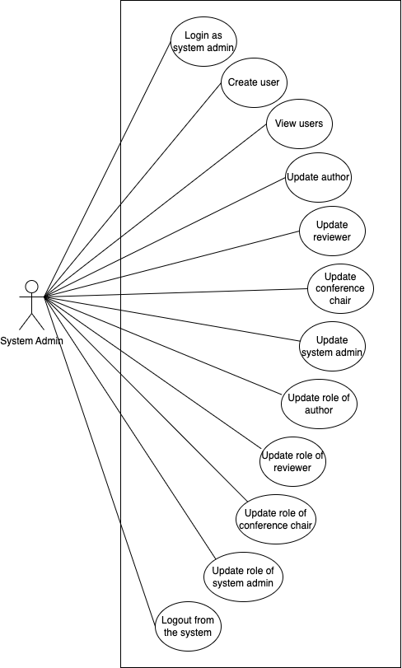

## Author

## 

## 

## Reviewer

## 

## Conference Chair

# 

# D. Analysis and Designs for Each Use Case

## SPRINT 1

### Taiga

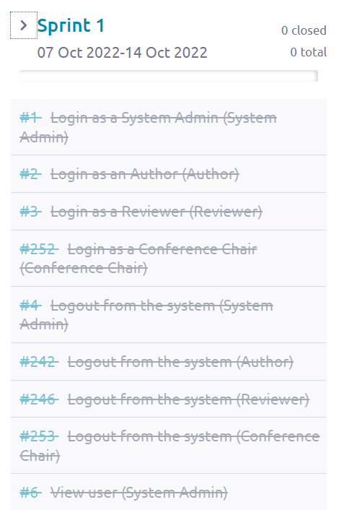

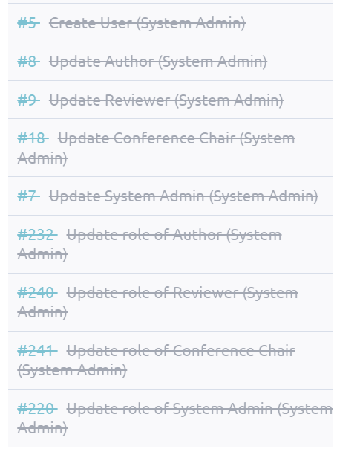

From the screenshots above, we can see that Sprint 1 started from 7 October 2022 to 14 October 2022. There are in total 18 use cases made in Sprint 1 and all of these use cases were closed after Sprint 1 ended which means that all the development process from diagrams, software developments and testing for those 18 use cases were done in Sprint 1.

### Class Diagram

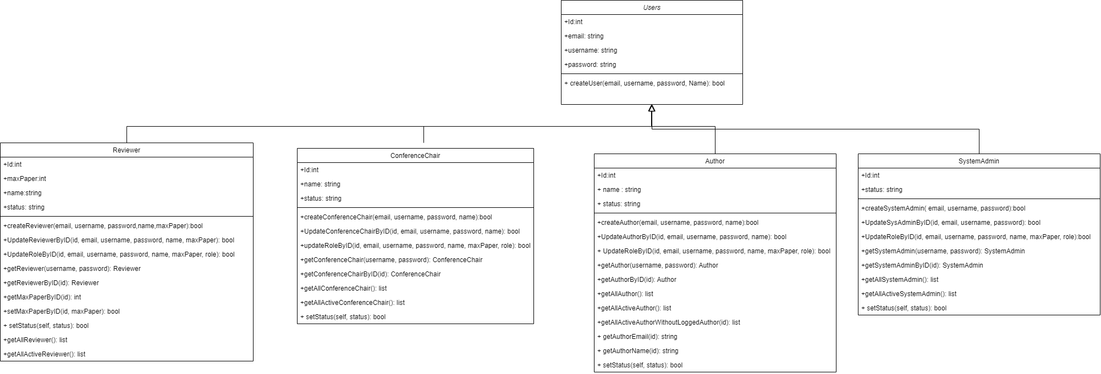

### Data Persistent

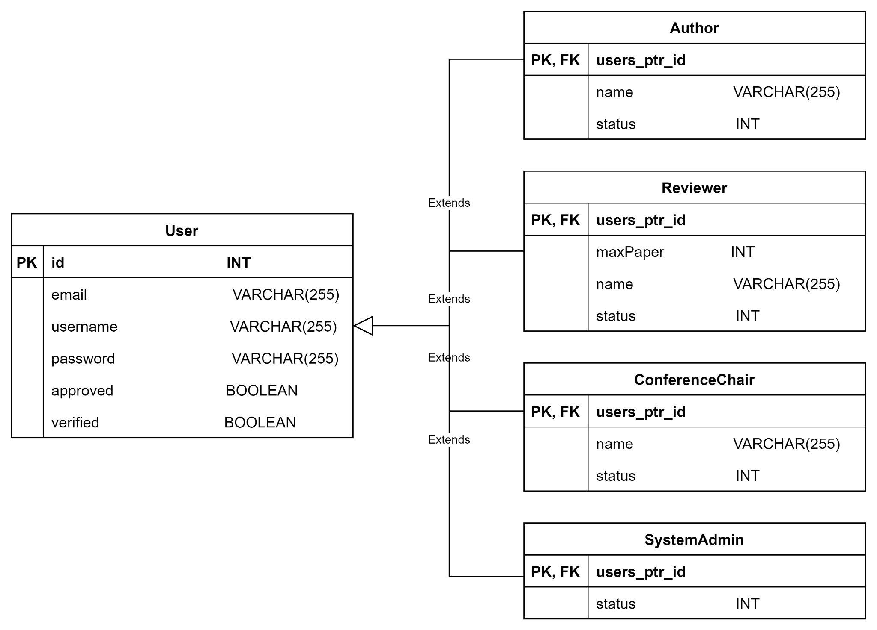

### 

### #1 - As a system admin, I want to login as a system admin so that I can access the system admin’s dashboard.

Use Case Description

|  |  |
| --- | --- |
| Use Case ID | 1 |
| Use Case Name | Login as a system admin |
| Description | The system admin will first select the role, “System Admin”, in a dropdownlist before keying in their username and password in order to gain access to the system admin’s dashboard. |
| Actor(s) | System admin |
| Trigger | System admin wants to login into the system |
| Pre-existing condition | 1. System admin must have an account registered. 2. System admin is in the login page. |
| Basic Flow | 1. System admin selects “System Admin” in the role dropdownlist, key in their username & password and clicks “Login” button. 2. System will verify if their username & password exist in the system admin database. If username found & password correct, the system will be redirect user to the system admin’s homepage together with a session being created in the system. |
| Sub Flow | None |
| Alternative Flow | 2a. If the username & password does not exist or is incorrect, an error message will be displayed informing that the username or password is incorrect. |

BCE Diagram

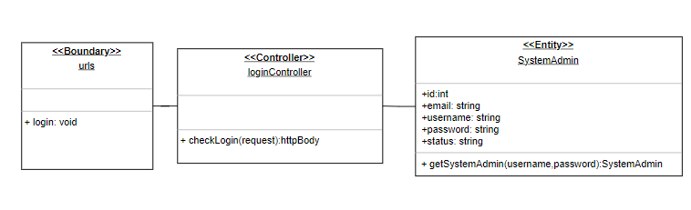

Sequence Diagram

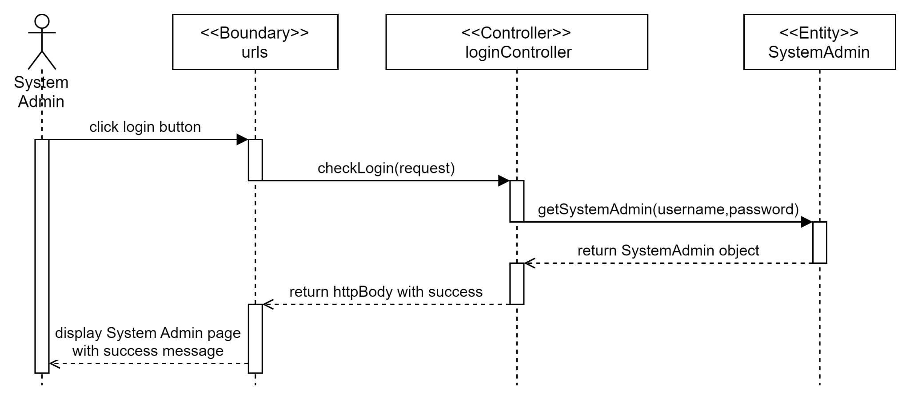

Test cases

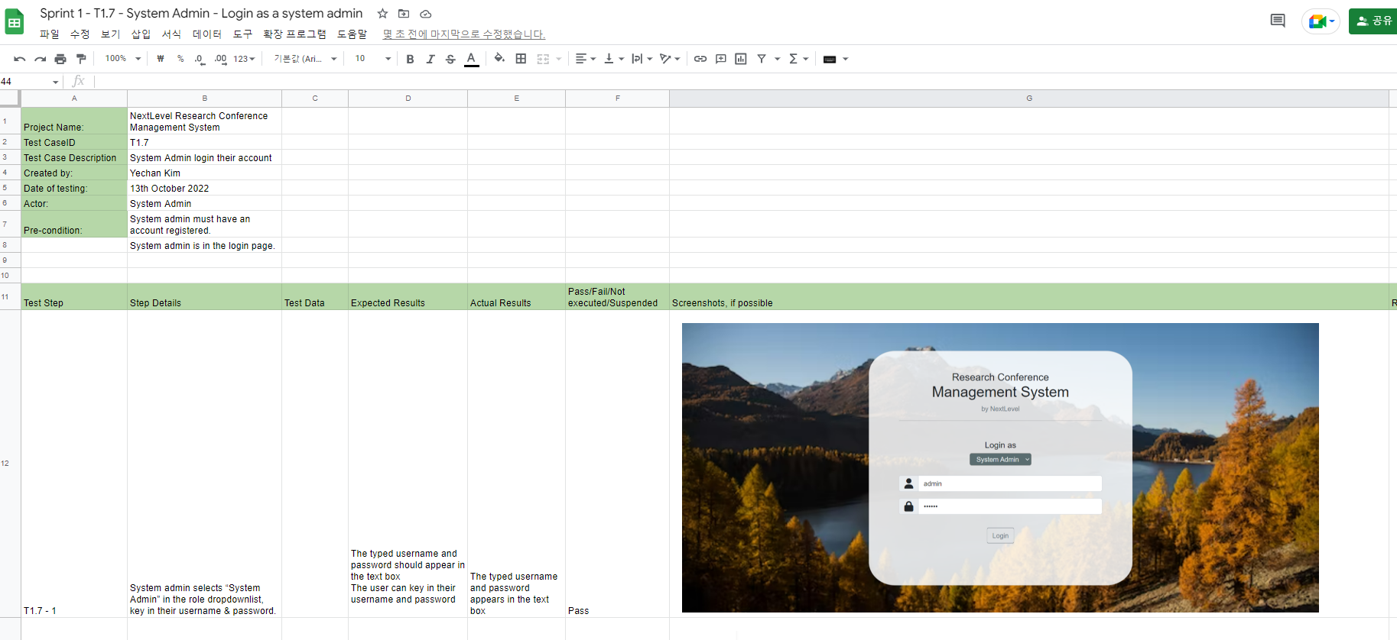

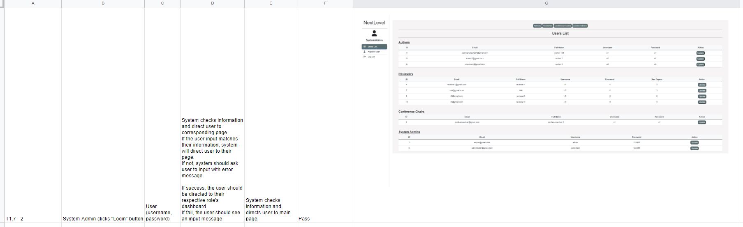

### 

### #4 - As a system admin, Logout from the system so that I can logout from the system.

Use Case Description

### 

|  |  |
| --- | --- |
| Use Case ID | 4 |
| Use Case Name | Logout from the system. |
| Description | System Admin clicks on the logout button and the system will remove the user’s session. |
| Actor(s) | System Admin |
| Trigger | System Admin wants to logout. |
| Pre-existing condition | 1. System Admin must have an existing account. 2. System Admin must be logged-in to the account. |
| Basic Flow | 1. System Admin clicks on the logout button. 2. System removes all session/cookies from the System Admin and redirects to the login page. |
| Sub Flow | None. |
| Alternative Flow | None. |

### 

BCE Diagram

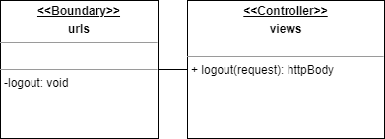

Sequence Diagram

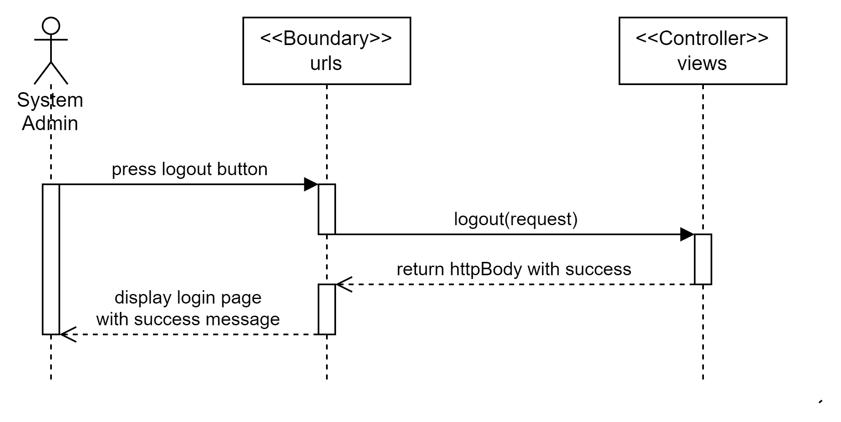

Test cases

### 

### #2 - As an author, I want to login as an author so that I can access the author’s dashboard.

Use Case Description

|  |  |
| --- | --- |
| Use Case ID | 2 |
| Use Case Name | Login as an Author |
| Description | The author will first select the role, “Author”, in a dropdownlist before keying in their username and password in order to gain access to the author’s dashboard. |
| Actor(s) | Author |
| Trigger | Author wants to login into the system. |
| Pre-existing condition | 1. Author must have an account registered. 2. Author is on the login page. |
| Basic Flow | 1. Author selects “Author” in the dropdownlist, key in their username & password and clicks “Login” button. 2. System will verify if their username & password exist in the Author database. If username found & password correct, the system will be redirect user to the author’s homepage together with a session being created in the system. |
| Sub Flow | None |
| Alternative Flow | 2a. If the username & password does not exist or is incorrect, an error message will be displayed informing that the username or password is incorrect. |

### 

BCE Diagram

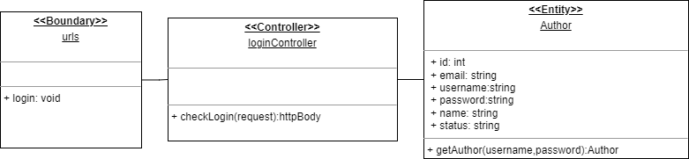

Sequence Diagram

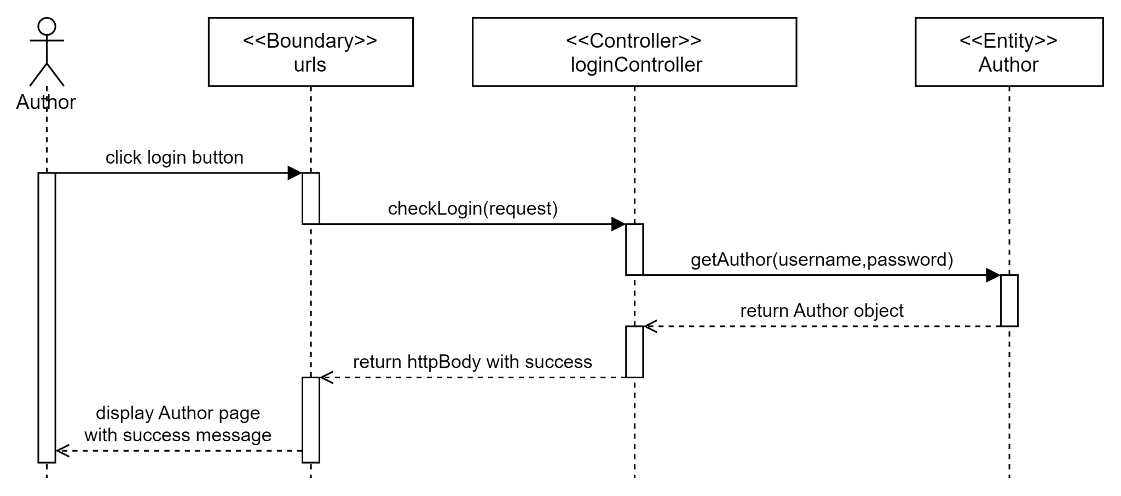

Test cases

### 

### 

### #242 - As an author, I want to logout from the system so that I can logout from the system.

Use Case Description

|  |  |
| --- | --- |
| Use Case ID | 242 |
| Use Case Name | Logout from the system. |
| Description | Author clicks on the logout button and the system will remove the Author’s session. |
| Actor(s) | Author |
| Trigger | Author wants to logout. |
| Pre-existing condition | 1. Author must have an existing account. 2. Author must be logged-in to the account. |
| Basic Flow | 1. Author clicks on the logout button. 2. The system removes all session/cookies from the Author and redirects to the login page. |
| Sub Flow | None. |
| Alternative Flow | None. |

### 

BCE Diagram

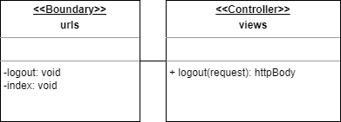

Sequence Diagram

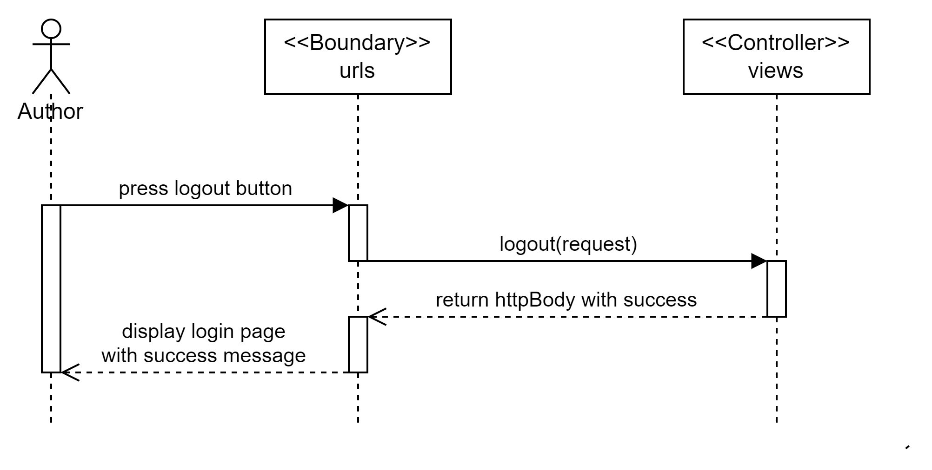

Test cases

### 

### #3 - As a reviewer, I want to login as a reviewer so that I can access the reviewer’s dashboard.

Use Case Description

|  |  |
| --- | --- |
| Use Case ID | 3 |
| Use Case Name | Login as a reviewer |
| Description | The reviewer will first select the role, “Reviewer”, in a dropdownlist before keying in their username and password in order to gain access to the reviewer’s dashboard. |
| Actor(s) | Reviewer |
| Trigger | Reviewer wants to login into the system |
| Pre-existing condition | 1. Reviewer must have an account registered. 2. Reviewer is on the login page. |
| Basic Flow | 1. Reviewer selects “Reviewer” in the dropdownlist, key in their username & password and clicks “Login” button. 2. System will verify if their username & password exist in the Reviewer database. If username found & password correct, the system will be redirect user to the reviewer’s homepage together with a session being created in the system. |
| Sub Flow | None |
| Alternative Flow | 2a. If the username & password does not exist or is incorrect, an error message will be displayed informing that the username or password is incorrect. |

### 

BCE Diagram

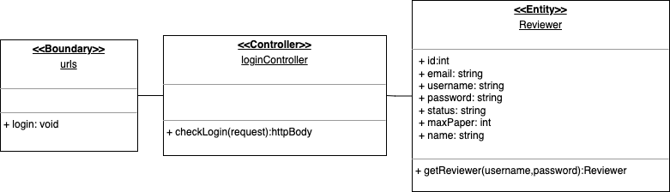

Sequence Diagram

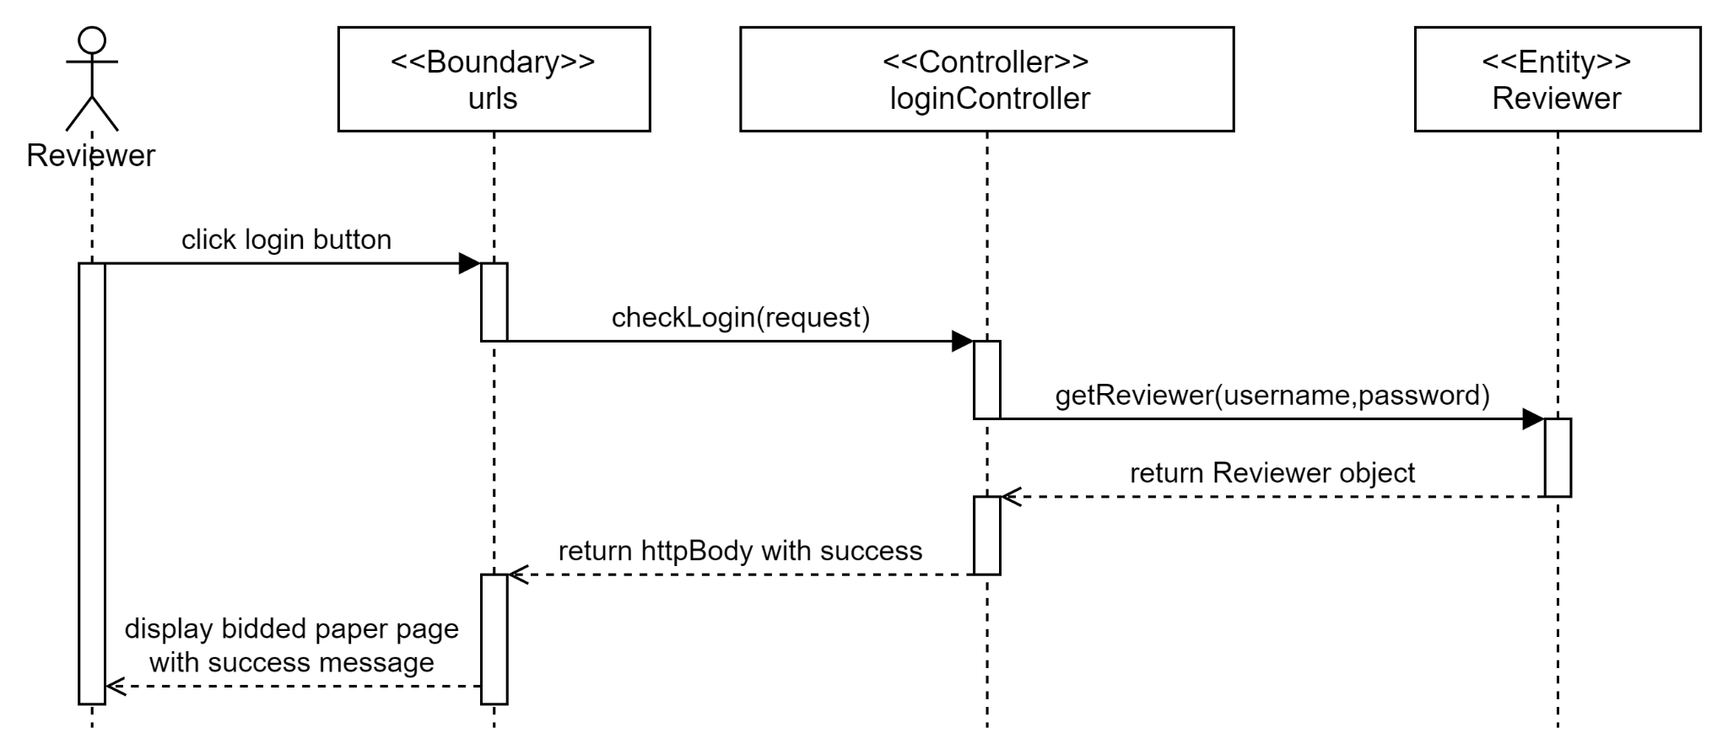

Test cases

### 

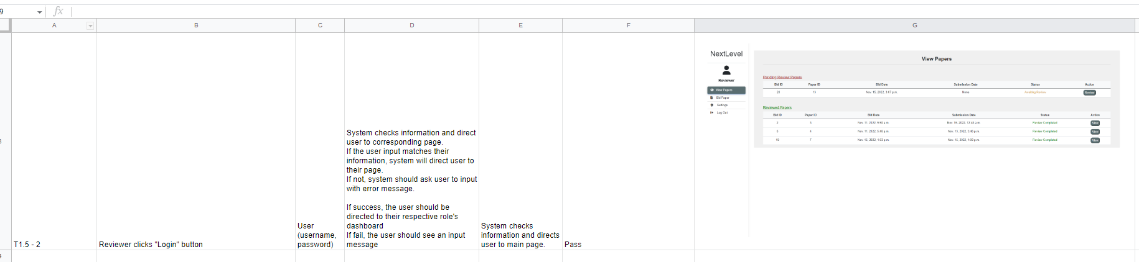

### #246 - As a reviewer, I want to logout from the system so that I can logout from the system.

Use Case Description

|  |  |
| --- | --- |
| Use Case ID | 246 |
| Use Case Name | Logout from the system. |
| Description | Reviewer clicks on the logout button and the system will remove the user’s session. |
| Actor(s) | Reviewer |
| Trigger | Reviewer wants to logout. |
| Pre-existing condition | 1. Reviewer must have an existing account. 2. Reviewer must be logged-in to the account. |
| Basic Flow | 1. Reviewer clicks on the logout button. 2. System removes all session/cookies from the Reviewer and redirects to the login page. |
| Sub Flow | None. |
| Alternative Flow | None. |

### 

BCE Diagram

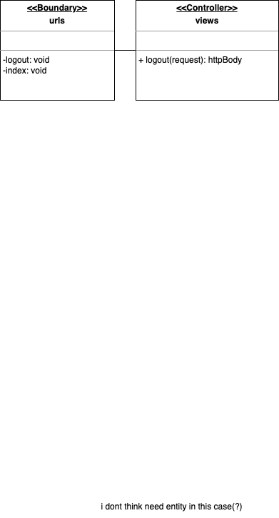

Sequence Diagram

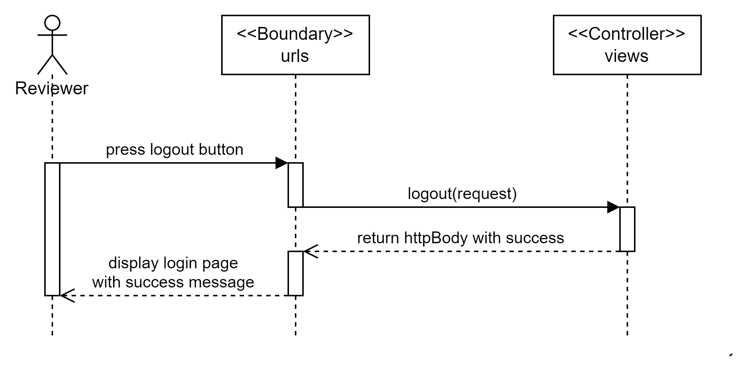

Test cases

### 

### 

### #252 As a conference chair, I want to login as a conference chair so that I can access the conference chair’s dashboard.

Use Case Description

### 

|  |  |
| --- | --- |
| Use Case ID | 252 |
| Use Case Name | Login as a Conference Chair |
| Description | The conference chair will first select the role, “Conference Chair”, in a dropdownlist before keying in their username and password in order to gain access to the conference chair’s dashboard. |
| Actor(s) | Conference Chair |
| Trigger | Conference Chair wants to login into the system |
| Pre-existing condition | 1. Conference Chair must have an account registered. 2. Conference Chair is on the login page. |
| Basic Flow | 1. Conference Chair selects “Conference Chair” in the dropdownlist, key in their username & password and clicks “Login” button. 2. System will verify if their username & password exist in the Conference Chair database. If username found & password correct, the system will be redirect user to the conference chair’s homepage together with a session being created in the system. |
| Sub Flow | None |
| Alternative Flow | 2a. If the username & password does not exist or is incorrect, an error message will be displayed informing that the username or password is incorrect. |

### 

BCE Diagram

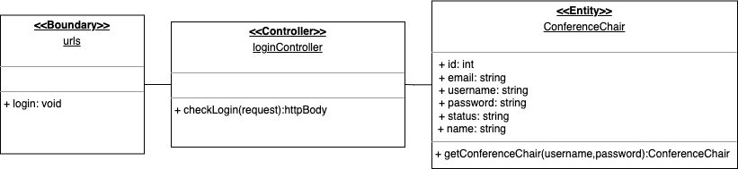

Sequence Diagram

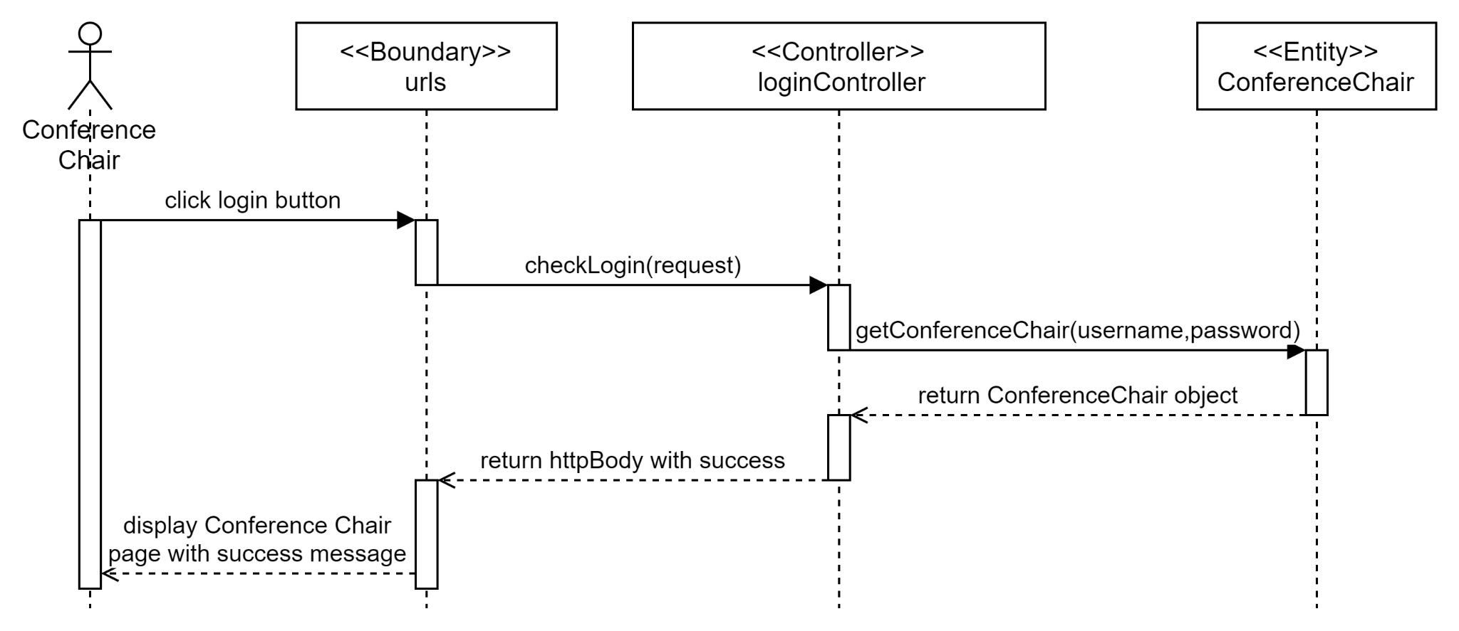

Test cases

### 

### 

### 

### #253 As a conference chair, I want to logout from the system so that I can logout from the system.

Use Case Description

### 

|  |  |
| --- | --- |
| Use Case ID | 253 |
| Use Case Name | Logout from the system. |
| Description | Conference Chair clicks on the logout button and the system will remove the user’s session. |
| Actor(s) | Conference Chair |
| Trigger | Conference Chair wants to logout. |
| Pre-existing condition | 1. Conference Chair must have an existing account. 2. Conference Chair must be logged-in to the account. |
| Basic Flow | 1. Conference Chair clicks on the logout button. 2. System removes all session/cookies from the Conference Chair and redirects to the login page. |
| Sub Flow | None. |
| Alternative Flow | None. |

## 

BCE Diagram

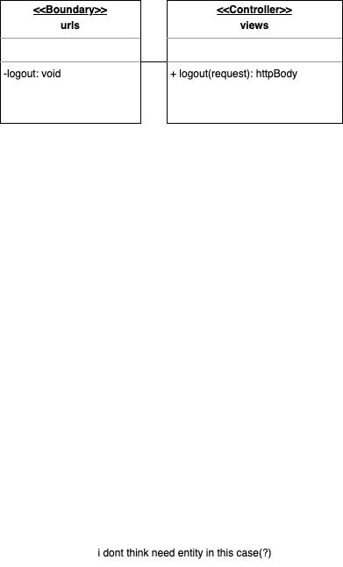

Sequence Diagram

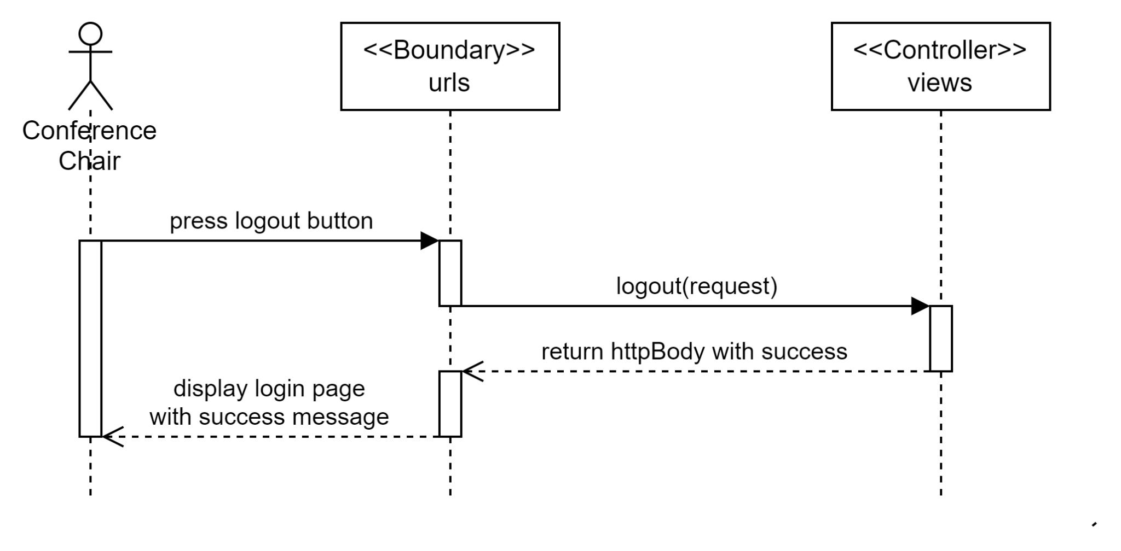

Test cases

### 

### #5 As a system admin, I want to create user so that I can create a user.

Use Case Description

|  |  |
| --- | --- |
| Use Case ID | 5 |
| Use Case Name | Create User |
| Description | To create a new user base on the selected role in a dropdownlist. The system admin will key in their information which will create a new object based on the role selected. |
| Actor(s) | System Admin |
| Trigger | System Admin wants to create a new user |
| Pre-existing condition | None. |
| Basic Flow | 1. System Admin clicks Register user button. 2. System will display the respective required details 3. System Admin keys in their details and submit. 4. System will verify the details and create the respective user to the database. |
| Sub Flow | None. |
| Alternative Flow | 3a. If the username exists in the DB, an error message will be displayed.  3b. If the email exists in the DB, an error message will be displayed.  3c. If any fields are empty, an error message will be displayed. |

### 

BCE Diagram

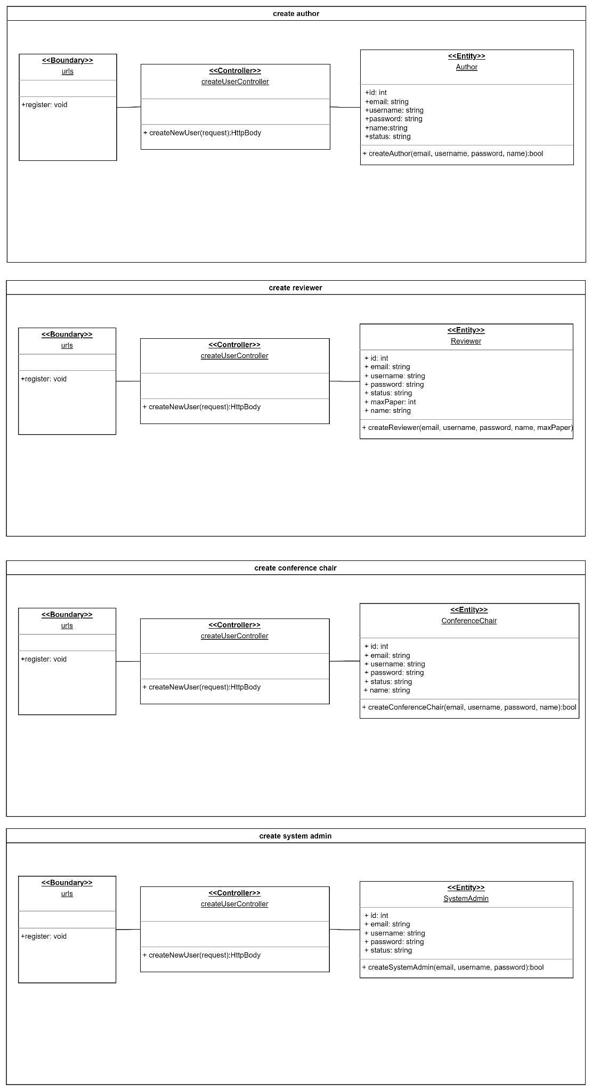

Sequence Diagram

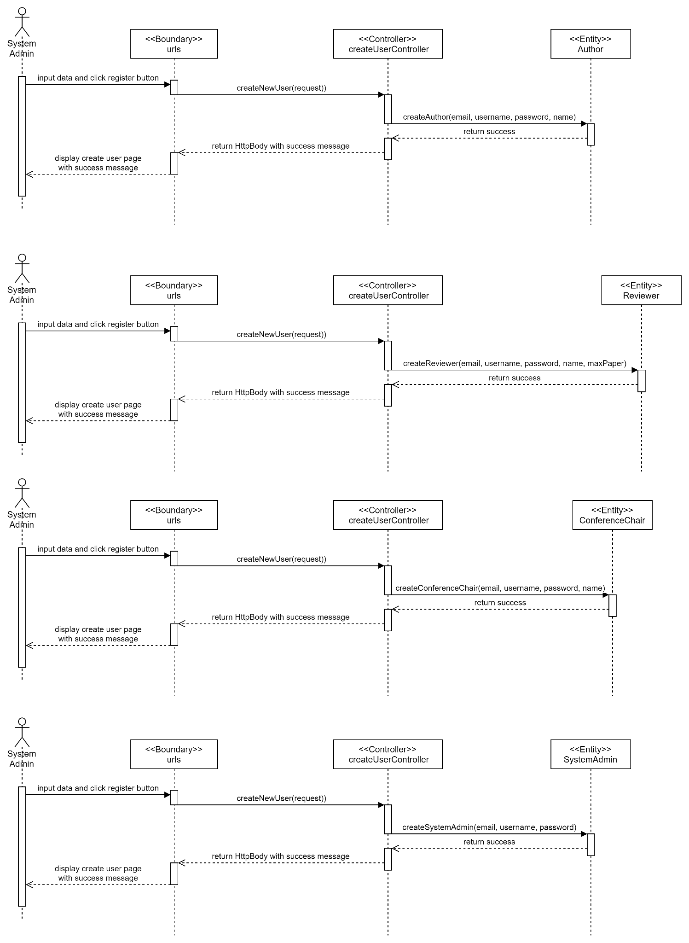

Test cases

### 

### 

### 

### 

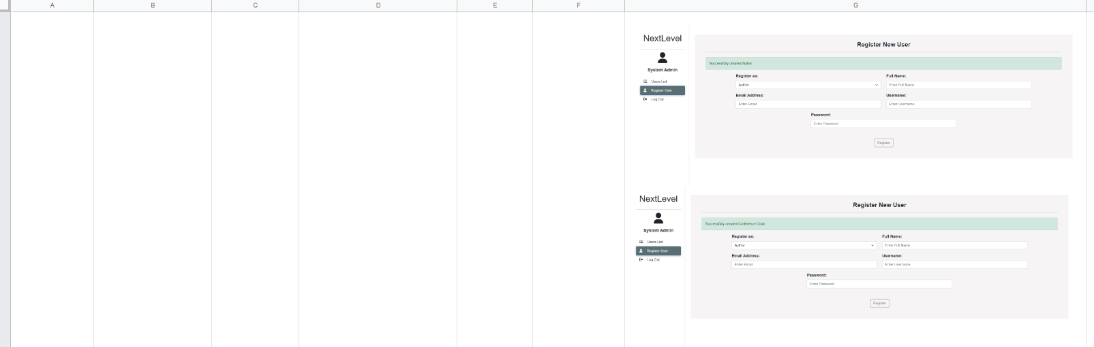

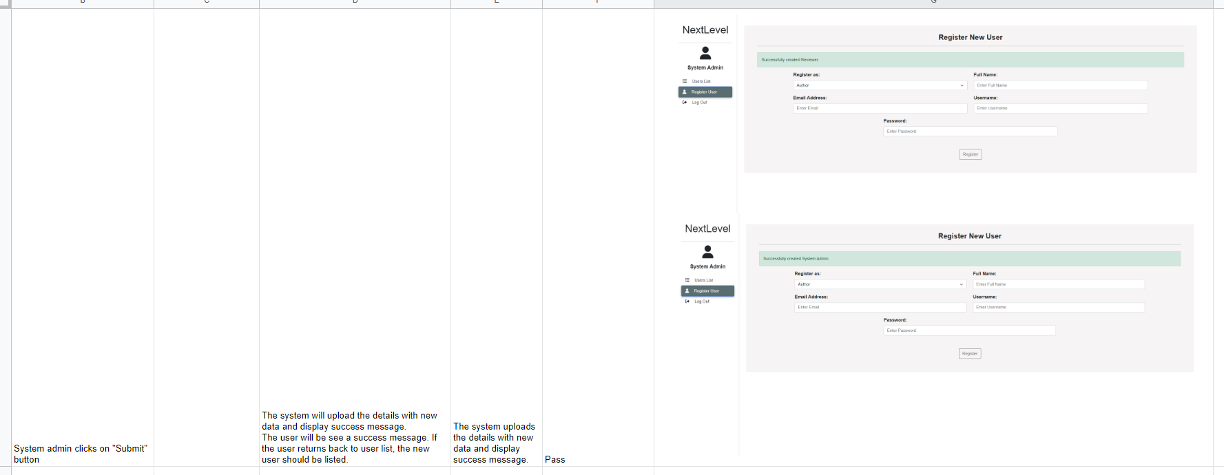

### 

### #6 As a system admin, I want to view user so that I can get all existing users and see their respective information.

Use Case Description

|  |  |
| --- | --- |
| Use Case ID | 6 |
| Use Case Name | View Users |
| Description | To view a list of user with their respective information |
| Actor(s) | System Admin |
| Trigger | System Admin wants to see all users with their details |
| Pre-existing condition | There must be existing users. |
| Basic Flow | 1. System admin clicks Users List button 2. System retrieves all existing users’ information from the database and displays them in a list. |
| Sub Flow | None. |
| Alternative Flow | None. |

BCE Diagram

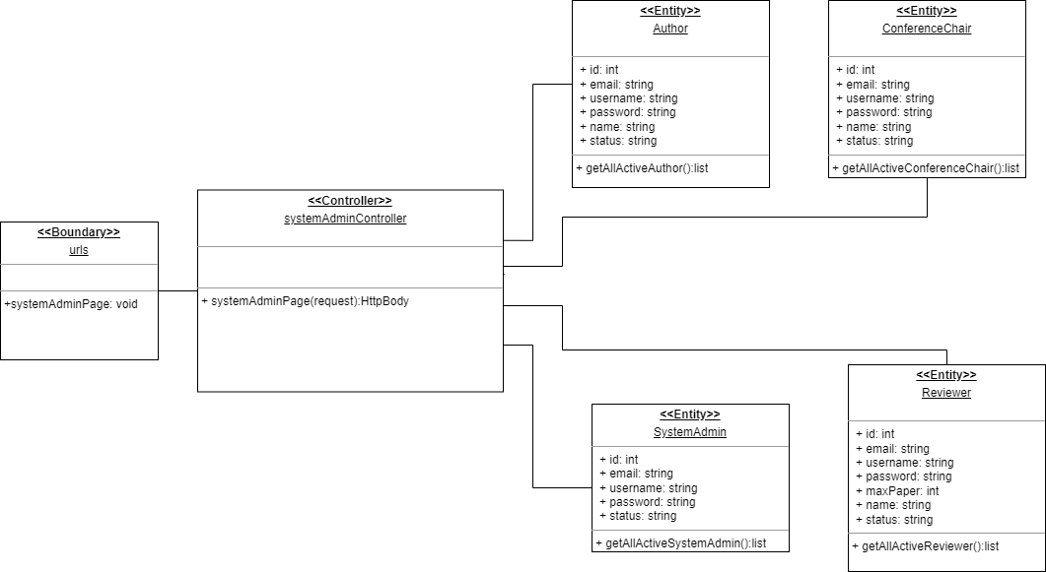

Sequence Diagram

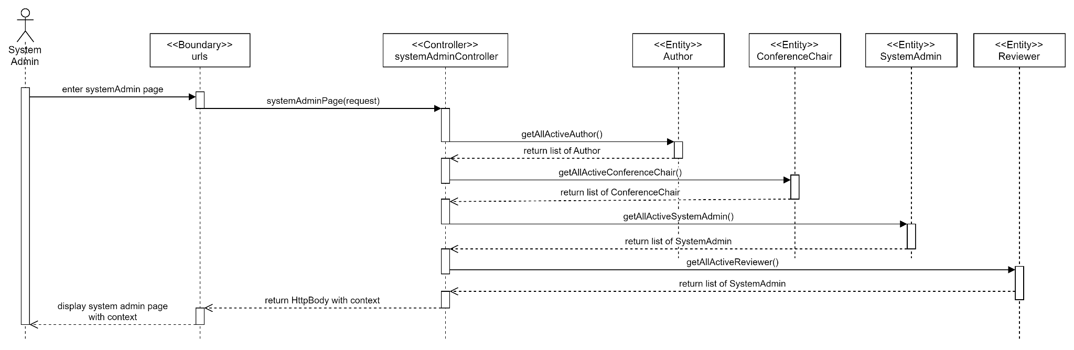

Test cases

### 

### #8 As a system admin, I want to update author so that I can update author information.

Use Case Description

|  |  |
| --- | --- |
| Use Case ID | 8 |
| Use Case Name | Update Author |
| Description | The System Admin can update Author profile |
| Actor(s) | System Admin |
| Trigger | System Admin wants to update the Author profile. |
| Pre-existing condition | 1. There must be existing users, author. 2. Logged in as a System Admin 3. System Admin is on the Users List page. |
| Basic Flow | 1. System Admin clicks the update button on one of the Author in Users List. 2. The system will display the fields of Authors to be updated. 3. System Admin key in any updates to the fields, and clicks “Update” button. 4. System will verify the updated fields and update the fields of the respective Author accordingly in the database. |
| Sub Flow | None. |
| Alternative Flow | None. |

### 

BCE Diagram

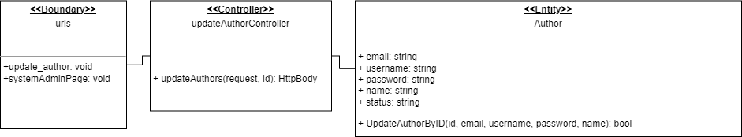

Sequence Diagram

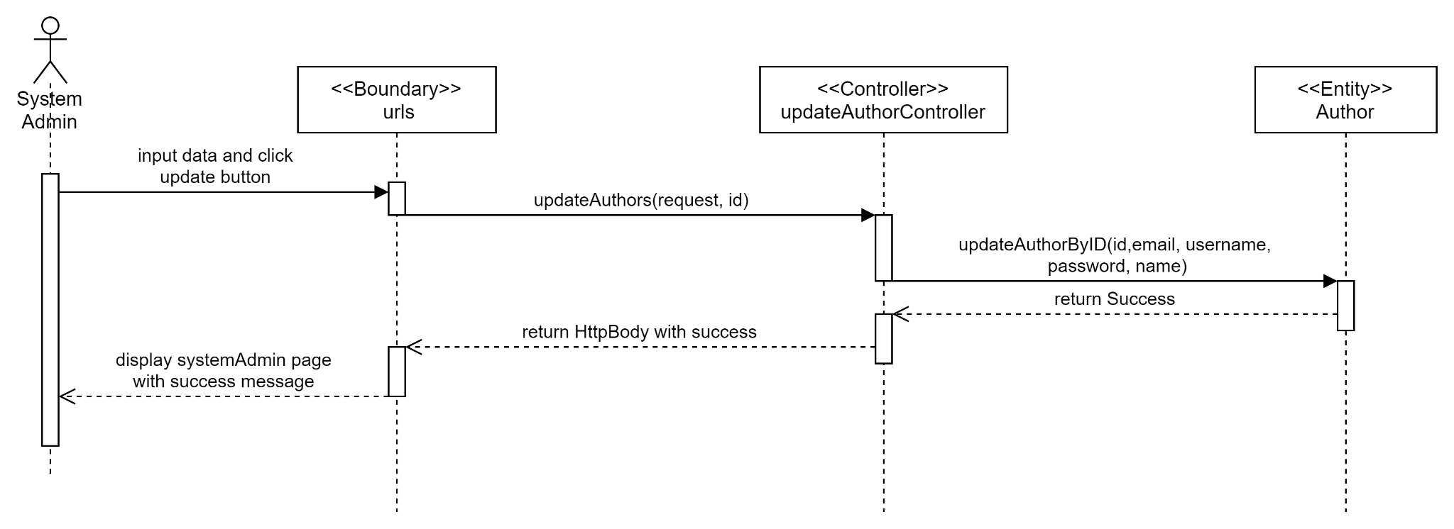

Test cases

### 

### 

### 

### 

### #9 As a system admin, I want to update reviewer so that I can update reviewer information.

Use Case Description

|  |  |
| --- | --- |
| Use Case ID | 9 |
| Use Case Name | Update Reviewer |
| Description | The Author can update Reviewer profile |
| Actor(s) | System Admin |
| Trigger | System Admin wants to update the Reviewer profile. |
| Pre-existing condition | 1. There must be existing users, reviewer. 2. Logged in as a System Admin 3. System Admin is on the Users List page. |
| Basic Flow | 1. System Admin clicks the update button on one of the Reviewer in Users List. 2. The system will display the fields of Reviewer to be updated. 3. System Admin key in any updates to their fields, and clicks “Update” button. 4. System will verify the updated fields and update the fields of the respective Reviewer accordingly in the database. |
| Sub Flow | None. |
| Alternative Flow | None. |

### 

BCE Diagram

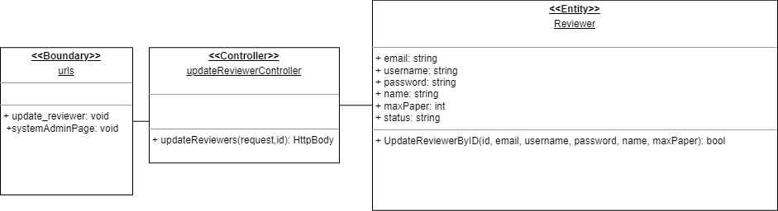

Sequence Diagram

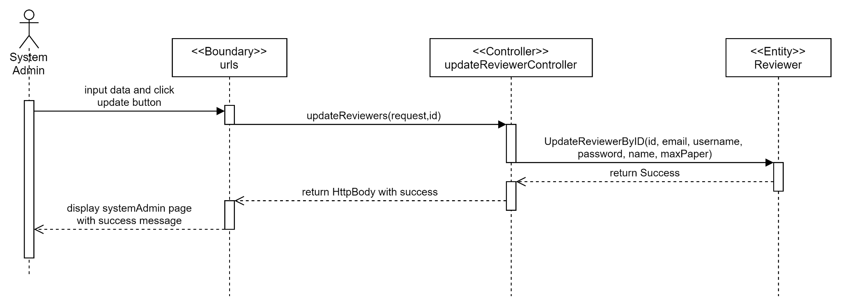

Test cases

### 

### 

### 

### #18 As a system admin, I want to update conference chair so that I can update conference chair information.

Use Case Description

|  |  |
| --- | --- |
| Use Case ID | 18 |
| Use Case Name | Update Conference Chair |
| Description | The System Admin can update Conference Chair profile |
| Actor(s) | System Admin |
| Trigger | System Admin wants to update the Conference Chair profile. |
| Pre-existing condition | 1. There must be existing users, conference chair. 2. Logged in as a System Admin 3. System Admin is on the Users List page. |
| Basic Flow | 1. System Admin clicks the update button on one of the Conference Chair Users List. 2. The system will display the fields of the Conference Chair to be updated. 3. System Admin key in any updates to their fields, and clicks “Update” button. 4. System will verify the updated fields and update the fields of the respective Conference Chair accordingly in the database. |
| Sub Flow | None. |
| Alternative Flow | None. |

### 

BCE Diagram

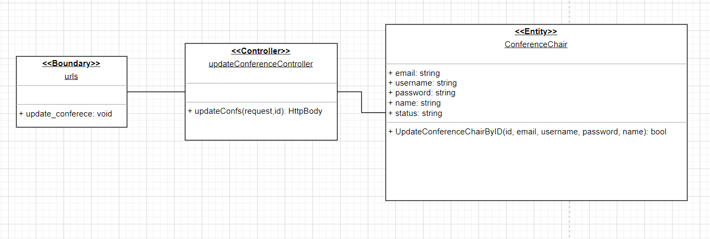

Sequence Diagram

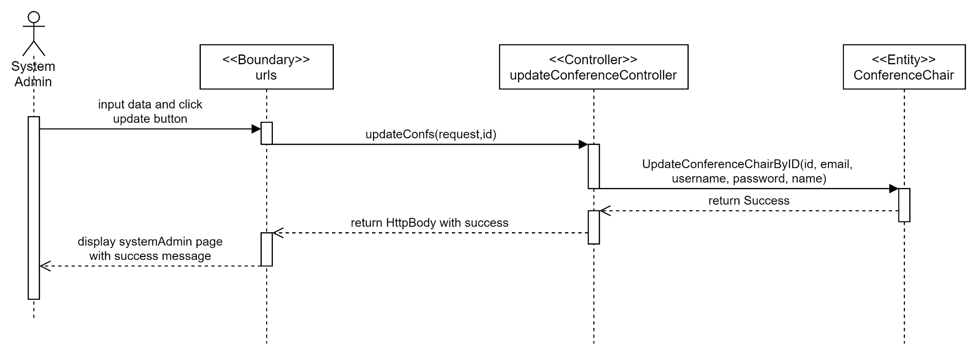

Test cases

### 

### 

### 

### 

### #7 As a system admin, I want to update system admin so that I can update system admin information.

Use Case Description

|  |  |
| --- | --- |
| Use Case ID | 7 |
| Use Case Name | Update System Admin |
| Description | The System Admin can update System Admin profile |
| Actor(s) | System Admin |
| Trigger | System Admin wants to update the System Admin profile. |
| Pre-existing condition | 1. There must be existing users, system admin. 2. Logged in as a System Admin 3. System Admin is on the Users List page. |
| Basic Flow | 1. System Admin clicks the update button on one of the System Admin in Users List. 2. The system will display the fields of System Admin to be updated. 3. System Admin key in any updates to their fields, and clicks “Update” button. 4. System will verify the updated fields and update the fields of the respective System Admin accordingly in the database. |
| Sub Flow | None. |
| Alternative Flow | None. |

### 

BCE Diagram

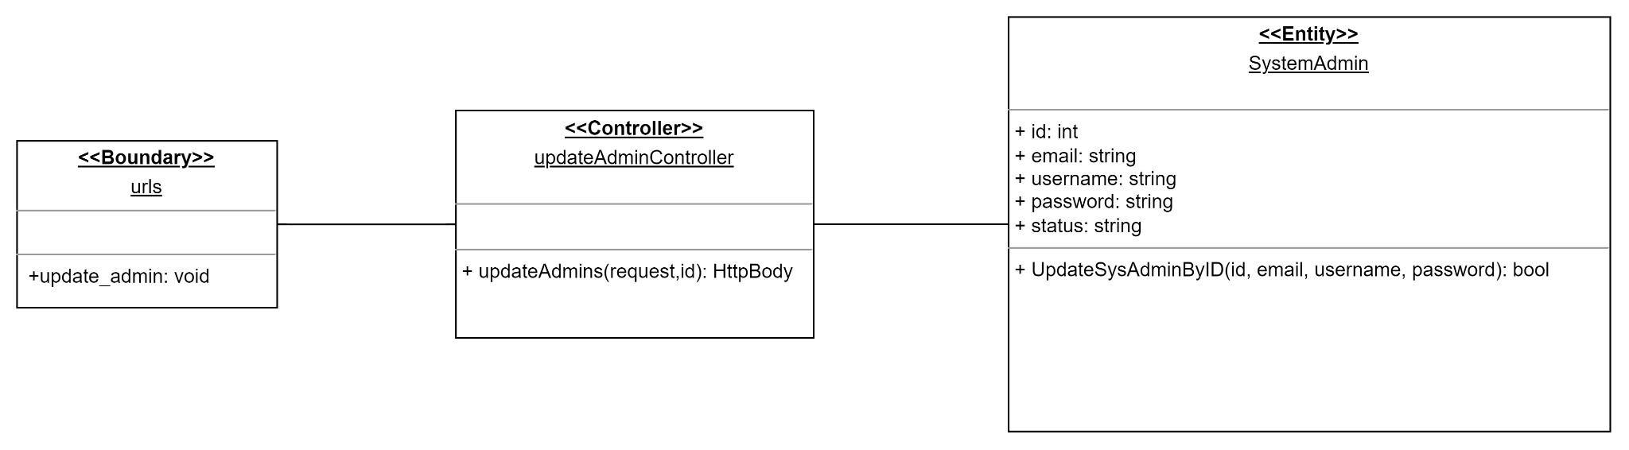

Sequence Diagram

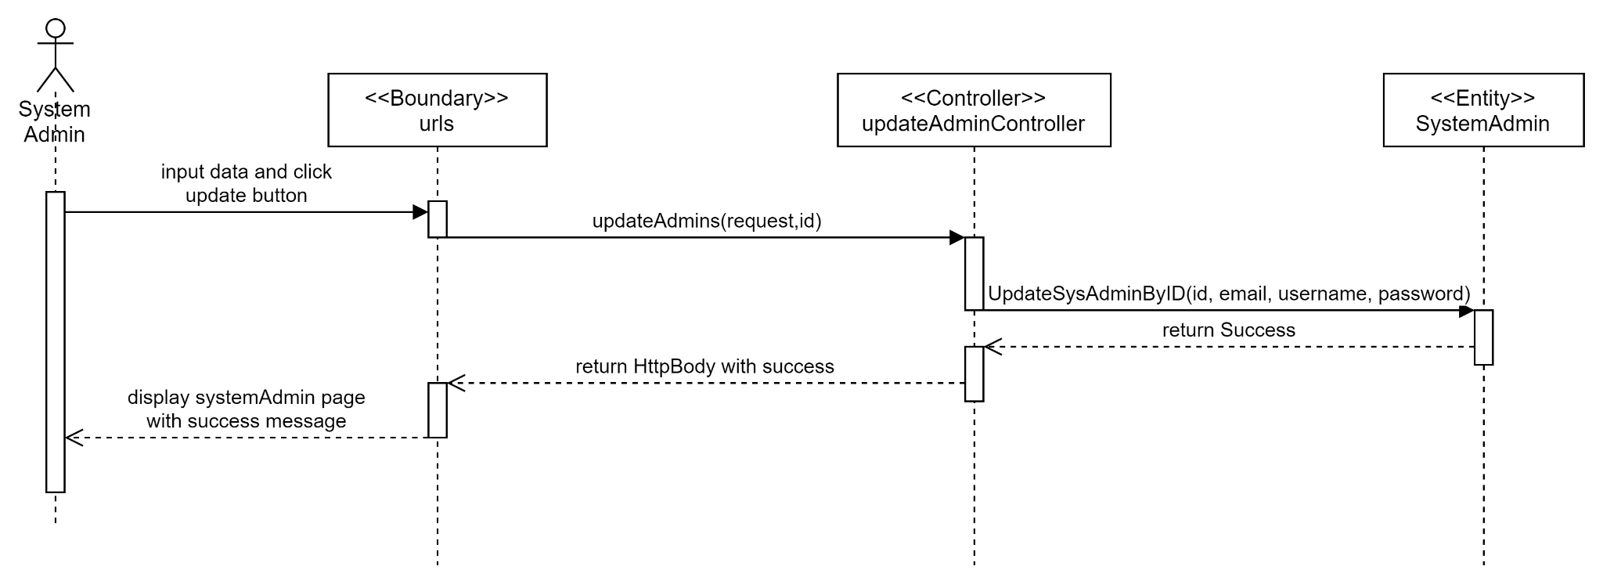

Test cases

### 

### 

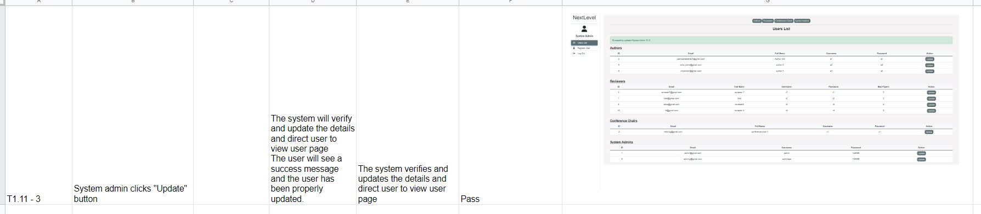

### #232 As a system admin, I want to update role of author so that I can update author role.

Use Case Description

|  |  |
| --- | --- |
| Use Case ID | 232 |
| Use Case Name | Update role of Author |
| Description | The System Admin can update Author role |
| Actor(s) | System Admin |
| Trigger | System Admin wants to update the Author role. |
| Pre-existing condition | 1. There must be existing users, author. 2. Logged in as a System Admin 3. System Admin is on the Users List page. |
| Basic Flow | 1. System Admin clicks the update button on one of the Author in Users List. 2. The system will display the fields of Authors to be updated. 3. System Admin updates the role drop down list by choosing one of the roles, key in any information needed for the new role and click “Update” button. 4. System will verify the updated information and update the role and information of the respective Author accordingly in the database. |
| Sub Flow | None. |
| Alternative Flow | None. |

BCE Diagram

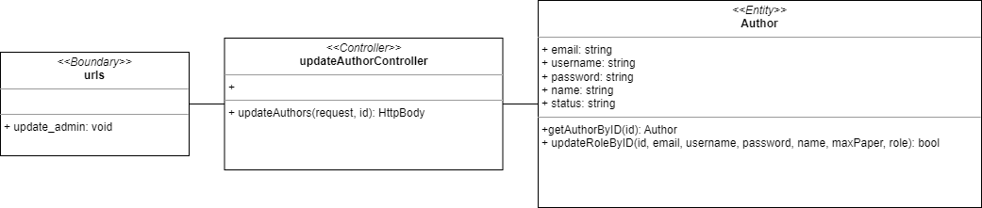

Sequence Diagram

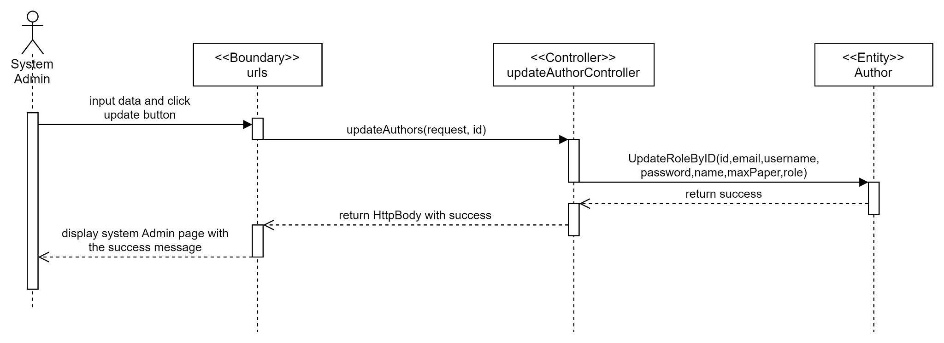

Test cases

### 

### 

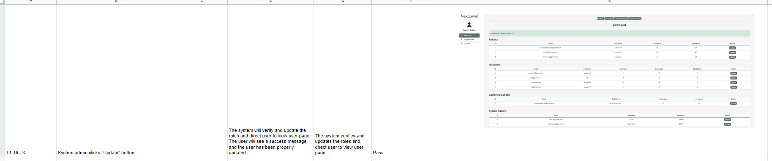

### 

### #240 As a system admin, I want to update role of reviewer so that I can update reviewer role.

Use Case Description

|  |  |
| --- | --- |
| Use Case ID | 240 |
| Use Case Name | Update role of Reviewer |
| Description | The System Admin can update Reviewer role |
| Actor(s) | System Admin |
| Trigger | System Admin wants to update the Reviewer role. |
| Pre-existing condition | 1. There must be existing users,reviewer. 2. Logged in as a System Admin 3. System Admin is on the Users List page. |
| Basic Flow | 1. System Admin clicks the update button on one of the System Admin in Users List. 2. The system will display the fields of Reviewer to be updated. 3. System Admin updates the role drop down list by choosing one of the roles, key in any information needed for the new role and click “Update” button. 4. System will verify the updated information and update the role and information of the respective Reviewer accordingly in the database. |
| Sub Flow | None. |
| Alternative Flow | None. |

### 

BCE Diagram

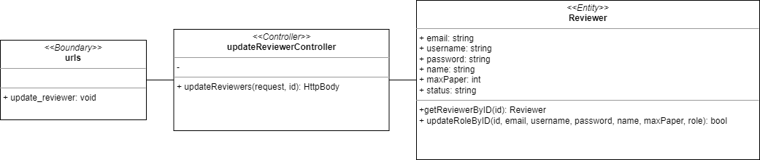

Sequence Diagram

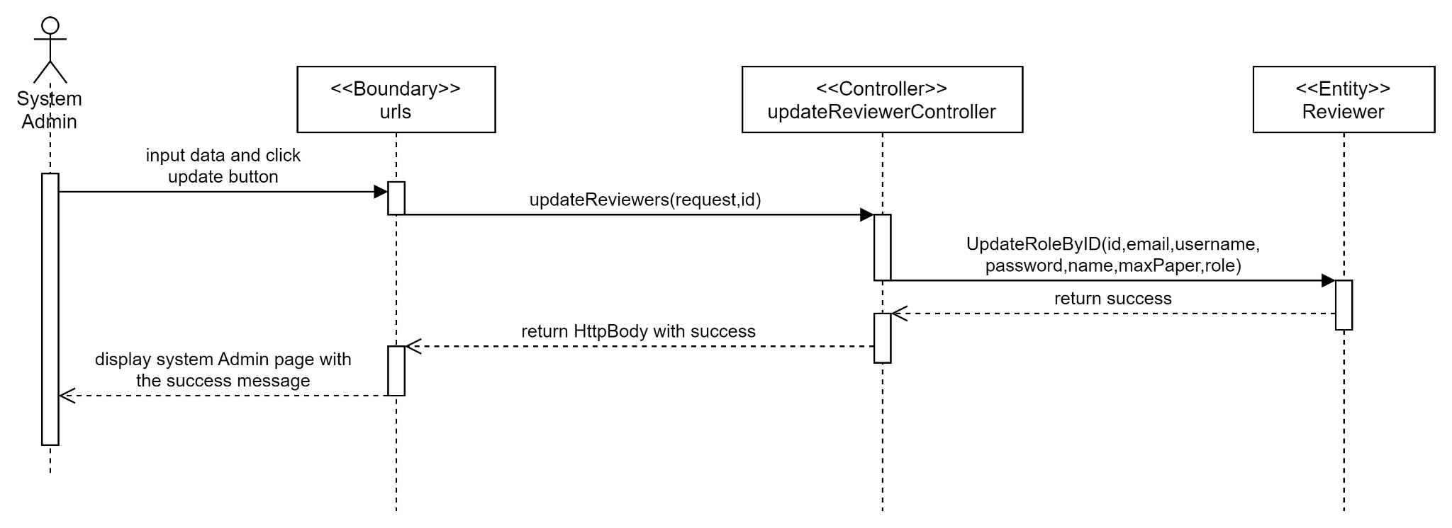

Test cases

### 

### 

### 

### #241 As a system admin, I want to update role of conference chair so that I can update conference chair role.

Use Case Description

|  |  |
| --- | --- |
| Use Case ID | 241 |
| Use Case Name | Update role of Conference Chair |
| Description | The System Admin can update Conference Chair role |
| Actor(s) | System Admin |
| Trigger | System Admin wants to update the Conference Chair role. |
| Pre-existing condition | 1. There must be existing users, conference chair. 2. Logged in as a System Admin 3. System Admin is on the Users List page. |
| Basic Flow | 1. System Admin clicks the update button on one of the System Admin in Users List. 2. The system will display the fields of the Conference Chair to be updated. 3. System Admin updates the role drop down list by choosing one of the roles, key in any information needed for the new role and click “Update” button. 4. System will verify the updated information and update the role and information of the respective Reviewer accordingly in the database. |
| Sub Flow | None. |
| Alternative Flow | None. |

### 

BCE Diagram

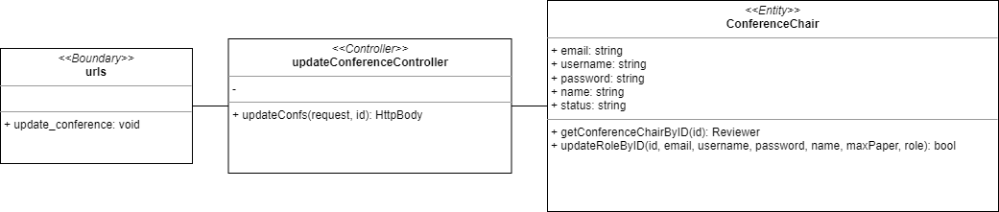

Sequence Diagram

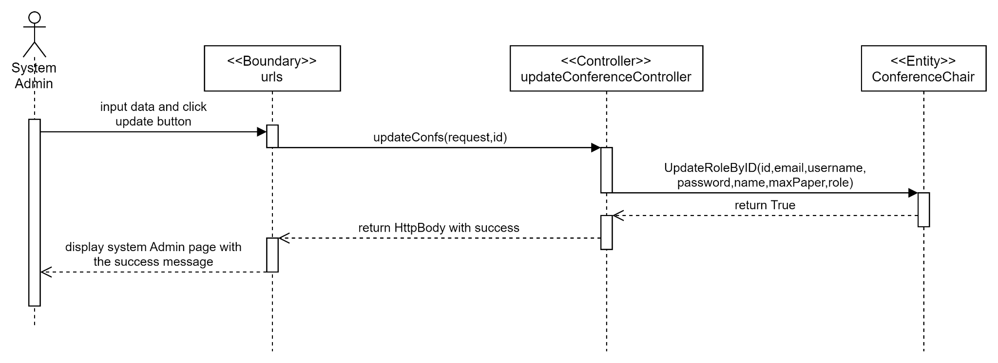

Test cases

### 

### 

### 

### #220 As a system admin, I want to update role of system admin so that I can update system admin role.

Use Case Description

|  |  |
| --- | --- |
| Use Case ID | 220 |
| Use Case Name | Update role of System Admin |
| Description | The System Admin can update System Admin role |
| Actor(s) | System Admin |
| Trigger | System Admin wants to update the System Admin role. |
| Pre-existing condition | 1. There must be existing users, system admin. 2. Logged in as a System Admin 3. System Admin is on the Users List page. |
| Basic Flow | 1. System Admin clicks the update button on one of the System Admin in Users List. 2. The system will display the fields of System Admin to be updated. 3. System Admin updates the role drop down list by choosing one of the roles, key in any information needed for the new role and click “Update” button. 4. System will verify the updated information and update the role and information of the respective System Admin accordingly in the database. |
| Sub Flow | None. |
| Alternative Flow | None. |

### 

BCE Diagram

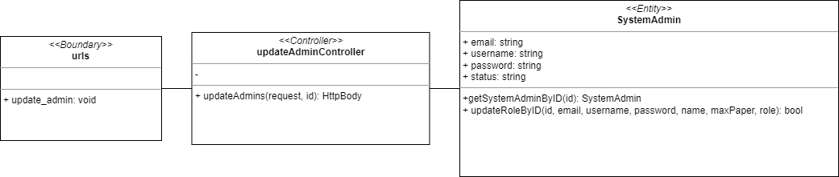

Sequence Diagram

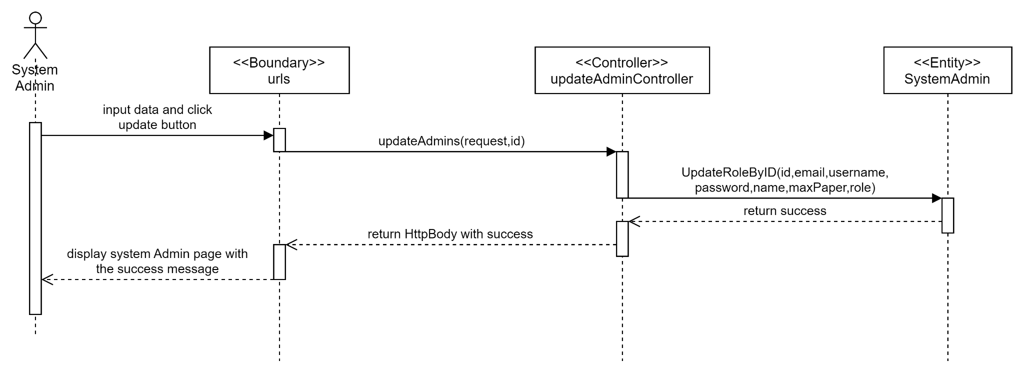

Test cases

# 

# 

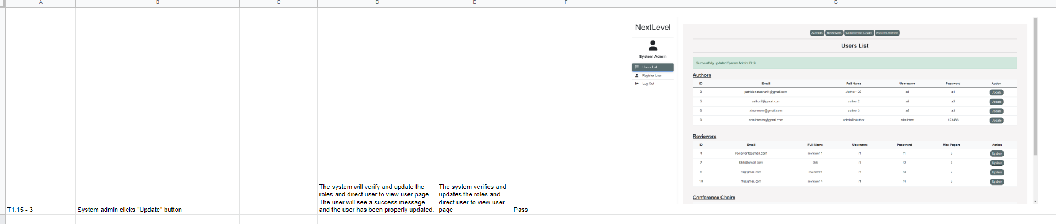

# 

## SPRINT 2

### Taiga

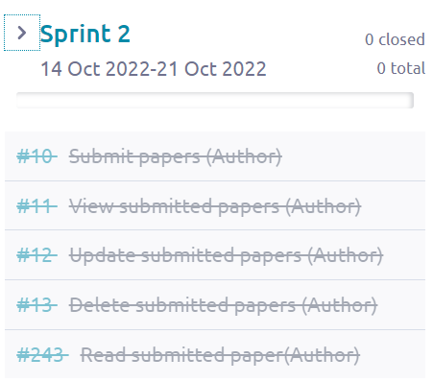

From the screenshots above, we can see that Sprint 2 started from 14 October 2022 to 21 October 2022. There are in total 5 use cases made in Sprint 2 and all of these use cases were closed after Sprint 2 ended which means that all the development process from diagrams, software developments and testing for those 5 use cases were done in Sprint 2.

### Class Diagram

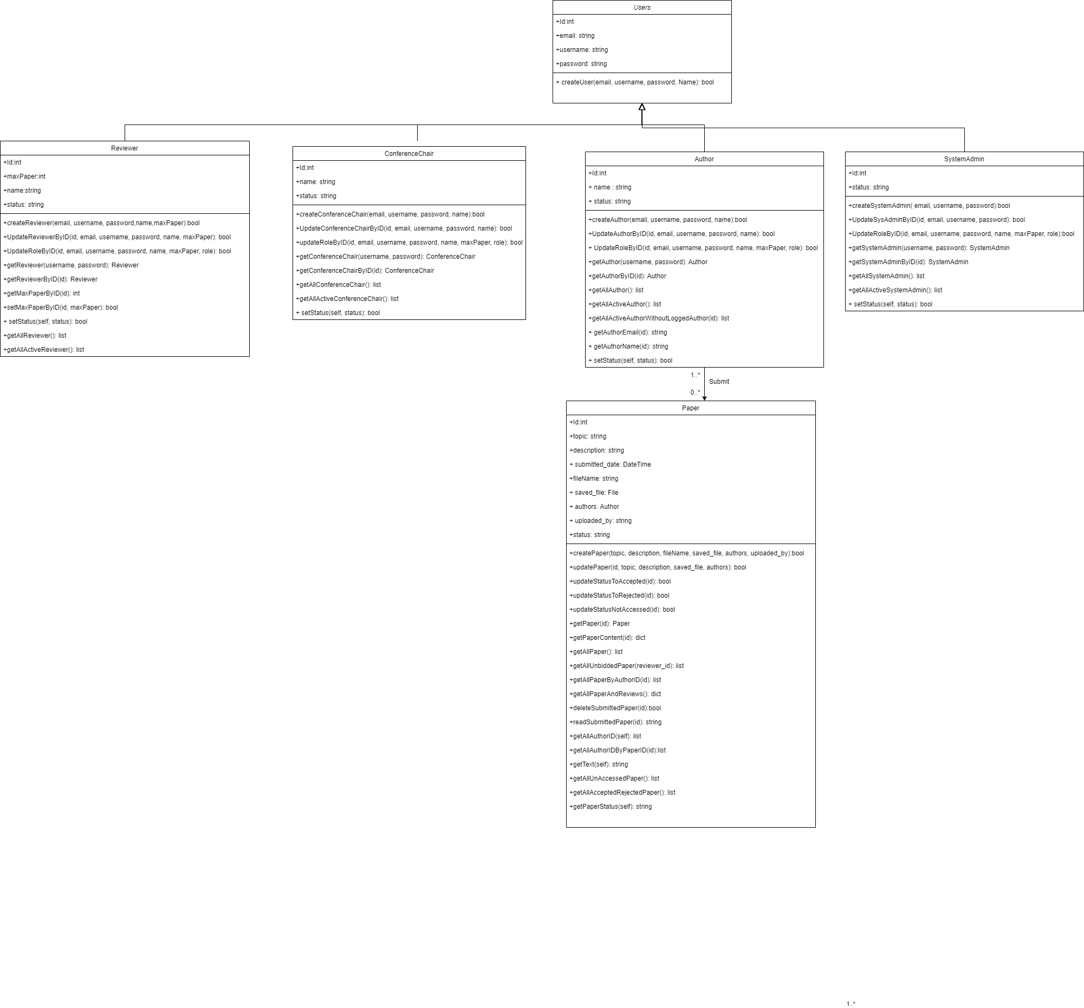

### Data Persistent

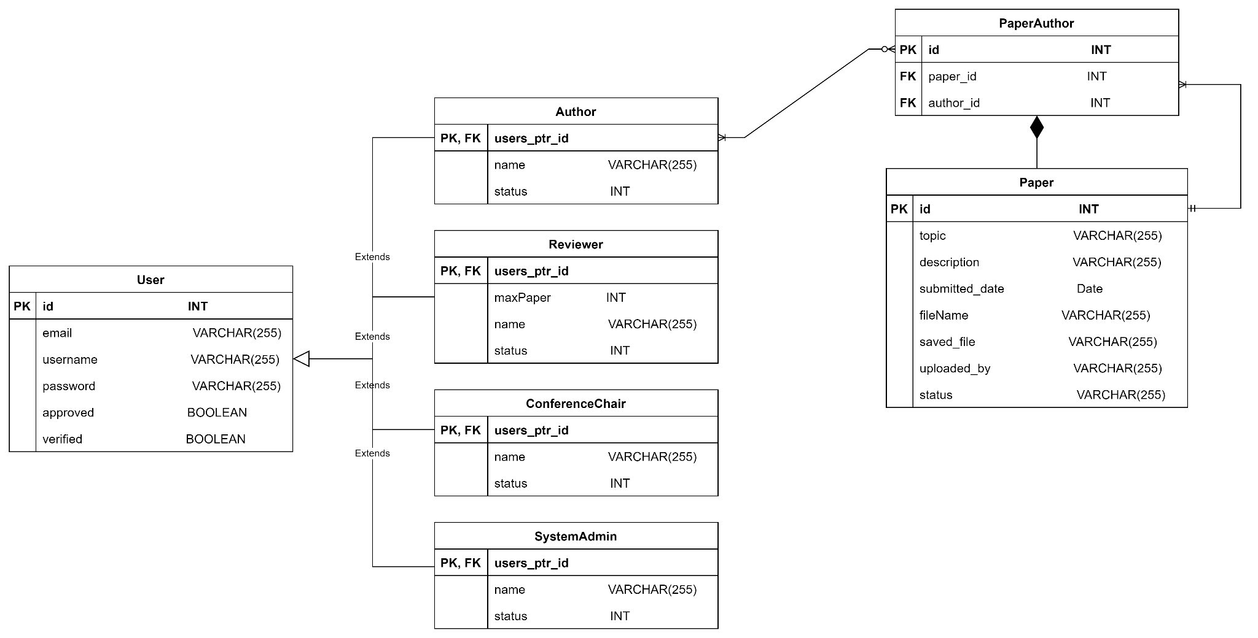

### 

### #10 As an author, I want to submit papers so that my papers can be reviewed.

Use Case Description

|  |  |
| --- | --- |
| Use Case ID | 10 |
| Use Case Name | Submit papers |
| Description | The Author will be able to submit his/her paper into the system. |
| Actor(s) | Author |
| Trigger | Author wants to submit papers. |
| Pre-existing condition | 1. Logged in as an Author. |
| Basic Flow | 1. Author clicks the Submit Paper button. 2. System display Submit Paper page. 3. Author keys in the necessary information, uploads the paper and clicks the submit button. 4. System uploads the paper into the Paper database and displays a success message. |
| Sub Flow | None. |
| Alternative Flow | None. |

### 

BCE Diagram

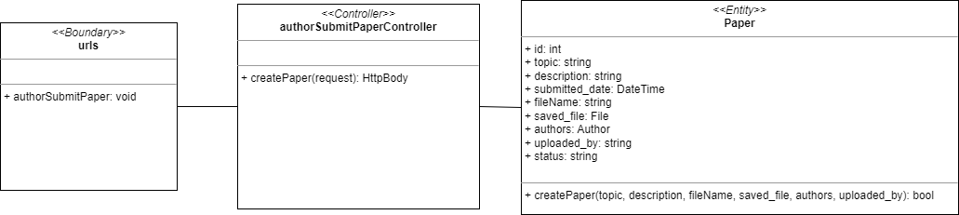

Sequence Diagram

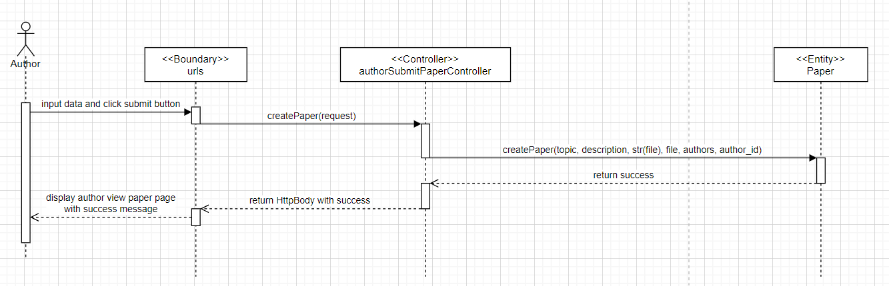

Test cases

### 

### 

### 

### #11 As an author, I want to view submitted papers so that I can view a list of papers that I have submitted.

Use Case Description

|  |  |
| --- | --- |
| Use Case ID | 11 |
| Use Case Name | View submitted papers |
| Description | Author will be able to view his submitted papers |
| Actor(s) | Author |
| Trigger | Author wants to view submitted papers |
| Pre-existing condition | 1. Logged in as an Author 2. Authors has submitted papers into the system |
| Basic Flow | 1. Author clicks the View Paper button 2. The system will show all the papers that have been submitted by the Author. 3. Author clicks the file name to view the paper. 4. System displays the content of the paper. |
| Sub Flow | None. |
| Alternative Flow | None. |

### 

BCE Diagram

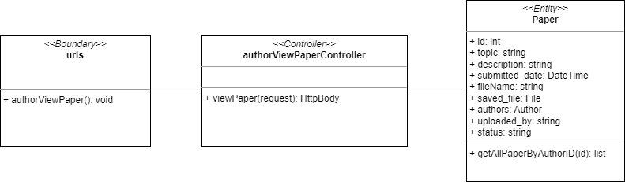

Sequence Diagram

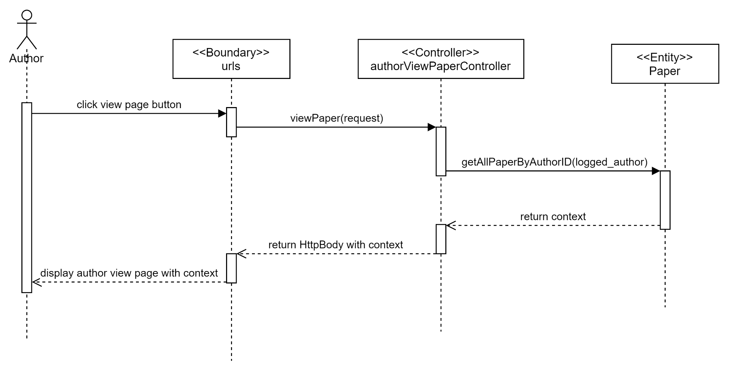

Test cases

### 

### #12 As an author, I want to update submitted papers so that the paper is updated.

Use Case Description

|  |  |
| --- | --- |
| Use Case ID | 12 |
| Use Case Name | Update submitted papers |
| Description | Author updates the paper has been submitted |
| Actor(s) | Author |
| Trigger | Author wants to make changes in the papers that they have submitted |
| Pre-existing condition | 1. Logged in as an Author. 2. User has submitted at least one paper before. 3. The paper has not yet been reviewed by reviewers. 4. Author clicks the View Paper button. |
| Basic Flow | 1. Author clicks the update button from one of the papers in the table. 2. The system displays the update paper page. 3. Author keys in any necessary changes to the fields and clicks submit. 4. The system will verify the updated information and update the information in the respective paper accordingly in the database and display a successful message. |
| Sub Flow | None. |
| Alternative Flow | 1. User cancel the update process |

### 

BCE Diagram

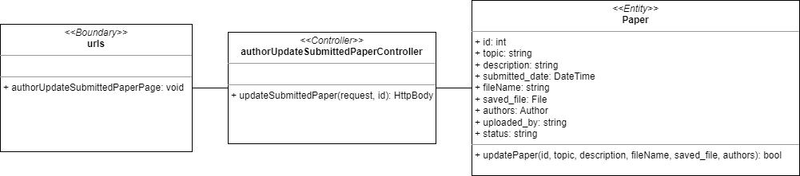

Sequence Diagram

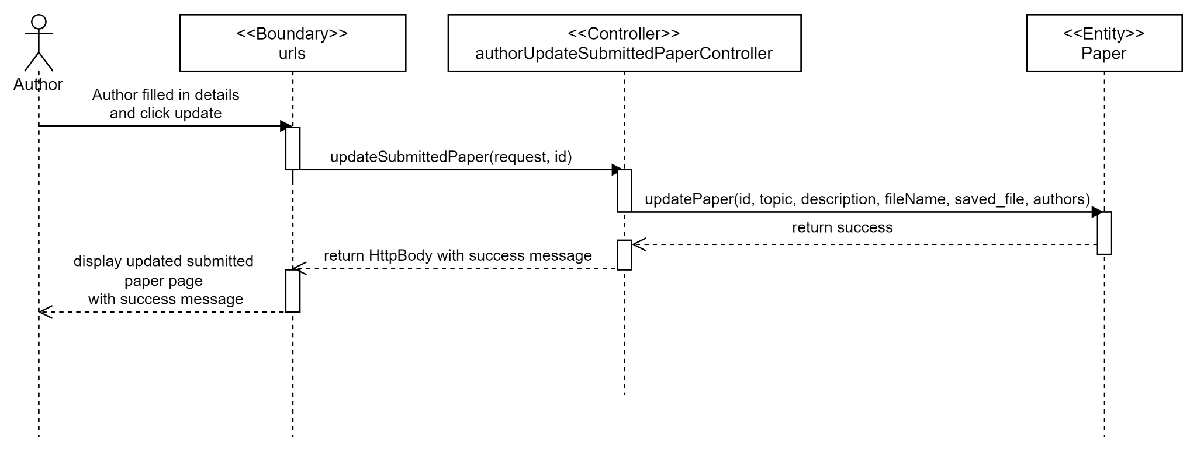

Test cases

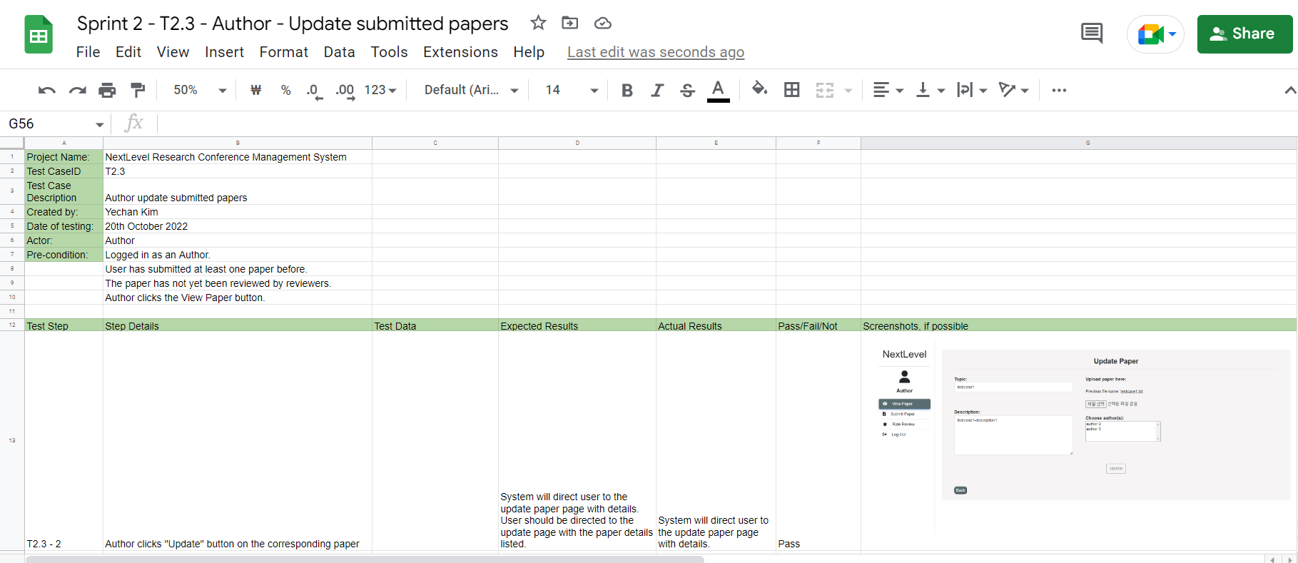

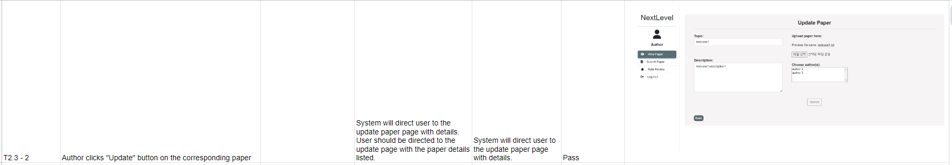

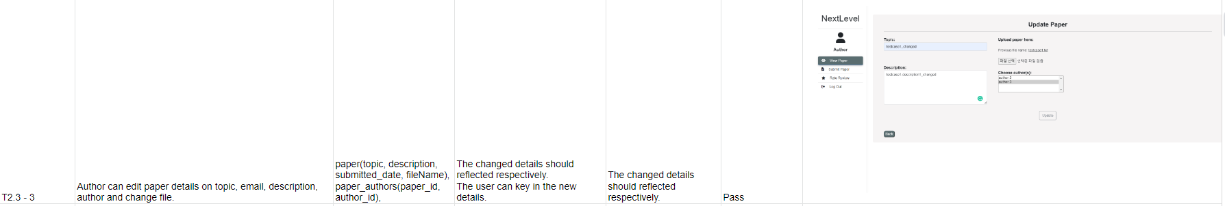

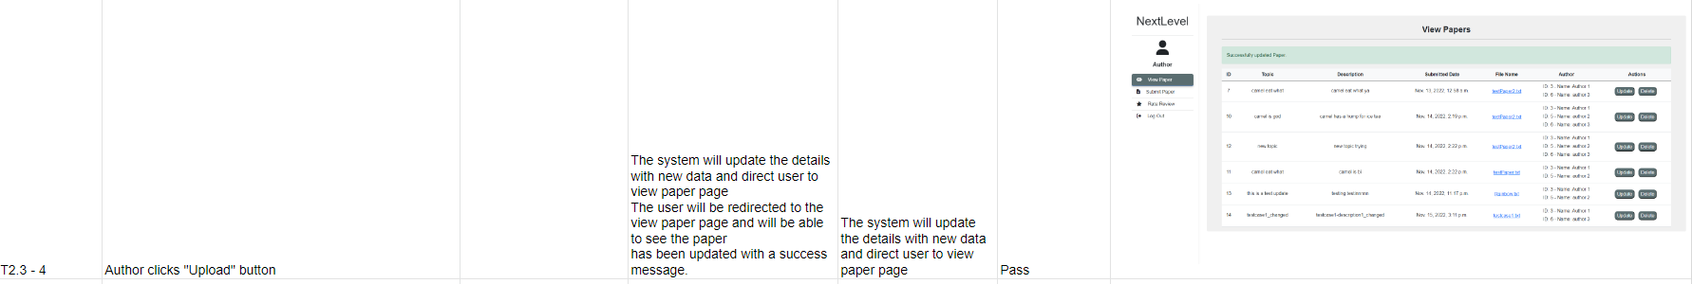

### 

### #13 As an author, I want to delete submitted papers so that the paper is removed from the list.

Use Case Description

|  |  |
| --- | --- |
| Use Case ID | 13 |
| Use Case Name | Delete submitted papers |
| Description | Author can delete his submitted paper from the system. |
| Actor(s) | Author |
| Trigger | Author wants to delete his paper |
| Pre-existing condition | 1. Logged in as Author 2. Author has submitted at least one paper 3. Author clicks the View Paper button |
| Basic Flow | 1. User clicks on the delete button of the respective paper. 2. The system deletes the respective paper in the database and displays a successful delete message. |
| Sub Flow | None. |
| Alternative Flow | None. |

BCE Diagram

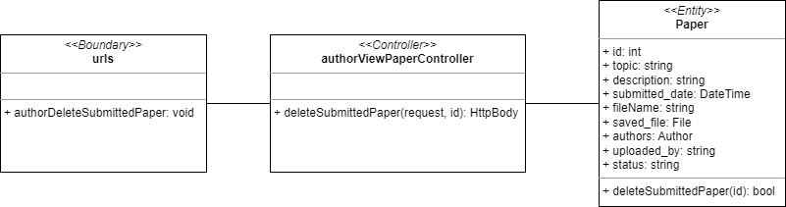

Sequence Diagram

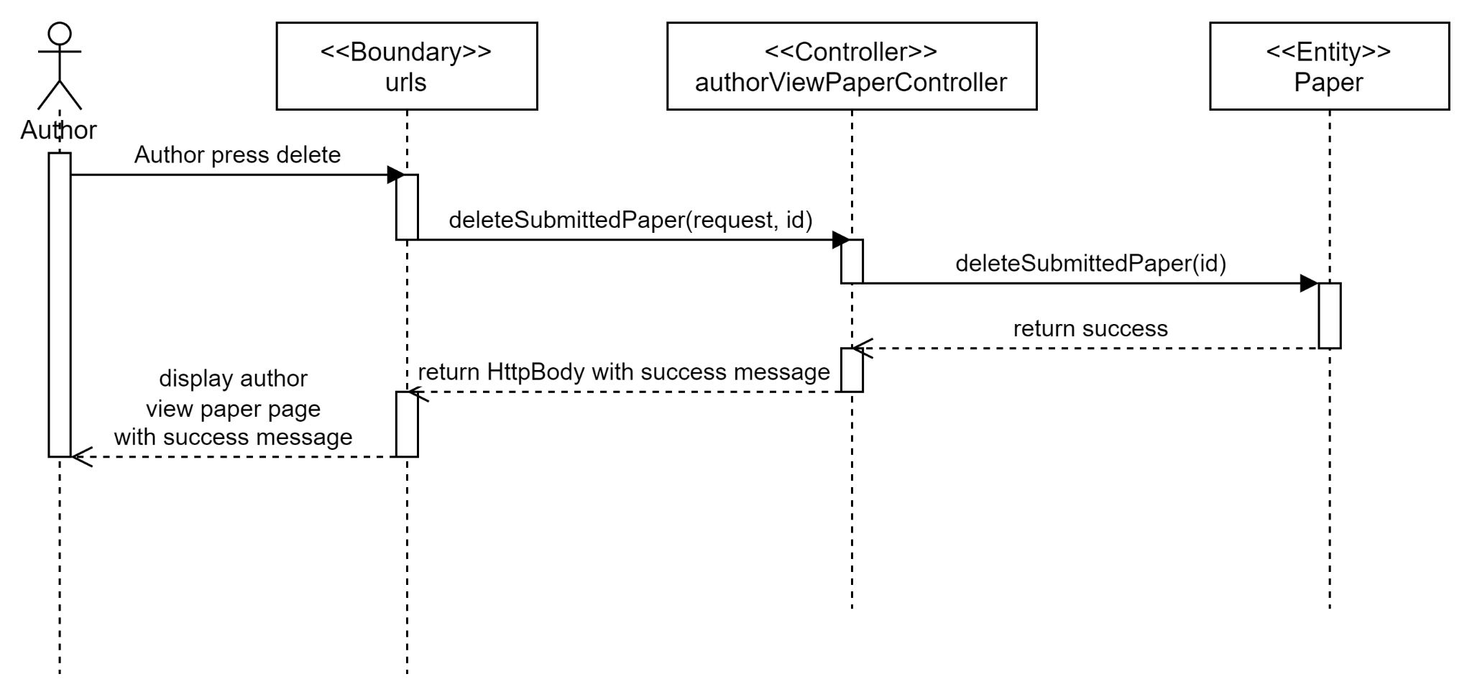

Test cases

### 

### #243 As an author, I want to read submitted paper so that I can see the content of my paper

Use Case Description

|  |  |
| --- | --- |
| Use Case ID | 243 |
| Use Case Name | Read submitted paper |
| Description | Author wants can paper’s content |
| Actor(s) | Author |
| Trigger | Author wants to read paper’s content |
| Pre-existing condition | 1. Author View Paper |
| Basic Flow | 1. Author clicks the file name 2. System will display the paper’s content |
| Sub Flow | None. |
| Alternative Flow | None. |

### 

BCE Diagram

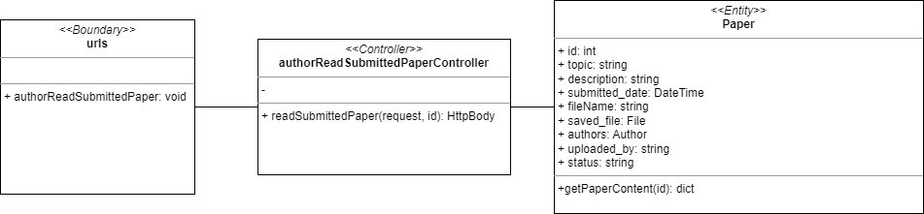

Sequence Diagram

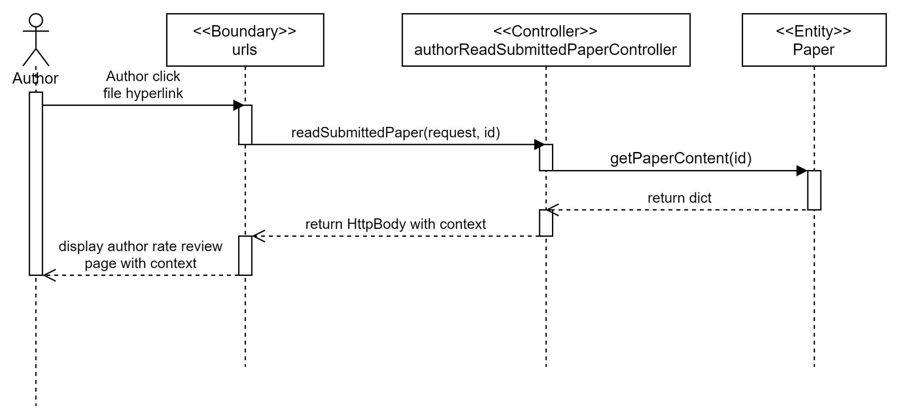

Test cases

## 

## **SPRINT 3**

### Taiga

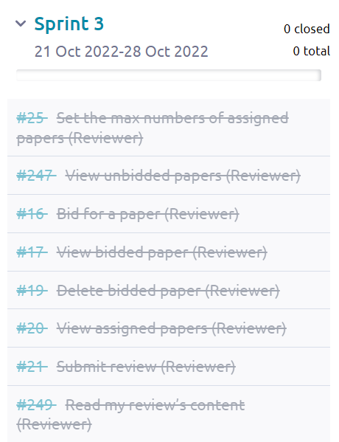

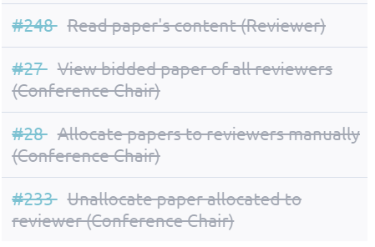

From the screenshots beside, we can see that Sprint 3 started from 21 October 2022 to 28 October 2022. There are in total 12 use cases made in Sprint 3 and all of these use cases were closed after Sprint 3 ended which means that all the development process from diagrams, software developments and testing for those 12 use cases were done in Sprint 3.

### Class Diagram

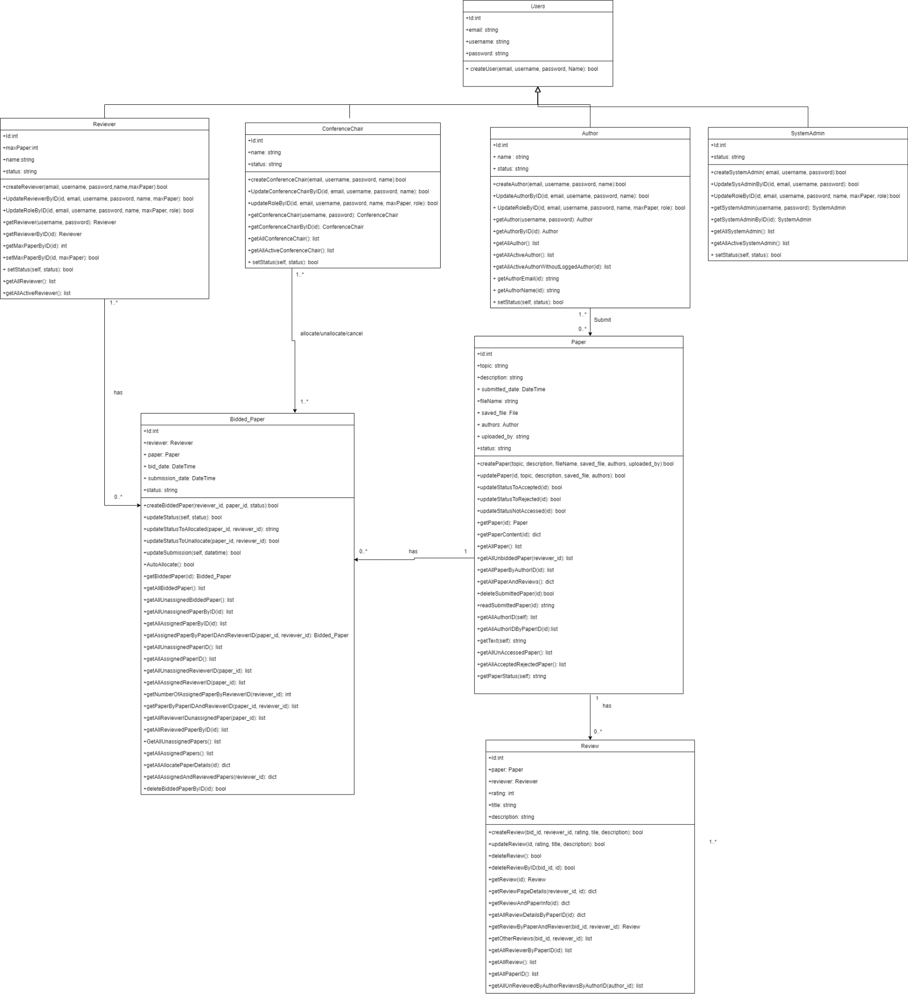

### Data Persistent

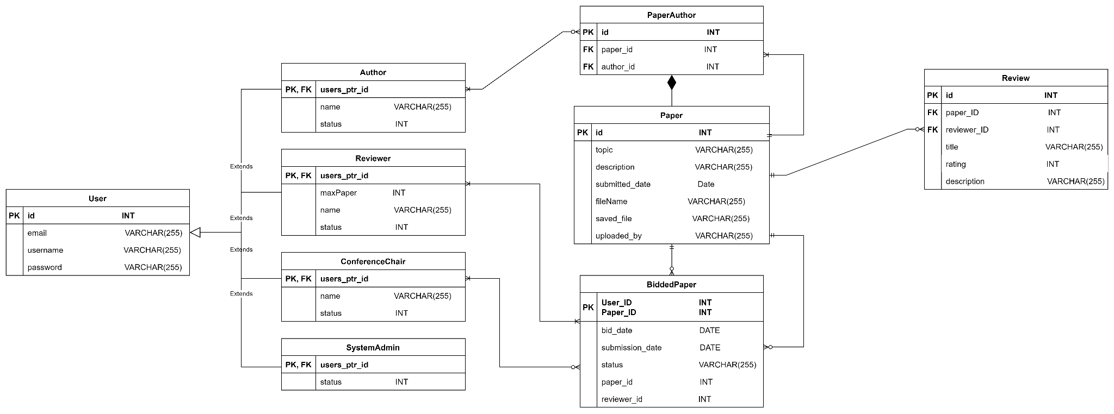

### 

### 

### #247 As a reviewer, I want to view unbidded papers so that I can view the paper that hasn’t been bidded

Use Case Description

|  |  |
| --- | --- |
| Use Case ID | 247 |
| Use Case Name | View unbidded papers |
| Description | The Reviewer can view the papers that haven’t bidded. |
| Actor(s) | Reviewer |
| Trigger | Reviewer wants to view the papers that haven’t bidded. |
| Pre-existing condition | 1. Logged in as Reviewer. |
| Basic Flow | 1. Reviewer clicks the “Bid Paper” button. 2. The system displays all the papers that hasn’t bidded. |
| Sub Flow | None. |
| Alternative Flow | None. |

BCE Diagram

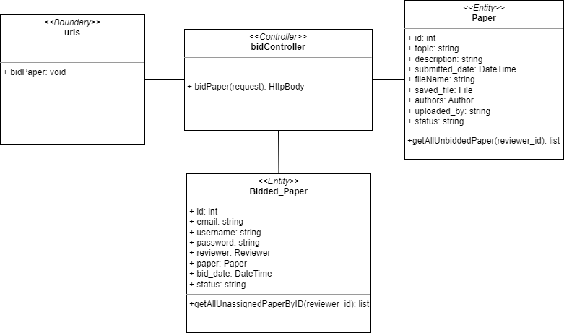

Sequence Diagram

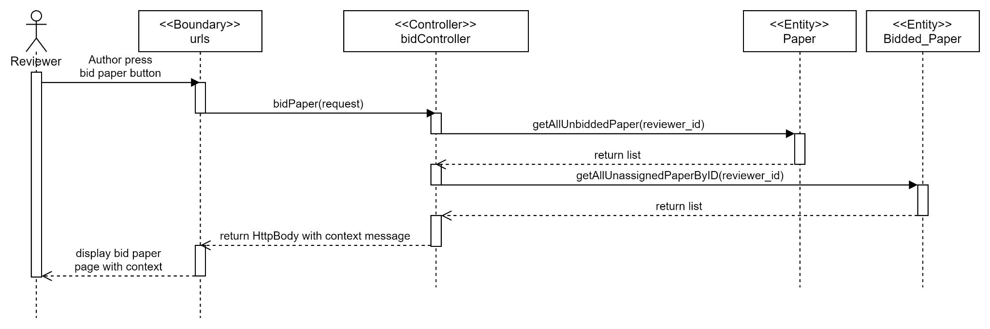

Test cases

### 

### #16 As a reviewer, I want to bid for a paper so that I am able to get the paper I wish to review.

Use Case Description

|  |  |
| --- | --- |
| Use Case ID | 16 |
| Use Case Name | Bid for a paper |
| Description | The Reviewer can bid for papers that the Reviewer wants to review. |
| Actor(s) | Reviewer |
| Trigger | Reviewer wants to review their preferred papers. |
| Pre-existing condition | 1. Logged in as Reviewer 2. Author submitted a paper or more. 3. Reviewer have enough credits to bid for a paper 4. Reviewer clicks the Bid Paper button 5. Reviewer view unbidded papers list. |
| Basic Flow | 1. Reviewer clicks the Bid button on one of the papers. 2. System will create a bidded paper and save it in the database. |
| Sub Flow | None. |

### 

BCE Diagram

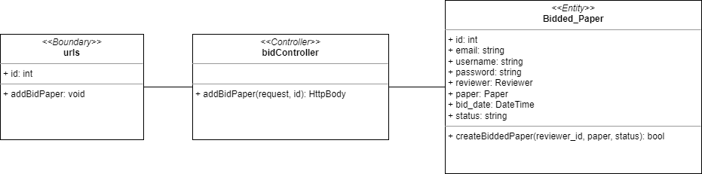

Sequence Diagram

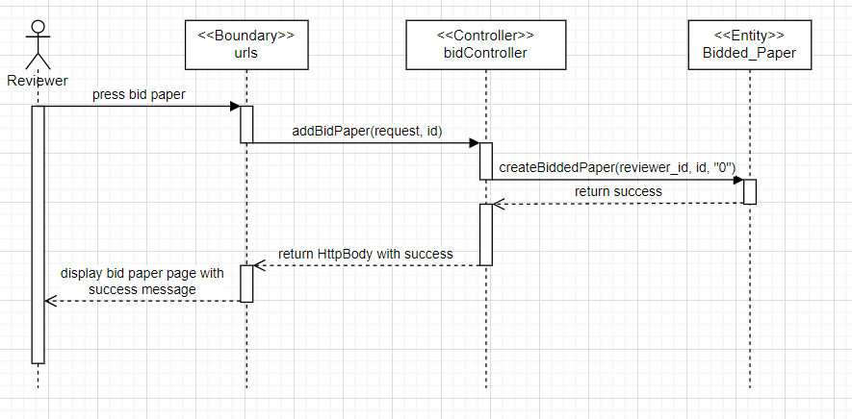

Test cases

### 

### #17 As a reviewer, I want to view bidded paper so that I can view my bidded paper.

Use Case Description

|  |  |
| --- | --- |
| Use Case ID | 17 |
| Use Case Name | View bidded papers |
| Description | The reviewer can see the bidded papers. |
| Actor(s) | Reviewer |
| Trigger | Reviewer wants to see the bidded papers. |
| Pre-existing condition | 1. Logged in as Reviewer 2. Author submitted a paper or more. 3. Reviewer has bid at least on one paper. |
| Basic Flow | 1. The user clicks on the Bid paper option 2. System displays all the bidded papers. |
| Sub Flow | None. |
| Alternative Flow | 2. If there isn’t any paper bidded, display nothing. |

### 

BCE Diagram

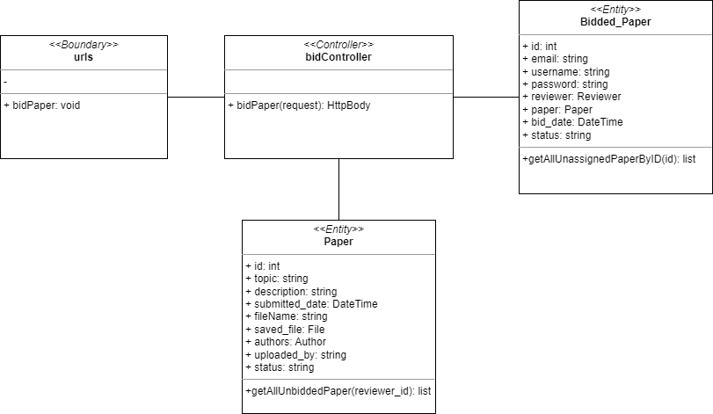

Sequence Diagram

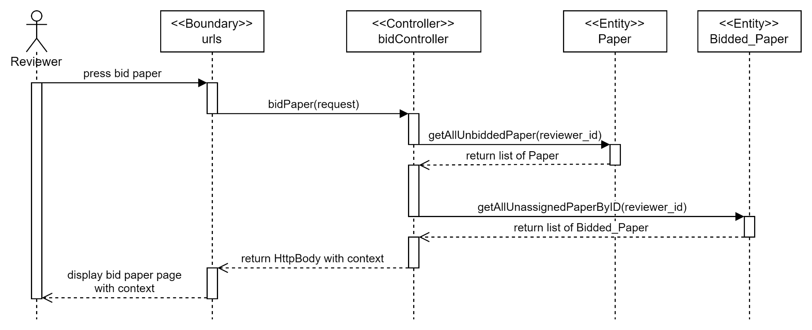

Test cases

### 

### #19 As a reviewer, I want to delete bidded paper so that I can undo my bids.

Use Case Description

|  |  |
| --- | --- |
| Use Case ID | 19 |
| Use Case Name | Delete bidded paper |
| Description | Reviewer wants to delete bidded paper. |
| Actor(s) | Reviewer |
| Trigger | The reviewer wants to delete bidded paper. |
| Pre-existing condition | 1. Logged in as reviewer. 2. Author submitted a paper or more. 3. Reviewer has bidded on at least a paper. 4. Reviewer clicks Bid Paper page. |
| Basic Flow | 1. Reviewer clicks Remove Bid button on the respective paper. 2. System will delete the bidded paper in database. |
| Sub Flow | None |
| Alternative Flow | None |

### 

BCE Diagram

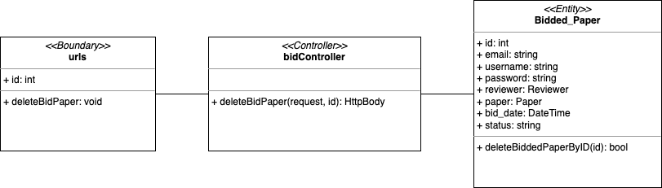

Sequence Diagram

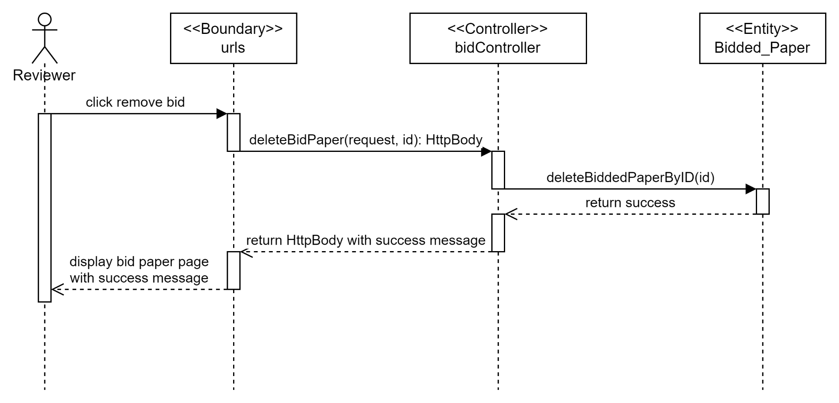

Test cases

### 

### #20 As a reviewer, I want to view assigned papers so that I can view my assigned papers.

Use Case Description

|  |  |
| --- | --- |
| Use Case ID | 20 |
| Use Case Name | View Assigned papers |
| Description | View papers that were successfully bidded for / assigned to me. |
| Actor(s) | Reviewer |
| Trigger | The Reviewer wants to view assigned papers. |
| Pre-existing condition | 1. Logged in as an Reviewer. 2. Author submitted a paper or more. 3. Reviewer has bidded on at least a paper. 4. Reviewer clicks Bid Paper page. 5. Conference Chair has allocated paper to the reviewer. |
| Basic Flow | 1. Reviewer clicks View Paper button 2. System will show all the papers that has been allocated to the respective Reviewer |
| Sub Flow | None. |
| Alternative Flow | 2a. If there are no assigned papers, it will show nothing in the table. |

### 

BCE Diagram

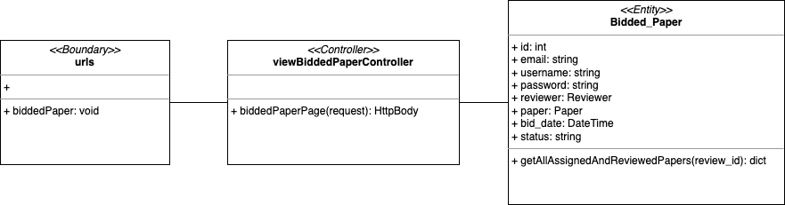

Sequence Diagram

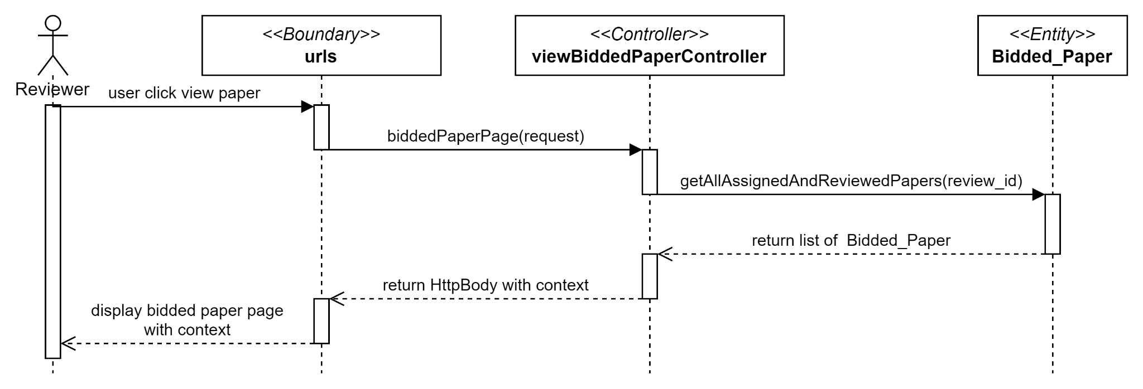

Test cases

### 

### #21 As a reviewer, I want to submit review to each paper so that I can review the paper.

Use Case Description

### 

|  |  |
| --- | --- |
| Use Case ID | 21 |
| Use Case Name | Submit review |
| Description | Reviewer wants to submit their review. |
| Actor(s) | Reviewer |
| Trigger | The reviewer wants to submit a review on the allocated paper. |
| Pre-existing condition | 1. Author submitted a paper or more. 2. Reviewer has bidded on at least a paper. 3. Reviewer clicks Bid Paper page. 4. Conference Chair has allocated paper to the reviewer. 5. Reviewer view assigned papers. |
| Basic Flow | 1. Reviewer clicks the review button on the respective paper. 2. System displays the Submit Your Review page. 3. Review keys in every field in the page and click submit. 4. System creates the review in the database with the fields and save it accordingly. |
| Sub Flow | None. |
| Alternative Flow | None. |

### 

BCE Diagram

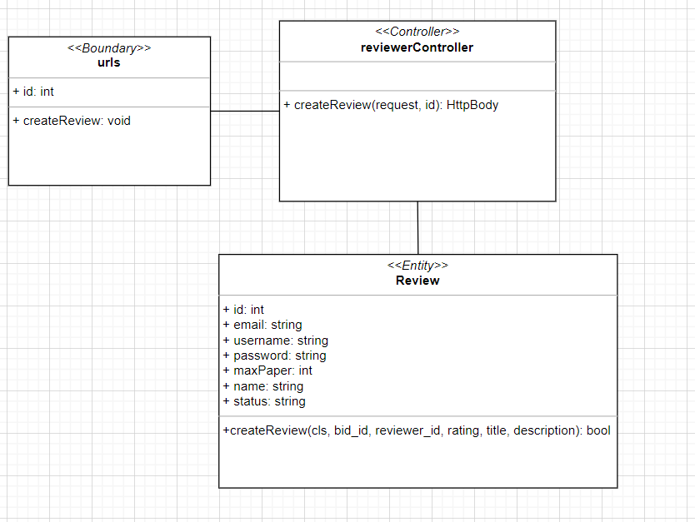

Sequence Diagram

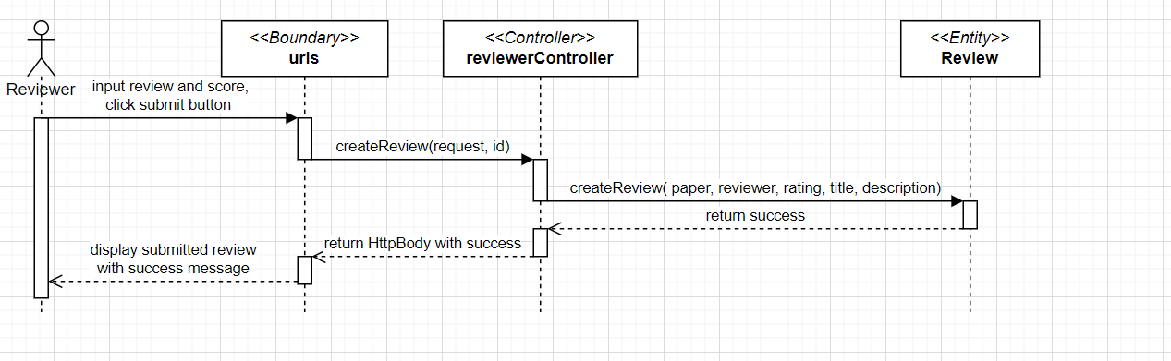

Test cases

### 

### 

### #25 As a reviewer, I want to set the max number of assigned papers so that I will not overwork myself.

Use Case Description

|  |  |
| --- | --- |
| Use Case ID | 25 |
| Use Case Name | Set the max number of assigned papers |
| Description | The reviewer can set the max numbers of papers that they want to be assigned to. |
| Actor(s) | Reviewer |
| Trigger | Reviewer wants to set the number of paper that they want to be assigned to. |
| Pre-existing condition | 1. Logged in as Reviewer |
| Basic Flow | 1. Reviewer click the settings button. 2. System will display a page with an input for max paper value. 3. Reviewer enters the new max paper value. 4. System sets the amount of paper assigned to the reviewer in the database. |
| Sub Flow | None. |
| Alternative Flow | None. |

BCE Diagram

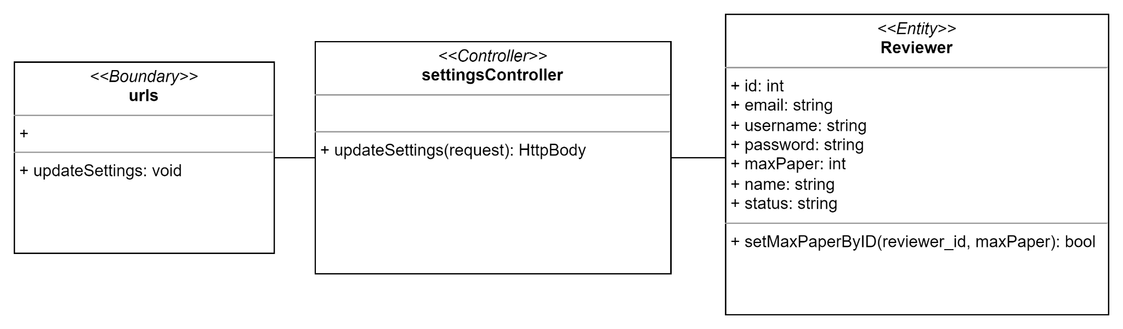

Sequence Diagram

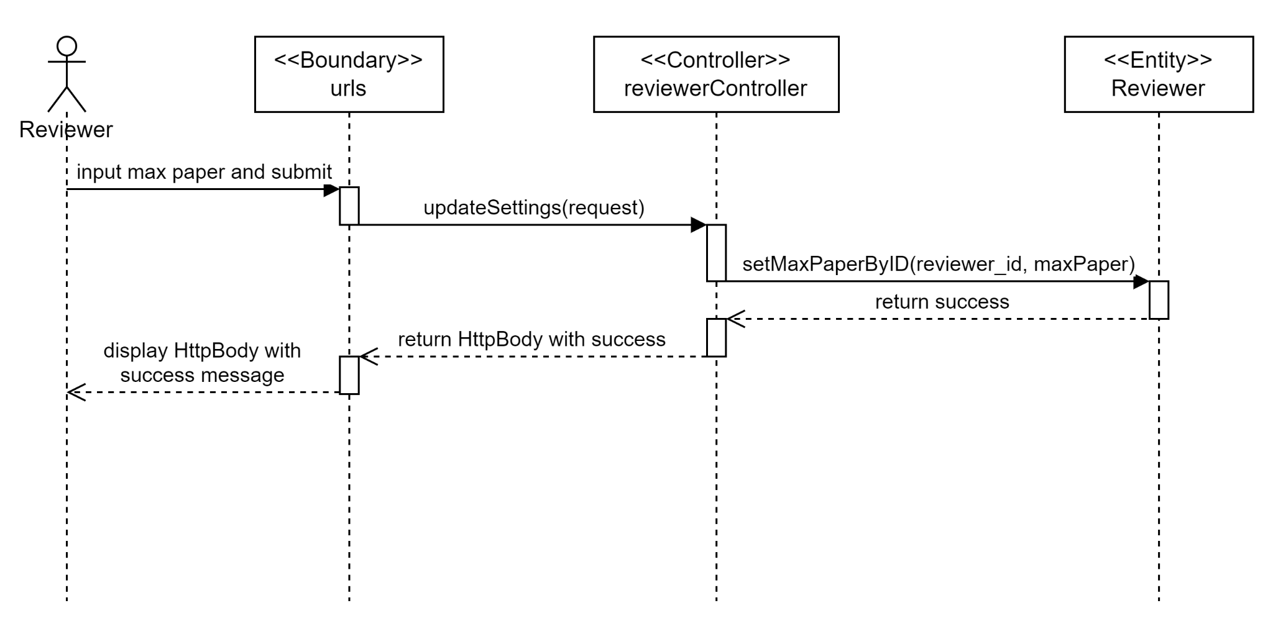

Test cases

### 

### 

### #249 As a reviewer, I want to read my review’s content so that I can read my own review on the paper

Use Case Description

|  |  |
| --- | --- |
| Use Case ID | 249 |
| Use Case Name | Read review’s content |
| Description | Reviewer can read review’s content |
| Actor(s) | Reviewer |
| Trigger | Reviewer wants to read review’s content |
| Pre-existing condition | 1. Reviewer has reviewed at least one of the paper they are assigned to. 2. Reviewer clicks View Papers button |
| Basic Flow | 1. Reviewer clicks view button 2. System displays the review’s content. |
| Sub Flow | None. |
| Alternative Flow | None. |

### 

BCE Diagram

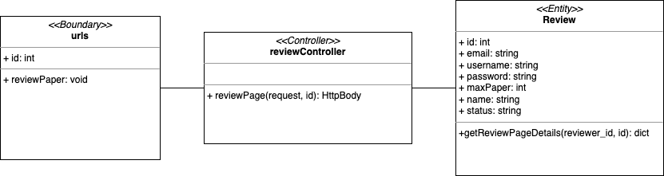

Sequence Diagram

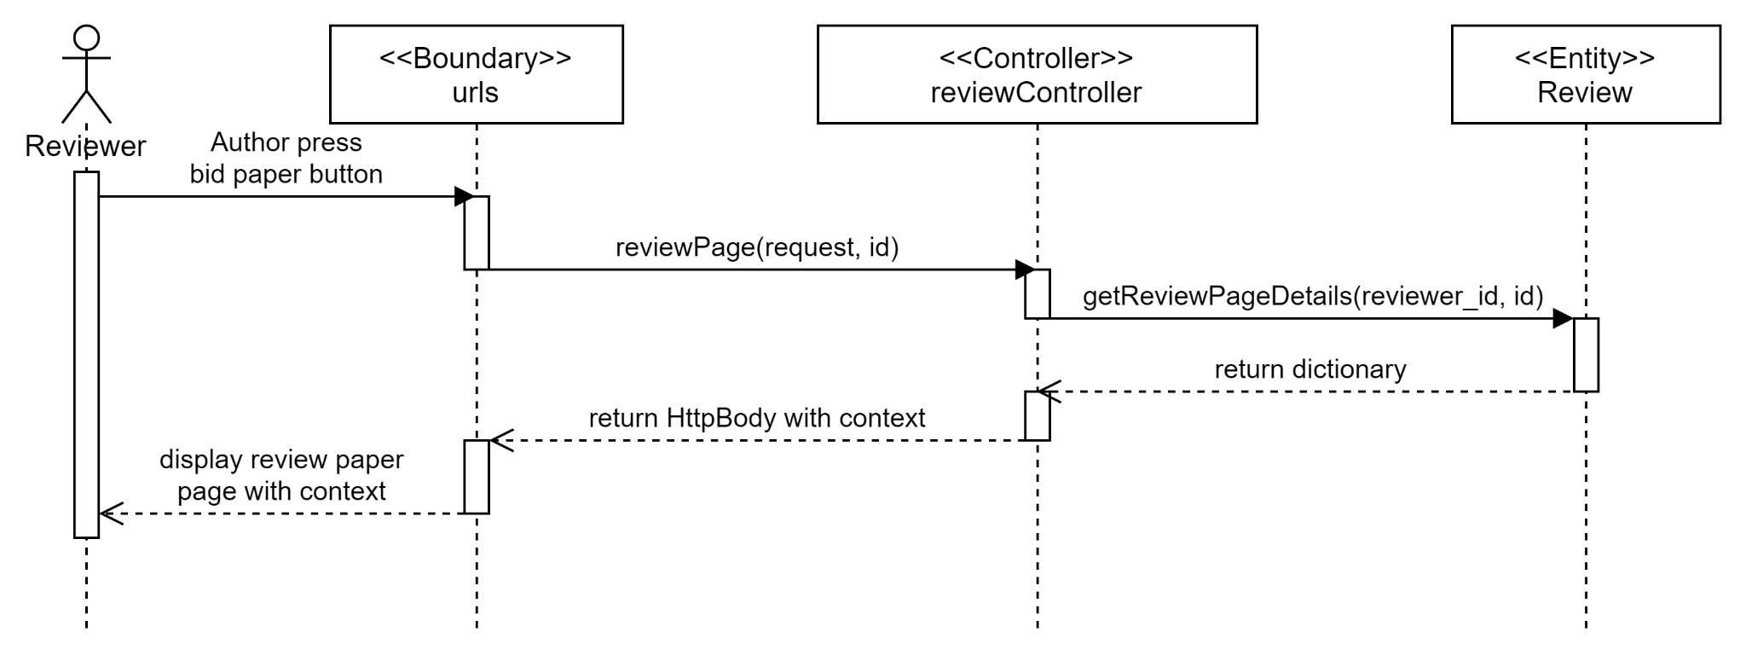

Test cases

### 

### #248 As a reviewer, I want to read paper’s content so that I can read the paper’s content.

Use Case Description

|  |  |
| --- | --- |
| Use Case ID | 248 |
| Use Case Name | Read paper’s content |
| Description | Reviewer can read the paper’s content. |
| Actor(s) | Reviewer |
| Trigger | Reviewer wants to read the paper’s content. |
| Pre-existing condition | 1. Reviewer clicks View button in View papers page |
| Basic Flow | 1. Reviewer clicks Click here beside the View Paper. 2. System displays a pop up with the contents of the paper. |
| Sub Flow | None. |
| Alternative Flow | None. |

### 

BCE Diagram

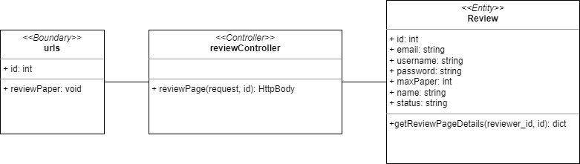

Sequence Diagram

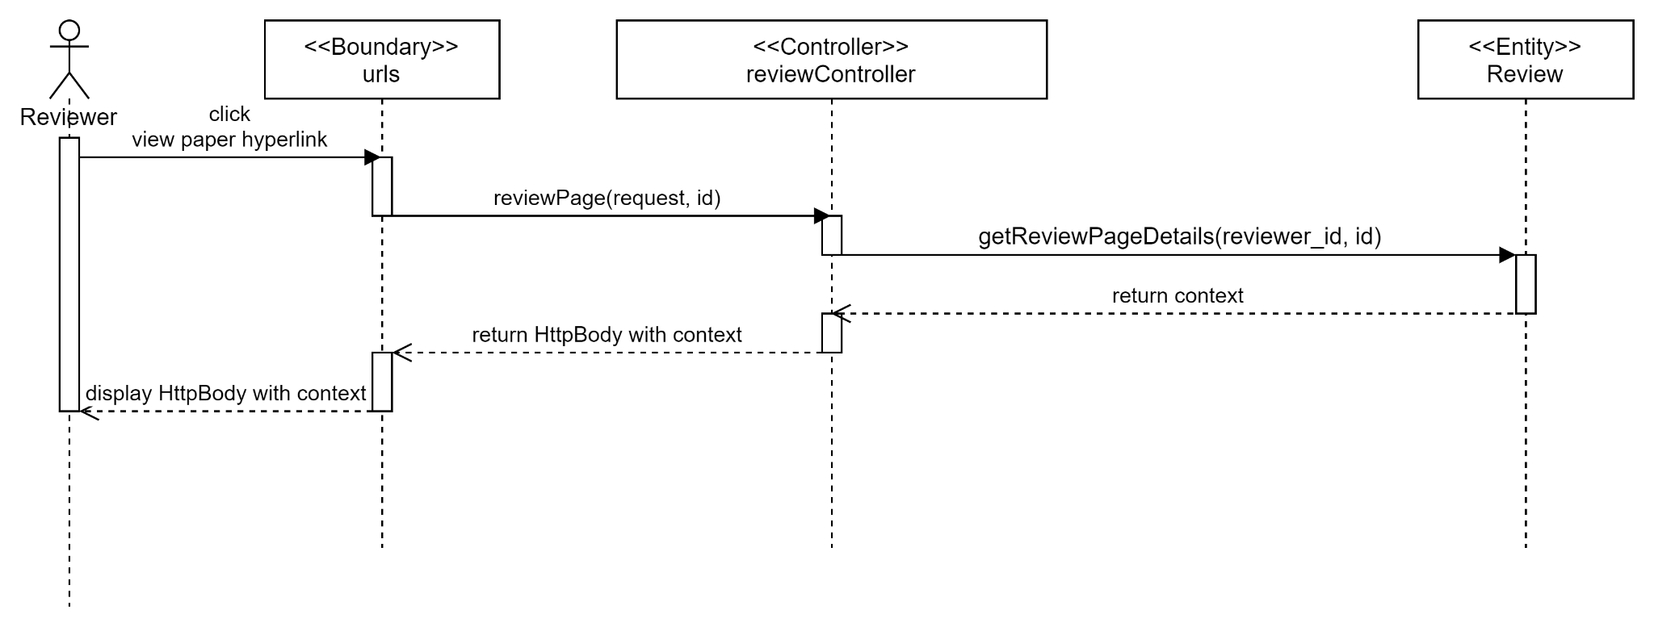

Test cases

### 

### #27 As a conference chair, I want to view bidded paper of all reviewer so that I can view all the papers that have been bidded by reviewers.

Use Case Description

|  |  |
| --- | --- |
| Use Case ID | 27 |
| Use Case Name | View bidded paper of all reviewers |
| Description | Conference Chair clicks on the Allocate Papers button and the system will direct user to papers allocation list page. |
| Actor(s) | Conference Chairs |
| Trigger | Conference chairs wants to see all the bidded paper |
| Pre-existing condition | 1. Conference Chair must be logged-in to the account. |
| Basic Flow | 1. The user clicks on Allocate Papers option. 2. System retrieves all existing bidded papers from the database and displays them in a list. |
| Sub Flow | None. |
| Alternative Flow | None. |

BCE Diagram

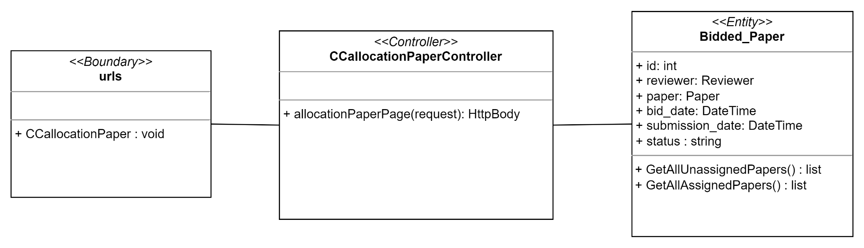

Sequence Diagram

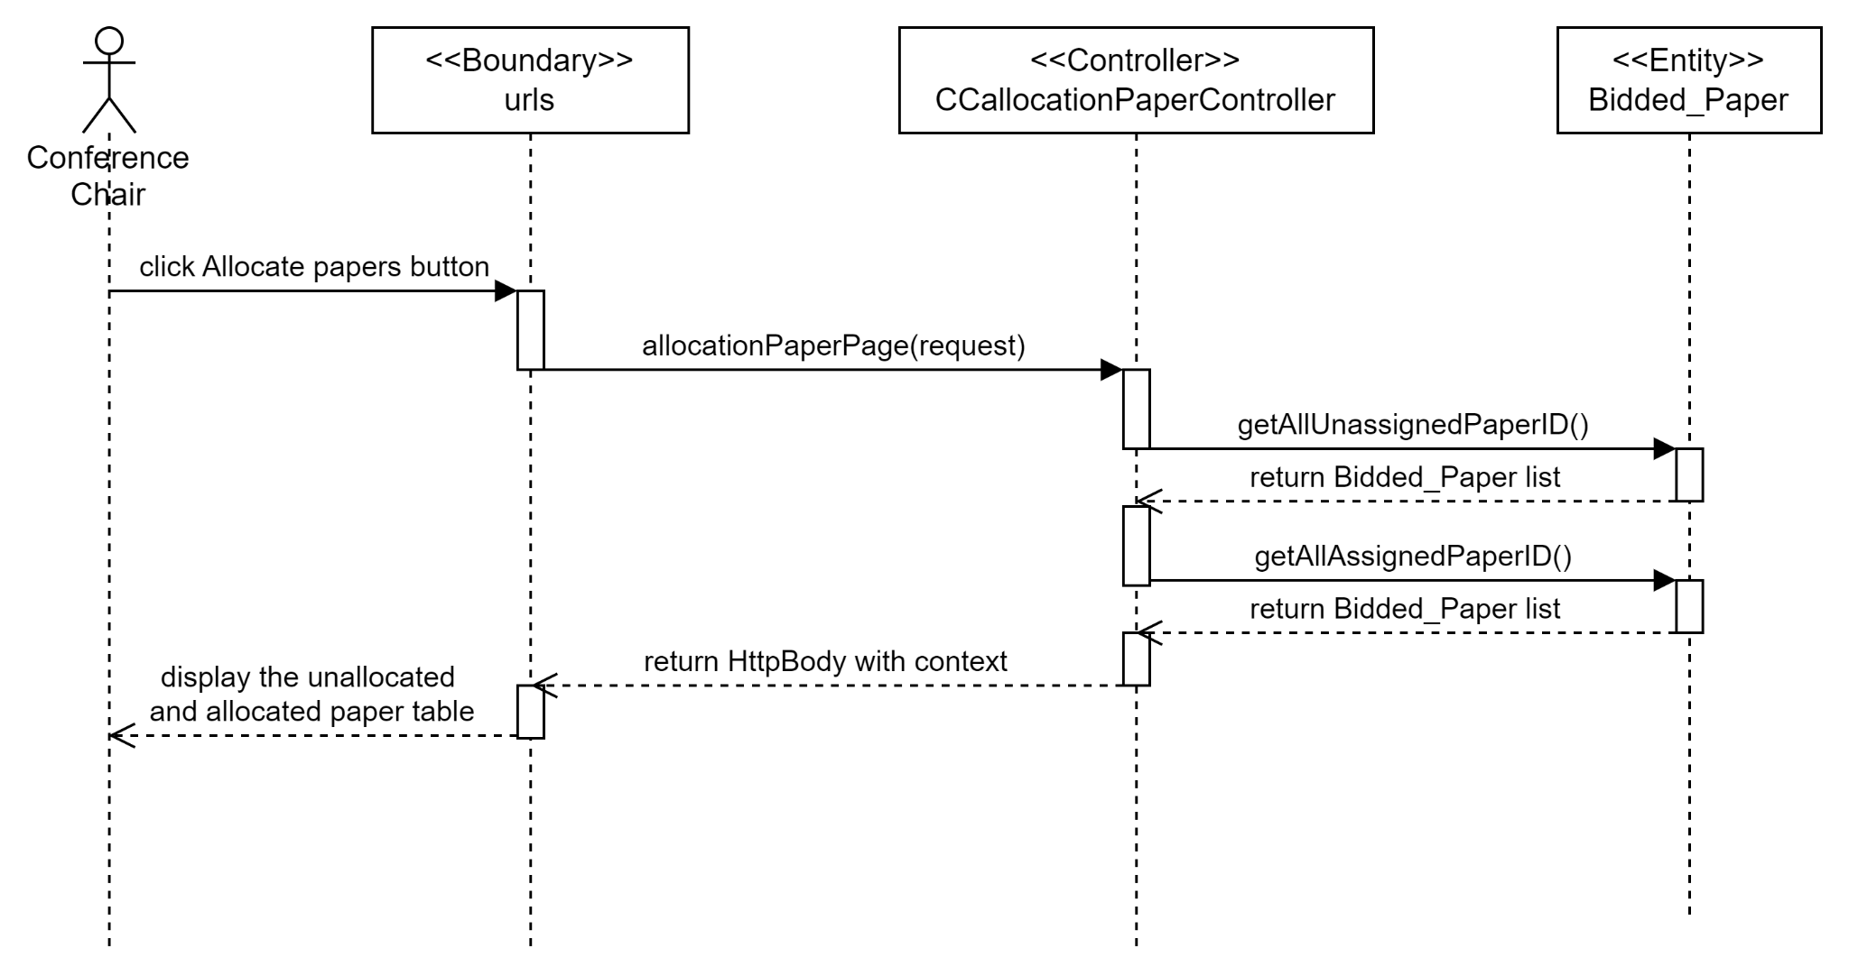

Test cases

### 

### #28 As a conference chair, I want to allocate papers to reviewers manually so that I can manually allocate the papers to the reviewers.

Use Case Description

|  |  |
| --- | --- |
| Use Case ID | 28 |
| Use Case Name | Allocate papers to reviewers manually |
| Description | Conference chair allocate papers to reviewers manually and the system will allocate paper to selected reviewer. |
| Actor(s) | Conference chair |
| Trigger | Conference chair wants to allocate papers to reviewers manually. |
| Pre-existing condition | 1. Any of the authors submitted at least one paper. 2. Reviewers should have put in bidding. 3. Conference Chair is on the Allocate Papers page. |
| Basic Flow | 1. Conference chair clicks the “Allocate” button on one of the papers under pending allocation table. 2. The system will show all the reviewers that have bidded for the paper. 3. Conference chair chooses the reviewer to be allocated and click Allocate button. 4. The system verify reviewer’s workload to allocate paper and direct user to Allocate Papers page with success message. |
| Sub Flow | Allocate papers automatically. |
| Alternative Flow | 4.a. If the reviewer’s workload exceeds, an error message will be displayed. |

BCE Diagram

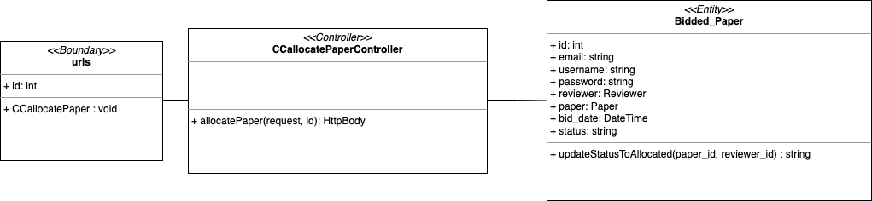

Sequence Diagram

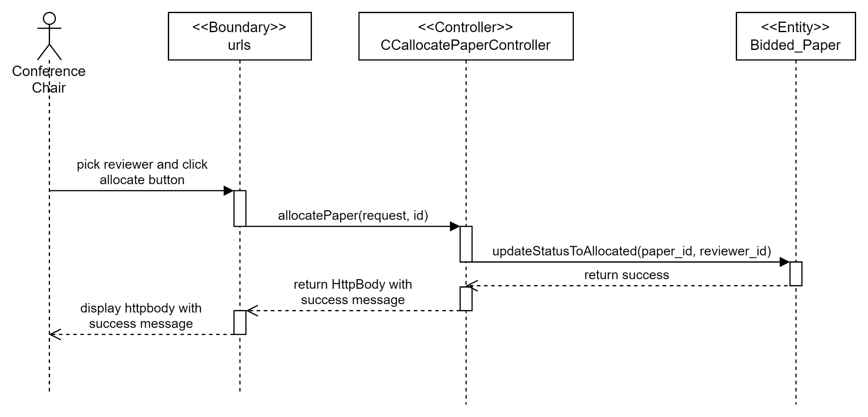

Test cases

### 

### #233 As a conference chair, I want to unallocate papers allocated to reviewers so that I can remove any allocations made.

Use Case Description

|  |  |
| --- | --- |
| Use Case ID | 233 |
| Use Case Name | Unallocate paper assigned to reviewer |
| Description | The Conference Chair clicks on “Unallocate” button to unallocate the assigned paper from the reviewer and system will unallocate the selected paper. |
| Actor(s) | Conference Chair |
| Trigger | Conference Chair wants to unallocate paper |
| Pre-existing condition | 1. Any of the authors submitted at least one paper. 2. Reviewers should have put in bidding. 3. Paper have been allocated to any of the reviewers. 4. Conference Chair is on the Allocate Papers page. |
| Basic Flow | 1. Conference chair clicks the “Unallocate” button on one of the allocated papers. 2. System will identify the reviewer id to unallocate the assigned paper. System will print a success message and redirect the paper to pending allocation table at the same page. |
| Sub Flow | None. |
| Alternative Flow | None. |

### 

BCE Diagram

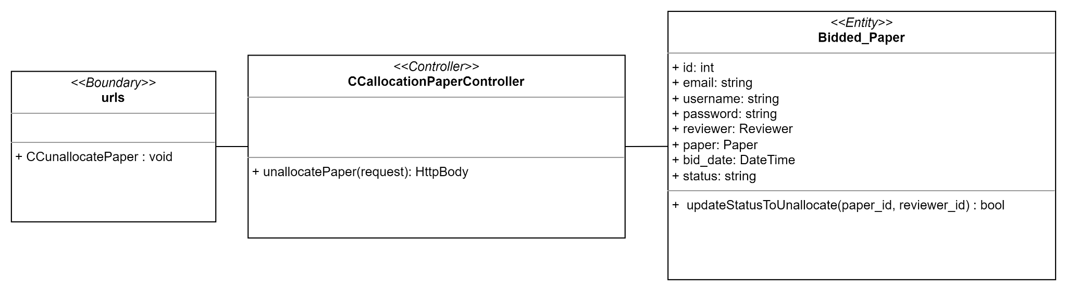

Sequence Diagram

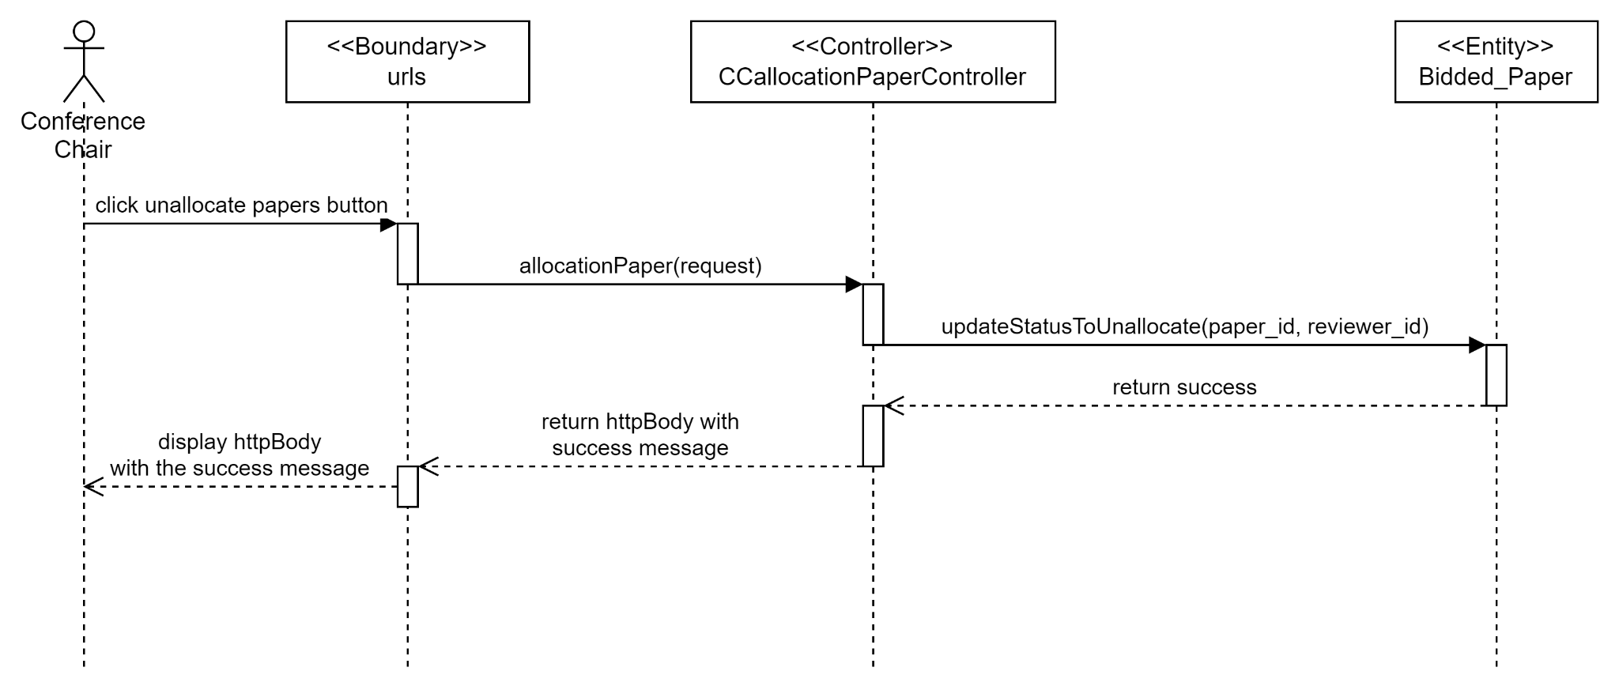

Test cases

#### 

## 

## **SPRINT 4**

### Taiga

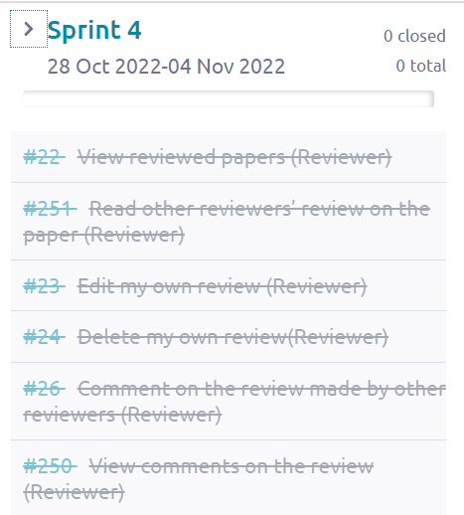

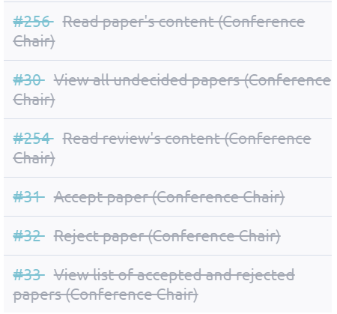

From the screenshots beside, we can see that Sprint 4 started from 28 October 2022 to 4 November 2022. There are in total 12 use cases made in Sprint 4 and all of these use cases were closed after Sprint 4 ended which means that all the development process from diagrams, software developments and testing for those 12 use cases were done in Sprint 4.

### Class Diagram

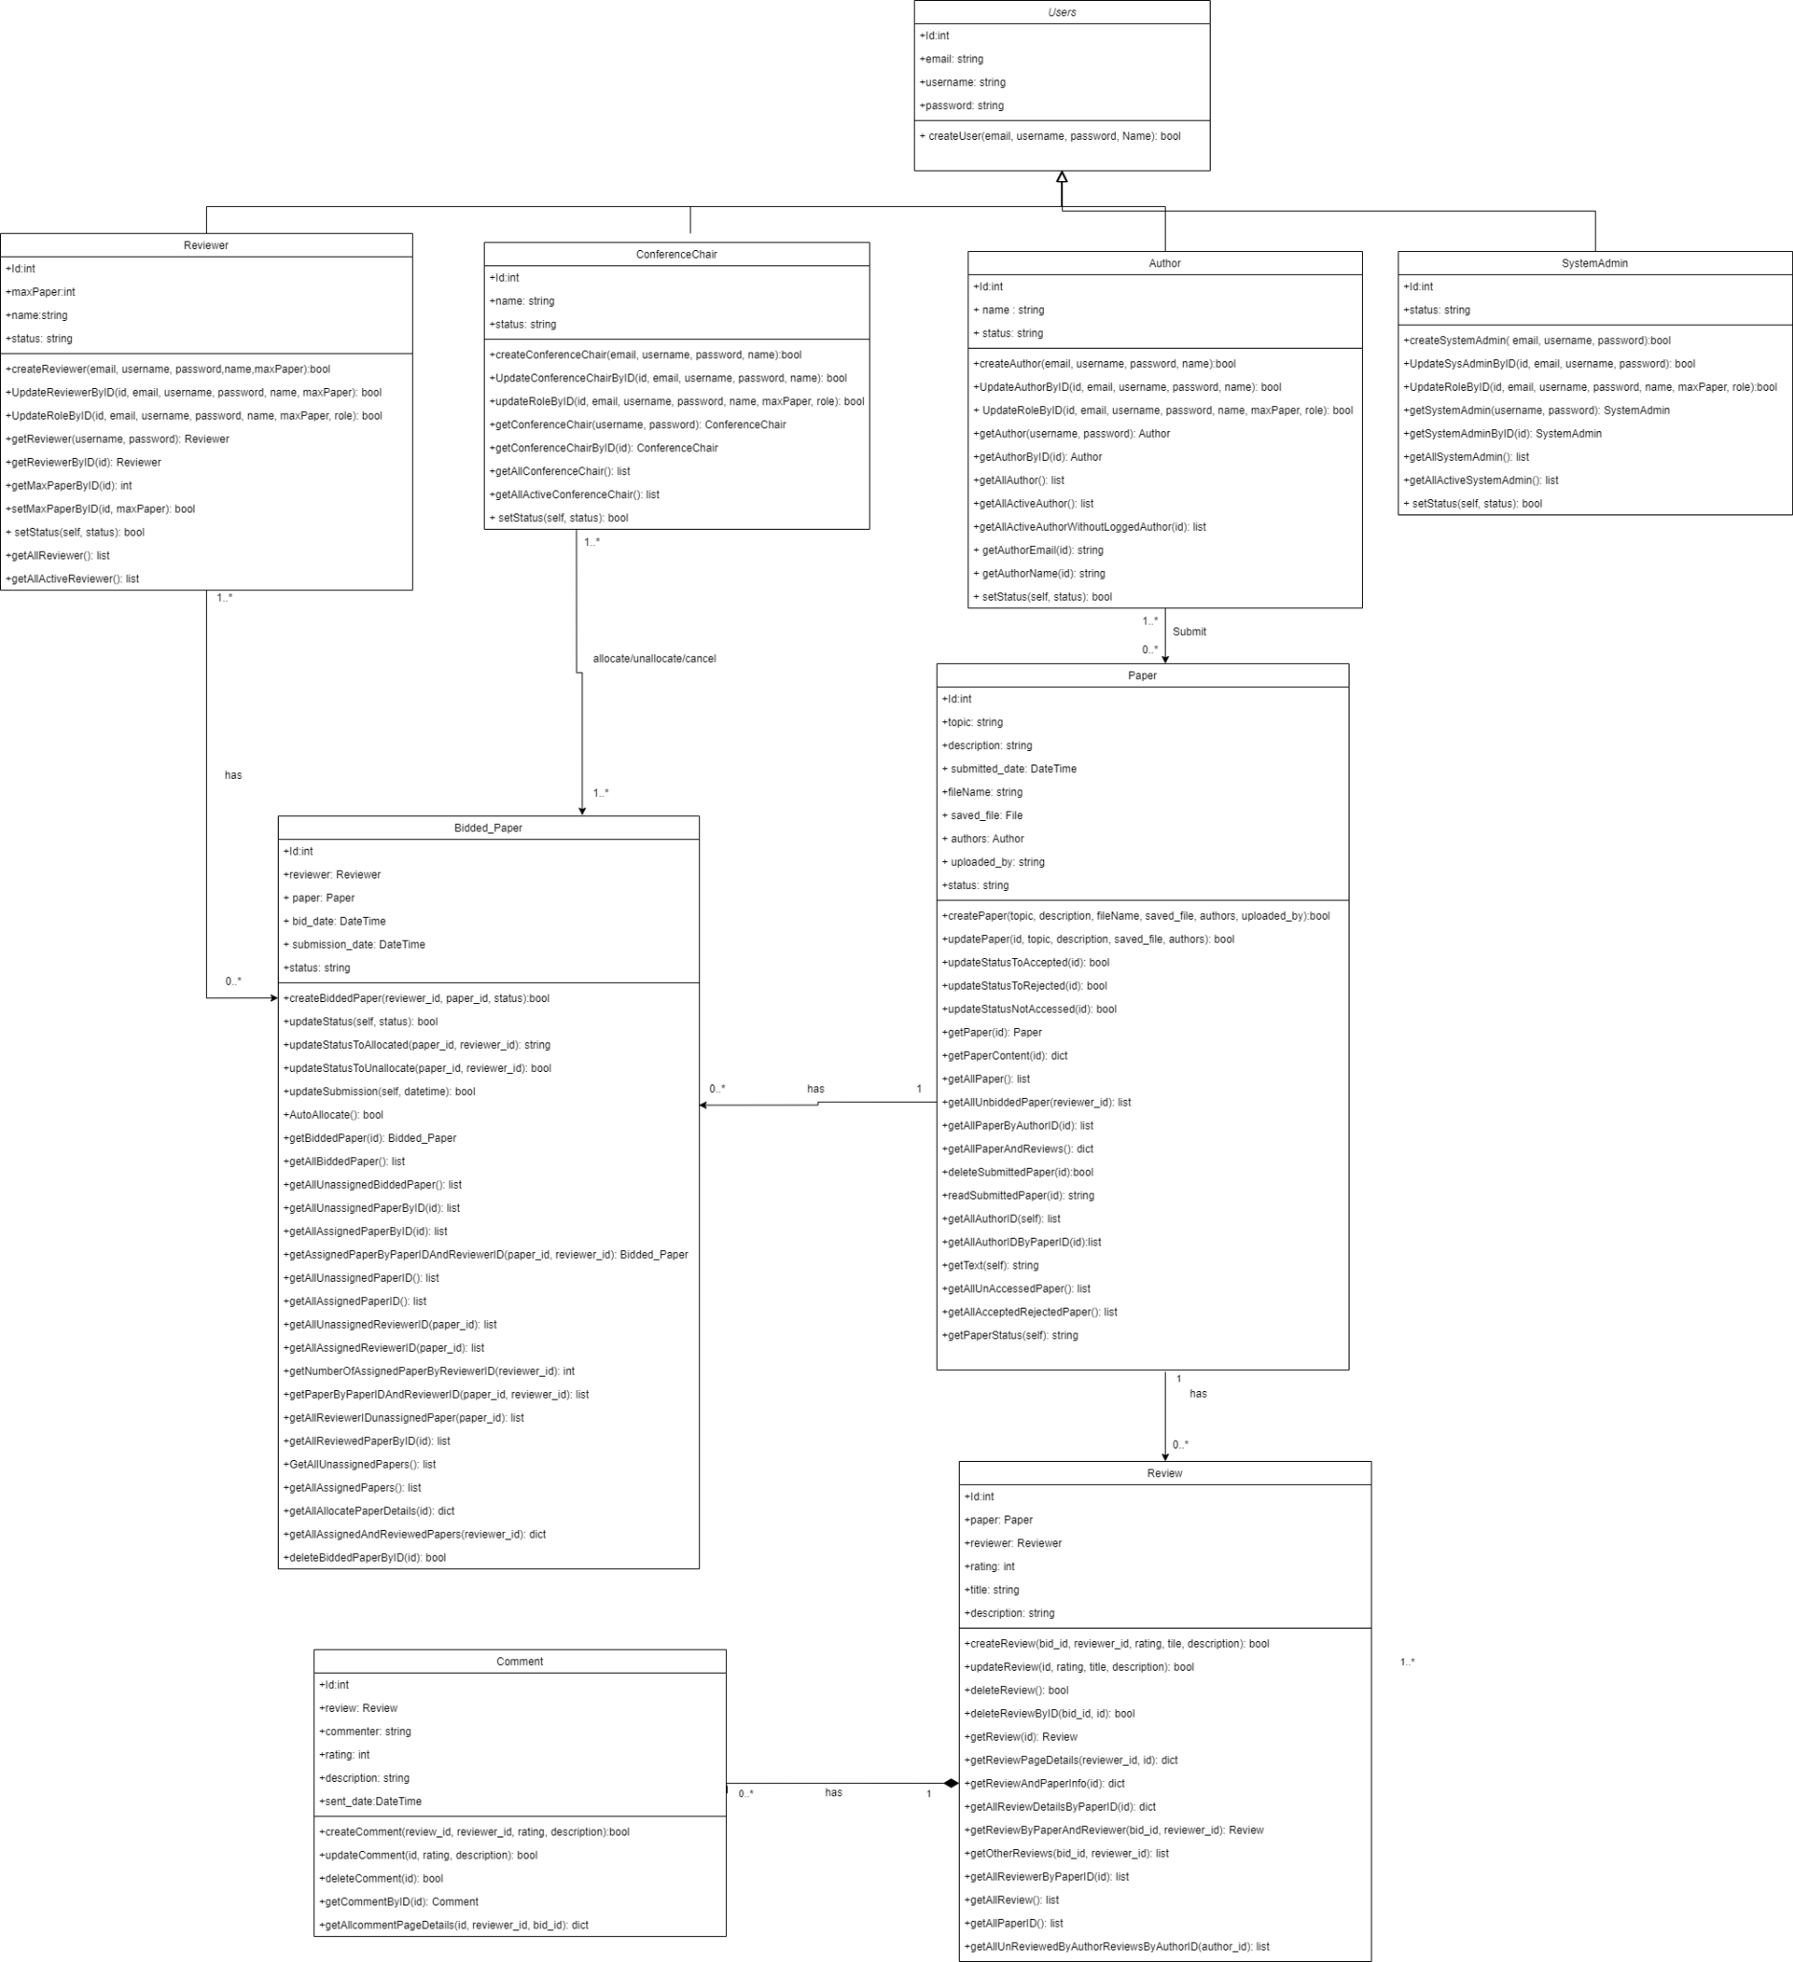

### Data Persistent

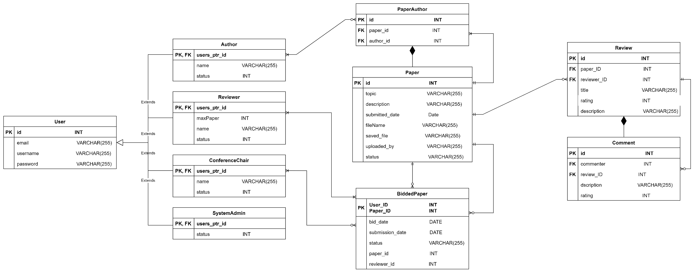

### 

### 

### #22 As a reviewer, I want to view other reviews of the same paper so that I can compare with other reviews.

Use Case Description

|  |  |
| --- | --- |
| Use Case ID | 22 |
| Use Case Name | View reviewed papers |
| Description | Reviewer can view the reviewed papers |
| Actor(s) | Reviewer |
| Trigger | Reviewer wants to view the reviewed papers |
| Pre-existing condition | 1. Logged in as an Reviewer. 2. Reviewer has made a review on at least on paper. |
| Basic Flow | 1. Reviewer clicks View Paper button 2. System will show all the papers that have been reviewed by the Reviewer. |
| Sub Flow | None. |
| Alternative Flow | None. |

### 

BCE Diagram

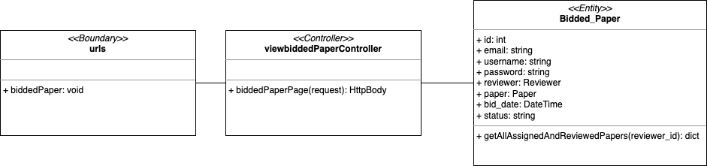

Sequence Diagram

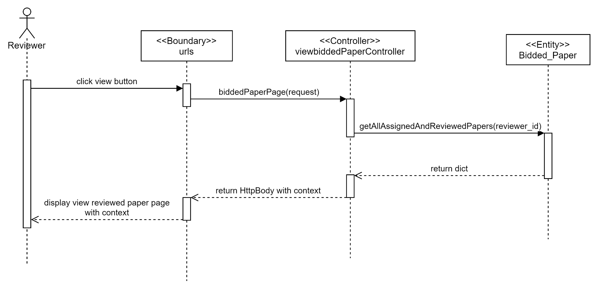

Test cases

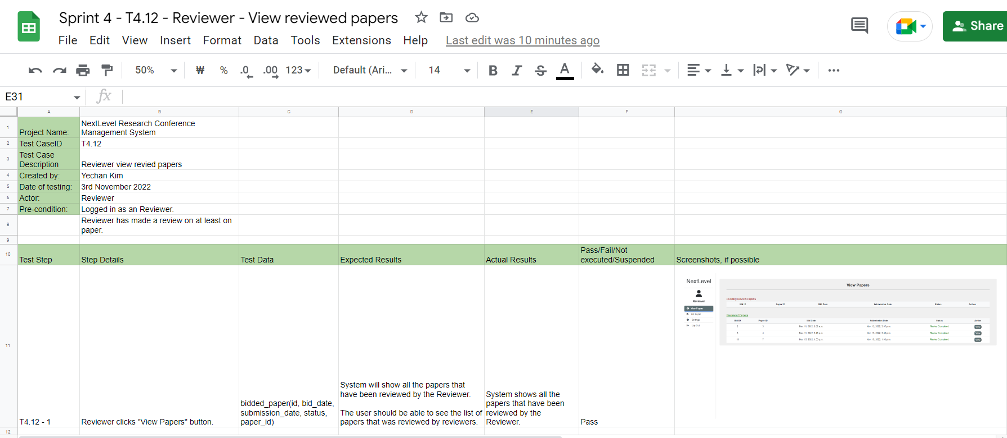

### 

### #251 As a reviewer, I want to read other reviewers’ review on the paper so that I can compare with other reviews

Use Case Description

|  |  |
| --- | --- |
| Use Case ID | 251 |
| Use Case Name | Read other reviewers review on the paper |
| Description | Reviewer can read the other reviewer’s review on the paper. |
| Actor(s) | Reviewer |
| Trigger | Reviewer wants to read other reviewer’s review on the paper |
| Pre-existing condition | 1. Reviewer clicks the View papers button 2. Reviewer clicks the View button on the paper and is on the paper content page. |
| Basic Flow | 1. Reviewer clicks the View Current Reviews button 2. System displays all the reviews made by other reviewer’s |
| Sub Flow | None. |
| Alternative Flow | None. |

### 

BCE Diagram

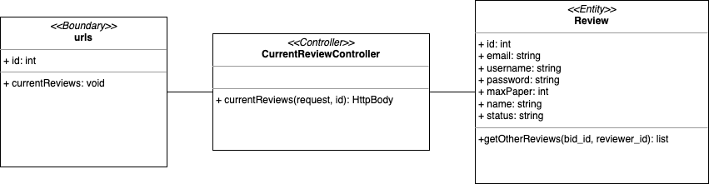

Sequence Diagram

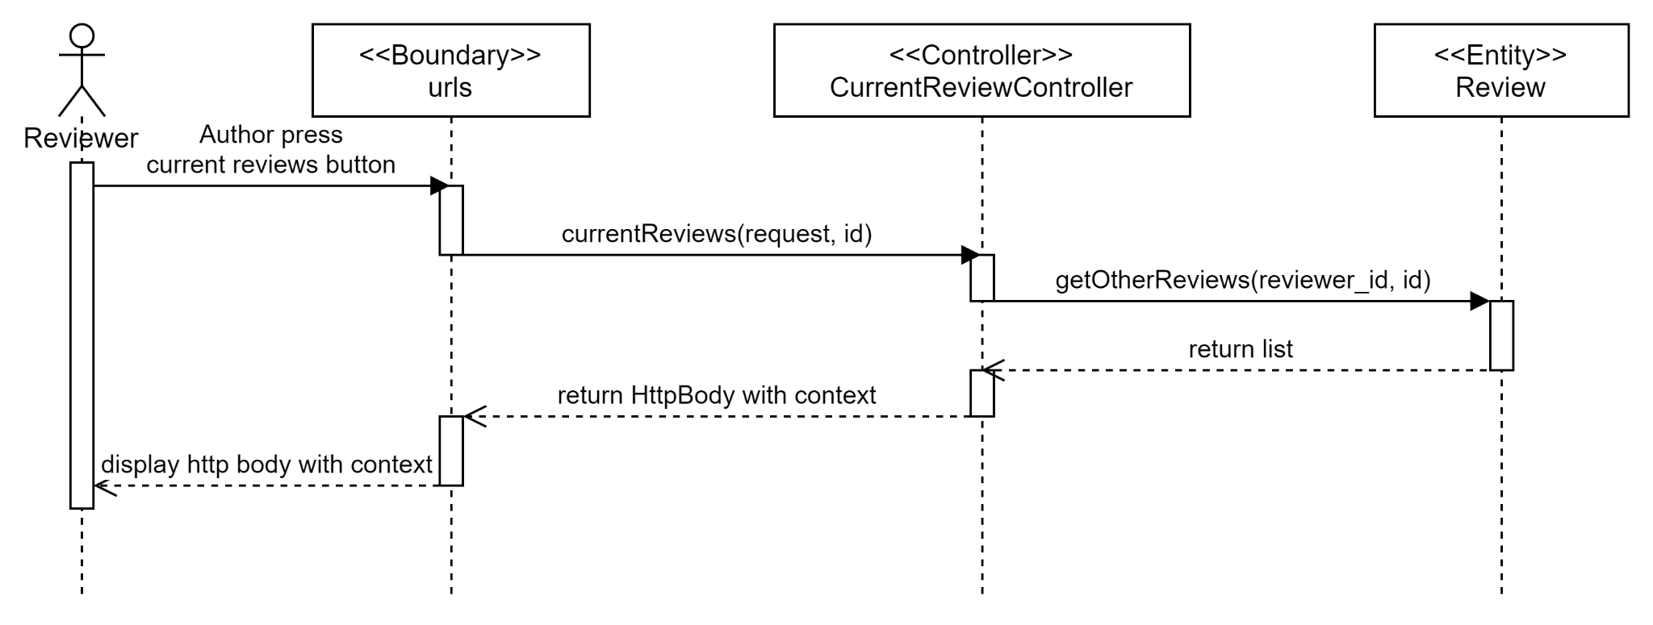

Test cases

### 

### #23 As a reviewer, I want to edit my own review so that I can edit my review accordingly.

Use Case Description

|  |  |
| --- | --- |
| Use Case ID | 23 |
| Use Case Name | Edit my own review |
| Description | Reviewers are able to edit their review for the respective paper that they have reviewed. |
| Actor(s) | Reviewer |
| Trigger | Reviewer wants to edit the review that they made. |
| Pre-existing condition | 1. Reviewer has made a review. 2. Reviewer view reviewed papers and is on paper content page. |
| Basic Flow | 1. Reviewer clicks the edit button. 2. System displays edit page. 3. Reviewer updates any necessary field and clicks submit. 4. System will update the review in the database with the updated information. |
| Sub Flow | None. |
| Alternative Flow | None. |

### 

BCE Diagram

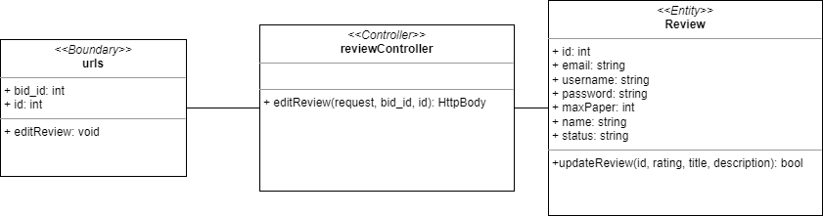

Sequence Diagram

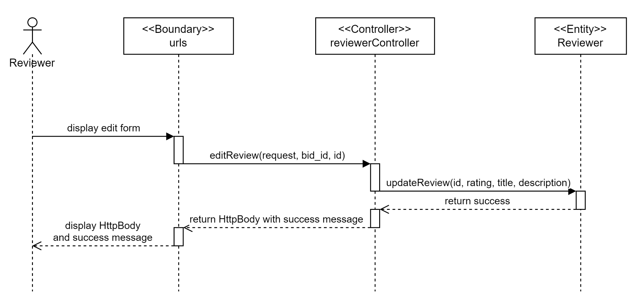

Test cases

### 

### 

### 

### #24 As a reviewer, I want to delete my own review so that I can delete my review if I wish to.

Use Case Description

|  |  |
| --- | --- |
| Use Case ID | 24 |
| Use Case Name | Delete my own review |
| Description | Reviewer delete their own review |
| Actor(s) | Reviewer |
| Trigger | Reviewer wants to delete the review that they made. |
| Pre-existing condition | 1. The Reviewer has submitted a review. 2. The Reviewer view reviewed papers. |
| Basic Flow | 1. The Reviewer clicks the delete button. 2. System delete the review from the database. |
| Sub Flow | None |
| Alternative Flow | None |

### 

BCE Diagram

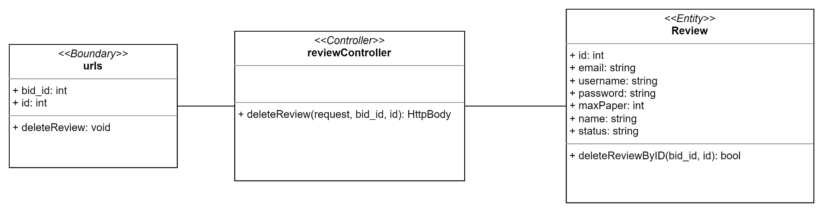

Sequence Diagram

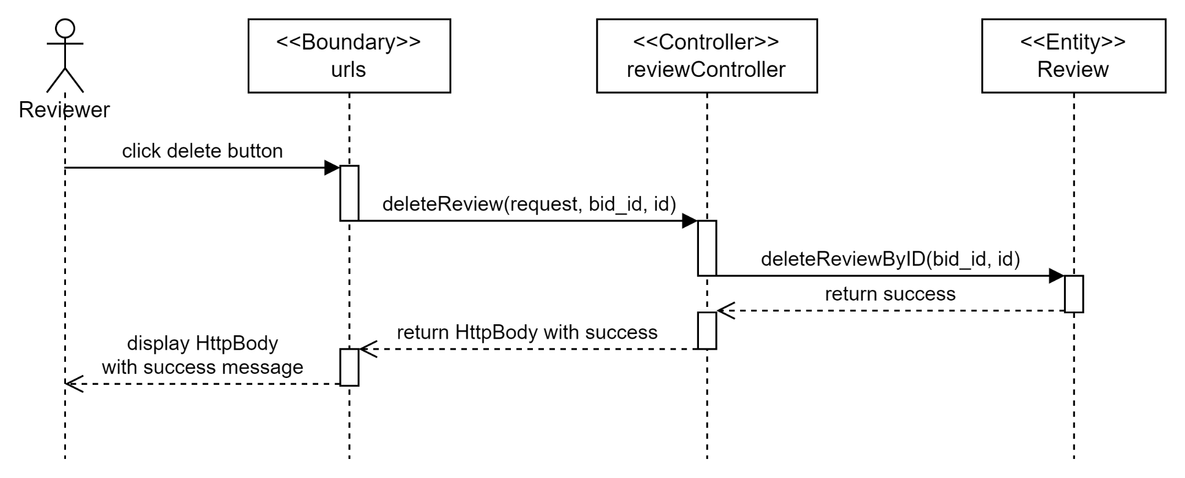

Test cases

### 

### #26 As a reviewer, I want to comment on the review made by other reviewers so that I can share my thoughts with other reviewers.

Use Case Description

|  |  |
| --- | --- |
| Use Case ID | 26 |
| Use Case Name | Comment on the review made by other reviewers |
| Description | Reviewer wants to post a comment on the review made by other reviewers |
| Actor(s) | Reviewer |
| Trigger | The reviewer wants to add comments to the review made by other reviewers. |
| Pre-existing condition | 1. At least one review has been made. 2. Reviewer clicks view comment button on the review. |
| Basic Flow | 1. Reviewer types in the comment and click submit 2. System will create a new comment in the database and save it accordingly. |
| Sub Flow | None. |
| Alternative Flow | None. |

### 

BCE Diagram

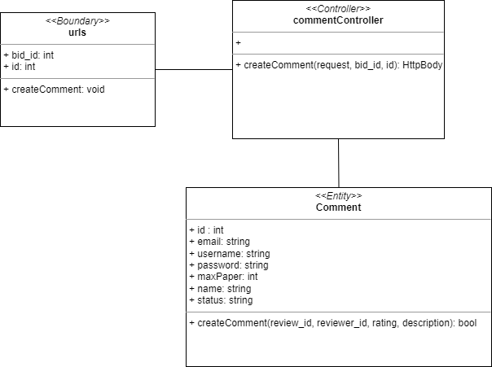

Sequence Diagram

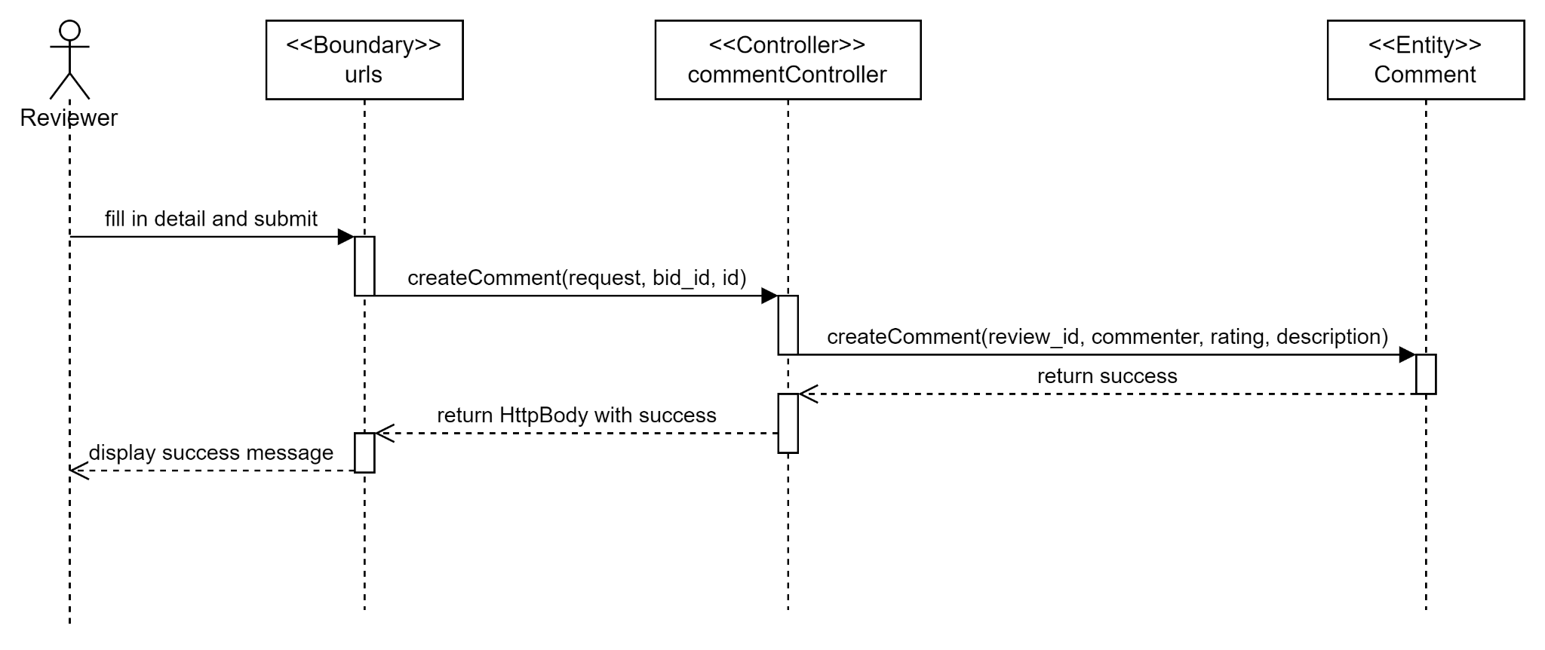

Test cases

### 

### 

### #250 As a reviewer, I want to view comments on the review so that I can view other reviewers’ comments.

Use Case Description

|  |  |
| --- | --- |
| Use Case ID | 250 |
| Use Case Name | View comments on the review |
| Description | Reviewer wants to view comments on the review |
| Actor(s) | Reviewer |
| Trigger | Reviewers wants to view comments on the respective review. |
| Pre-existing condition | 1. Reviewer view review’s content |
| Basic Flow | 1. Reviewer clicks View Comment button. 2. System displays all the comments of the respective reviews. |
| Sub Flow | None. |
| Alternative Flow | None. |

### 

BCE Diagram

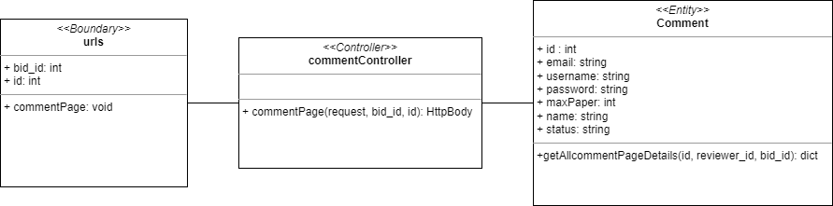

Sequence Diagram

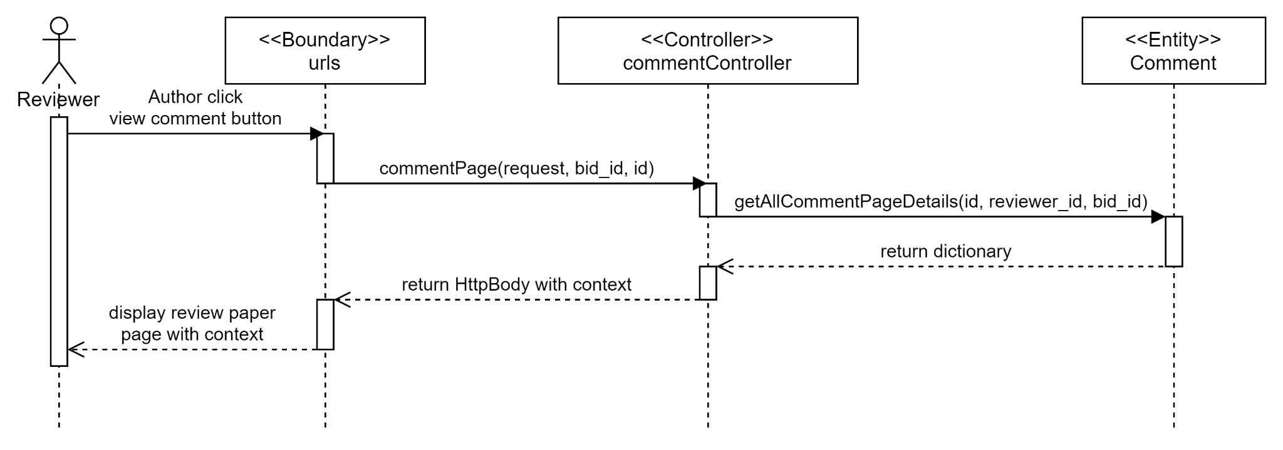

Test cases

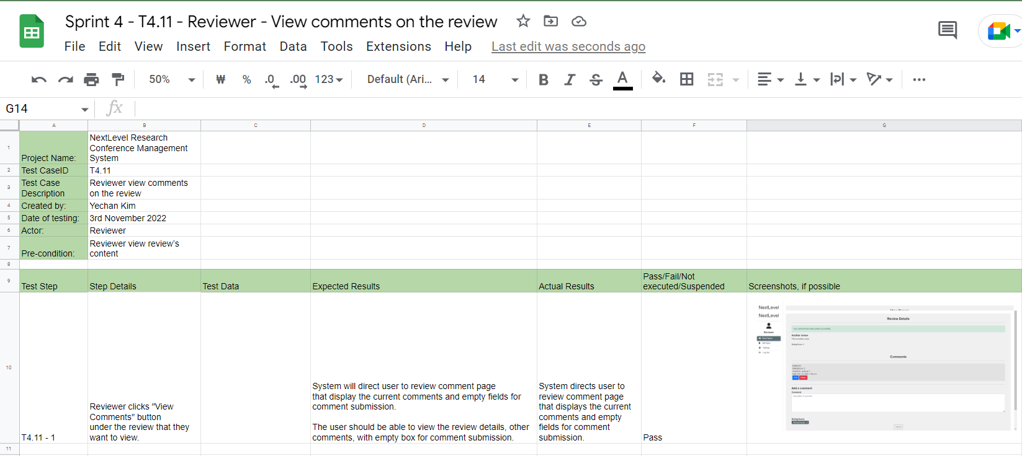

### 

### #256 As a conference chair, I want to read paper’s content so that I can read the paper’s content

Use Case Description

### 

|  |  |
| --- | --- |
| Use Case ID | 256 |
| Use Case Name | Read paper’s content |
| Description | Conference Chair reads the paper content. |
| Actor(s) | Conference Chair |
| Trigger | Conference Chair wants to read the paper before he makes a decision on paper. |
| Pre-existing condition | 1. Authors submit their papers 2. Conference Chair has accepted/rejected at least one paper. 3. Conference Chair is on the Accept/Reject Paper page. |
| Basic Flow | 1. Conference Chair clicks on file name button on any of the paper under accept or reject paper. 2. The system shows the relevant information of the paper, including file name, paper id, topic and the content. |
| Sub Flow | None. |
| Alternative Flow | None. |

### 

BCE Diagram

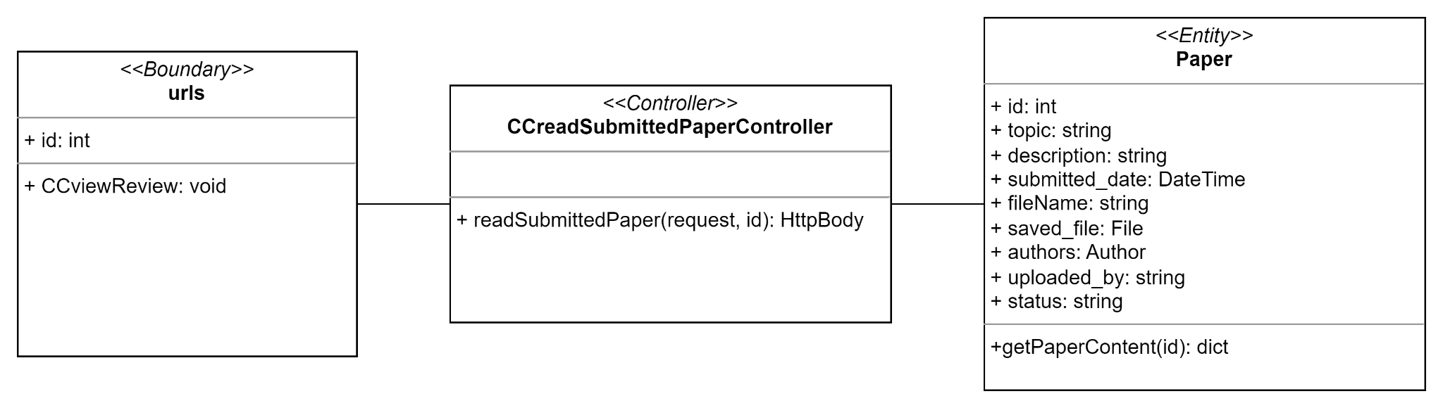

Sequence Diagram

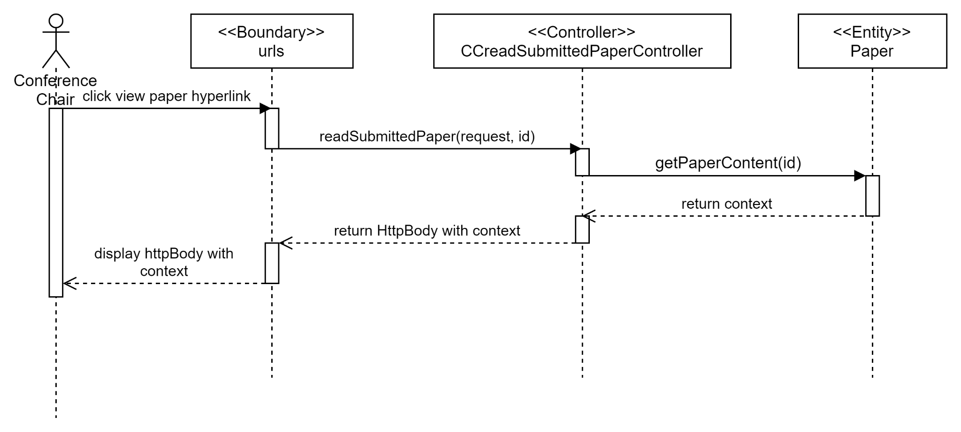

Test cases

### 

### #30 As a conference chair, I want to view all undecided papers so that I can view all undecided papers and decide on them.

Use Case Description

|  |  |
| --- | --- |
| Use Case ID | 30 |
| Use Case Name | View all undecided papers |
| Description | Conference Chair views the list of reviews from different reviewers on different papers. |
| Actor(s) | Conference Chair |
| Trigger | Conference Chair wants to view the list of reviews and ratings. |
| Pre-existing condition | 1. Authors submit their papers |
| Basic Flow | 1. Conference Chair clicks “Accept/Reject Paper” button. 2. The system shows the all undecided papers under accept or reject paper table. |
| Sub Flow | None. |
| Alternative Flow | None. |

### 

BCE Diagram

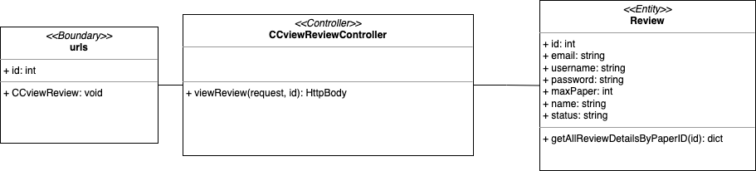

Sequence Diagram

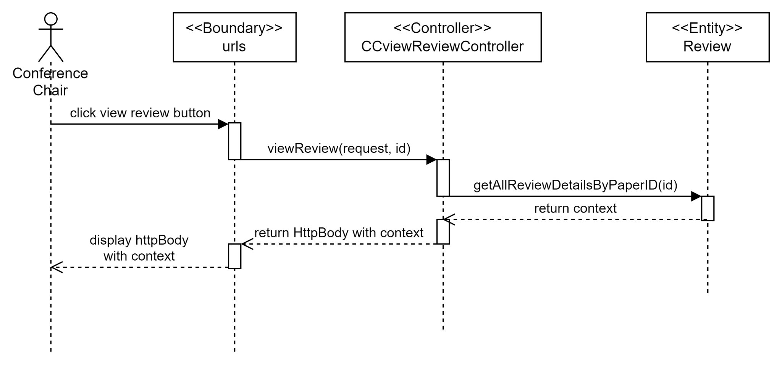

Test cases

### 

### #254 As a conference chair, I want to read the reviews’ content so that I can make a decision.

Use Case Description

### 

|  |  |
| --- | --- |
| Use Case ID | 254 |
| Use Case Name | Read review’s content |
| Description | Conference Chair views the review’s content made by the reviewers which will aid the decision making process on accepting/rejecting the paper. |
| Actor(s) | Conference Chair |
| Trigger | Conference Chair wants to make a decision whether to accept or reject the paper by viewing the paper reviews and rating. |
| Pre-existing condition | 1. Authors submit their papers 2. Papers are allocated to reviewers 3. Reviewers submit their review and rating 4. Conference Chair is on the Accept/Reject Paper page. |
| Basic Flow | 1. Conference Chair clicks “View Review” button. 2. The system shows the relevant information of the paper and reviews. |
| Sub Flow | None. |
| Alternative Flow | None. |

### 

BCE Diagram

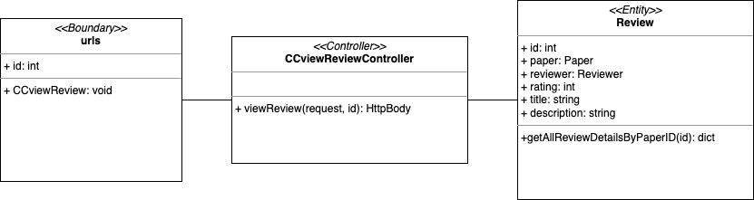

Sequence Diagram

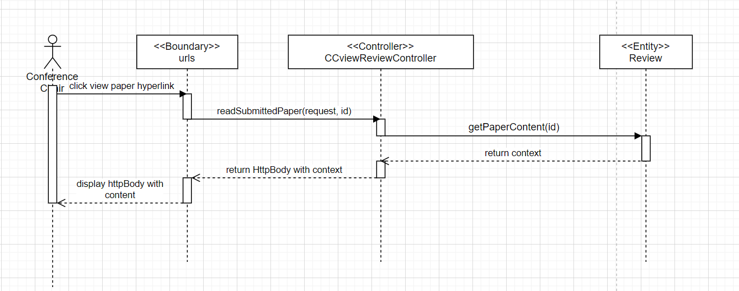

Test cases

### 

### 

### #31 As a conference chair, I want to accept paper so that the author can be marked pass.

Use Case Description

|  |  |
| --- | --- |
| Use Case ID | 31 |
| Use Case Name | Accept paper |
| Description | Conference Chair decides whether the paper should be accepted based on the ratings and reviews by the reviewers |
| Actor(s) | Conference Chair |
| Trigger | Conference Chair wants to make a decision whether to accept or reject the paper. |
| Pre-existing condition | 1. Authors submit their papers 2. Papers are allocated to reviewers 3. Reviewers submit their review and rating 4. Conference Chair is on the Accept/Reject Paper page. |
| Basic Flow | 1. Conference Chair chooses “Reject” button on one of the paper under accept or reject paper table. 2. The system will display success message for paper decision and move it to the decisions table. At the same time, it will notify the authors of the decision result via email. |
| Sub Flow | None. |
| Alternative Flow | None. |

### 

BCE Diagram

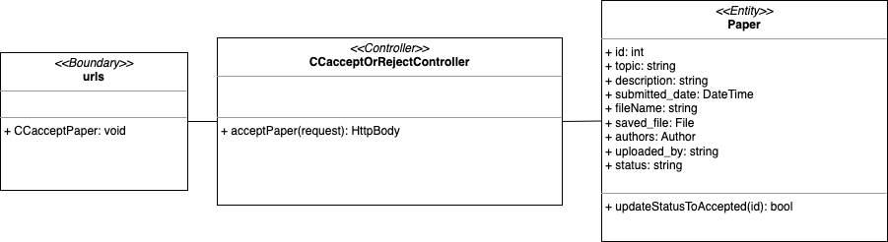

Sequence Diagram

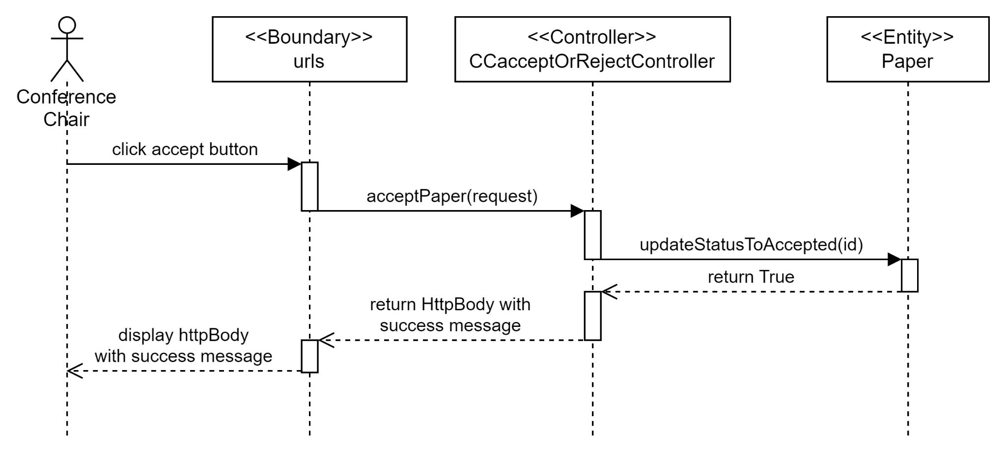

Test cases

### 

### #32 As a conference chair, I want to reject paper so that the author can be marked fail.

Use Case Description

### 

|  |  |
| --- | --- |
| Use Case ID | 32 |
| Use Case Name | Reject paper |
| Description | Conference Chair decides whether the paper should be rejected based on the ratings and reviews by the reviewers |
| Actor(s) | Conference Chair, Reviewer |
| Trigger | Conference Chair wants to make a decision whether to accept or reject the paper. |
| Pre-existing condition | 1. Authors submit their papers 2. Papers are allocated to reviewers 3. Reviewers submit their review and rating 4. Conference Chair is on the Accept/Reject Paper page. |
| Basic Flow | 1. Conference Chair chooses “Reject” button on one of the paper under accept or reject paper table. 2. The system will display success message for paper decision and move it to the decisions table. At the same time, it will notify the authors of the decision result via email. |
| Sub Flow | None. |
| Alternative Flow | None. |

BCE Diagram

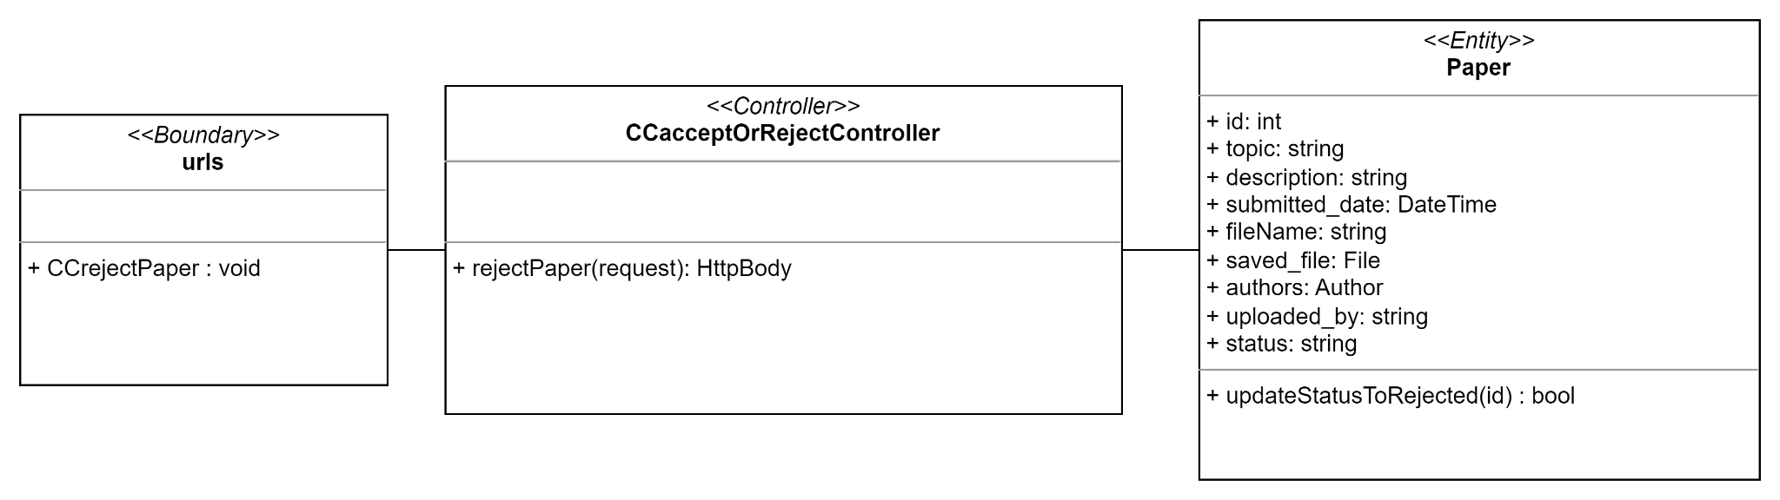

Sequence Diagram

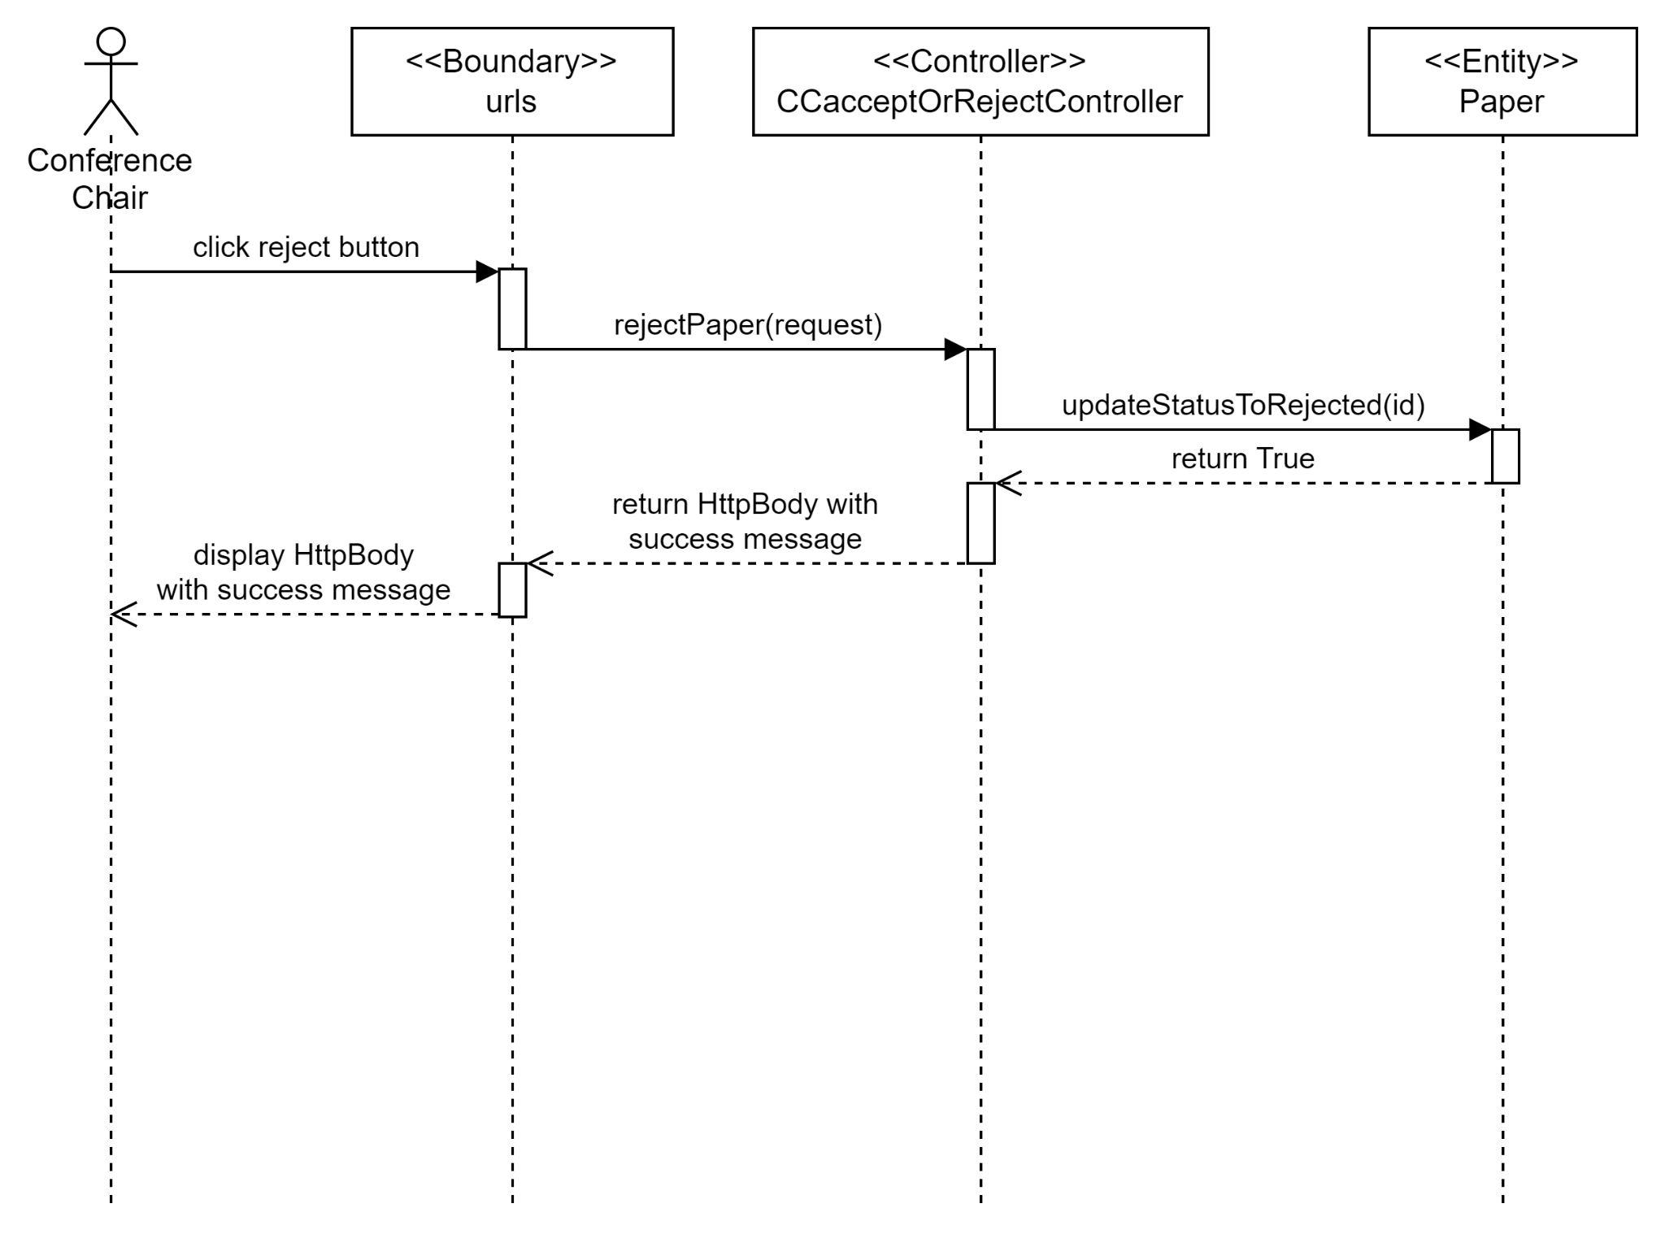

Test cases

### 

### 

### #33 As a conference chair, I want to view list of accepted and rejected papers so that I can check the list.

Use Case Description

### 

|  |  |
| --- | --- |
| Use Case ID | 33 |
| Use Case Name | View list of accepted and rejected papers |
| Description | Conference Chair checks the list of papers that they have accepted or rejected. |
| Actor(s) | Conference Chair |
| Trigger | Conference Chair wants to check on the paper decisions. |
| Pre-existing condition | 1. Authors submit their papers 2. Papers are allocated to reviewers 3. Reviewers submit their review and rating. 4. Conference Chair has accepted/rejected at least one paper. |
| Basic Flow | 1. Conference Chair clicks “Accept/Reject Paper” button. 2. The system shows the relevant information of the paper and decision made under decisions table. |
| Sub Flow | None. |
| Alternative Flow | None. |

BCE Diagram

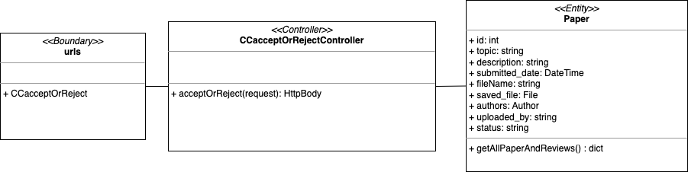

Sequence Diagram

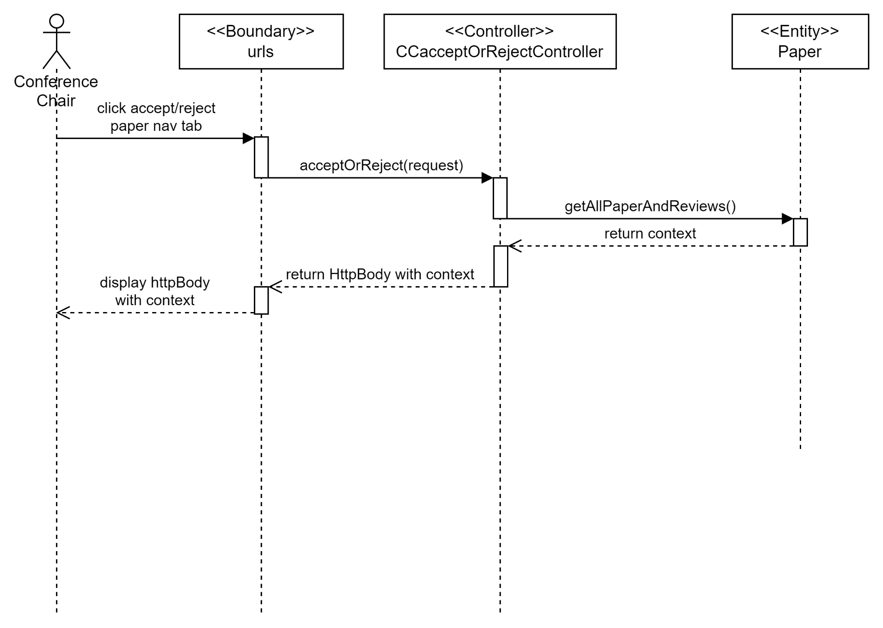

Test cases

#### 

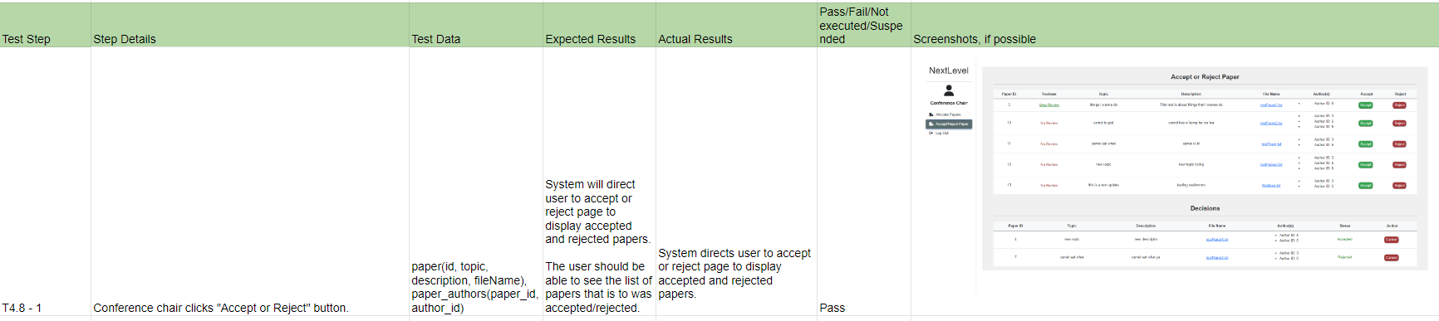

### 

## 

## **SPRINT 5**

### Taiga

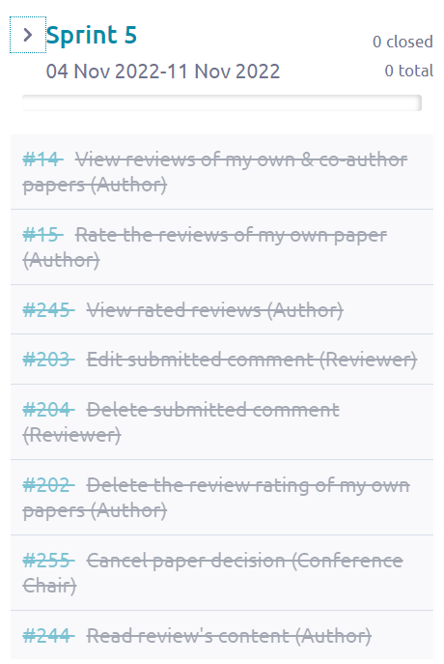

From the screenshots above, we can see that Sprint 5 started from 04 November 2022 to 11 November 2022. There are in total 8 use cases made in Sprint 5 and all of these use cases were closed after Sprint 5 ended which means that all the development process from diagrams, software developments and testing for those 8 use cases were done in Sprint 5.

### Class Diagram

### 

### 

### Data Persistent

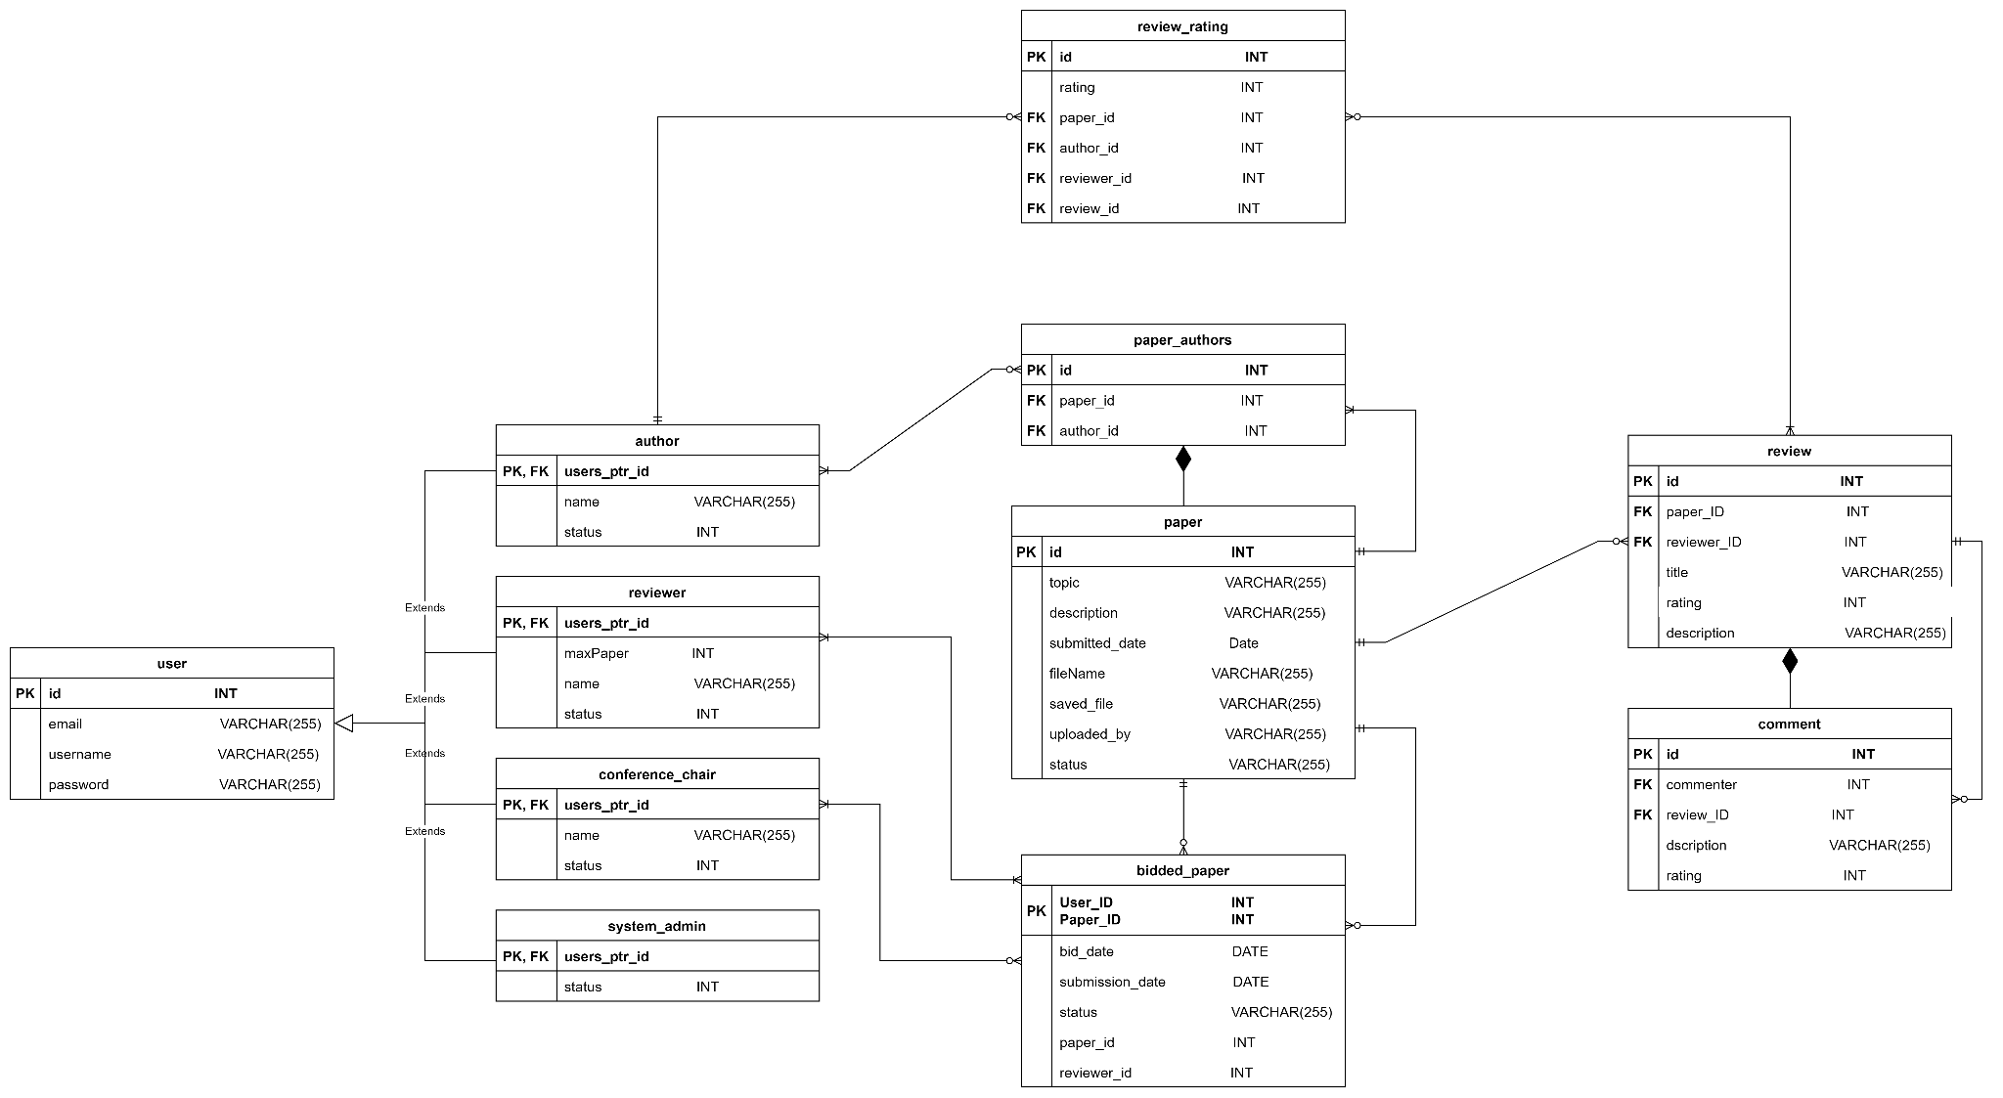

### 

### 

### #203 As a reviewer, I want to edit submitted comment so that I can edit/update my submitted comment for other reviewer’s review.

Use Case Description

### 

|  |  |
| --- | --- |
| Use Case ID | 203 |
| Use Case Name | Edit submitted comment |
| Description | Reviewer can edit their own submitted comment for other reviewer’s review |
| Actor(s) | Reviewer |
| Trigger | Reviewer wants to edit their own submitted comment for other reviewer’s review |
| Pre-existing condition | 1. Reviewer has made a comment on the review made by others. 2. Reviewer view comments of the review |
| Basic Flow | 1. Reviewer click edit button. 2. System display a pop-up that prompt user to input the new edit. 3. Reviewer input all the necessary edits and click submit button. 4. System save the updated/edited comment on the other reviewer’s. review |
| Sub Flow | None. |
| Alternative Flow | None. |

BCE Diagram

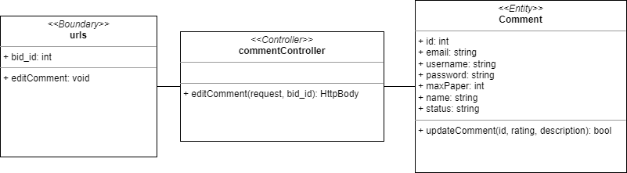

Sequence Diagram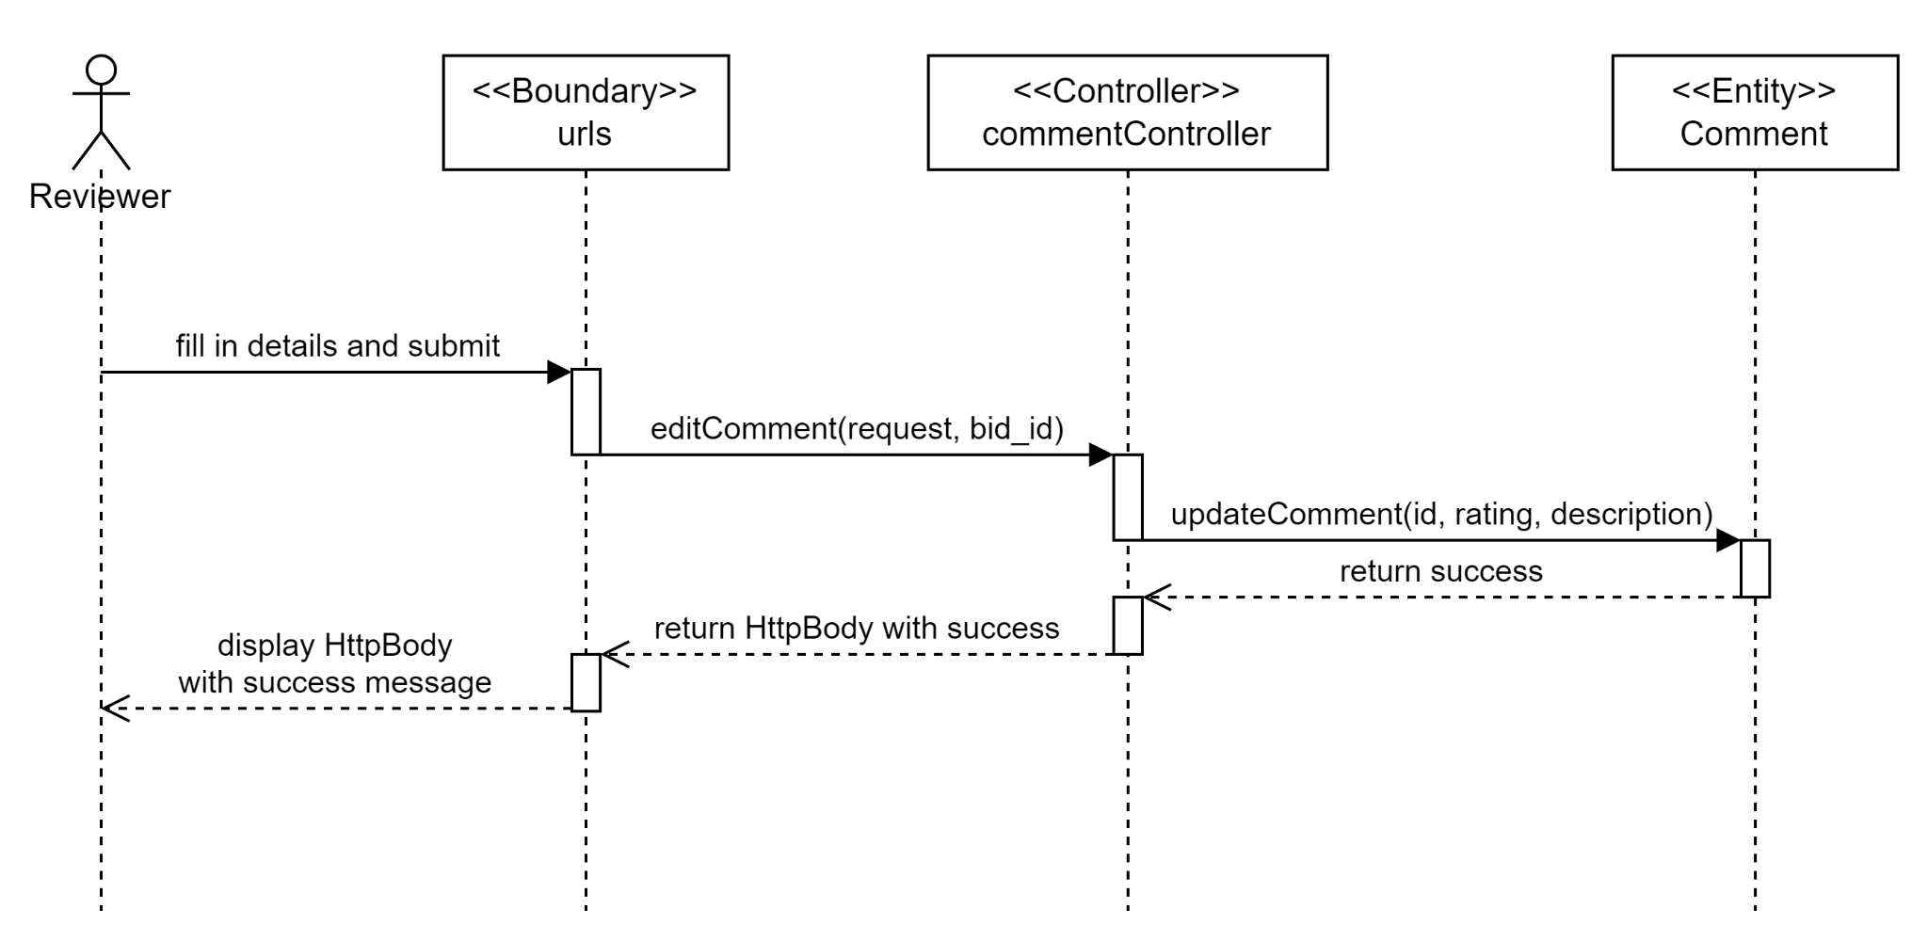

Test cases

### 

### 

### #204 As a reviewer, I want to delete submitted comment so that I can delete my submitted comment for other reviewer’s review.

Use Case Description

### 

|  |  |
| --- | --- |
| Use Case ID | 204 |
| Use Case Name | Delete submitted comment |
| Description | Reviewer can delete the submitted comment for other reviewer review |
| Actor(s) | Reviewer |
| Trigger | Click delete |
| Pre-existing condition | 1. Reviewer has made a comment on the review made by others. 2. Reviewer view comments of the review |
| Basic Flow | 1. Reviewer click delete button under the submitted comment 2. System delete the comment of the review in the database |
| Sub Flow | None. |
| Alternative Flow | None. |

## 

BCE Diagram

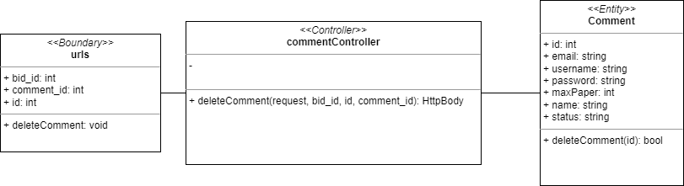

Sequence Diagram

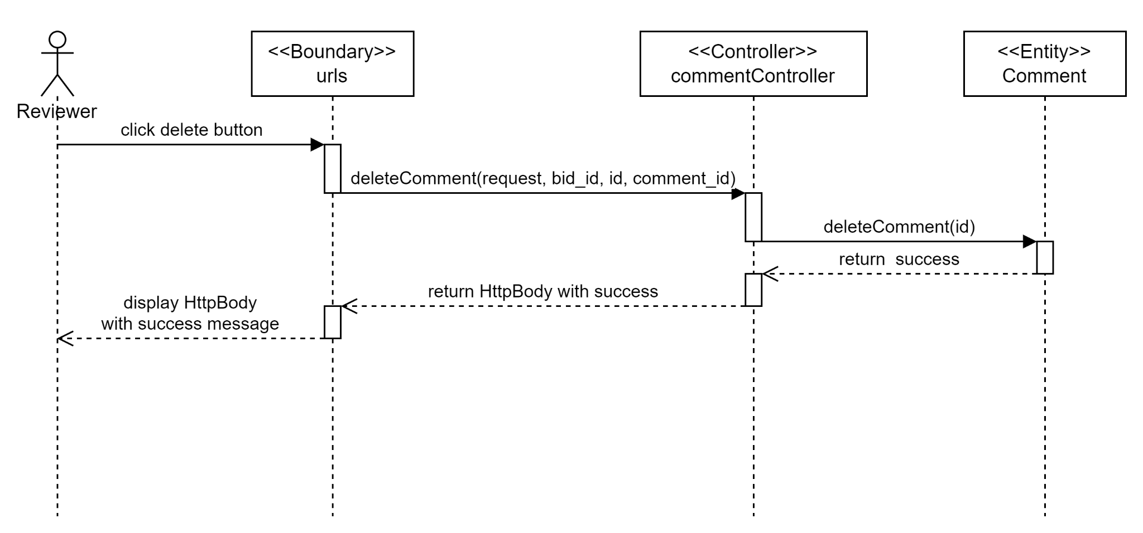

Test cases

### 

### #14 As an author, I want to view reviews of my own & co-author papers so that I can view a list of reviews on reviewers’ opinions.

Use Case Description

### 

|  |  |
| --- | --- |
| Use Case ID | 14 |
| Use Case Name | View reviews of my own & co-author papers |
| Description | The Author can view the reviews of their submitted paper that they authored or co-authored. |
| Actor(s) | Author |
| Trigger | Author wants to see the reviews of the paper that they authored or co-authored. |
| Pre-existing condition | 1. Logged in as author 2. Author should submit at least one paper. 3. Reviewer bade for the paper. 4. Conference chair allocated paper to the reviewer. 5. The reviewer submitted review and score on the paper. |
| Basic Flow | 1. Author clicks Rate Review button 2. The system will show a list of papers that they authored or co-authored and have been reviewed. |
| Sub Flow | none |
| Alternative Flow | 2a. If submitted paper(s) haven’t got any review, the paper will not show up in the list. |

### 

BCE Diagram

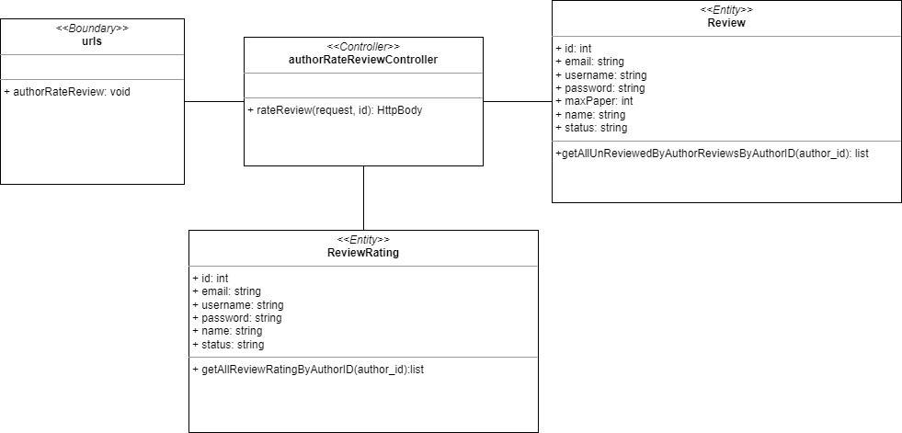

Sequence Diagram

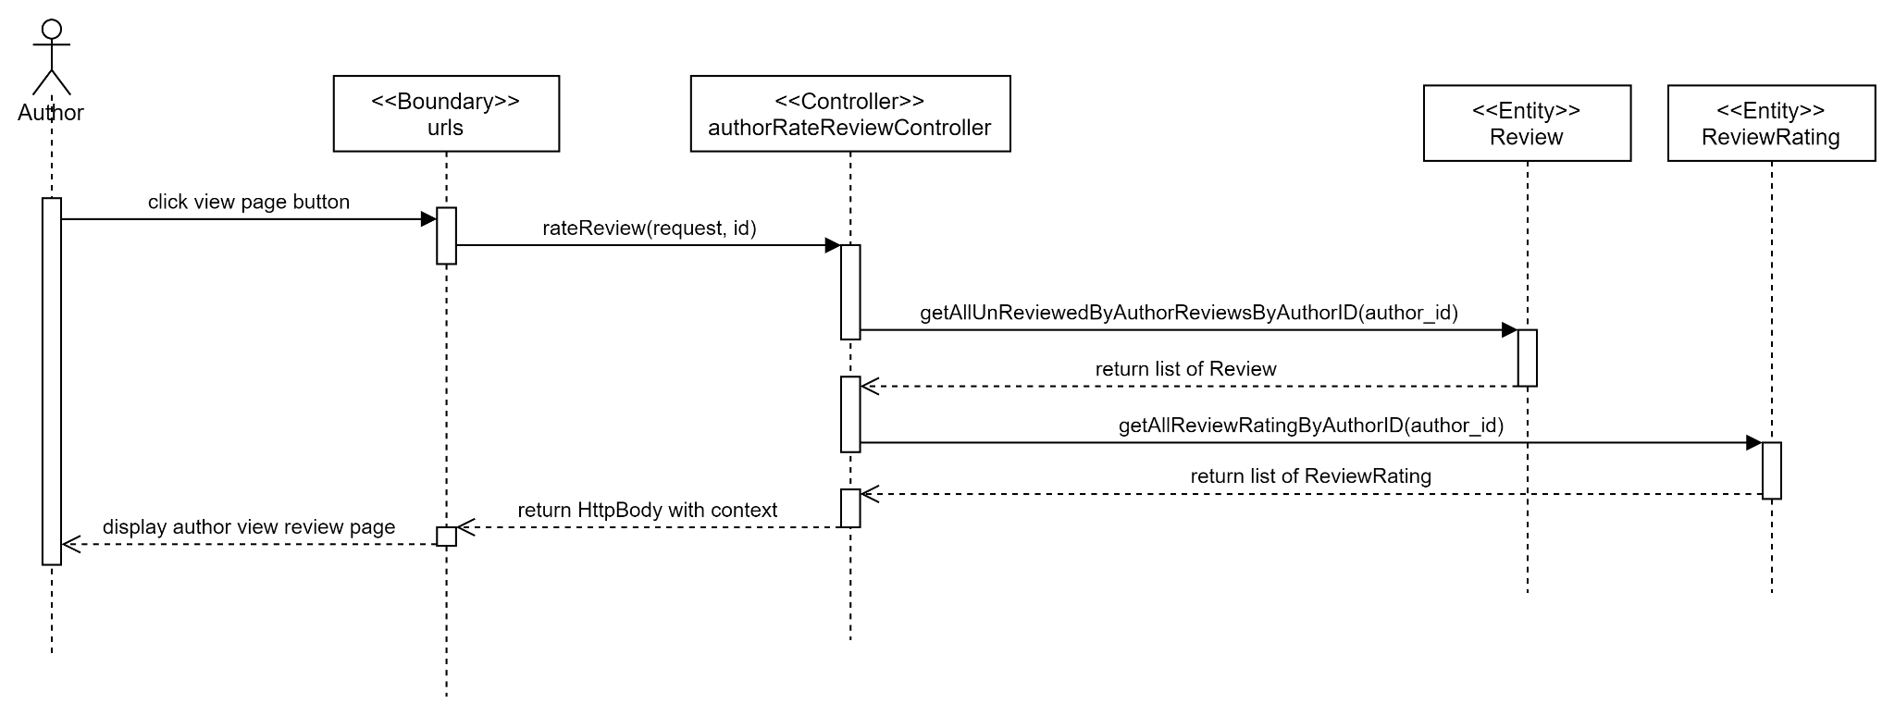

Test cases

### 

### 

### 

### #15 As an author, I want to rate the reviews of my own papers so that I can rate the reviews on my submitted paper.

Use Case Description

|  |  |
| --- | --- |
| Use Case ID | 15 |
| Use Case Name | Rate the reviews of my own papers. |
| Description | Author can rate the reviews of his own papers. |
| Actor(s) | Author |
| Trigger | Author wants to rate the reviews of his own paper. |
| Pre-existing condition | 1. Logged in as Author. 2. Author has at least one paper submitted in the system. 3. The paper should already be reviewed by the reviewer. 4. Author clicks the rate review button. 5. Author view reviews of their own papers. |
| Basic Flow | 1. Author select one of the options in the rating drop-down list of the review and clicks save. 2. System creates a review rating with the respective information and save it in database. |
| Sub Flow | None. |
| Alternative Flow | None. |

### 

BCE Diagram

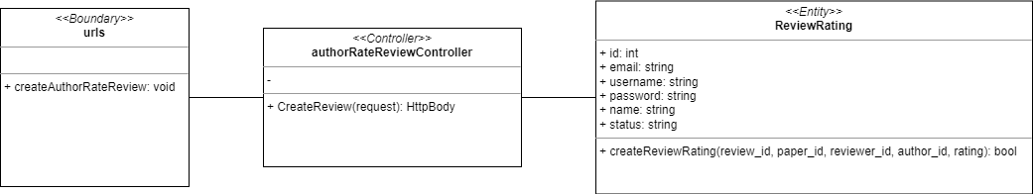

Sequence Diagram

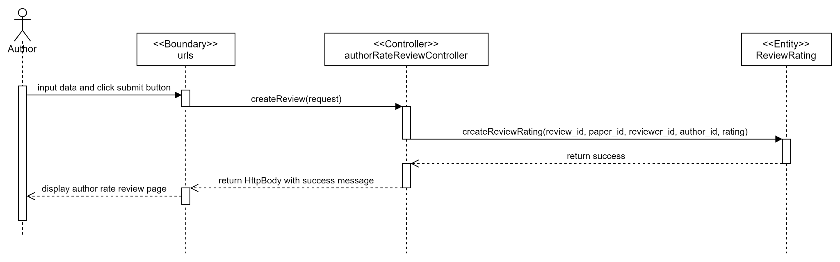

Test cases

### 

### 

### 

### #245 As an author, I want to view rated reviews so that I can see my ratings on paper reviews.

Use Case Description

|  |  |
| --- | --- |
| Use Case ID | 245 |
| Use Case Name | View rated reviews |
| Description | Author can view list of rated reviews |
| Actor(s) | Author |
| Trigger | Author wants to view the rated reviews. |
| Pre-existing condition | 1. Logged in as Author. 2. Author has at least one paper submitted in the system. 3. The paper should already be reviewed by the reviewer. 4. Author has rated the review. |
| Basic Flow | 1. Author clicks the Rate Review button. 2. System display all the review that has been rated with rating. |
| Sub Flow | None. |
| Alternative Flow | None. |

BCE Diagram

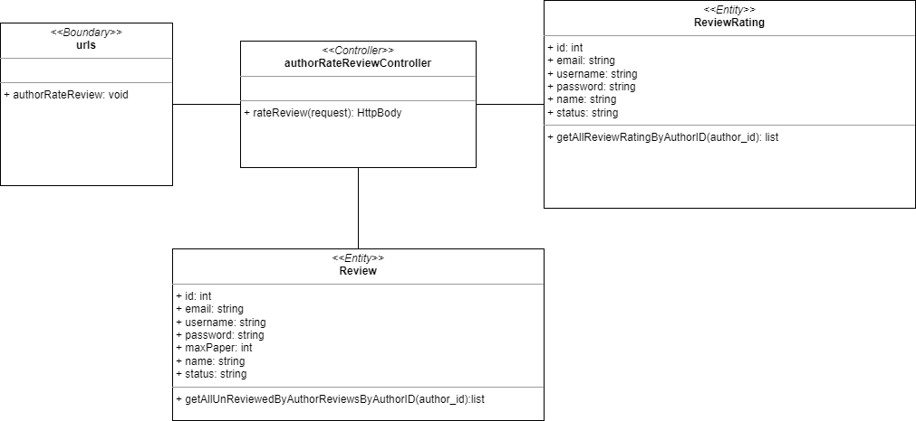

Sequence Diagram

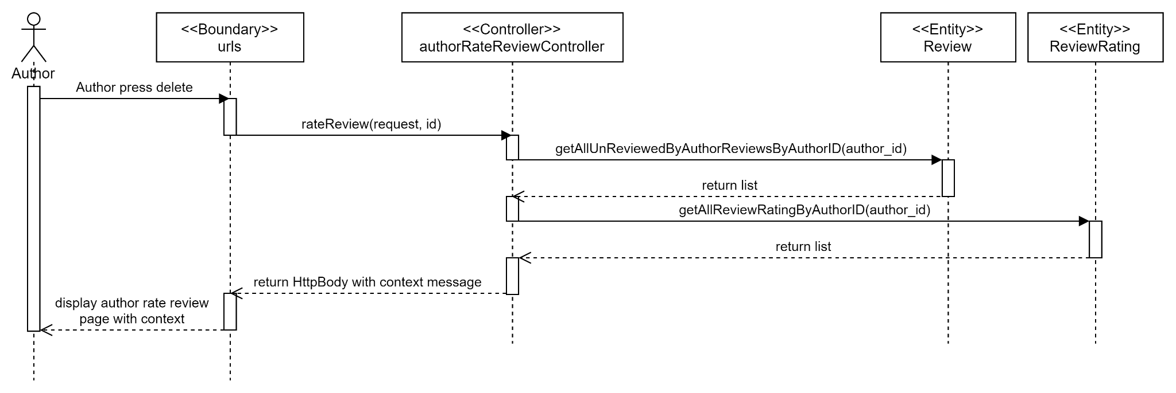

Test cases

### 

### #202 As an author, I want to delete my rating of the reviews on my own papers so that I can delete my own rating for the reviews on my submitted paper.

Use Case Description

### 

|  |  |
| --- | --- |
| Use Case ID | 202 |
| Use Case Name | Delete the review rating of my own papers |
| Description | Author can delete the review rating that they have made. |
| Actor(s) | Author |
| Trigger | Author wants to remove their rating. |
| Pre-existing condition | 1. Logged in as Author. 2. Author has at least one paper submitted in the system. 3. The paper should already be reviewed by the reviewer. 4. Author has rated the reviews of their own papers. 5. Author clicks the rate review button. |
| Basic Flow | 1. Author clicks the delete button on the respective review rating. 2. System deletes the review rating from the database. |
| Sub Flow | None. |
| Alternative Flow | None. |

BCE Diagram

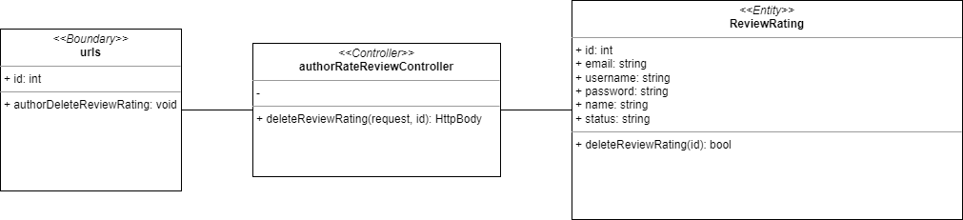

Sequence Diagram

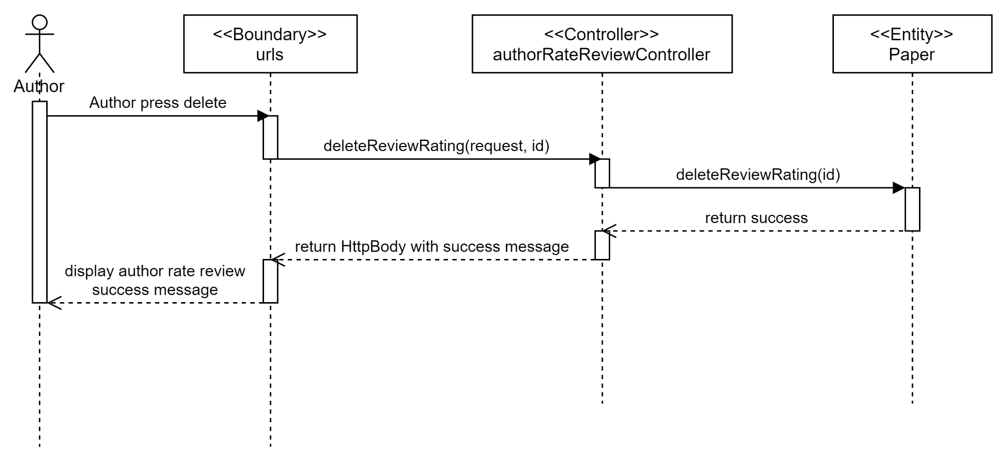

Test cases

### 

### #255 As a conference chair, I want to cancel paper decision so that I can redecide whether to accept or reject the papers.

Use Case Description

### 

|  |  |
| --- | --- |
| Use Case ID | 255 |
| Use Case Name | Cancel paper decision |
| Description | Conference Chair cancels the paper decision. |
| Actor(s) | Conference Chair |
| Trigger | Conference Chair wants to cancel his decision on the paper. |
| Pre-existing condition | 1. Authors submit their papers 2. Papers are allocated to reviewers 3. Reviewers submit their review and rating. 4. Conference Chair has accepted/rejected at least one paper 5. Conference Chair is on the Accept/Reject Paper page. |
| Basic Flow | 1. Conference Chair clicks on “Cancel” button on any of the paper under decisions table. 2. The system will display success message for paper decision cancellation and move it to the accept or reject paper table. At the same time, it will notify the authors of the decision cancellation result via email. |
| Sub Flow | None. |
| Alternative Flow | None. |

### 

BCE Diagram

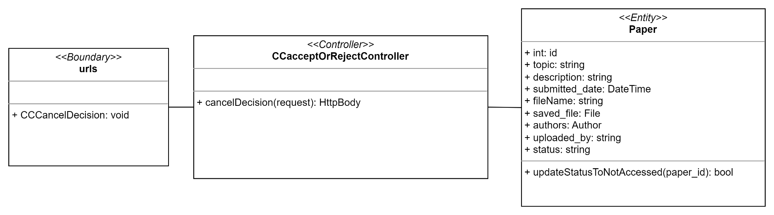

Sequence Diagram

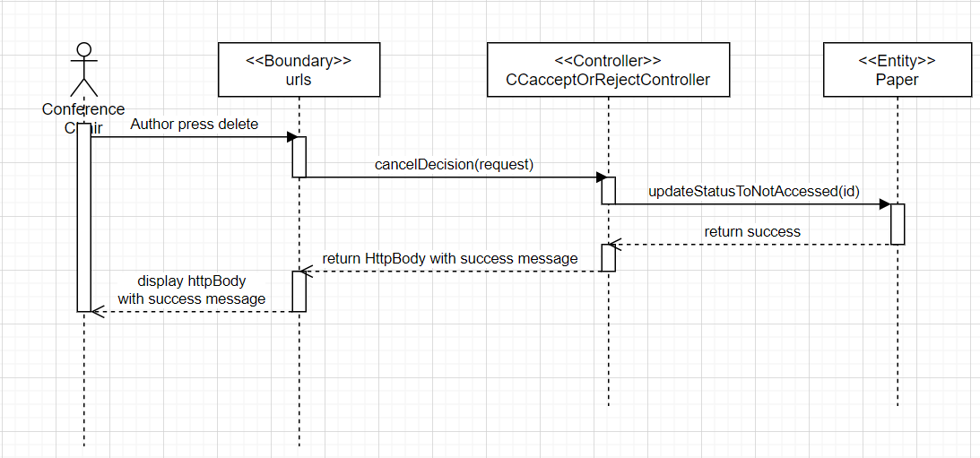

Test cases

### 

### #244 As an author, I want to read review’s content so that I can read the review on my submitted paper

Use Case Description

|  |  |
| --- | --- |
| Use Case ID | 244 |
| Use Case Name | Read Review’s content |
| Description | Author can read review’s content |
| Actor(s) | Author |
| Trigger | Author wants to read review’s content |
| Pre-existing condition | 1. Author should submit at least one paper. 2. Reviewer bade for the paper. 3. Conference chair allocated paper to the reviewer. 4. The reviewer submitted review on the paper. 5. Author clicks Rate Review button |
| Basic Flow | 1. Author clicks View Review button 2. System displays review content. |
| Sub Flow | None. |
| Alternative Flow | None. |

### 

BCE Diagram

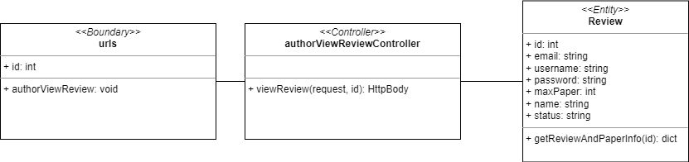

Sequence Diagram

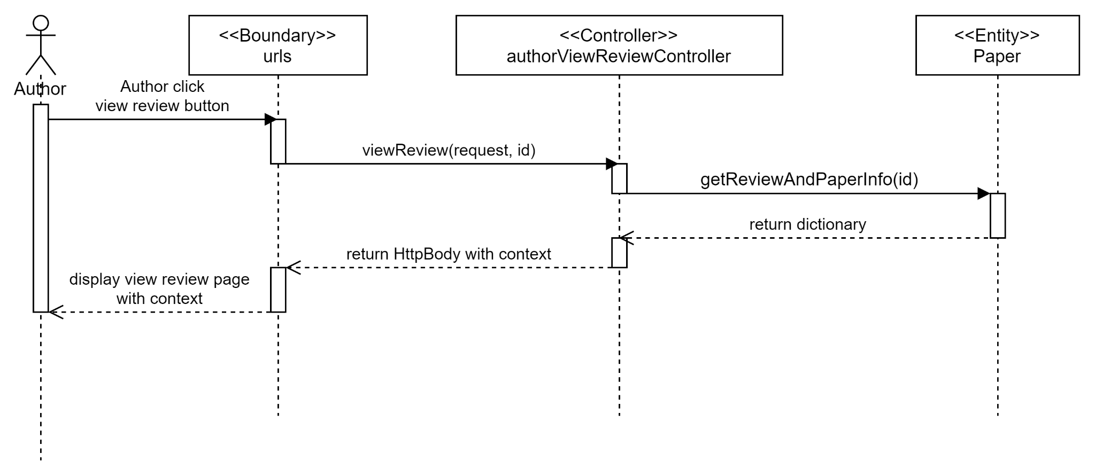

Test cases

#### 

## 

## SPRINT 6

### Taiga

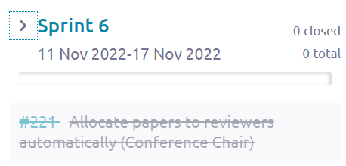

From the screenshot above, we can see that Sprint 6 started from 11 November 2022 to 17 November 2022. There are in total 1 use case made in Sprint 6 and all of these use cases were closed after Sprint 6 ended which means that all the development process from diagrams, software developments and testing for those 1 use case was done in Sprint 6.

### Class Diagram

### 

### 

### Data Persistent

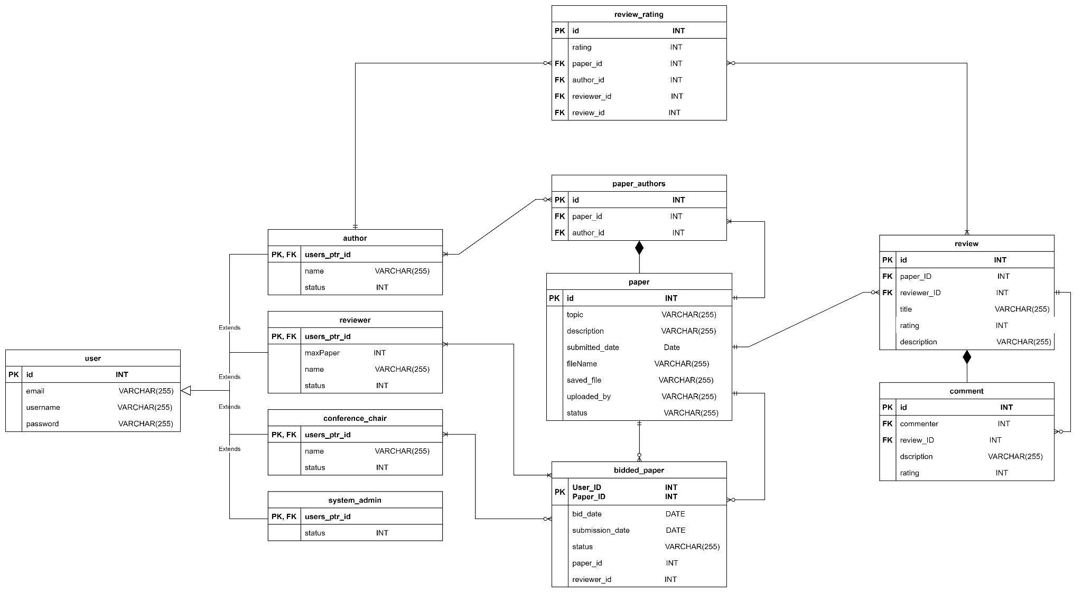

### 

### 

### #221 As a conference chair, I want to allocate papers to reviewers automatically so that I can quickly allocate the papers to the reviewers.

Use Case Description

|  |  |
| --- | --- |
| Use Case ID | 221 |
| Use Case Name | Allocate papers to reviewers automatically |
| Description | Conference chair clicks Allocate Automatically button to allocate all bidded papers to their respective reviewers automatically and the system will allocate them automatically. |
| Actor(s) | Conference chair |
| Trigger | Conference chair wants to quickly allocate papers to reviewers |
| Pre-existing condition | 1. Any of the authors submitted at least one paper. 2. Reviewers should have put in bidding. 3. Conference Chair is on the Allocate Papers page. |
| Basic Flow | 1. Conference chair clicks “Allocate Automatically” button. 2. The system will verify reviewer’s workload to perform the allocation process automatically and display a success message. |
| Sub Flow | None. |
| Alternative Flow | None. |

### 

BCE Diagram

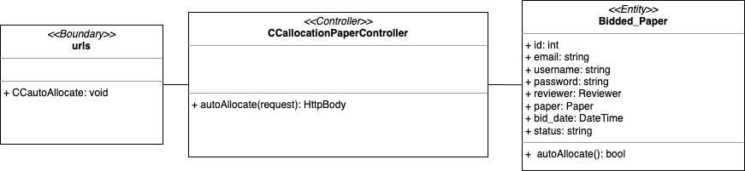

Sequence Diagram

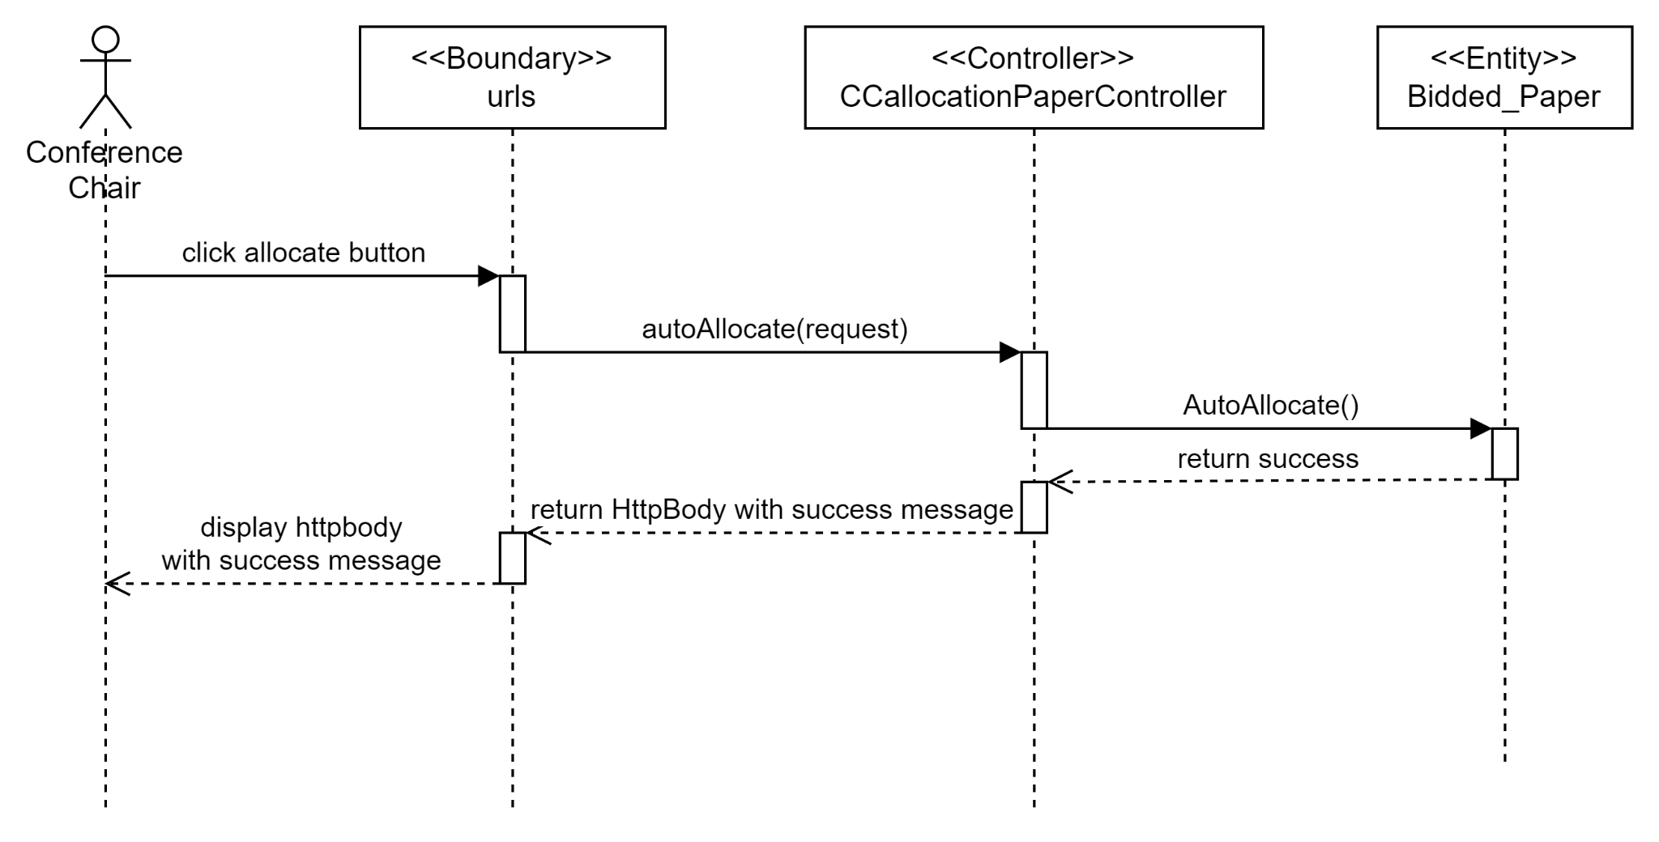

Test cases

## 

## Wireframe for Index / Login

## 

## Wireframe for Author

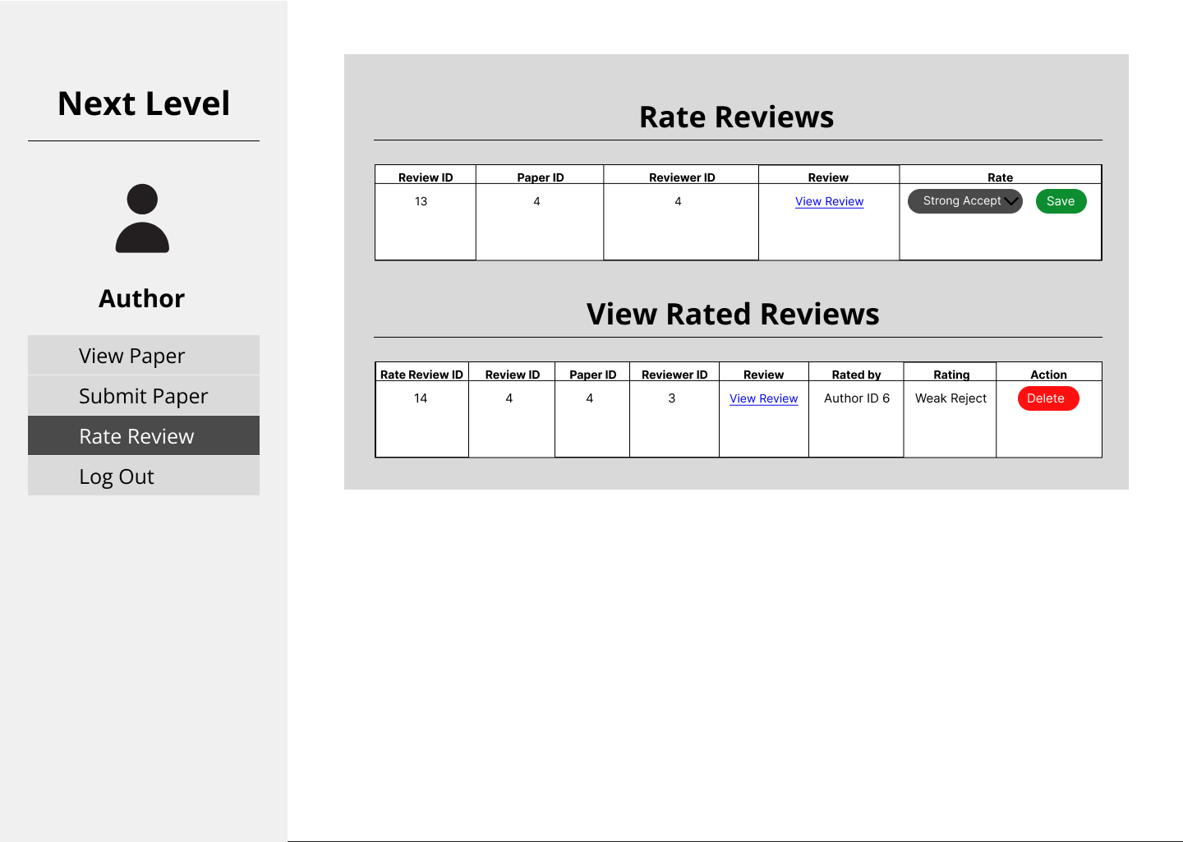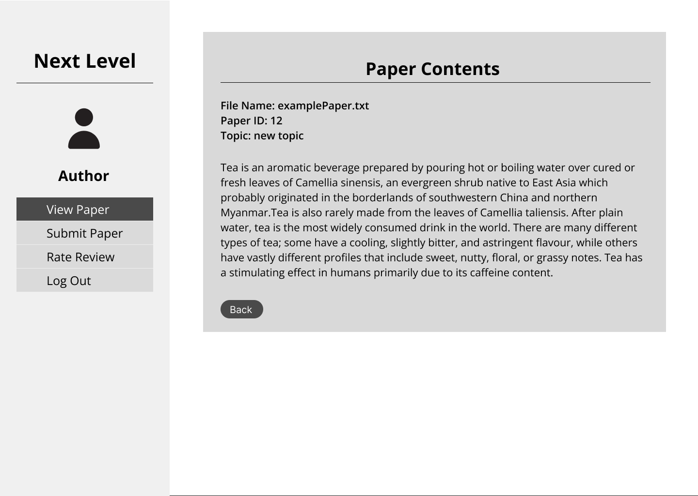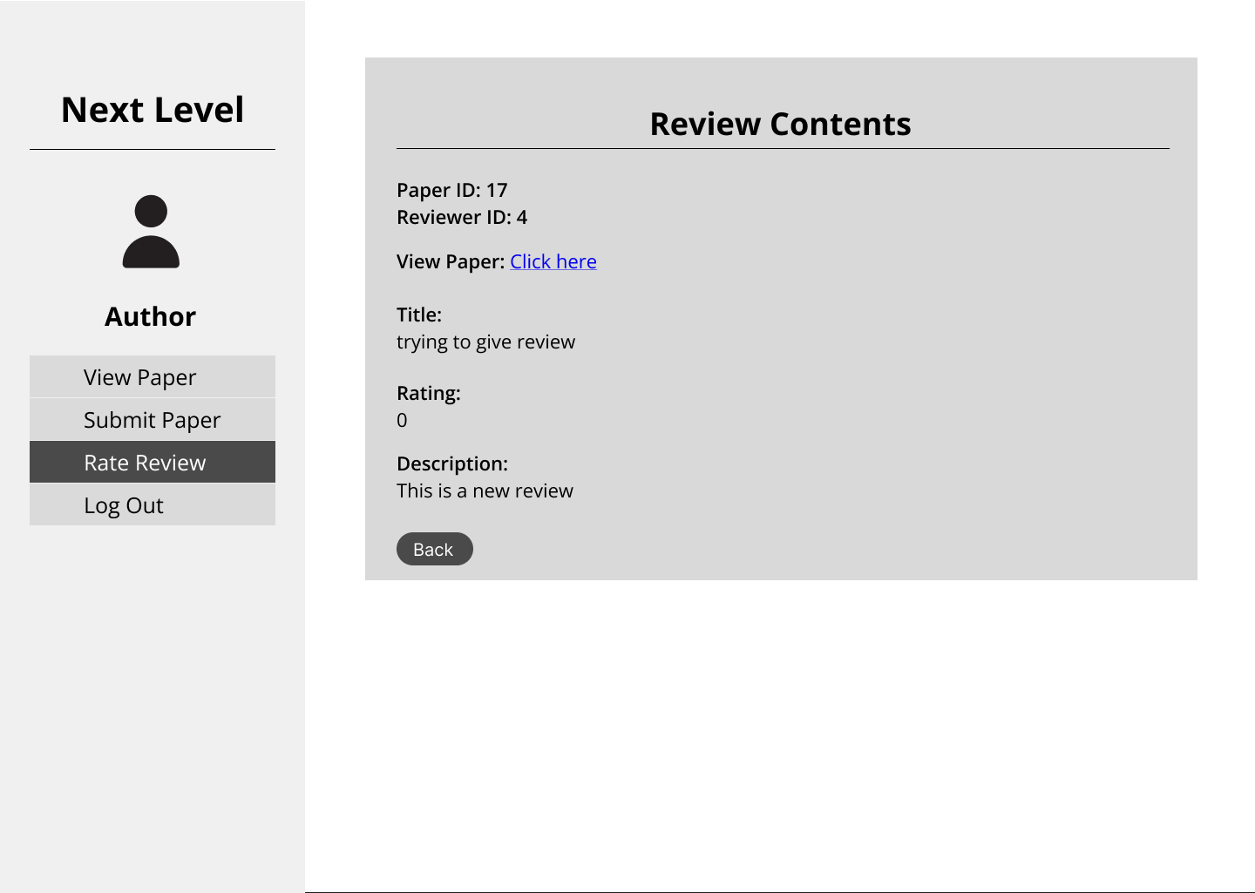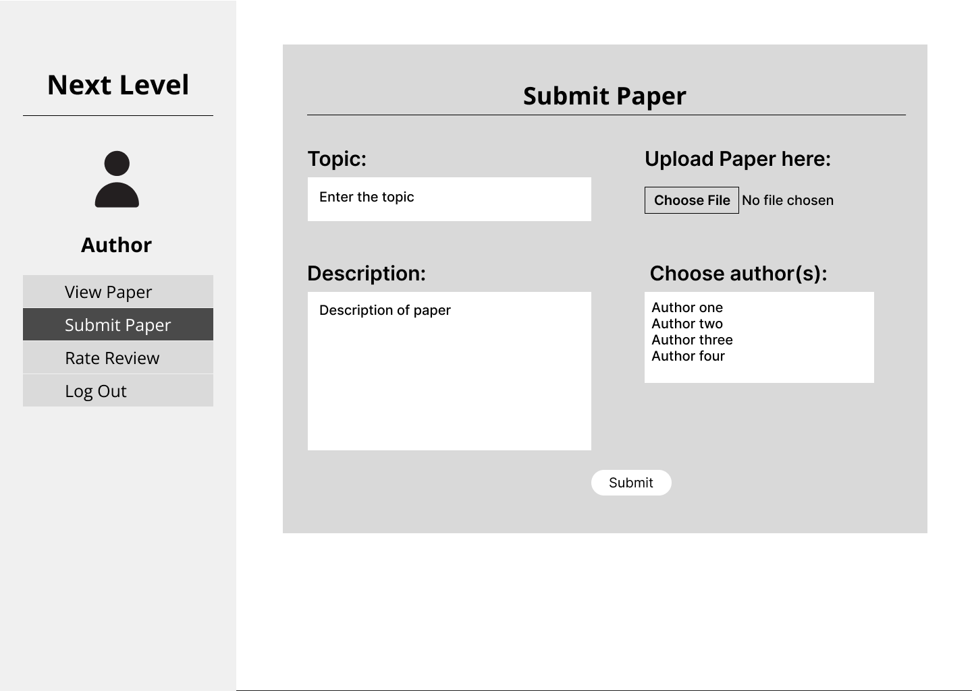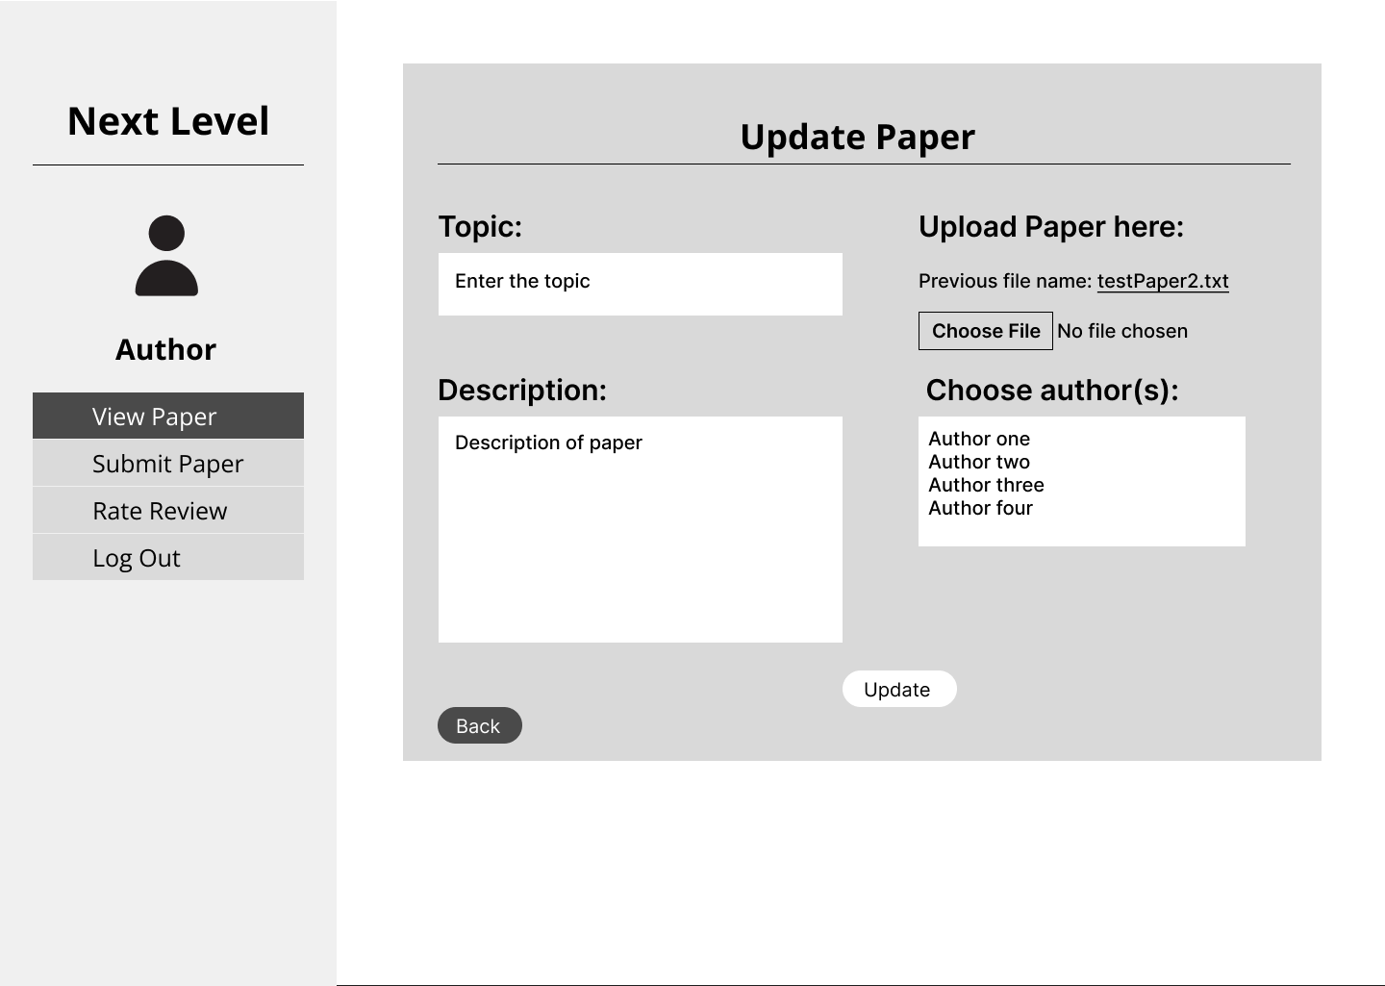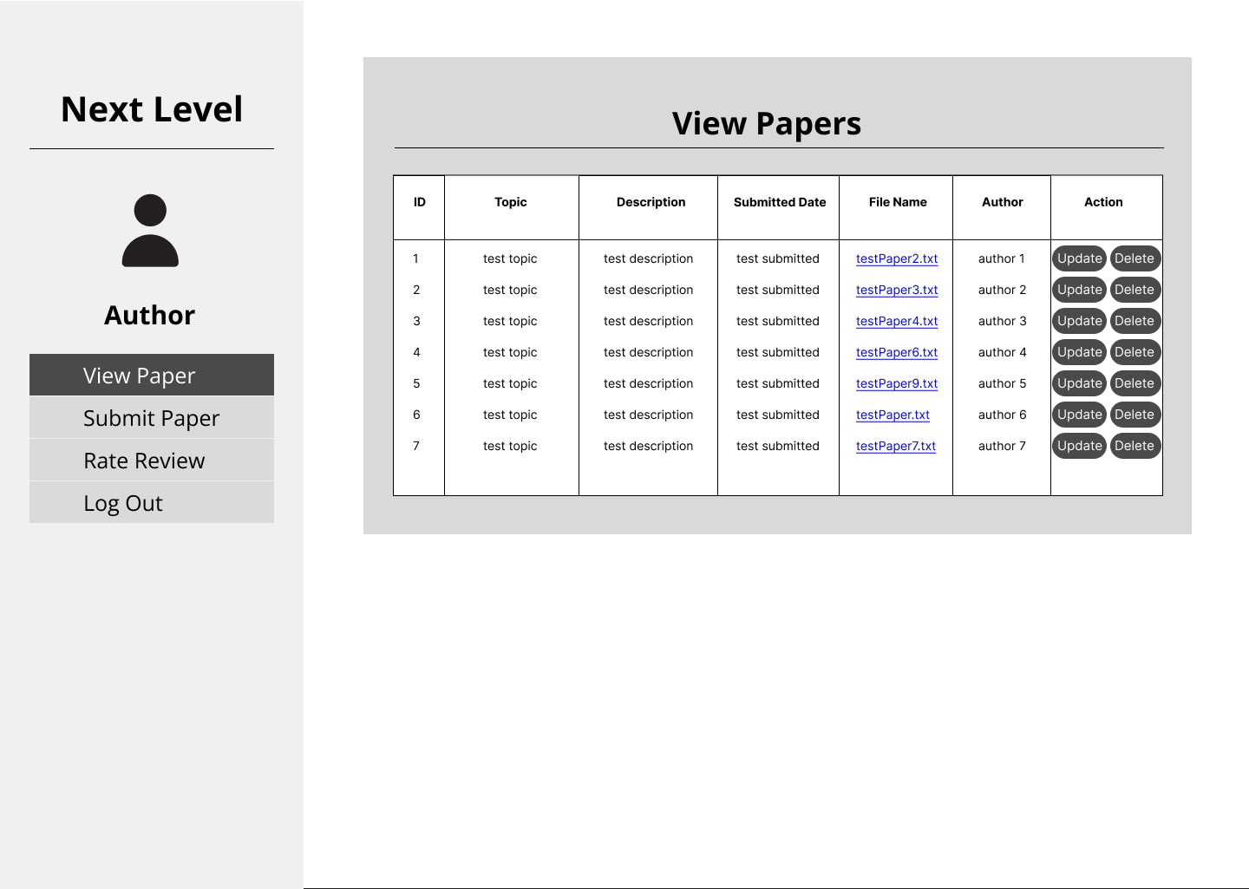

## Wireframe for Conference Chair

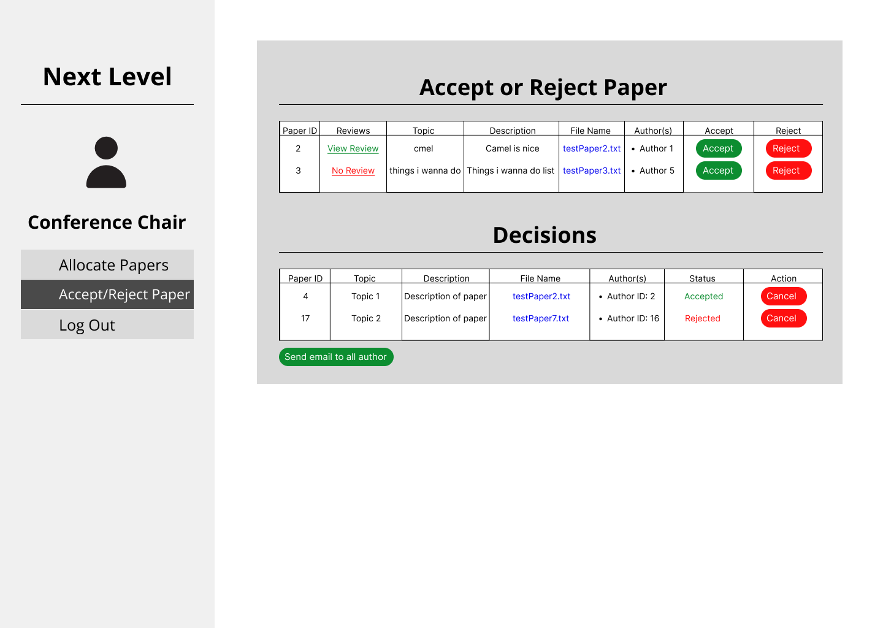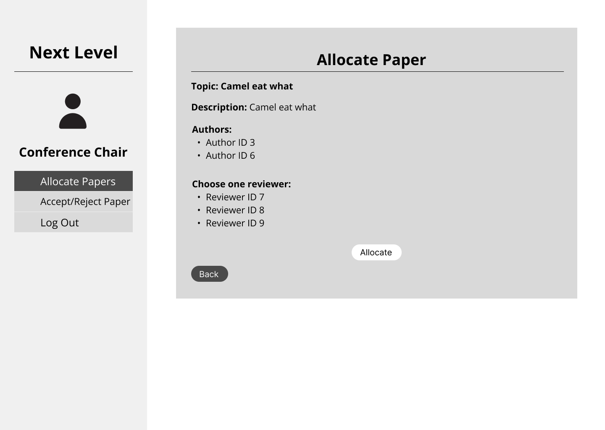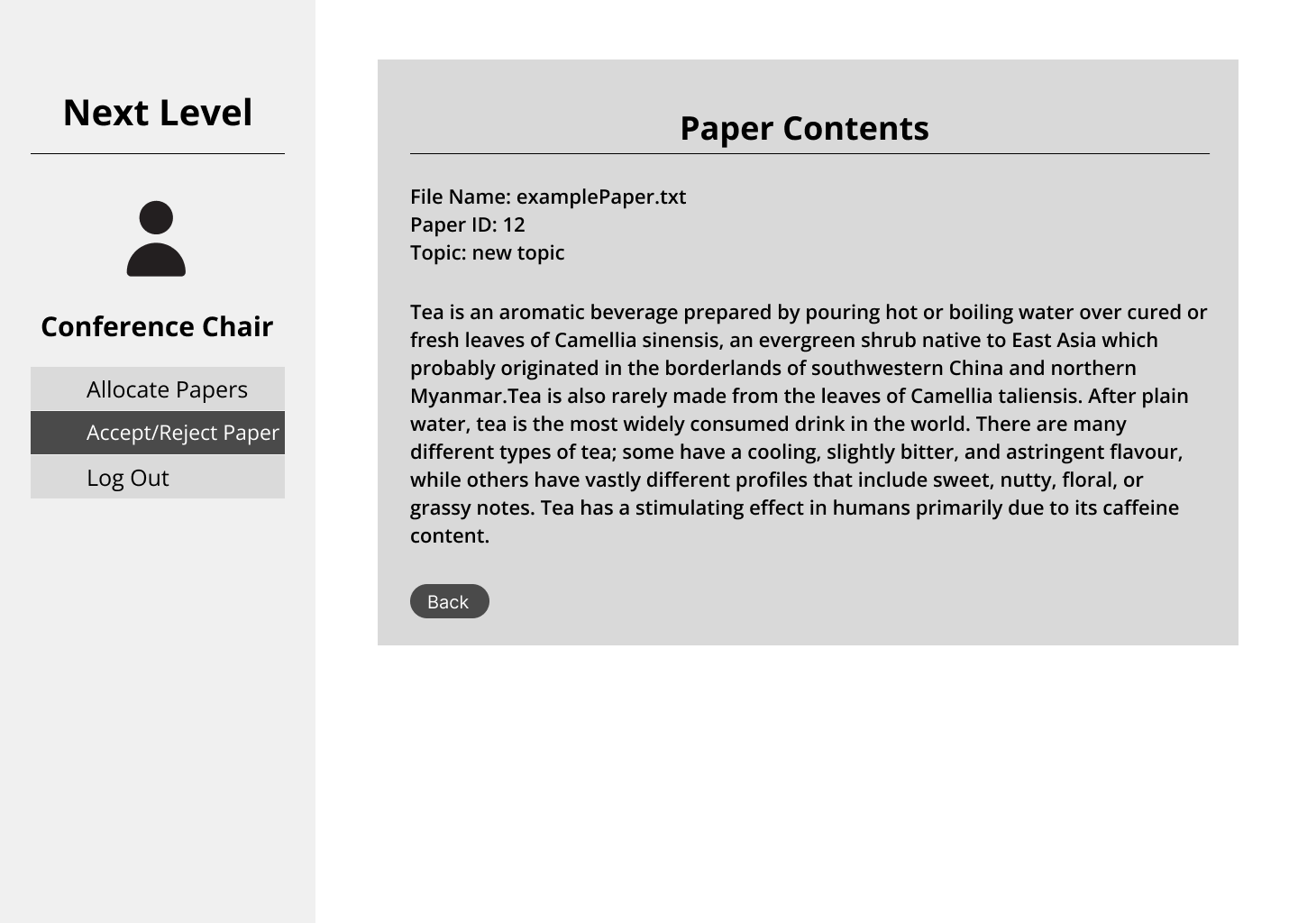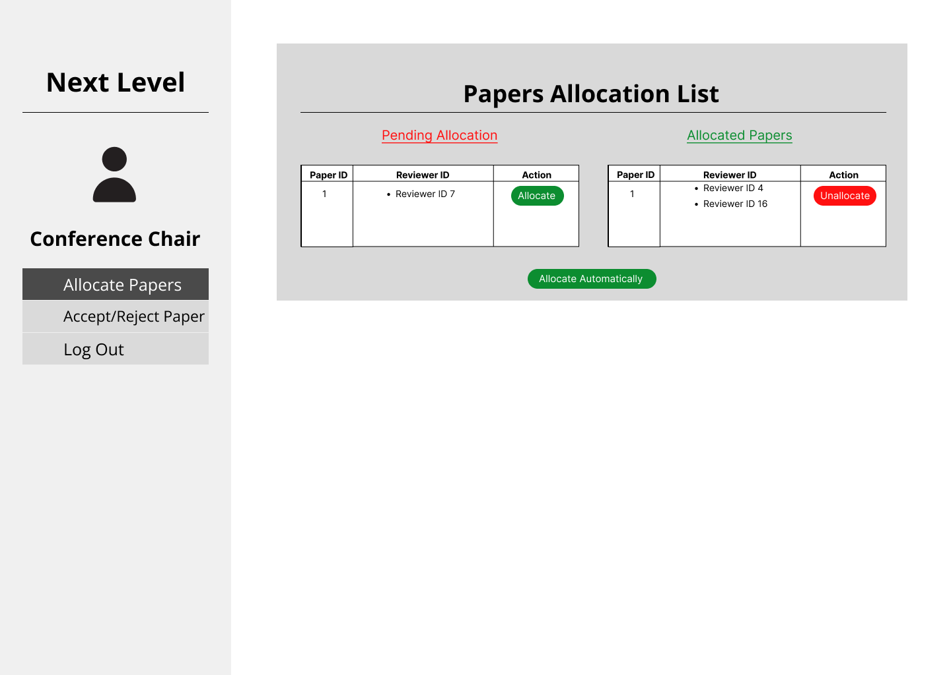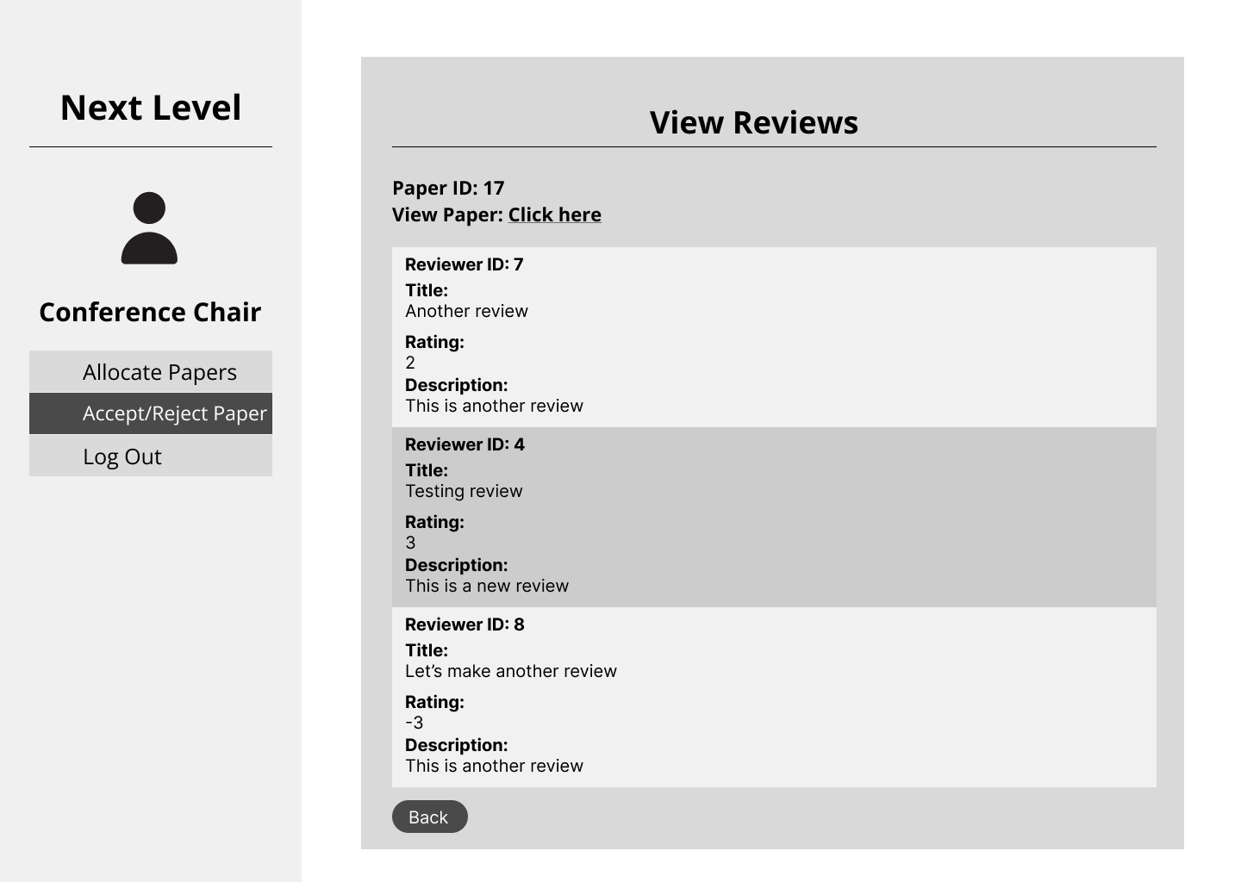

## Wireframe for Reviewer

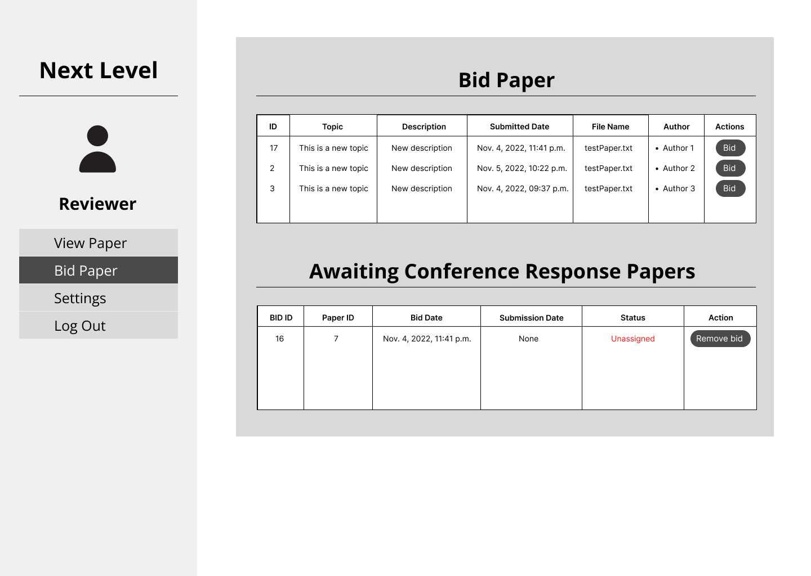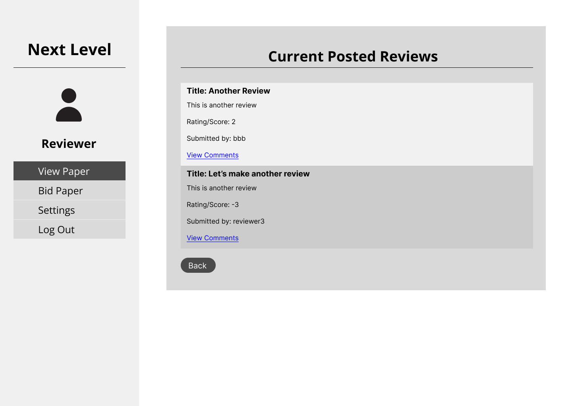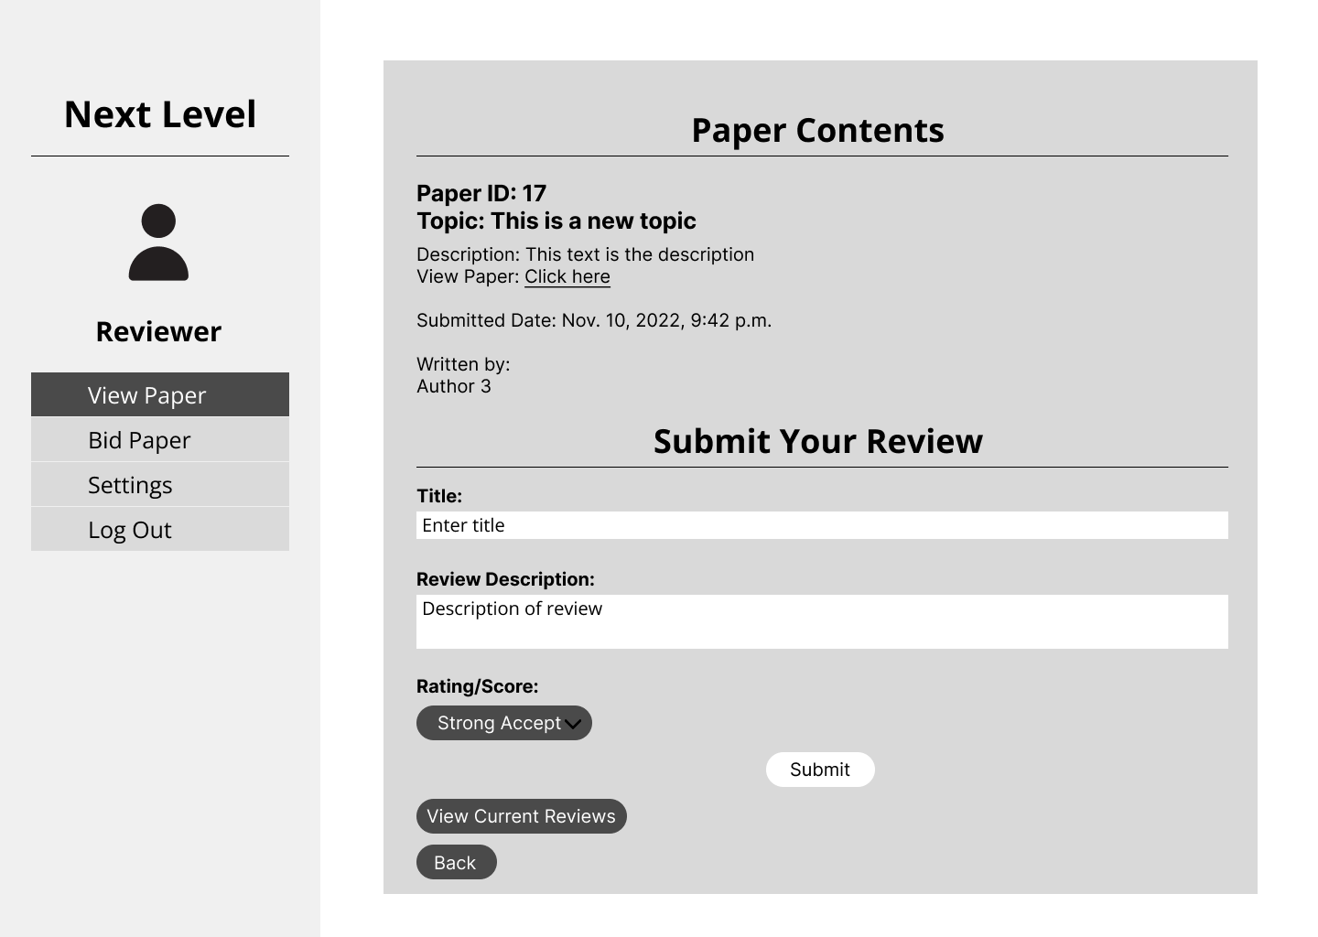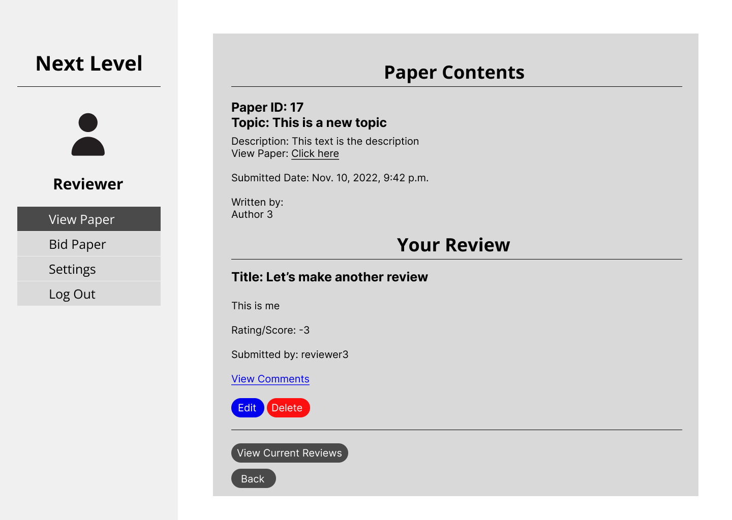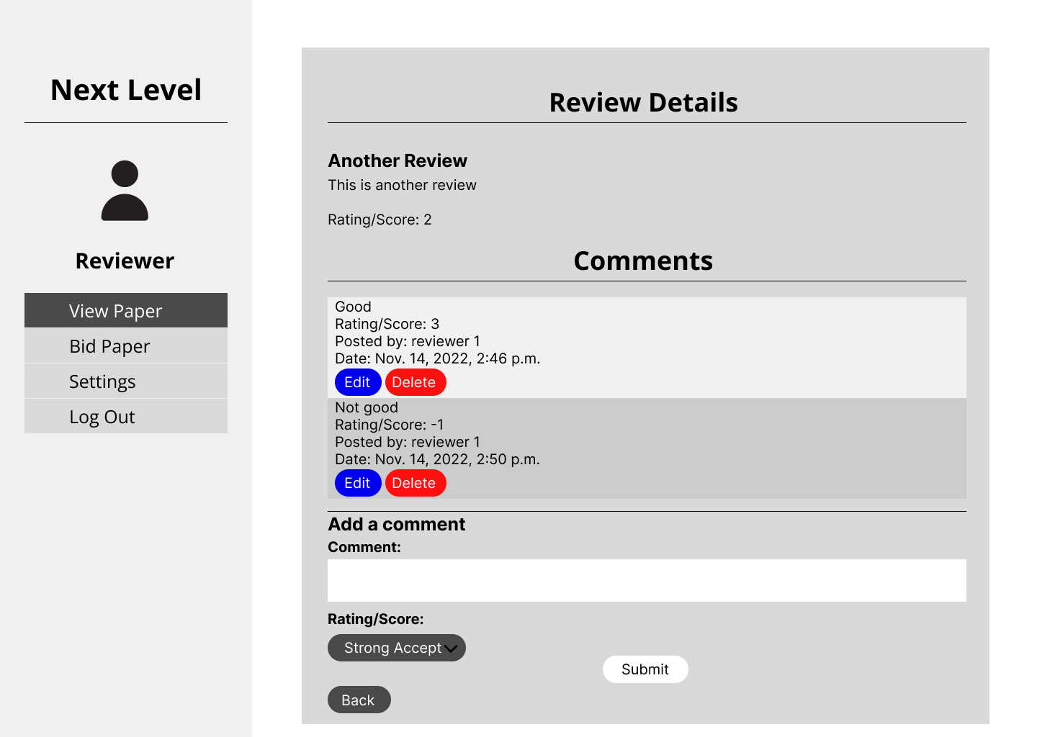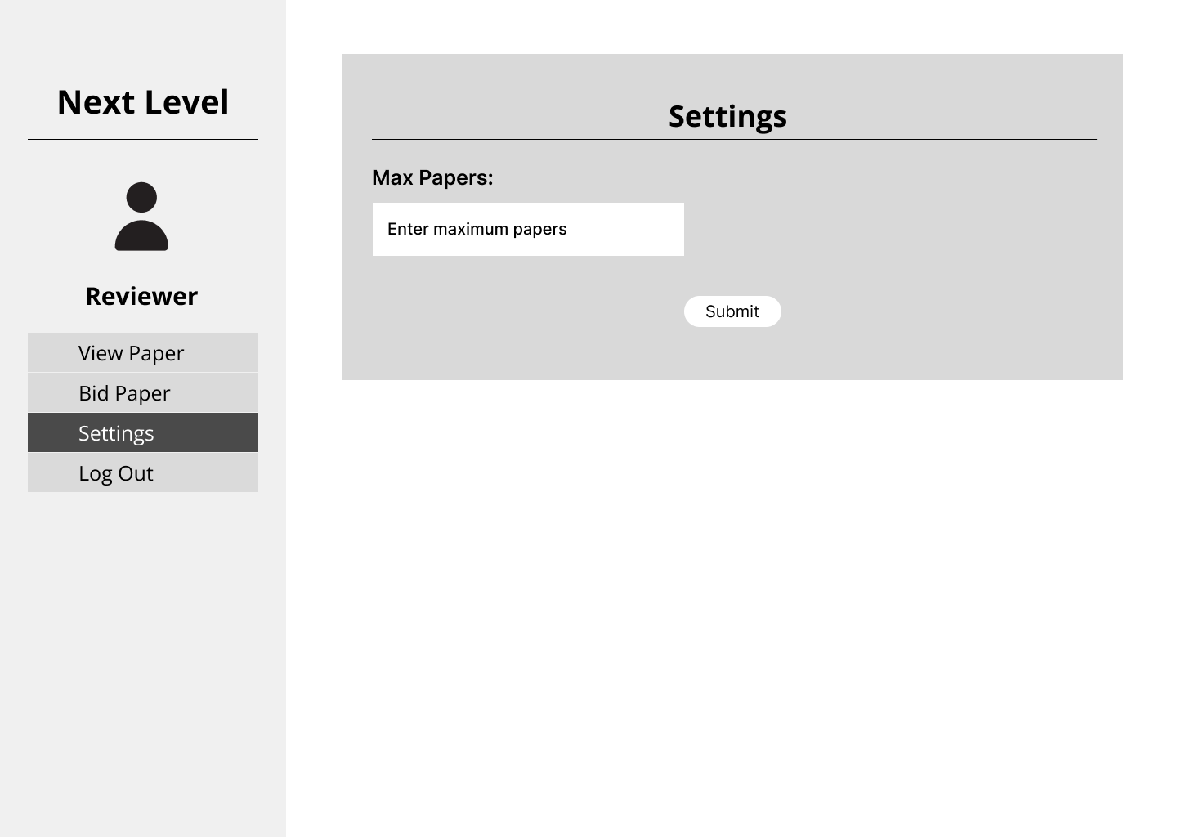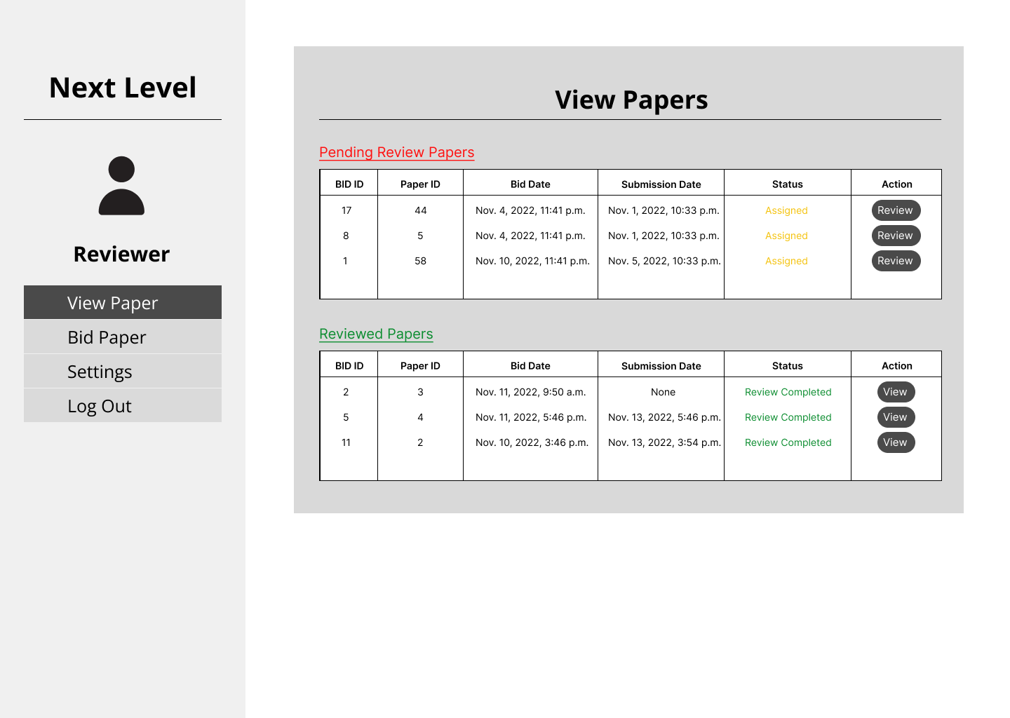

## Wireframe for System Admin

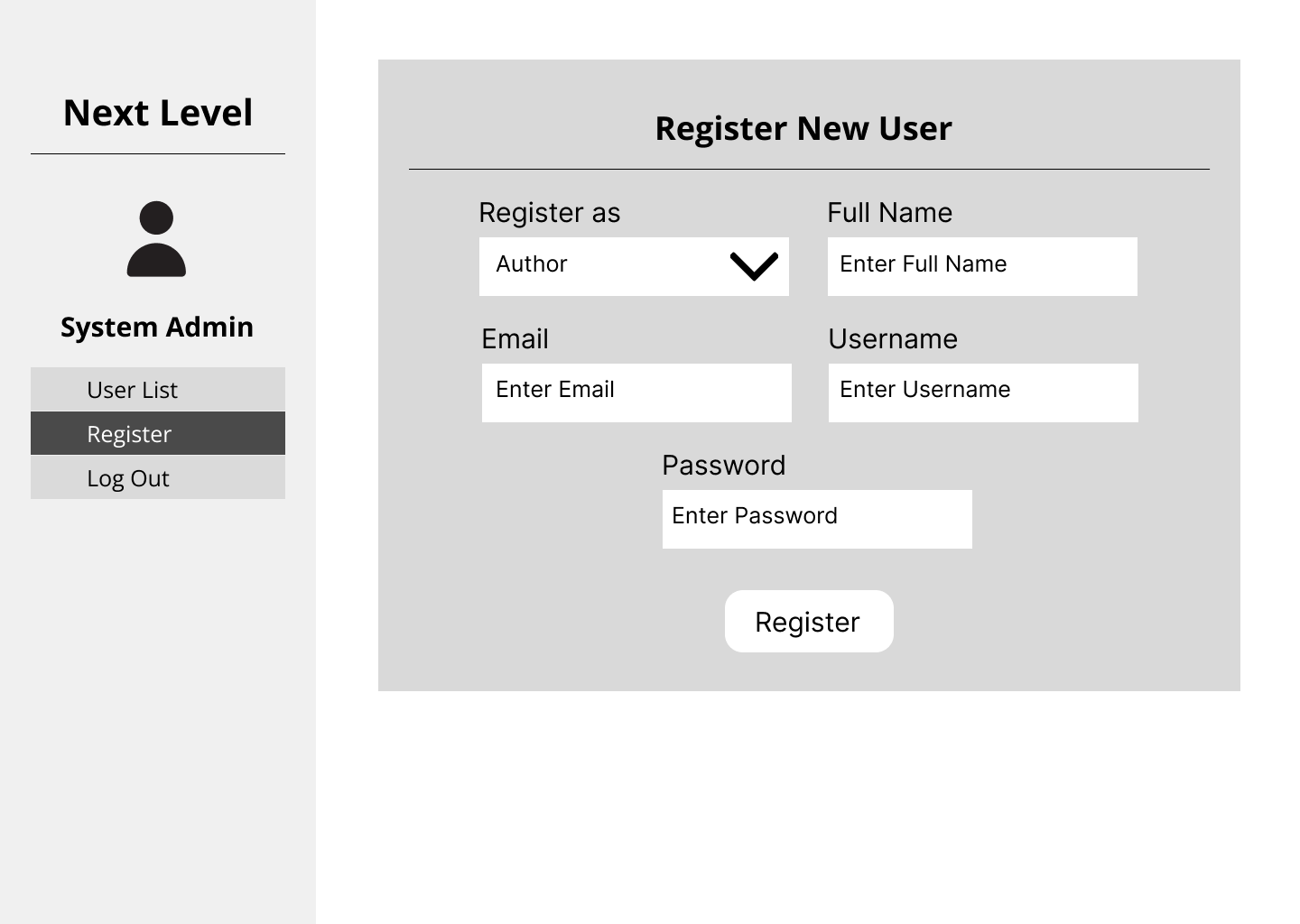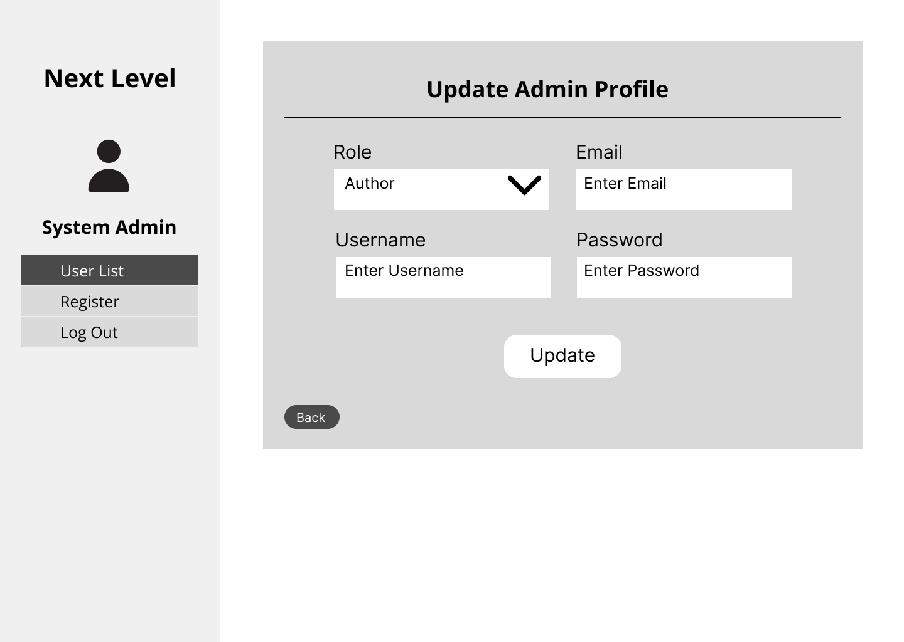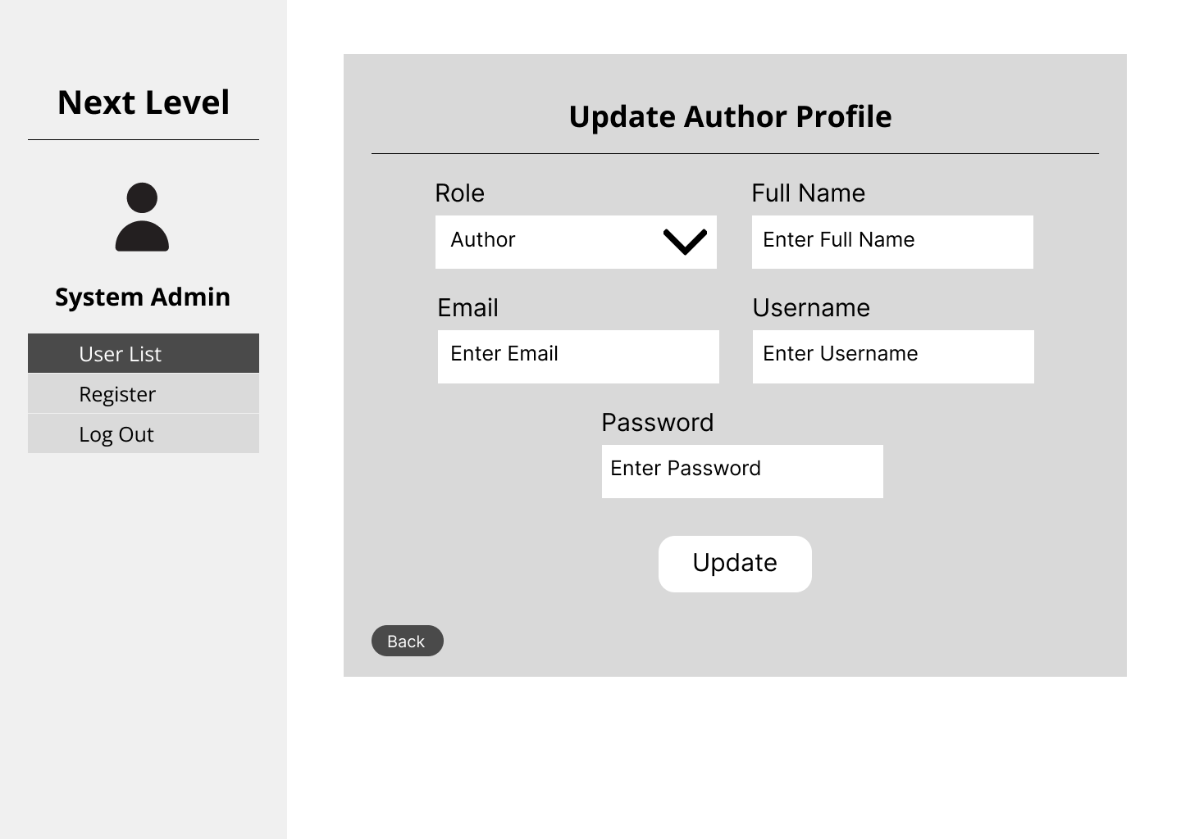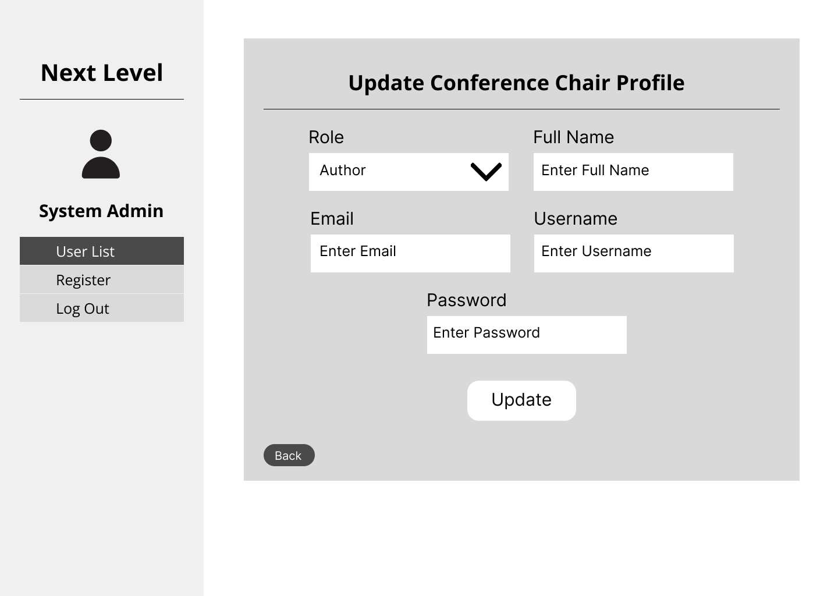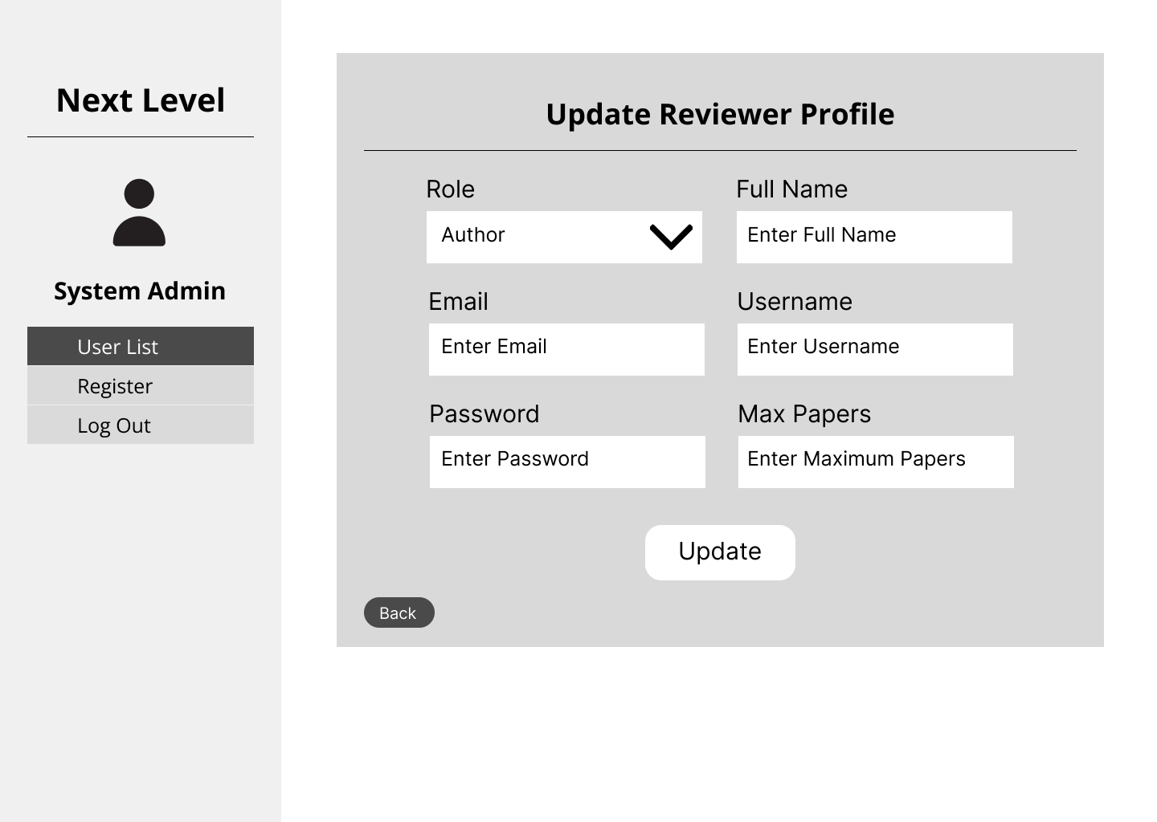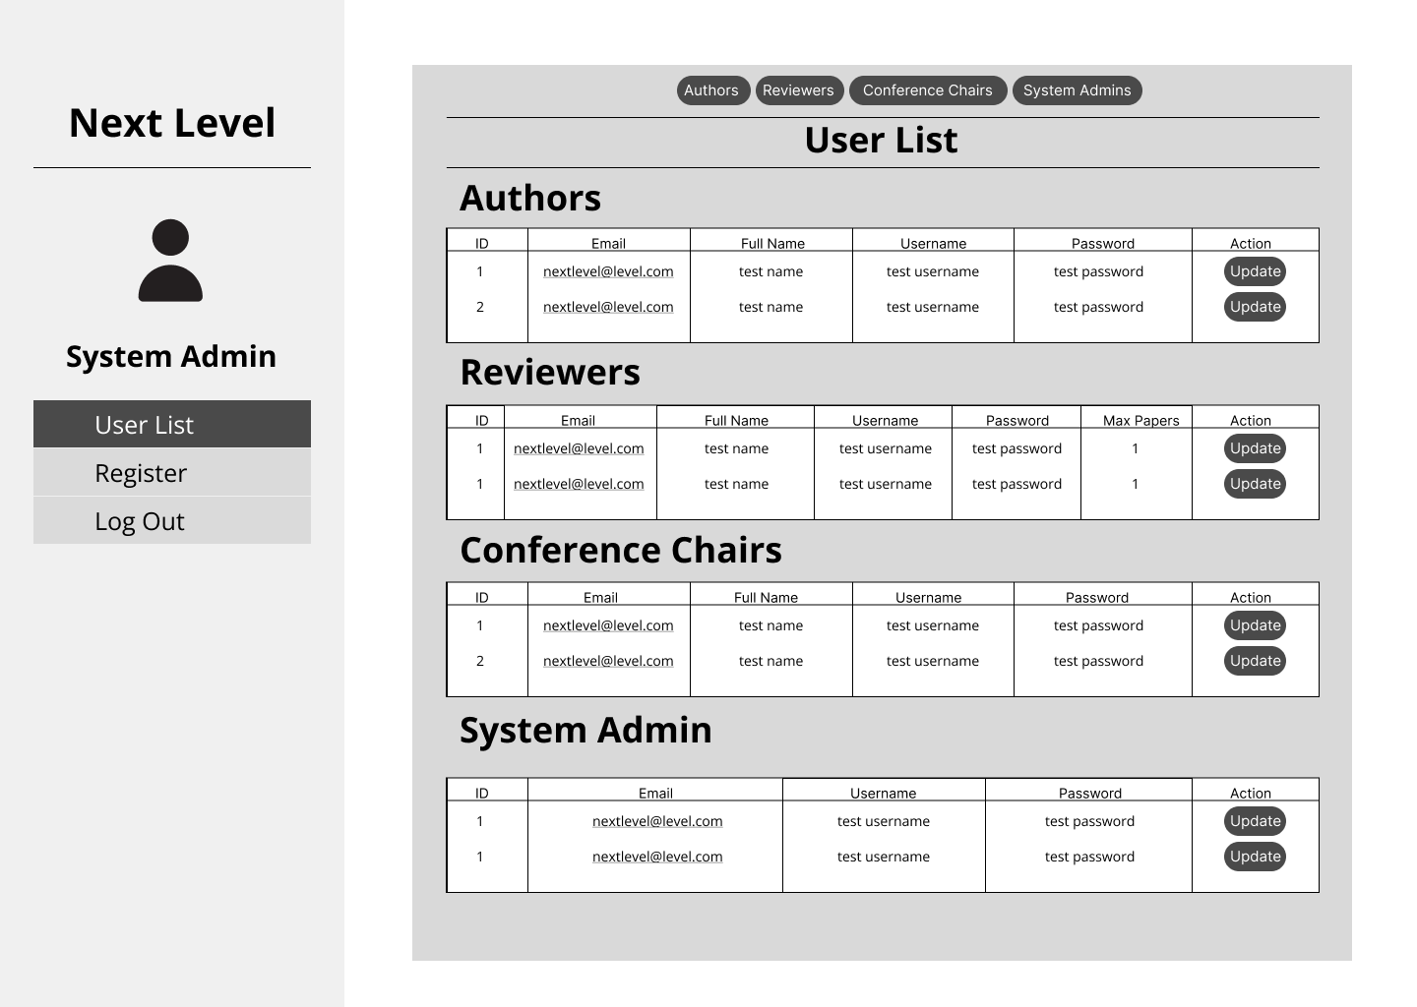

# 

# C. Test-Driven Development

## Sprint 1 Unit Testing

### Codes

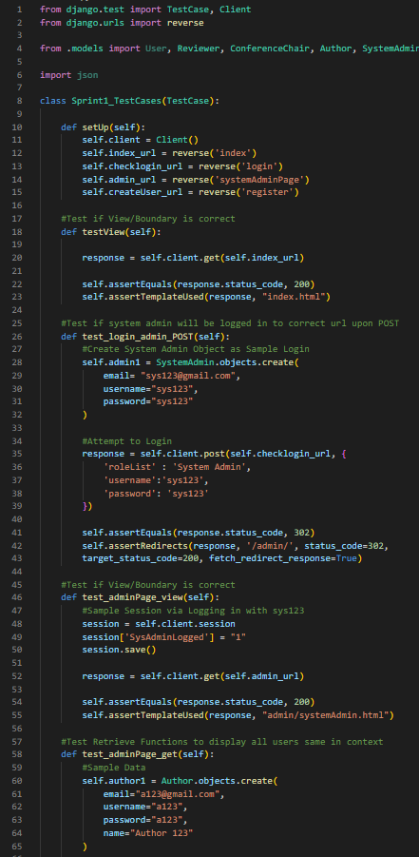

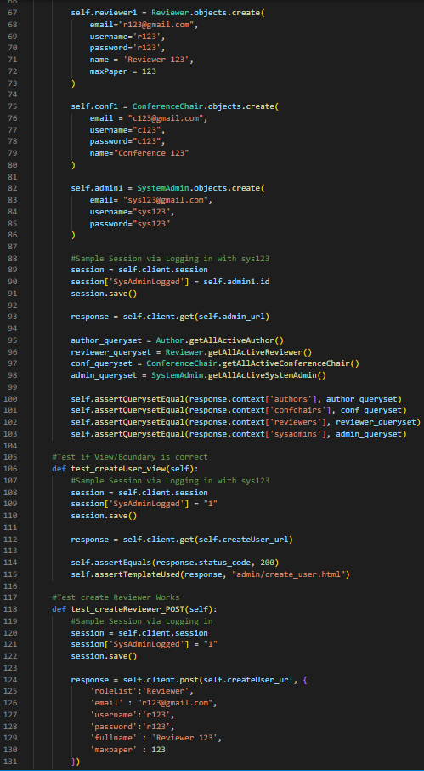

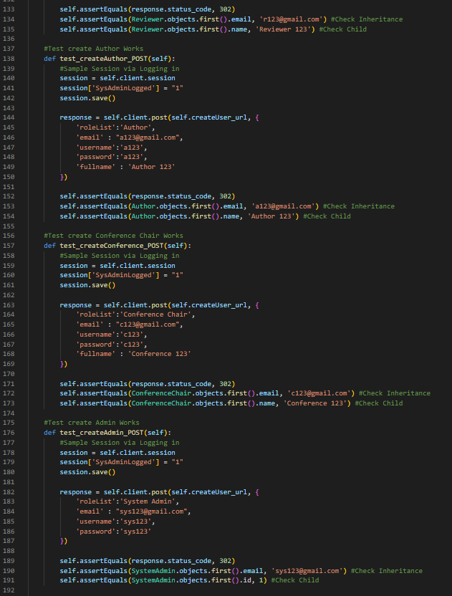

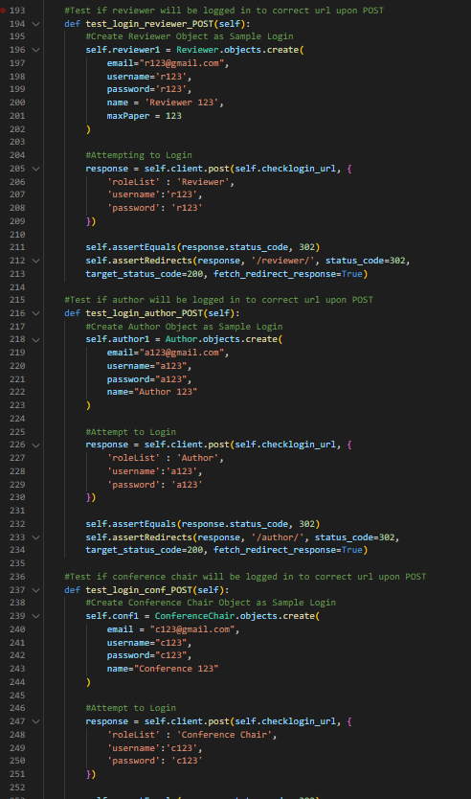

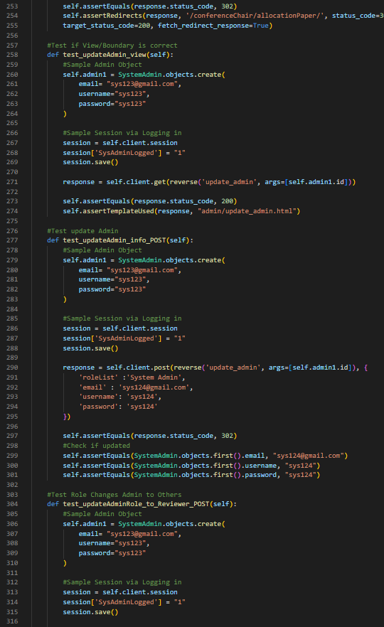

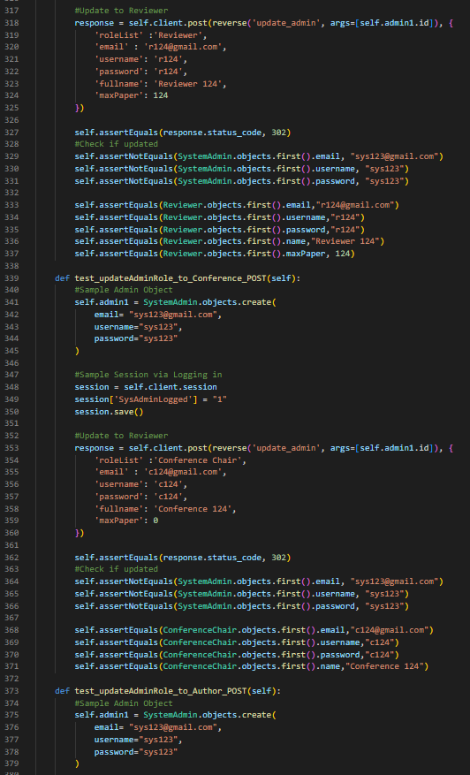

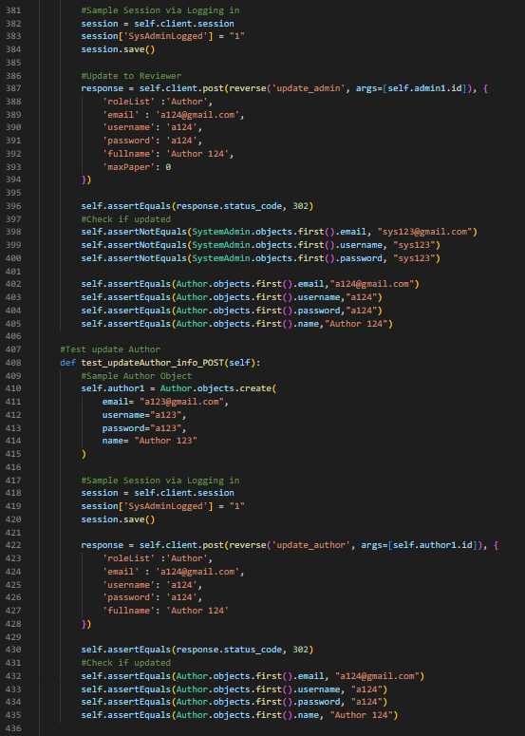

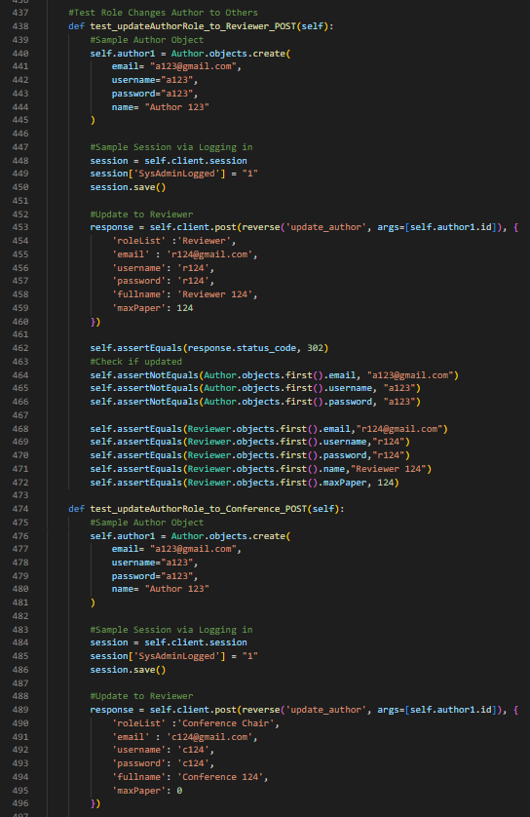

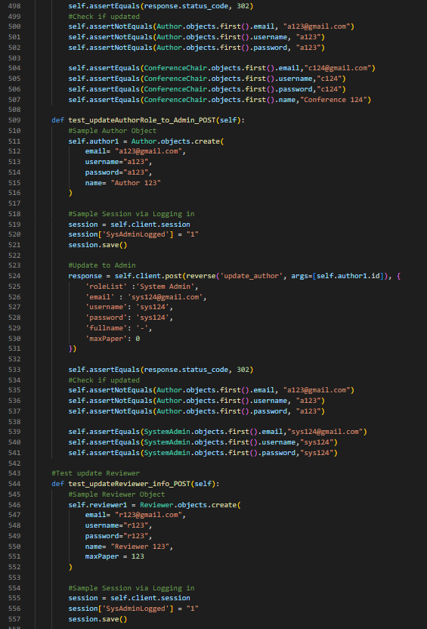

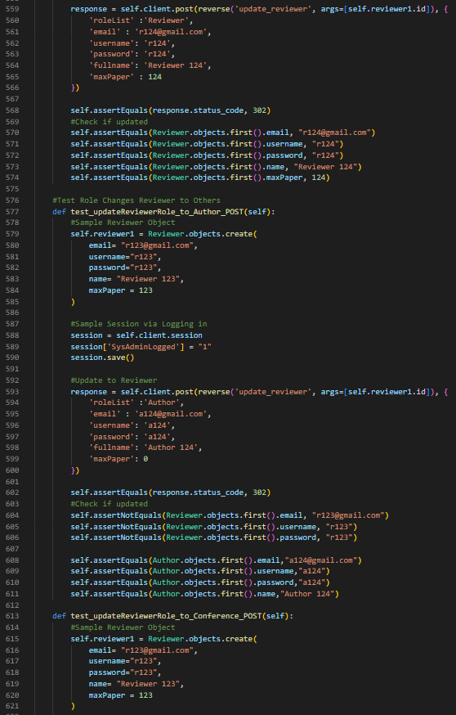

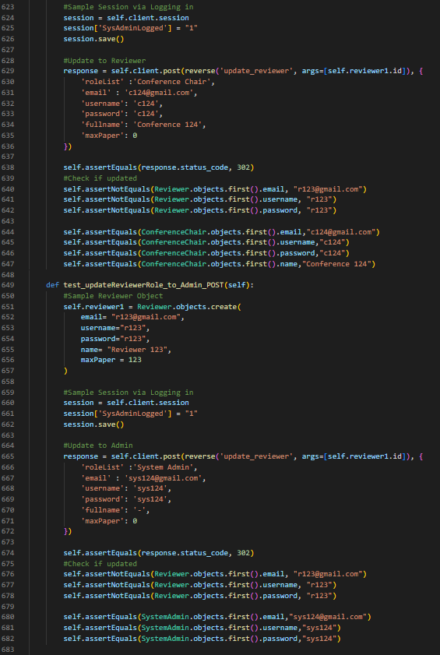

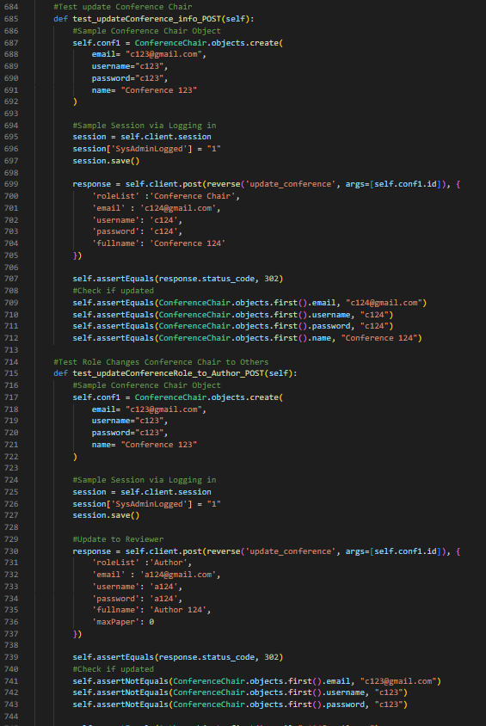

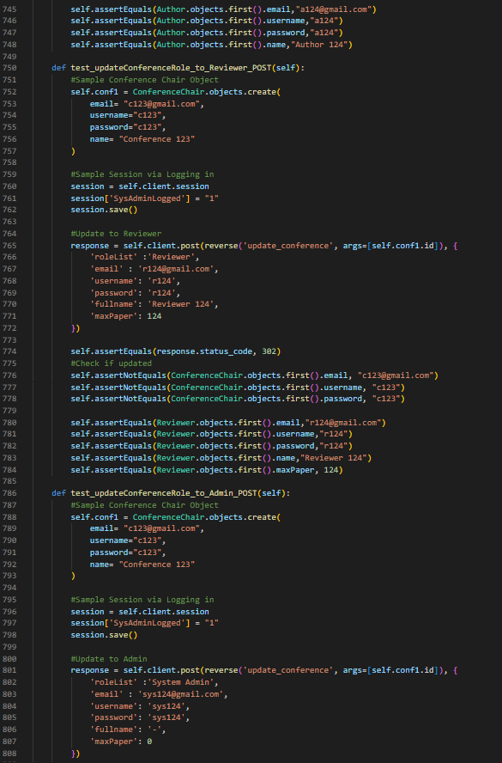

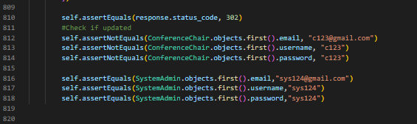

### CMD result when running test units

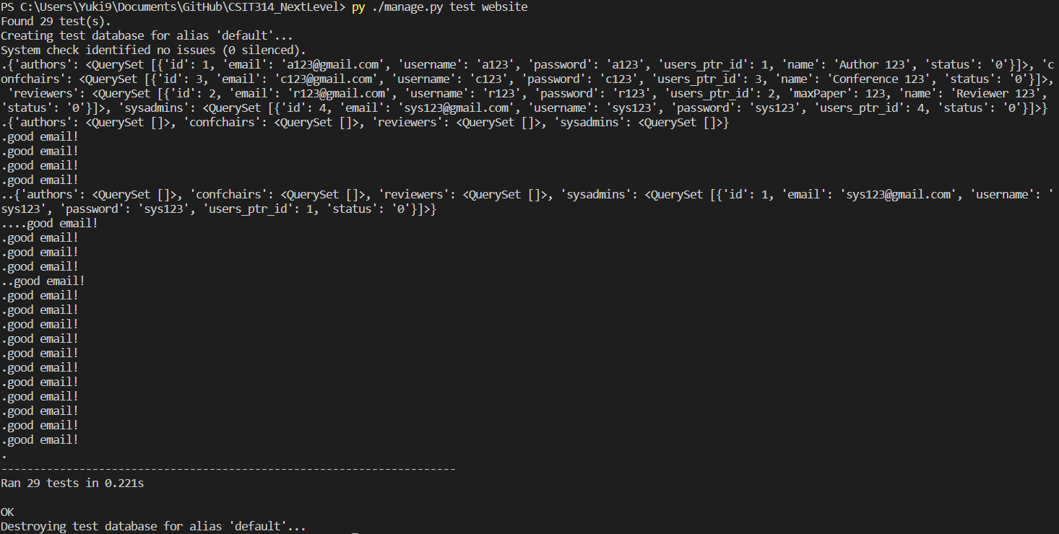

## SPRINT 1

### Test Plan

**SPRINT 1 TEST PLAN**

**Introduction**

The Test Plan is designed to prescribe the scope, resources, and schedule of testing activities in the **1st sprint** of the project NextLevel Research Conference Management System.

The plan identifies the items to be tested, the features to be tested, the types of testing to be performed, the personnel responsible for testing, the resources and schedule required to complete testing, and the risks associated with the plan.

**Test scope:**

The following functions of NextLevel which were defined in software requirement specifications need to be tested in Sprint :

Requirements for functional requirements:

|  |  |  |
| --- | --- | --- |
| **Use Case** | **Applicable Roles** | **Description** |
| Login as a system admin | System Admin | System admin can log in to the system |
| Login as a author | Author | Author can log in to the system |
| Login as a reviewer | Reviewer | Reviewer can log in to the system |
| Login as a conference chair | Conference chair | Conference chair can log in to the system |
| Logout from the system | System Admin | System admin can logout from the system |
| Logout from the system | Author | Author can logout from the system |
| Logout from the system | Reviewer | Reviewer can logout from the system |
| Logout from the system | Conference chair | Conference chair can logout from the system |
| Create user | System Admin | System admin can create user |
| View user | System Admin | System admin can view users |
| Update system admin | System Admin | System admin can update system admin data |
| Update author | System Admin | System admin can update author data |
| Update reviewer | System Admin | System admin can update reviewer data |
| Update conference chair | System Admin | System admin can update conference chair data |
| Update role of system admin | System Admin | System admin can update system admin role |
| Update role of author | System Admin | System admin can update author role |
| Update role of reviewer | System Admin | System admin can update reviewer role |
| Update role of conference chair | System Admin | System admin can update conference chair role |

**Test out of scope:**

* user interfaces
* hardware interfaces
* software interfaces
* website security and performance

**Quality Objective:**

* Ensure the application user test conforms to functional requirements
* bugs/issues are identified and fixed based on evaluation before next sprint

**Roles & Responsibilities**

|  |  |
| --- | --- |
| Tester | Yechan Kim |
| Tasks | * Design test case * Carry out the test for sprint 1 * Evaluate test based on test result |

**Test Methodology**

1. Testing strategies: Function testing to test functional requirements of Sprint 1 use cases.
2. Test acceptance and rejection criteria:
   1. System will be accepted if the actual results matches the expected result.
   2. System will be rejected if the actual results don’t match the expected result.

**Resource and Environment**

Environment set-up: All testers are required to have the following set-up to perform the system testing:

1. Front-end: Chrome
2. Test cases: Excel
3. Code Integration: GitHub
4. Code Programming framework: Django, BootStrap, Python,
5. Database programming language : SQL

**Testing Deliverables**

Before testing

1. Generate test cases
2. Open all tools that is needed for testing

During testing

1. Run test cases one by one

After testing

1. Make a report on carried test cases

**Test Plan Approval**

The following undersigned have acknowledged that they have reviewed the above test plan for NextLevel Research Conference Management

Name: Brandon Chew

Date: 9th October 2022

Role: Project Manager

Name: Yechan Kim

Date: 9th October 202

Role: Tester

## SPRINT 2

### Test Plan

**SPRINT 2 TEST PLAN**

**Introduction**

The Test Plan is designed to prescribe the scope, resources, and schedule of testing activities in the **2nd sprint** of the project NextLevel Research Conference Management System.

The plan identifies the items to be tested, the features to be tested, the types of testing to be performed, the personnel responsible for testing, the resources and schedule required to complete testing, and the risks associated with the plan.

**Test scope:**

The following functions of NextLevel which were defined in software requirement specifications need to be tested in Sprint 2:

Requirements for functional requirements:

|  |  |  |
| --- | --- | --- |
| **Use Case** | **Applicable Roles** | **Description** |
| Submit papers | Author | Author can submit papers to a conference. |
| View submitted papers | Author | Author can view submitted papers. |
| Update submitted papers | Author | Author can update papers from his submitted papers. |
| Delete submitted papers | Author | Author can delete a submitted paper. |
| Read submitted papers | Author | Author can read a submitted paper. |

**Test out of scope:**

* user interfaces
* hardware interfaces
* software interfaces
* website security and performance

**Quality Objective:**

* Ensure the application user test conforms to functional requirements
* bugs/issues are identified and fixed based on evaluation before next sprint

**Roles & Responsibilities**

|  |  |
| --- | --- |
| Tester | Yechan Kim |
| Tasks | * Design test case * Carry out the test for sprint 2 * Evaluate test based on test result |

**Test Methodology**

1. Testing strategies: Function testing to test functional requirements of Sprint 2 use cases.
2. Test acceptance and rejection criteria:
   1. System will be accepted if the actual results matches the expected result.
   2. System will be rejected if the actual results don’t match the expected result.

**Resource and Environment**

Environment set-up: All testers are required to have the following set-up to perform the system testing:

1. Front-end: Chrome
2. Test cases: Excel
3. Code Integration: GitHub
4. Code Programming framework: Django, BootStrap, Python,
5. Database programming language : SQL

**Testing Deliverables**

Before testing

1. Generate test cases
2. Open all tools that is needed for testing

During testing

1. Run test cases one by one

After testing

1. Make a report on carried test cases

**Test Plan Approval**

The following undersigned have acknowledged that they have reviewed the above test plan for NextLevel Research Conference Management

Name: Brandon Chew

Date: 16th October 2022

Role: Project Manager

Name: Yechan Kim

Date: 16th October 202

Role: Tester

## SPRINT 3

### Test Plan

**SPRINT 3 TEST PLAN**

**Introduction**

The Test Plan is designed to prescribe the scope, resources, and schedule of testing activities in the **3rd sprint** of the project NextLevel Research Conference Management System.

The plan identifies the items to be tested, the features to be tested, the types of testing to be performed, the personnel responsible for testing, the resources and schedule required to complete testing, and the risks associated with the plan.

**Test scope:**

The following functions of NextLevel which were defined in software requirement specifications need to be tested in Sprint 3:

Requirements for functional requirements:

|  |  |  |
| --- | --- | --- |
| **Use Case** | **Applicable Roles** | **Description** |
| Bid for a paper | Reviewer | Reviewer can bid for a paper as much as they want. But they still have a limit for max paper for paper review. |
| View bidded paper | Reviewer | Reviewer can view a list of papers that they bidded. |
| Delete bidded paper | Reviewer | Reviewer can cancel the their bid on certain paper. |
| View assigned papers | Reviewer | Reviewer can view a list of assigned papers which is to be reviewed or reviewed previously. |
| Submit review | Reviewer | Reviewer can submit review and score to respective allocated paper. |
| Set the max number of assigned papers | Reviewer | Reviewer can set the maximum number for papers for paper allocation. |
| Read paper’s content | Reviewer | Reviewer can read the content of the paper. |
| View unbidded papers | Reviewer | Reviewer can view a list of unbidded papers. |
| Read my review’s content | Reviewer | Reviewer can read their previous review on the paper. |
| Allocate papers to reviewers manually | Conference Chair | Conference chair can allocate papers to reviewers based on their maximum number of papers. |
| View bidded paper of all reviewers | Conference Chair | Conference chair can view a list of bidded papers. |
| Unallocate paper assigned to reviewer | Conference Chair | Conference chair can unallocate allocated paper. |

**Test out of scope:**

* user interfaces
* hardware interfaces
* software interfaces
* website security and performance

**Quality Objective:**

* Ensure the application user test conforms to functional requirements
* bugs/issues are identified and fixed based on evaluation before next sprint

**Roles & Responsibilities**

|  |  |
| --- | --- |
| Tester | Yechan Kim |
| Tasks | * Design test case * Carry out the test for sprint 3 * Evaluate test based on test result |

**Test Methodology**

1. Testing strategies: Function testing to test functional requirements of Sprint 3 use cases.
2. Test acceptance and rejection criteria:
   1. System will be accepted if the actual results matches the expected result.
   2. System will be rejected if the actual results don’t match the expected result.

**Resource and Environment**

Environment set-up: All testers are required to have the following set-up to perform the system testing:

1. Front-end: Chrome
2. Test cases: Excel
3. Code Integration: GitHub
4. Code Programming framework: Django, BootStrap, Python,
5. Database programming language : SQL

**Testing Deliverables**

Before testing

1. Generate test cases
2. Open all tools that is needed for testing

During testing

1. Run test cases one by one

After testing

1. Make a report on carried test cases

**Test Plan Approval**

The following undersigned have acknowledged that they have reviewed the above test plan for NextLevel Research Conference Management

Name: Brandon Chew

Date: 23rd October 2022

Role: Project Manager

Name: Yechan Kim

Date: 23rd October 202

Role: Tester

## SPRINT 4

### Test Plan

**SPRINT 4 TEST PLAN**

**Introduction**

The Test Plan is designed to prescribe the scope, resources, and schedule of testing activities in the **4th sprint** of the project NextLevel Research Conference Management System.

The plan identifies the items to be tested, the features to be tested, the types of testing to be performed, the personnel responsible for testing, the resources and schedule required to complete testing, and the risks associated with the plan.

**Test scope:**

The following functions of NextLevel which were defined in software requirement specifications need to be tested in Sprint 4:

Requirements for functional requirements:

|  |  |  |
| --- | --- | --- |
| **Use Case** | **Applicable Roles** | **Description** |
| View reviews | Conference Chair | Conference chair can read reviews from reviewers. |
| Accept paper | Conference Chair | Conference chair can approve paper based on their ratings and reviews |
| Reject paper | Conference Chair | Conference chair can reject paper based on their ratings and reviews |
| View list of accepted and rejected paper | Conference Chair | Conference chair can view a list of papers that are accepted and/or rejected. |
| Read paper’s content | Conference Chair | Conference chair can read paper’s content. |
| Read review’s content | Conference Chair | Conference chair can read review’s content. |
| Read other reviewer’s review on the paper | Reviewer | Reviewer can view other reviews of the same paper. |
| Edit my own review | Reviewer | Reviewer can edit his own review and score of specific paper. |
| Delete my own review | Reviewer | Reviewer can delete his own review and score of specific paper. |
| Comment on the review made by other reviewers | Reviewer | Reviewer can comment on the review made by other reviewers. |
| View reviewed papers | Reviewer | Reviewer can view reviewed papers |
| View comments on the review | Reviewer | Reviewer can view comments on the review |

**Test out of scope:**

* user interfaces
* hardware interfaces
* software interfaces
* website security and performance

**Quality Objective:**

* Ensure the application user test conforms to functional requirements
* bugs/issues are identified and fixed based on evaluation before next sprint

**Roles & Responsibilities**

|  |  |
| --- | --- |
| Tester | Yechan Kim |
| Tasks | * Design test case * Carry out the test for sprint 4 * Evaluate test based on test result |

**Test Methodology**

1. Testing strategies: Function testing to test functional requirements of Sprint 4 use cases.
2. Test acceptance and rejection criteria:
   1. System will be accepted if the actual results matches the expected result.
   2. System will be rejected if the actual results don’t match the expected result.

**Resource and Environment**

Environment set-up: All testers are required to have the following set-up to perform the system testing:

1. Front-end: Chrome
2. Test cases: Excel
3. Code Integration: GitHub
4. Code Programming framework: Django, BootStrap, Python,
5. Database programming language : SQL

**Testing Deliverables**

Before testing

1. Generate test cases
2. Open all tools that is needed for testing

During testing

1. Run test cases one by one

After testing

1. Make a report on carried test cases

**Test Plan Approval**

The following undersigned have acknowledged that they have reviewed the above test plan for NextLevel Research Conference Management

Name: Brandon Chew

Date: 30th October 2022

Role: Project Manager

Name: Yechan Kim

Date: 30th October 2022

Role: Tester

## SPRINT 5

### Test Plan

**SPRINT 5 TEST PLAN**

**Introduction**

The Test Plan is designed to prescribe the scope, resources, and schedule of testing activities in the **5th sprint** of the project NextLevel Research Conference Management System.

The plan identifies the items to be tested, the features to be tested, the types of testing to be performed, the personnel responsible for testing, the resources and schedule required to complete testing, and the risks associated with the plan.

**Test scope:**

The following functions of NextLevel which were defined in software requirement specifications need to be tested in Sprint 5:

Requirements for functional requirements:

|  |  |  |
| --- | --- | --- |
| **Use Case** | **Applicable Roles** | **Description** |
| Rate the reviews of my own papers | Author | Reviewer can rate the reviews that he received for his own paper. |
| View reviews of my own & co-author papers | Author | Reviewer can view reviews of his own and co-author papers. |
| View rated reviews | Author | Reviewer can view rated reviews. |
| Read review’s content | Author | Reviewer can read review’s content. |
| Delete my rating of the reviews on my own papers | Author | Author can delete his previous rating on paper review. |
| Edit submitted comment | Reviewer | Reviewer can edit submitted comment that reviewer wrote before. |
| Delete submitted comment | Reviewer | Reviewer can delete submitted comment that reviewer wrote before. |
| Cancel paper decision | Conference Chair | Reviewer can cancel paper decision. |

**Test out of scope:**

* user interfaces
* hardware interfaces
* software interfaces
* website security and performance

**Quality Objective:**

* Ensure the application user test conforms to functional requirements
* bugs/issues are identified and fixed based on evaluation before next sprint

**Roles & Responsibilities**

|  |  |
| --- | --- |
| Tester | Yechan Kim |
| Tasks | * Design test case * Carry out the test for sprint 5 * Evaluate test based on test result |

**Test Methodology**

1. Testing strategies: Function testing to test functional requirements of Sprint 5 use cases.
2. Test acceptance and rejection criteria:
   1. System will be accepted if the actual results matches the expected result.
   2. System will be rejected if the actual results don’t match the expected result.

**Resource and Environment**

Environment set-up: All testers are required to have the following set-up to perform the system testing:

1. Front-end: Chrome
2. Test cases: Excel
3. Code Integration: GitHub
4. Code Programming framework: Django, BootStrap, Python,
5. Database programming language : SQL

**Testing Deliverables**

Before testing

1. Generate test cases
2. Open all tools that is needed for testing

During testing

1. Run test cases one by one

After testing

1. Make a report on carried test cases

**Test Plan Approval**

The following undersigned have acknowledged that they have reviewed the above test plan for NextLevel Research Conference Management

Name: Brandon Chew

Date: 6th November 2022

Role: Project Manager

Name: Yechan Kim

Date: 6th November 2022

Role: Tester

## SPRINT 6

### Test Plan

**SPRINT 6 TEST PLAN**

**Introduction**

The Test Plan is designed to prescribe the scope, resources, and schedule of testing activities in the **6th sprint** of the project NextLevel Research Conference Management System.

The plan identifies the items to be tested, the features to be tested, the types of testing to be performed, the personnel responsible for testing, the resources and schedule required to complete testing, and the risks associated with the plan.

**Test scope:**

The following functions of NextLevel which were defined in software requirement specifications need to be tested in Sprint 6:

Requirements for functional requirements:

|  |  |  |
| --- | --- | --- |
| **Use Case** | **Applicable Roles** | **Description** |
| Allocate papers to reviewers automatically | Conference Chair | Conference chair can allocate paper automatically. |

**Test out of scope:**

* user interfaces
* hardware interfaces
* software interfaces
* website security and performance

**Quality Objective:**

* Ensure the application user test conforms to functional requirements
* bugs/issues are identified and fixed based on evaluation before next sprint

**Roles & Responsibilities**

|  |  |
| --- | --- |
| Tester | Yechan Kim |
| Tasks | * Design test case * Carry out the test for sprint 4 * Evaluate test based on test result |

**Test Methodology**

1. Testing strategies: Function testing to test functional requirements of Sprint 4 use cases.
2. Test acceptance and rejection criteria:
   1. System will be accepted if the actual results matches the expected result.
   2. System will be rejected if the actual results don’t match the expected result.

**Resource and Environment**

Environment set-up: All testers are required to have the following set-up to perform the system testing:

1. Front-end: Chrome
2. Test cases: Excel
3. Code Integration: GitHub
4. Code Programming framework: Django, BootStrap, Python,
5. Database programming language : SQL

**Testing Deliverables**

Before testing

1. Generate test cases
2. Open all tools that is needed for testing

During testing

1. Run test cases one by one

After testing

1. Make a report on carried test cases

**Test Plan Approval**

The following undersigned have acknowledged that they have reviewed the above test plan for NextLevel Research Conference Management

Name: Brandon Chew

Date: 13th November 2022

Role: Project Manager

Name: Yechan Kim

Date: 13th November 2022

Role: Tester

### 

# 

# D. CI/CD

The first picture shows the initial commit of the project

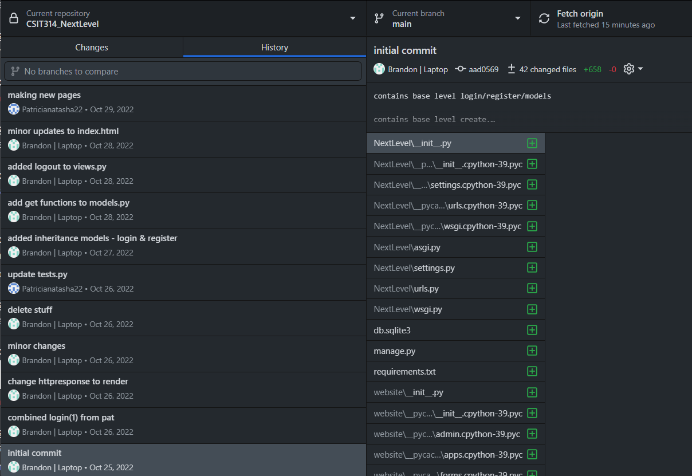

This picture shows Patricia Natasha committing other portions of the project code into the github. it is then merged into our project as Continuous Integration.

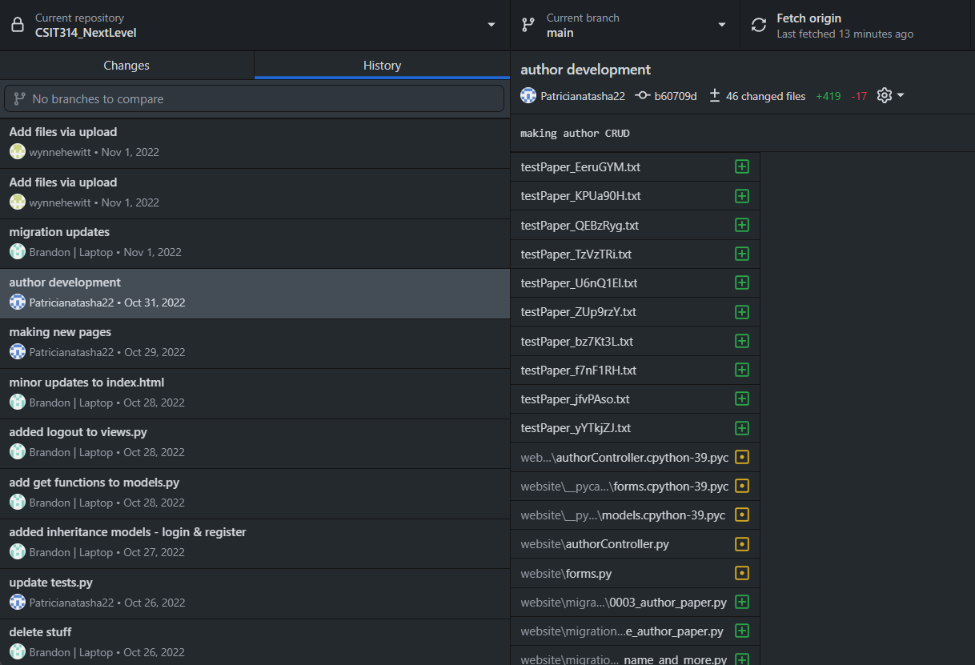

This picture shows Wynne Hewitt committing the frontend of the project code into the github.

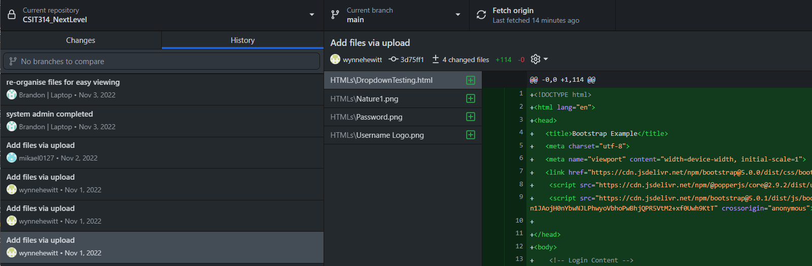

# 

# E. Ethical Consideration and Discussions

1. **Fairness and inclusiveness**

* Project

In our program, we ensure that it is fair for every user according to the role they possess. In this case, for instance, an author posts a paper. The reviewer is able to review the paper and post the review. They can write their review in any way that they want.

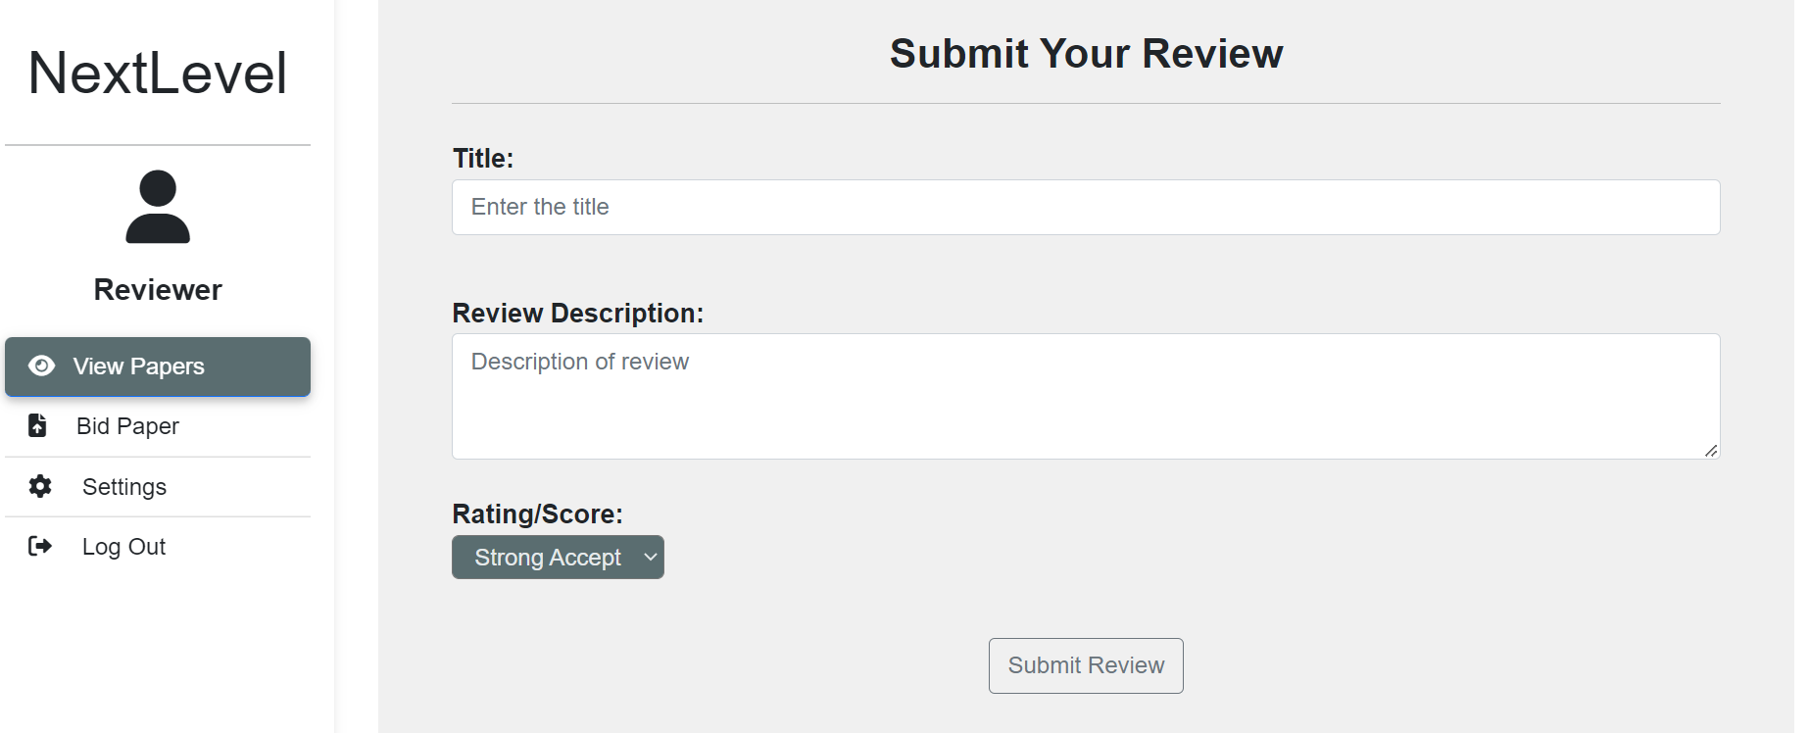

However, to be fair, the author can also rate the review if they feel that they are satisfied/not satisfied by the review.

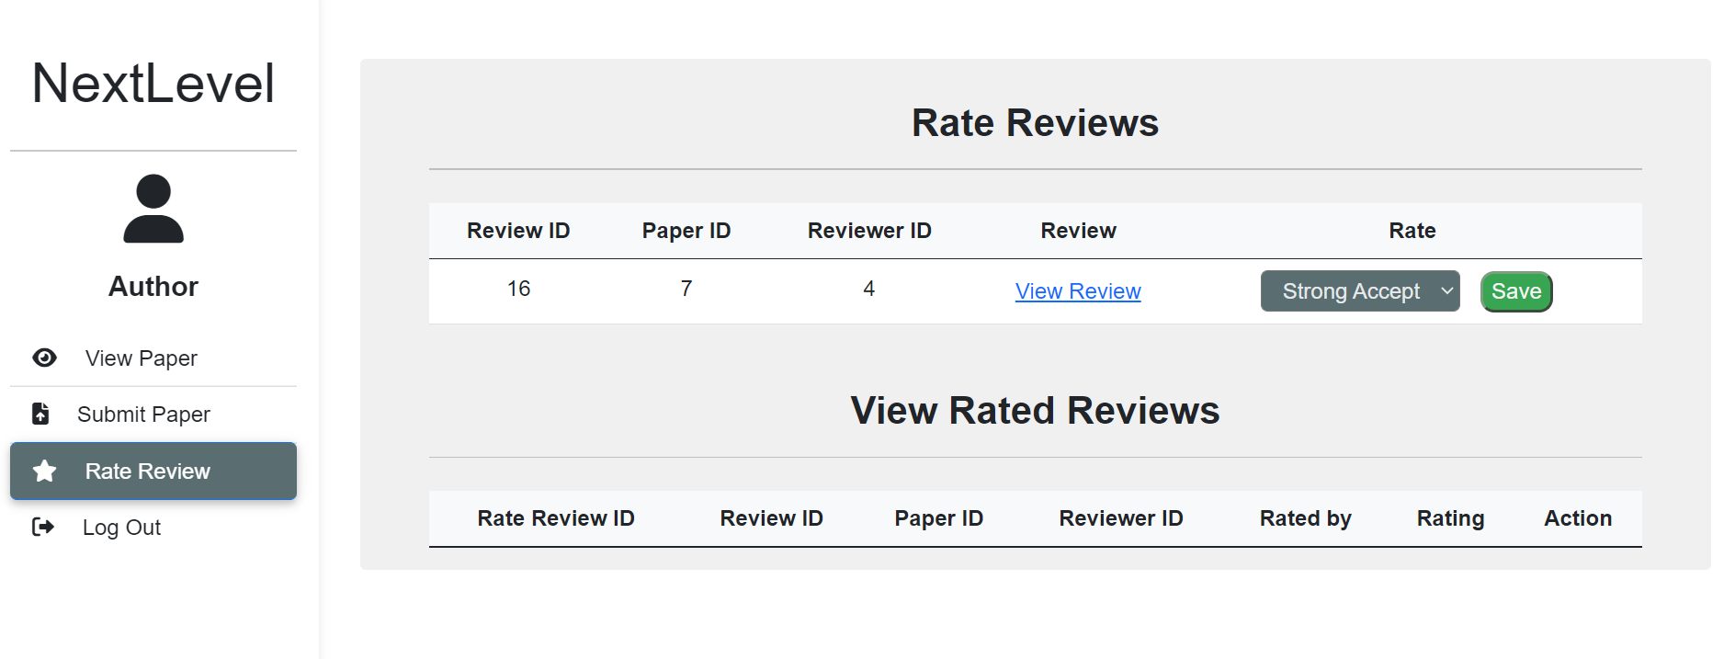

Team

In a team project, there are possibilities that some members do more work and some members contribute less. To address this issue, our team has assigned respective responsibilities and roles to each member based on our skills and experiences since the very first sprint. This is to enhance the productivity of the project and everyone can maximize their potential in each role assigned. In addition, in every meeting, all of the team members explained and elaborated the things we had done so the other members could understand and keep up with the projects’ progress.

1. **Reliability and Safety**

* Project

The paper conference management system might be used for people that are not familiar with technology. To accommodate, in the program, the users can easily navigate around the features (use cases) that are implemented. This is shown by the navigation bars provided in the left hand side and the relevant texts and buttons in each section according to its functionalities.

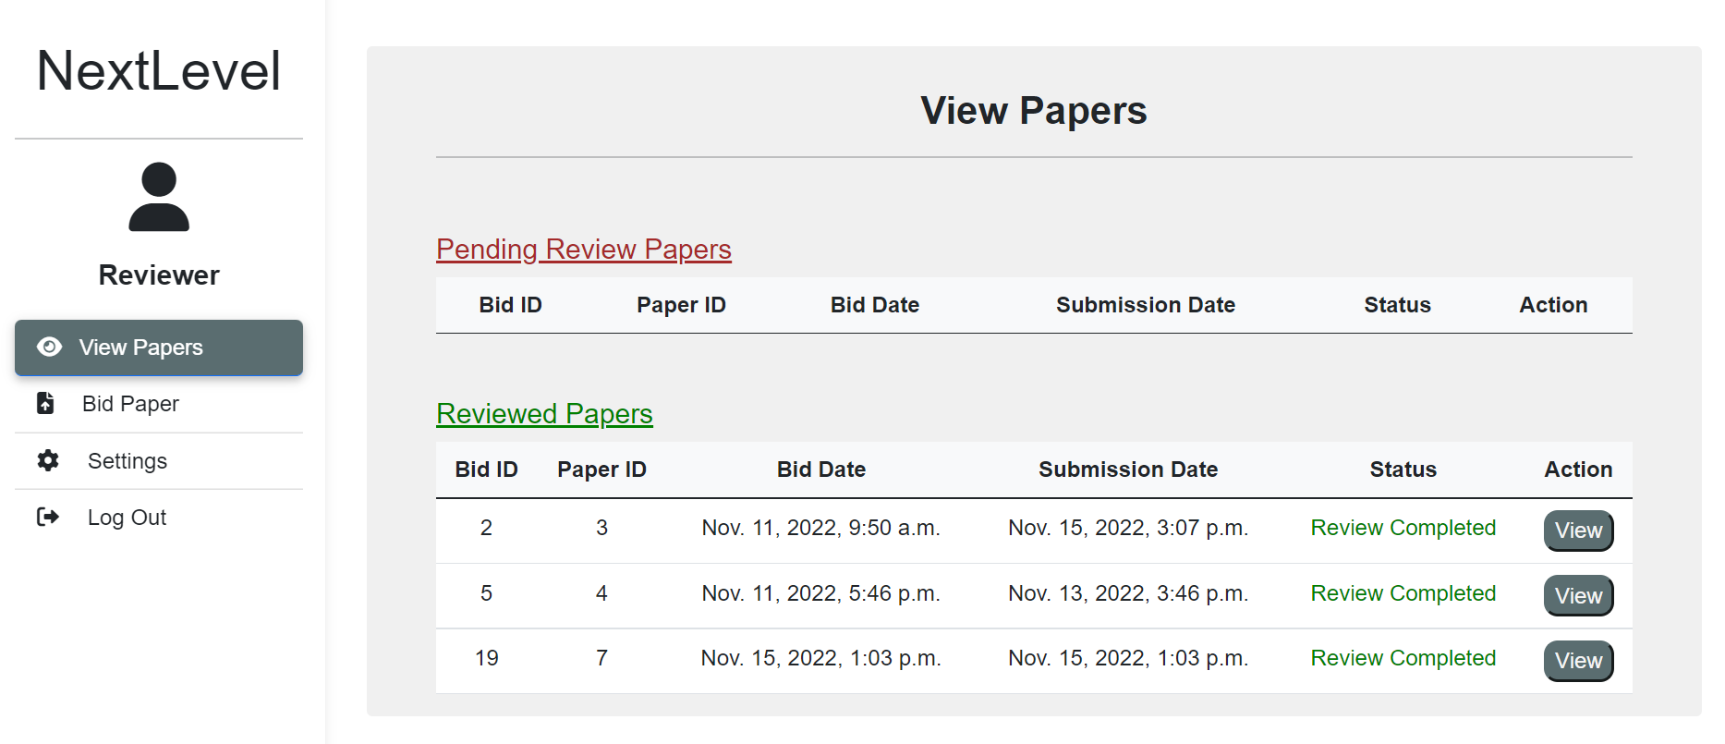

The program also handles various potential errors that might be resulted from the user such as it is not possible to create a user that has the same email account, text pop-ups to indicate whenever an action succeeds or fails.

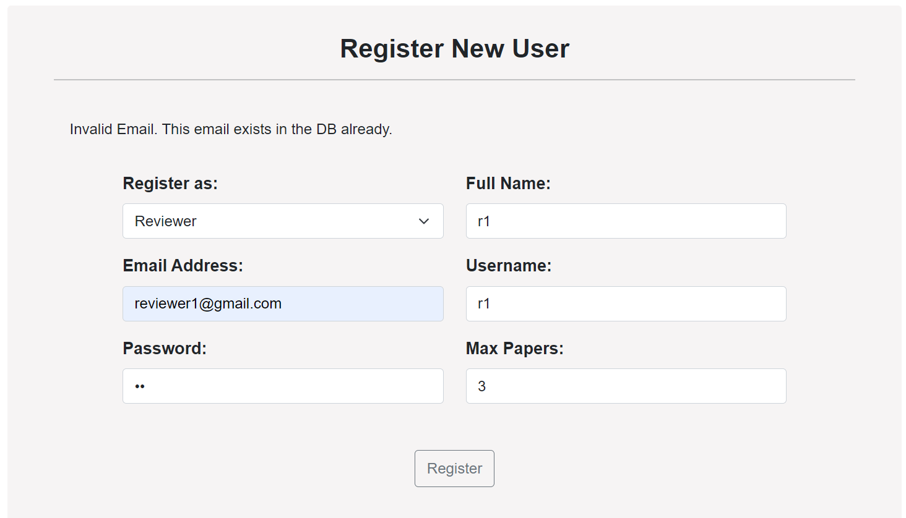

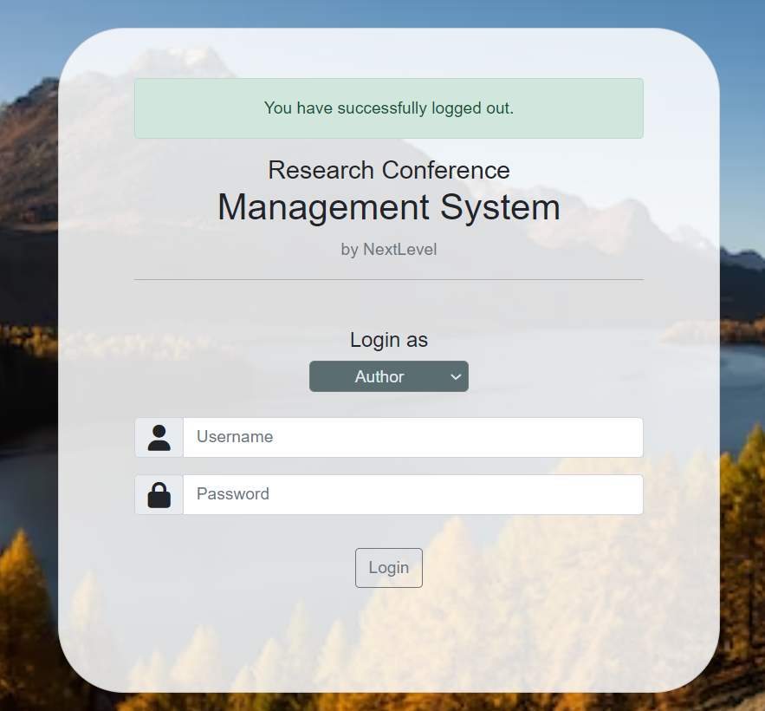

It is possible for the reviewer to post a wrong review. The program has an “Edit” and “Delete” features which enables the reviewer to edit their review or delete it when they feel that it is not necessary anymore.

The functions are also restricted according to the certain user only. For instance, an author is not able to post a review. A reviewer is not able to rate the review they make themselves. These are all to address the safety considerations.

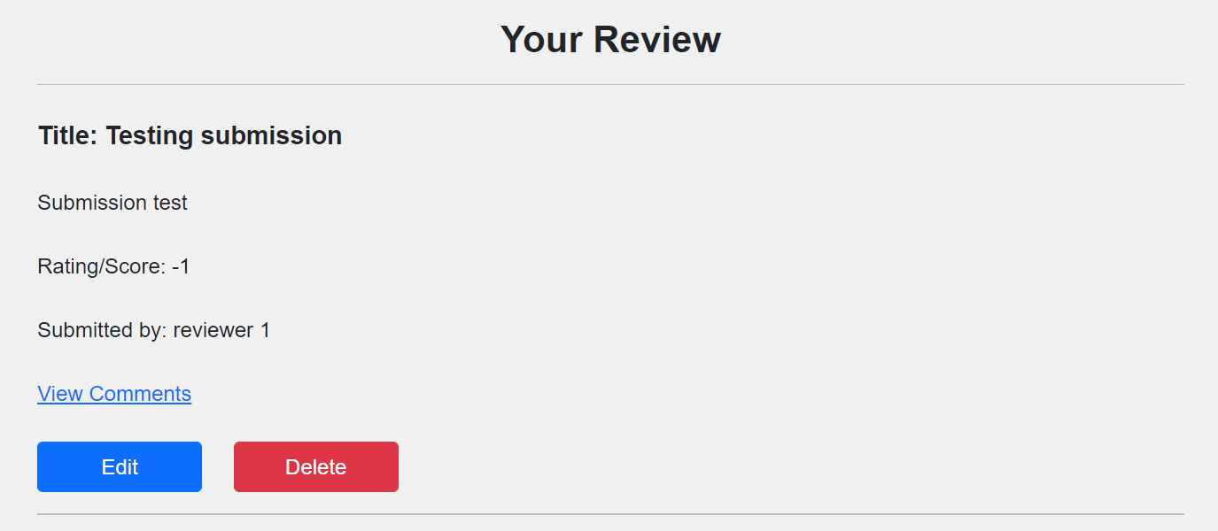

This also applies to the comments. The reviewer is able to edit or delete the comments according to what they need.

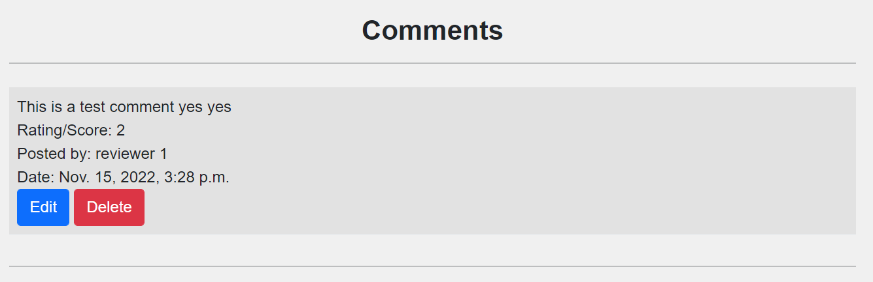

* Team

Since all of the members are assigned to respective roles in which we are most comfortable and skilled in, we trust and rely on each other regarding the tasks that we do individually. All of the members are also contactable and respond fast whenever there is a question/issue raised in the group chat. In addition, all of our members commit to keep all of our data private to only ourselves and will not share it to the others.

1. **Transparency**

* Project

Since the paper is the major component in the program in which everyone should be able to see, the program makes it possible for all the users to read the papers.

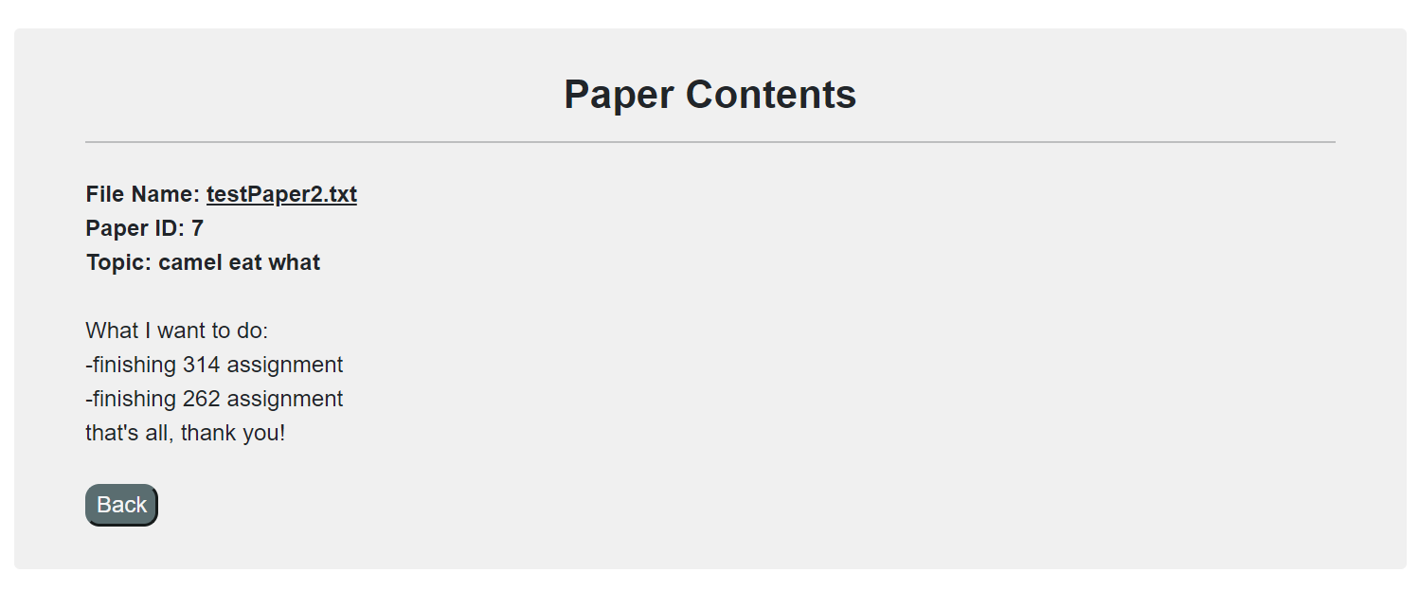

In addition, everyone can also read the reviews. This is to address the transparency and clarity of ethical considerations in the program. The reviewer is able to post a review based on what they feel regarding the paper. They can also write comments in their review.

* Team

Since all of us have different roles and responsibilities, communication is very essential to ensure that every member is on the same page. Whenever there is someone that was unclear or felt something was wrong about a certain part, he/she can clarify directly with the person that is responsible for that particular section.

After certain parts were done, the other members usually helped to re-check the parts and if it did not satisfy the projects’ requirements, the specific member would be asked to make necessary amendments.

1. **Privacy and Security**

* Project

To address possible security issues in a server such as DOS (Denial of Service) attack, data breach or SQL injection, our program is hosted on a local server. This will minimize the possible threats of security issues on the server. For the HTML of the program, we also use the POST method instead of GET method to ensure the safety and security of the information that is being passed in the parameter.

One ethical issue is when the system admins are able to see all the details of a user including the password itself. In the future, we might implement password hashing and encryption. This is to make sure that the accounts of each user are private and secured.

The other ethical issue is in the program, only the system admin is able to create an account. This means that any new users are not able to register and create an account for themselves. They will need to notify the admin to create an account for them. In the future, we might provide a feature where new users are able to create a new account for themselves which enables them to login using the account they have created next time.

Another possible approach in the future is that there can be an implementation to limit the number of login attempts such as it will disable the account for a certain period of time when there are several failed login attempts.

As the program is hosted in a local server, we ensure that there are file backups such as in GitHub or even our own local repositories in our desktops.

* Team

All relevant documents and files are only made accessible by our group members. In other words, any other users outside our group are not given access to all of our files which makes it only private to ourselves. Every action that has been made by a member will be stored in the history section which lets other members be able to see which member has made a specific change/update.

1. **Accountability**

* Project

In the program, whenever a reviewer posts a review, the name of the reviewer will also be posted. This is to ensure that all other users are able to know which reviewer is responsible and accountable for the review that he/she has written.

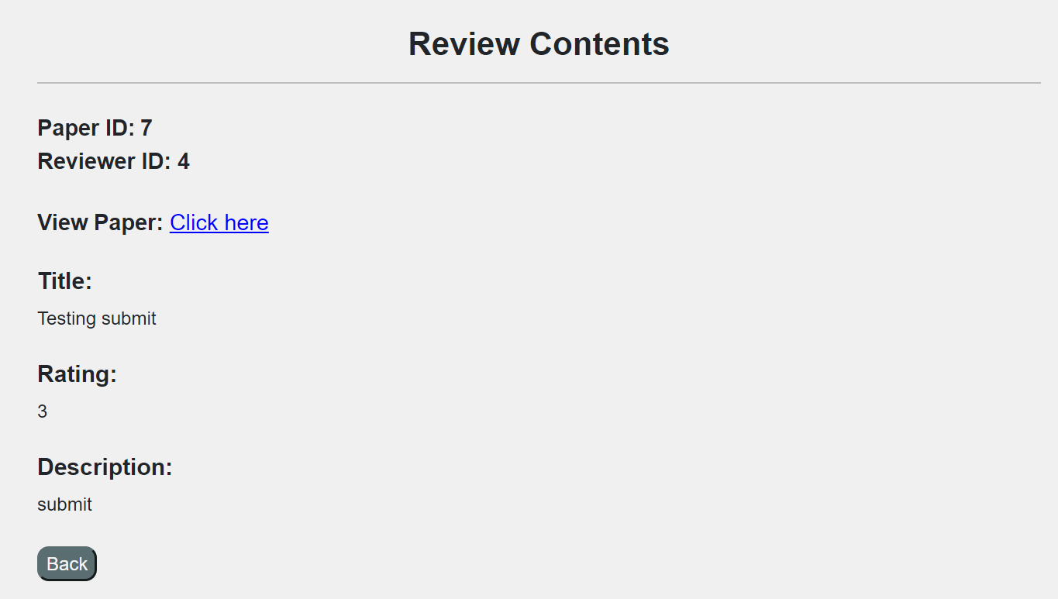

This also applies to the view comments. Whenever a reviewer has posted a comment, the reviewer id will be displayed including the other information such as date and time posted.

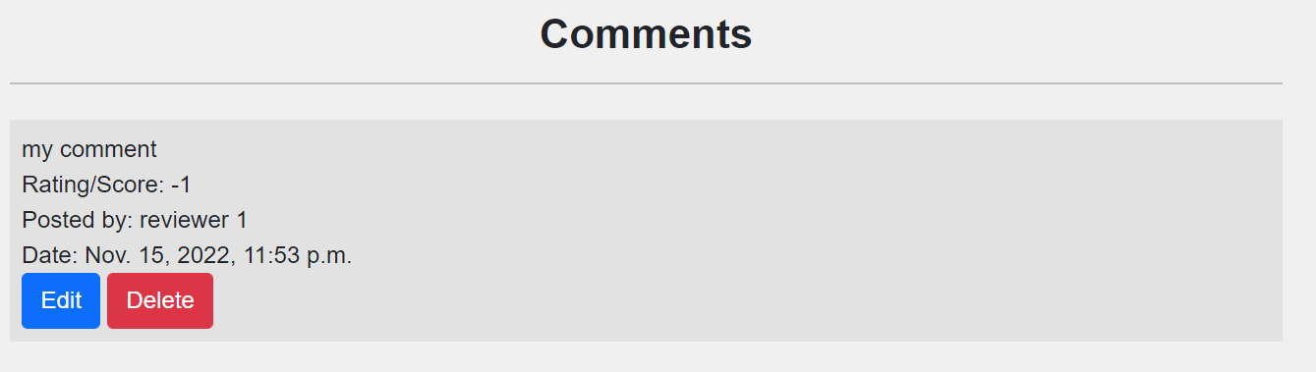

* Team

Based on each of the roles that are assigned to our members, we commit to finish our own tasks in a specific deadline. This is monitored closely by our project manager and scrum master. If there are any changes made, the respective members also make the necessary amendments to their own parts. The members are also responsible in reporting their works to the whole group in every group meeting.

# 

# F. Data-Driven Development

Learn the likeliness of a paper to be rejected or accepted by a Conference Chair member and thus be able to provide suggestions to the Conference Chair if a paper should be rejected or accepted.

### Model Requirements

In the ‘Accept / Reject’ paper page from the Conference Chair’s dashboard, we can provide suggestions to the Conference Chair to help speed up the approval/rejection process. This can be done by identifying the common patterns and the relationship of the review ratings and if a paper becomes approved or rejected as a result.

Therefore, by using this pattern and relationship, it is possible to implement a machine-learning algorithm. However, a large amount of data , estimated at least 500 records, is required first.

### Data Collection

Data collected from the reviews and the papers table can be used. More specifically, from the reviews table - rating and from the papers table - status. These values can be added into a dataset.

### Data Cleaning

Before using the data collected, we will have to ensure that all values are consistent. For example, the rating field from the reviews table should contain data within -3 to 3.

The status field from the papers table should contain the following data - “Not accessed”, “Rejected” and “Accepted”.

Any data that are not of the following values should either be replaced with the mean value or entirely not be used in the dataset.

### Feature Engineering

The software should use the relationship of the reviews and their respective ratings and the resulting status and classify them accordingly. The key value that should be taken into consideration is the rating columns in the Reviews Table. It should be compared and classified in respect to the status column in the Papers Table.

The software should be able to guess based on the mean of the reviews made and identify if it will likely be “Approved” or “Rejected”.

### Model Training

In this stage, we can split our dataset into two different training and testing sets. We will insert 80% of the dataset into X_train and X_test and the remaining 20% into Y_train and Y_test.

Next, we will select the classifier algorithm. Some examples of classifier algorithms are Random Forests, Neural Networks, Decision Tree, Linear Regression, Support Vector Machines (SVM). The decision of which algorithm is used will be based on the accuracy of the model.

### Model Evaluation

Several tests using various classifier algorithms should be done with test data. Information such as the precision, recall rate and F-score should be graphed out. This is to aid in the selection of the classifier algorithm that will be used for the software.

### Model Deployment

The model will be deployed into the software after a decent amount of data has been provided. It will be displayed as a new column called “Suggestion”. This can be found in the ‘Accept’ or ‘Rejected’ page.

### Model Monitoring

We can create a page to continuously display the precision, recall rate or F-score of the model. We can also upload our own test-data in order to view how accurate the suggestions are.

By doing so, we will be able to quickly identify potential errors and performance issues.

# 

# G. Meeting Records

## Minutes-of-Meeting

### Kick Off meeting

**NextLevel**

**Meeting Minutes**

**Kickoff Meeting**

**Date: 6 October 2022**

**Project Name:** *NextLevel Research Conference Management System*

**Opening**

The regular meeting of NextLevel research conference management system was called to order at 10:00AM on 6 October, 2022 by Aaron Vincent in SIM.

**Present**

* Aaron Vincent
* Brandon Chew
* Mikael Denys Widjaja
* Patricia Natasha
* Roswin Dingenus
* Wynne Hewitt
* Yechan Kim

**Agenda**

* Introductions of team members
* Introductions of the project
* Project preparation and understanding
* Determine and assign the roles of each member
* Setup Taiga for project management

**Summary of events**

Preparation:

All members are to understand the project requirements and the roles assigned to them. Further details and information regarding the project will be discussed in the next meeting. Everybody will create a rough idea on the functional requirements of the project which will be discussed in the next meeting.

Taiga Setup

Aaron, the Scrum Master, will set up taiga and add everybody to Taiga.

Roles Decision

All members have come together and decided on their roles respectively.

The roles table can be found below.

|  |  |
| --- | --- |
| **Name** | **Role** |
| Aaron Vincent | Scrum Master, Tester, Diagram designer |
| Brandon Chew | Project Manager, Back-End, Tester |
| Mikael Denys Widjaja | Front-End |
| Patricia Natasha | Back-End |
| Roswin Dingenus | Diagram Designer |
| Wynne Hewitt | Front-End |
| Yechan Kim | Database Designer, Tester |

**Adjournment**

Meeting was adjourned at 11:30AM by Aaron Vincent . The next regular meeting will be on 7 October, 2022 in SIM.

**Minutes submitted by:** Wynne Hewitt

**Approved by:** Aaron Vincent

### Sprint 1 meeting

**NextLevel**

**Meeting Minutes**

**Sprint 1 Meeting**

**Date: 7 October 2022**

**Project Name:** *NextLevel Research Conference Management System*

**Opening**

The regular meeting of NextLevel research conference management system was called to order at 10:00AM on 7 October, 2022 by Aaron Vincent in SIM.

**Present**

* Aaron Vincent
* Brandon Chew
* Mikael Denys Widjaja
* Patricia Natasha
* Roswin Dingenus
* Wynne Hewitt
* Yechan Kim

**Agenda**

* Sprint 1 Briefing
* Create sprint 1 and add the user story from the backlog in Taiga
* Task distribution of Sprint 1 based of Roles
* Create list of prioritized use cases for Sprint 1
* Setup GitHub for software repositories

**Summary of events**

Sprint 1 Briefing:

All members are to create user stories for the research conference management system to be reviewed by the client through face-to-face meetings in which Brandon Chew will be in charge of. The user stories are to be completed by the end of this meeting.

Prioritized Use Cases

All members have discussed which use cases should be prioritized for sprint 1.

The task has been distributed according to the roles decided during the kickoff meeting.

The System Admin use cases are as followed:

* #1 - Login as a System Admin
* #2 - Login as an Author
* #3 - Login as a Reviewer
* #252 - Login as a Conference Chair
* #4 - Logout from the system (System Admin)
* #242 - Logout from the system (Author)
* #246 - Logout from the system (Reviewer)
* #253 - Logout from the system (Conference Chair)
* #6 - View Users
* #5 - Create User
* #8 - Update Author
* #9 - Update Reviewer
* #18 - Update Conference Chair
* #7 - Update System Admin
* #232 - Update role of Author
* #240 - Update role of Reviewer
* #241 - Update role of Conference Chair
* #220 - Update role of System Admin

The frontend will be done by Wynne Hewitt and Mikael Denys Widjaja while the backend will be done by Brandon Chew and Patricia Natasha.

The prioritized use cases diagrams and programming should be done by sprint 2.

Taiga follow-up

Aaron, the Scrum Master, has added the use cases into sprint 1 on Taiga. Group members may refer to Taiga if required on what tasks are required to be completed.

Github Setup

Brandon will set up the github repository and invite everyone into the github. All group members are expected to download github desktop software for easy access to the repository. Brandon will perform the initial commit with the base project.

**Adjournment**

Meeting was adjourned at 11:30AM by Aaron Vincent . The next regular meeting will be on 14 October, 2022 in SIM.

**Minutes submitted by:** Wynne Hewitt

**Approved by:** Aaron Vincent

### Sprint 2 meeting

**NextLevel**

**Meeting Minutes**

**Sprint 2 Meeting**

**Date: 14 October 2022**

**Project Name:** *NextLevel Research Conference Management System*

**Opening**

The regular meeting of NextLevel research conference management system was called to order at 10:00AM on 14 October, 2022 by Aaron Vincent in SIM.

**Present**

* Aaron Vincent
* Brandon Chew
* Mikael Denys Widjaja
* Patricia Natasha
* Roswin Dingenus
* Wynne Hewitt
* Yechan Kim

**Agenda**

* Sprint 1 Review
* Create sprint 2 and add the user story from the backlog in Taiga
* Task distribution of Sprint 2
* Create a list of prioritized use cases for Sprint 2

**Summary of Events**

Sprint 1 Review:

All members came up and showed what they have completed. Everyone has completed their assigned tasks and we will now move on to Sprint 2. The Scrum Master has closed Sprint 1 on Taiga.

Prioritized Use Cases

All members have discussed which use cases should be prioritised for sprint 2.

The Author use cases are as followed:

* #10 - Submit papers
* #11 - View submitted papers
* #12 - Update submitted papers
* #13 - Delete submitted papers
* #243 - Read submitted paper

The frontend will be done by Wynne Hewitt and the backend will be done by Patricia Natasha for the following tasks.

The prioritized use cases diagrams and programming should be done by sprint 3.

Taiga follow-up

Aaron, the Scrum Master, has added the use cases into sprint 2 on Taiga. Group members may refer to Taiga if required on what tasks are required to be completed.

**Adjournment**

Meeting was adjourned at 11:30AM by Aaron Vincent . The next regular meeting will be on 21 October, 2022 in SIM.

**Minutes submitted by:** Wynne Hewitt

**Approved by:** Aaron Vincent

### Sprint 3 meeting

**NextLevel**

**Meeting Minutes**

**Sprint 3 Meeting**

**Date: 21 October 2022**

**Project Name:** *NextLevel Research Conference Management System*

**Opening**

The regular meeting of NextLevel research conference management system was called to order at 22.17 PM on 26 October, 2022 by Aaron Vincent in SIM.

**Present**

* Aaron Vincent
* Brandon Chew
* Mikael Denys Widjaja
* Patricia Natasha
* Roswin Dingenus
* Wynne Hewitt
* Yechan Kim

**Agenda**

* Sprint 2 Review
* Create sprint 3 and add the user story from the backlog in Taiga
* Task distribution of Sprint 3
* Create a list of prioritized use case for Sprint 3

**Summary of Events**

Sprint 2 Review

All members came up and showed what they have done for Sprint 2. Everyone has completed their assigned task and we will move on to Sprint 3. The Scrum Master has closed Sprint 2 on Taiga.

Prioritized Use Cases

All members have discussed and agreed on which use cases should be prioritized for sprint 3.

The Reviewer use cases are as followed:

* #25 - Set the max number of assigned papers
* #247 - View unbidded papers
* #16 - Bid for a paper
* #17 - View bidded papers
* #19 - Delete bidded paper
* #20 - View assigned papers
* #21 - Submit review
* #249 - Read my review’s content
* #248 - Read paper’s content

The Conference Chair use cases are as followed:

* #27 - View bidded paper of all reviewers
* #28 - Allocate papers to reviewers manually
* #233 - Unallocate paper assigned to reviewer

The frontend of Reviewer use cases will be done by Wynne Hewitt and the backend of Reviewer use cases will be done by Brandon Chew.

The frontend of Conference Chairs use cases will be done by Wynne Hewitt and the backend of Conference Chairs use cases will be done by Patricia Natasha.

The diagrams and programming should be completed by sprint 3.

Taiga Follow-up

Aaron, the Scrum Master, has added the use cases into sprint 3 on Taiga. Group members may refer to Taiga if required on what tasks are required to be completed.

**Adjournment**

Meeting was adjourned at 11:30AM by Aaron Vincent. The next regular meeting will be on 28 October, 2022 in SIM.

**Minutes submitted by:** Wynne Hewitt

**Approved by:** Aaron Vincent

### Sprint 4 meeting

**NextLevel**

**Meeting Minutes**

**Sprint 4 Meeting**

**Date: 28 October 2022**

**Project Name:** *NextLevel Research Conference Management System*

**Opening**

The regular meeting of NextLevel research conference management system was called to order at 10:00 AM on 28 October, 2022 by Aaron Vincent in SIM.

**Present**

* Aaron Vincent
* Brandon Chew
* Mikael Denys Widjaja
* Patricia Natasha
* Roswin Dingenus
* Wynne Hewitt
* Yechan Kim

**Agenda**

* Sprint 3 Review
* Create sprint 4 and add the user story from the backlog in Taiga
* Task distribution of Sprint 4
* Create a list of prioritized use case for Sprint 4

**Summary of Events**

Sprint 3 Review

All members came up and showed what they have done for Sprint 3. Everyone has completed their assigned task and we will move on to Sprint 4. The Scrum Master has closed Sprint 3 on Taiga.

Prioritized Use Cases

All members have discussed and agreed on which use cases should be prioritized for sprint 4.

The Reviewer use cases are as followed:

* #22 - View reviewed papers
* #251 - Read other reviewer’s review on the paper
* #23 - Edit my own review
* #24 - Delete my own review
* #26 - Comment on the review made by other reviewers
* #250 - View comments on the review

The Conference Chair use cases are as followed:

* #256 - Read paper’s content
* #30 - View all undecided papers
* #254 - Read review’s content
* #31 - Accept Paper
* #32 - Reject Paper
* #33 - View list of accepted or rejected papers

The frontend of Reviewer use cases will be done by Wynne Hewitt and the backend of Reviewer use cases will be done by Brandon Chew.

The frontend of Conference Chairs use cases will be done by Wynne Hewitt and the backend of Conference Chairs use cases will be done by Patricia Natasha.

The diagrams and programming should be completed by sprint 5.

Taiga Follow-up

Aaron, the Scrum Master, has added the use cases into sprint 4 on Taiga. Group members may refer to Taiga if required on what tasks are required to be completed.

**Adjournment**

Meeting was adjourned at 11:30AM by Aaron Vincent. The next regular meeting will be on 04 November, 2022 in SIM.

**Minutes submitted by:** Brandon Chew

**Approved by:** Aaron Vincent

### Sprint 5 meeting

**NextLevel**

**Meeting Minutes**

**Sprint 5 Meeting**

**Date: 04 November 2022**

**Project Name:** *NextLevel Research Conference Management System*

**Opening**

The regular meeting of NextLevel research conference management system was called to order at 10:00 AM on 04 November, 2022 by Brandon Chew in SIM.

**Present**

* Aaron Vincent
* Brandon Chew
* Mikael Denys Widjaja
* Patricia Natasha
* Roswin Dingenus
* Wynne Hewitt
* Yechan Kim

**Agenda**

* Sprint 4 Review
* Create sprint 5 and add the user story from the backlog in Taiga
* Task distribution of Sprint 5
* Create a list of prioritized use case for Sprint 5
* Ethical Consideration Discussion
* Data-driven Development Discussion

**Summary of Events**

Sprint 4 Review

All members came up and showed what they have done for Sprint 4. Everyone has completed their assigned task and we will move on to Sprint 5. The Scrum Master has closed Sprint 5 on Taiga.

Prioritized Use Cases

All members have discussed and agreed on which use cases should be prioritized for sprint 5.

The Author use cases are as followed:

* #14 - View reviews of my own’ & co-authors’ papers
* #15 - Rate the reviews of my own papers
* #245 - View rated reviews
* #202 - Delete the review rating of my own papers
* #244 - Read review’s content

The Reviewer use cases are as followed:

* #203 - Edit submitted comment
* #204 - Delete submitted comment

The Conference Chair use cases are as followed:

* #255 - Cancel paper decision

The frontend of Authors use cases will be done by Wynne Hewitt and the backend of Authors use cases will be done by Patricia Natasha.

The frontend of Conference Chairs use cases will be done by Wynne Hewitt and the backend of Conference Chairs use cases will be done by Patricia Natasha.

The frontend of Reviewers use cases will be done by Wynne Hewitt and the backend of Reviewers use cases will be done by Brandon Chew.

The diagrams and programming should be completed by sprint 6.

Taiga Follow-up

Aaron, the Scrum Master, has added the use cases into sprint 5 on Taiga. Group members may refer to Taiga if required on what tasks are required to be completed.

Ethical Consideration Discussion

Our group has come together to discuss possible ethical considerations. **Wynne Hewitt** has been assigned to write the document.

Data-driven Development

Our group has come together to discuss possible functions that could use machine-learning algorithms. **Brandon Chew** has been assigned to write the document.

**Adjournment**

Meeting was adjourned at 11:30AM by Aaron Vincent. The next regular meeting will be on 11 November, 2022 in SIM.

**Minutes submitted by:** Brandon Chew

**Approved by:** Aaron Vincent

### Sprint 6 meeting

**NextLevel**

**Meeting Minutes**

**Sprint 6 Meeting**

**Date: 11 November 2022**

**Project Name:** *NextLevel Research Conference Management System*

**Opening**

The regular meeting of NextLevel research conference management system was called to order at 10:00AM on 11 November, 2022 by Brandon Chew in SIM.

**Present**

* Aaron Vincent
* Brandon Chew
* Mikael Denys Widjaja
* Patricia Natasha
* Roswin Dingenus
* Wynne Hewitt
* Yechan Kim

**Agenda**

* Sprint 5 Review
* Create sprint 6 and add the user story from the backlog in Taiga
* Task distribution of Sprint 6
* Create a list of prioritized use case for Sprint 6
* Database Schema
* Project Overall Review
* Test-Case & Test-Plans Overall Review

**Summary of Events**

Sprint 5 Review

All members came up and showed what they have done for Sprint 5. Everyone has completed their assigned task and we will move on to Sprint 6. The Scrum Master has closed Sprint 5 on Taiga.

Prioritized Use Cases

All members have discussed and agreed on which use cases should be prioritized for sprint 5.

The Conference Chair use cases are as followed:

* #221 - Allocate papers to reviewers automatically

The frontend of Conference Chairs use cases will be done by Wynne Hewitt and the backend of Conference Chairs use cases will be done by Patricia Natasha.

The diagrams and programming should be completed before the final meeting.

Taiga Follow-up

Aaron, the Scrum Master, has added the use cases into sprint 6 on Taiga. Group members may refer to Taiga if required on what tasks are required to be completed.

Database Schema

The final database schema has been made and properly finalized. The schema has been created by **Yechan Kim**.

Project Overall Review

The team will now begin reviewing the overall project and perform any adjustments if required. All diagrams will be reviewed and ensured that it is consistent with the backend programming. **Aaron Vincent** will be supervising the reviewing process.

Test-Case & Test-Plan Review

The team has gathered and reviewed the test cases and test plans that were created by **Yechan Kim**.

**Adjournment**

Meeting was adjourned at 11:30AM by Aaron Vincent. The final meeting will be on 16 November, 2022 in SIM.

**Minutes submitted by:** Wynne Hewitt

**Approved by:** Aaron Vincent

### Final meeting

**NextLevel**

**Meeting Minutes**

**Final Meeting**

**Date: 16 November 2022**

**Project Name:** *NextLevel Research Conference Management System*

**Opening**

The regular meeting of NextLevel research conference management system was called to order at 10:00AM on 16 November, 2022 by Brandon Chew in SIM.

**Present**

* Aaron Vincent
* Brandon Chew
* Mikael Denys Widjaja
* Patricia Natasha
* Roswin Dingenus
* Wynne Hewitt
* Yechan Kim

**Agenda**

* Sprint 6 Review
* Project Overall Review
* Test-Case & Test-Plans Overall Review
* Video

**Summary of Events**

Sprint 6 Review

All members came up and showed what they have done for Sprint 5. Everyone has completed their assigned task and we will move on to Sprint 6. The Scrum Master has closed Sprint 6 on Taiga.

Project Overall Review

The team will continue with the reviewing of the overall project and perform any adjustments if required. All diagrams will be reviewed and ensured that it is consistent with the backend programming. **Aaron Vincent** will be supervising the reviewing process.

Video

The team has come together to record the video required for the project. The video recording and editing will be done by **Wynne Hewitt**. The video is expected to be completed by 17 November.

**Adjournment**

Meeting was adjourned at 11:30AM by Brandon Chew.

**Minutes submitted by:** Brandon Chew

**Approved by:** Aaron Vincent

## 

## Gantt Chart

### SPRINT 1

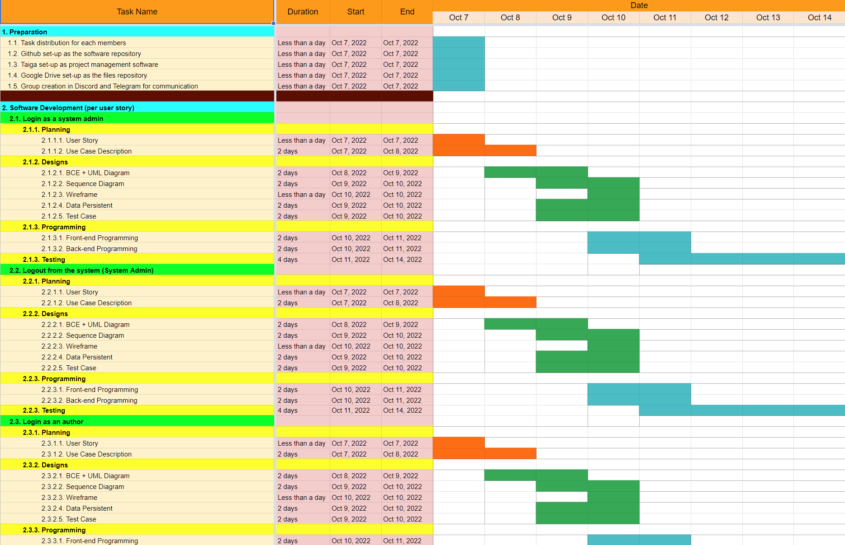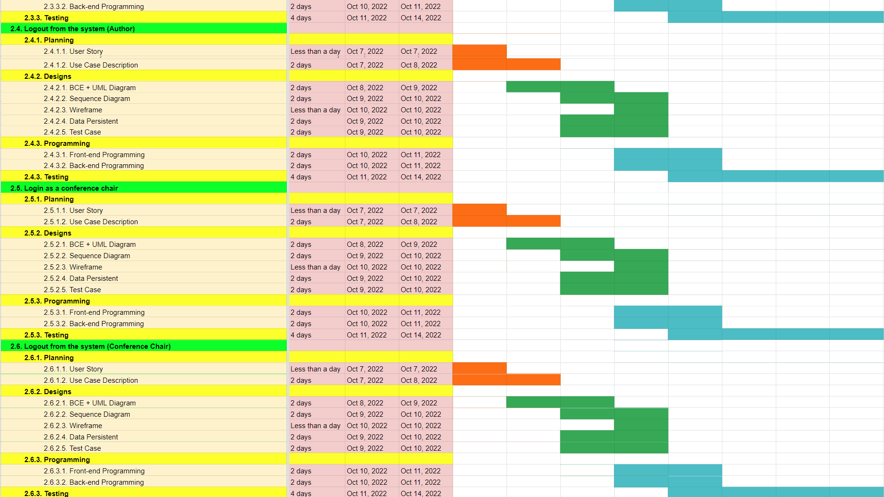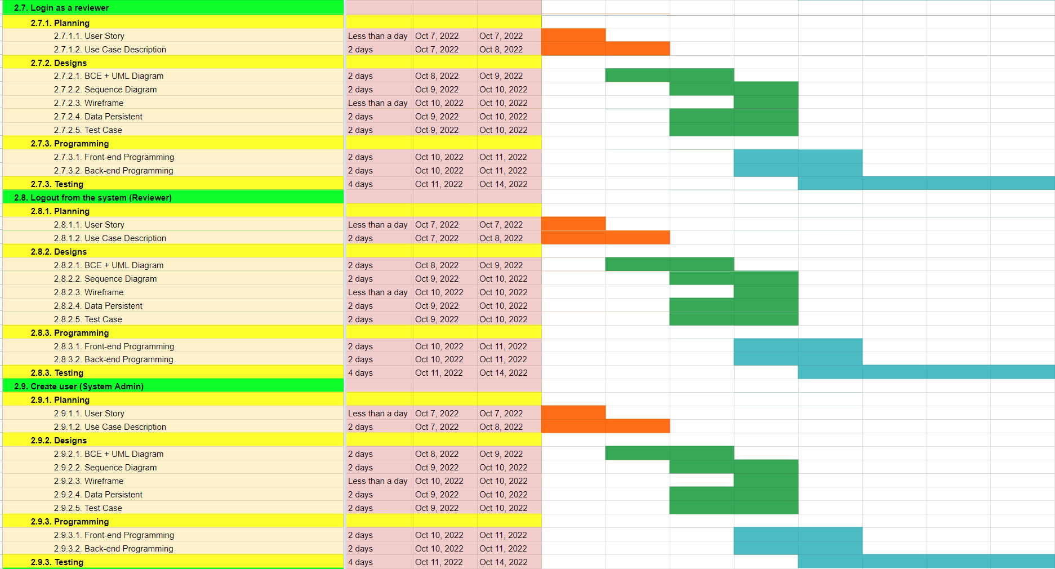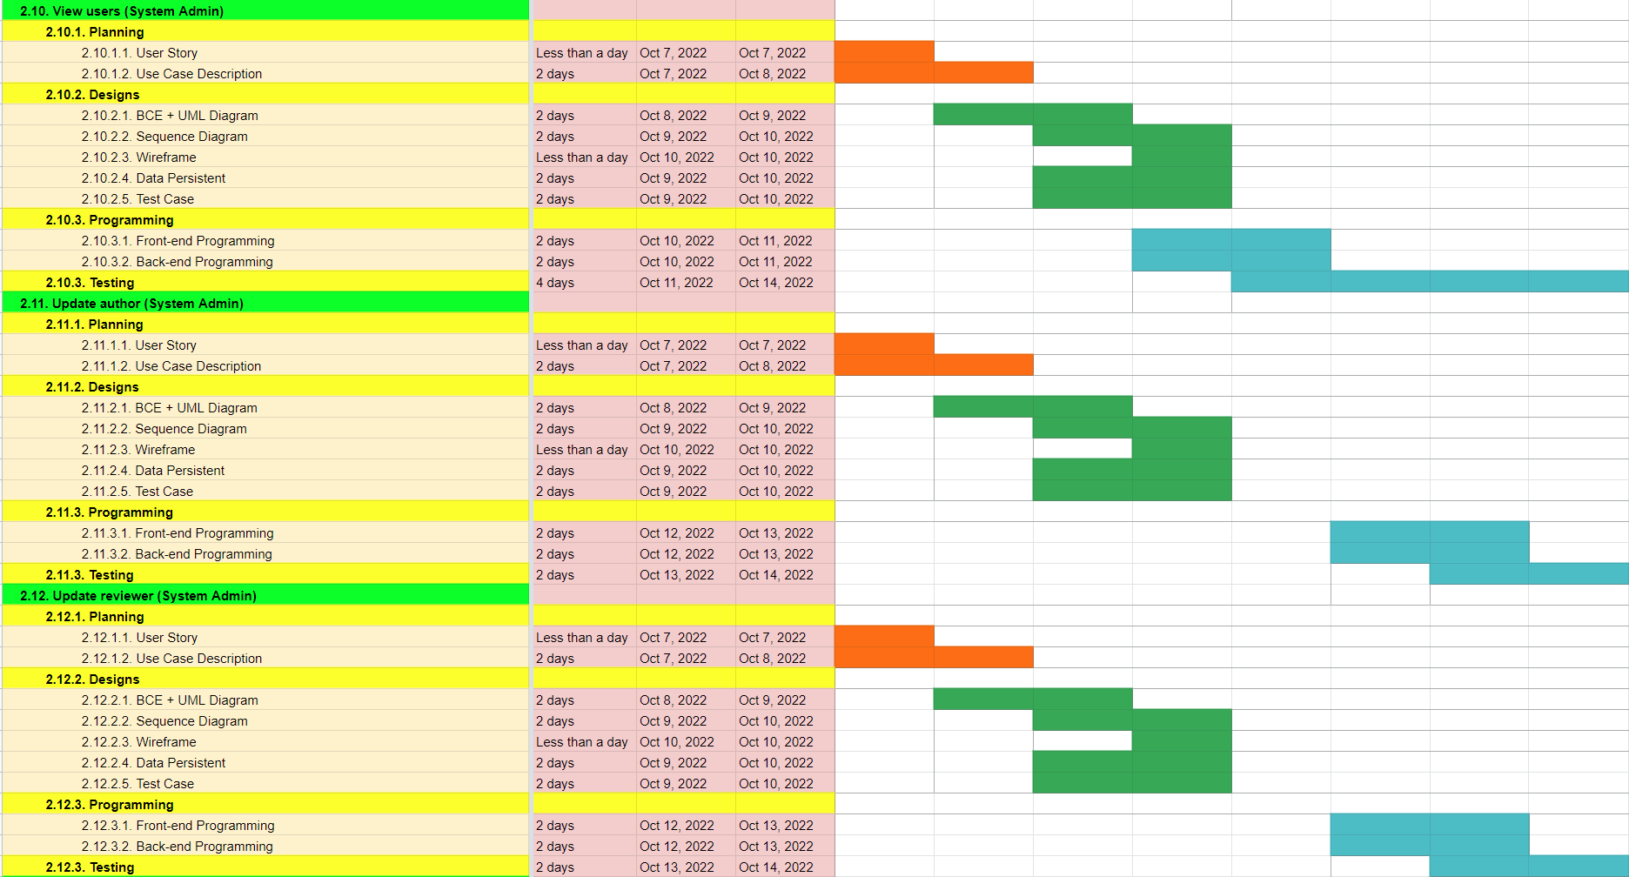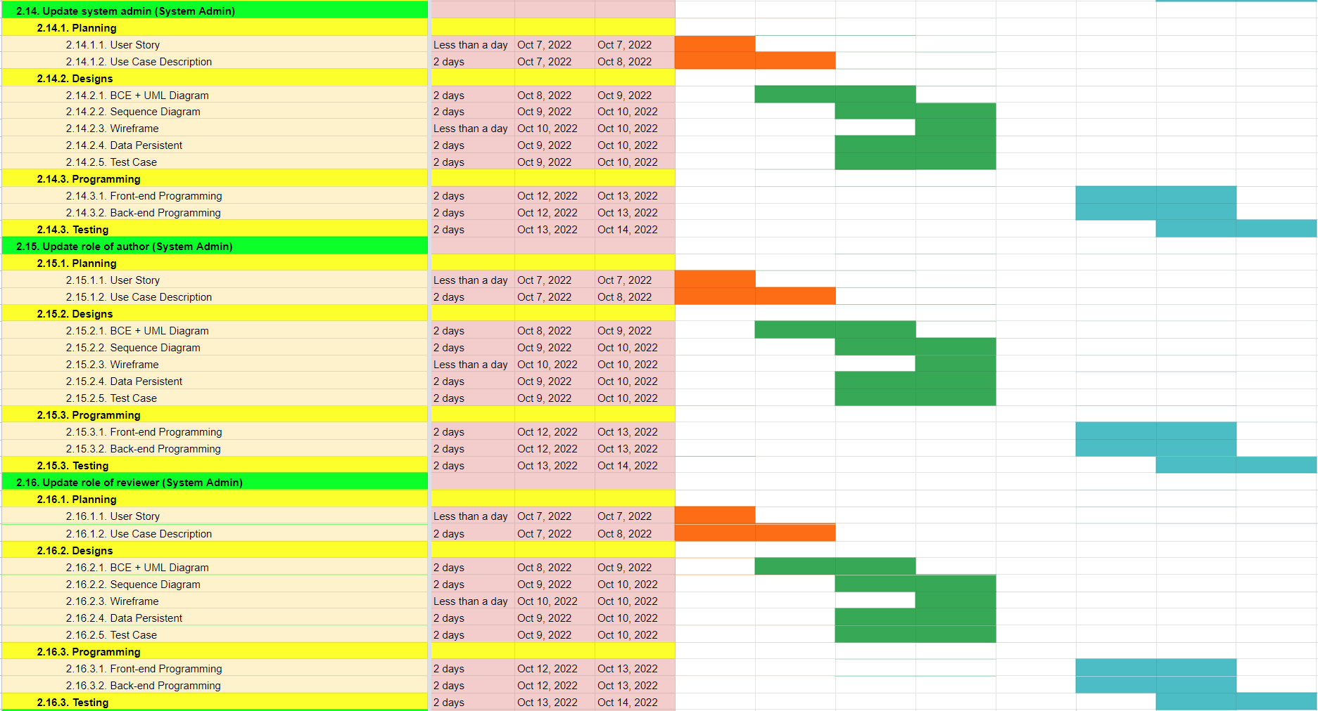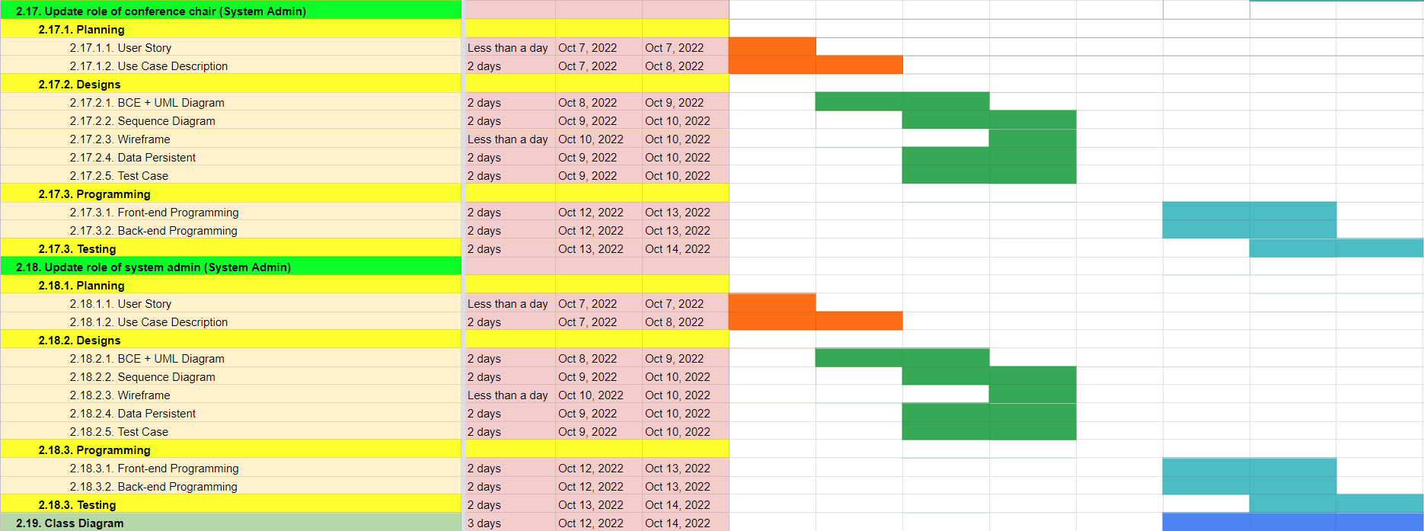

### SPRINT 2

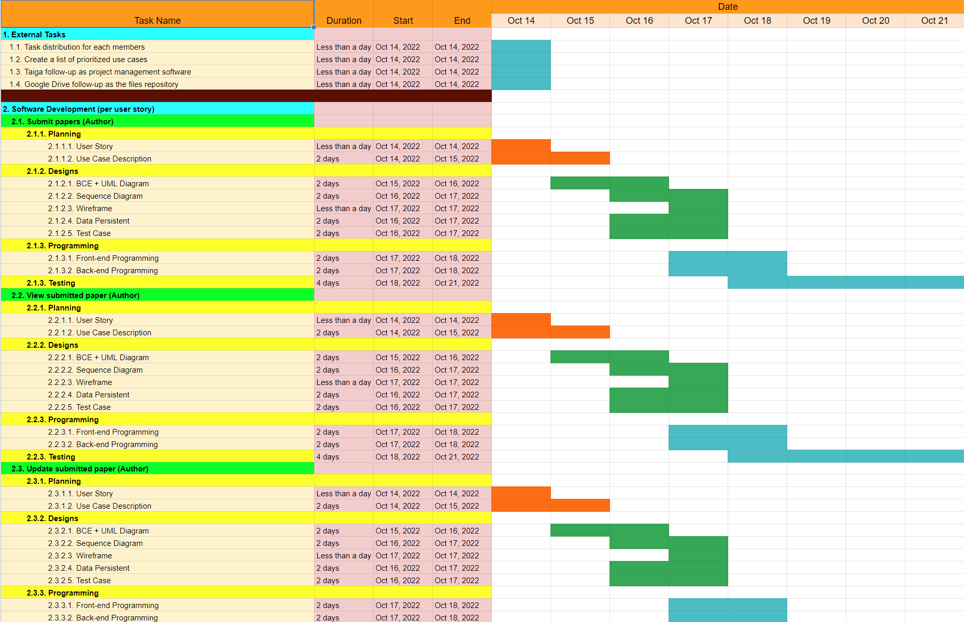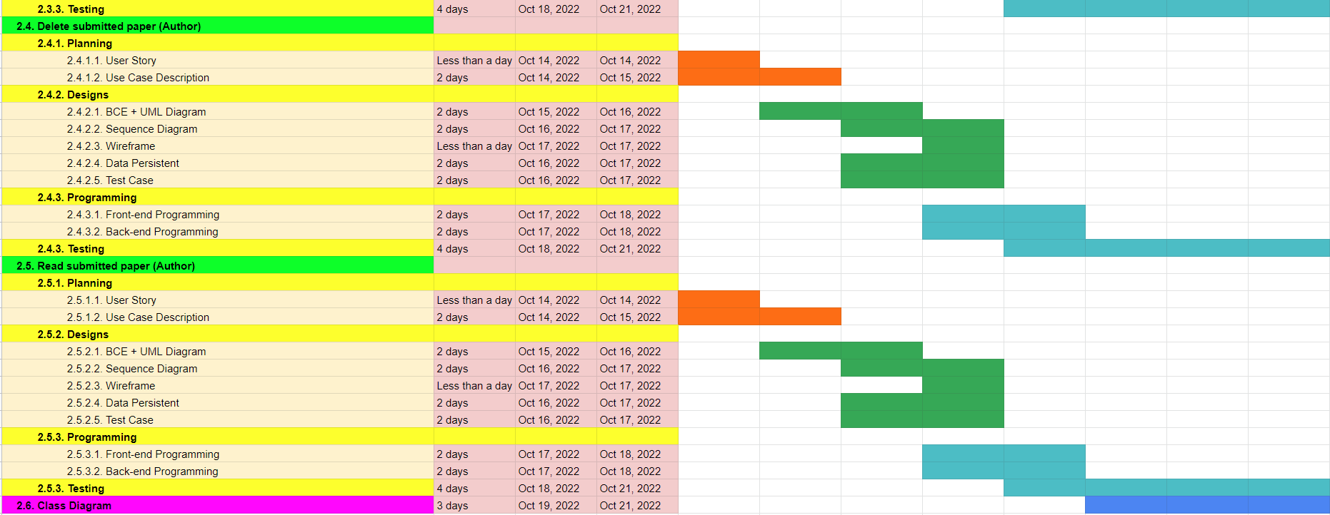

### SPRINT 3

### SPRINT 4

### 

### 

### 

### 

### SPRINT 5

### SPRINT 6



 